

Meta Ads Performance Audit
Client: Box Divvy
Campaign: Hubster Lead Gen
Period: 4 May 2026 – 10 May 2026

Executive Summary
The Box Divvy campaign is delivering solid results with a blended CPL of $13.33 across 36 leads. Total ad spend for the period was $479.96 with an average CTR of 7.83%. The top performer achieved a CPL of $2.33 (DEC-15-2025 - copy_08771CC1-D4C9-4210-BE). High CTR indicates strong creative-audience fit.

Key Metrics
Period | Spend | Leads | CPL | CTR
This Week | $479.96 | 36 | $13.33 | 7.83%
This Month | $2,091.62 | 187 | $11.19 | 7.63%
Since Starting | $8,278.95 | 879 | $9.42 | 6.68%

Latest Batch — Top Performers
# | Release Lot | CPL | Leads | CTR | Ad ID | Preview
🔥 | May-4 | $6.33 | 14 | 5.33% | ...419360360 | 
2 | May-4 | $11.96 | 5 | 5.15% | ...418000360 | 
⭐ | May-4 | $16.74 | 2 | 4.97% | ...392360360 | 
4 | May-4 | $23.93 | 16 | 7.66% | ...417160360 | 

Top 5 Performers by CPL — All Time
# | Release Lot | CPL | Leads | CTR | Ad ID | Preview
🔥 | Feb-6 | $2.33 | 2 | 2.44% | ...917610360 | 
2 | Feb-6 | $3.18 | 1 | 6.74% | ...917210360 | 
⭐ | Feb-6 | $3.87 | 3 | 4.63% | ...917220360 | 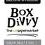
4 | Jan-29 | $4.03 | 11 | 6.22% | ...743430360 | 
5 | Jan-12 | $4.07 | 12 | 6.18% | ...985710360 | 
🔥 = Top performer | ⭐ = Volume star | Sorted by cost per conversion (lowest first)

Release Lot Performance
• DEC-15 Release: 5 conversions from 2 ad(s) – Best cost: $2.33
• DEC-29 Release: 1 conversions from 1 ad(s) – Best cost: $3.18
• Jan-17 Release: 11 conversions from 1 ad(s) – Best cost: $4.03
• Dec-15 Release: 12 conversions from 1 ad(s) – Best cost: $4.07

Creative Insights
Top Performer:
DEC-15-2025 - copy_08771CC1-D4C9-4210-BE7C-B4582E8D0709 - Copy – 2 conversions at $2.33 cost, 2.44% CTR
Runner Up:
DEC-29-2025 - copy_E5D9847D-795E-4D9C-A9E6-1F25D6F4D5D1 - Copy – 1 conversions at $3.18 cost, 6.74% CTR

Demographic Sweet Spot
• Female 35-44: 32 leads, $12.93 CPL, 6.83% CTR
• Female 45-54: 19 leads, $15.59 CPL, 8.02% CTR
• Female 25-34: 13 leads, $18.78 CPL, 5.66% CTR

Key Insights
What's Working:
✓ 36 leads generated from $479.96 spend
✓ CTR of 7.83% indicates strong ad relevance
✓ Cost per lead of $13.33 is within viable range
✓ Top performer "DEC-15-2025 - copy_08771CC1-D4C9-4210-BE7C-B4582E8D0709 - Copy" driving 2 leads

Opportunities:
→ Reduce CPL by pausing ads with CTR below 7.8% average
→ Scale spend on winning ad creatives to increase volume
→ Create new ad variations based on top-performing creative patterns
→ Expand audience targeting based on demographic insights

Recommended Next Steps
▸ Increase budget on top 2 performers by 20-30%
▸ Review underperforming ads and pause or refresh creative
▸ Set up A/B experiment for new headline or creative variation
▸ Monitor frequency caps to avoid ad fatigue

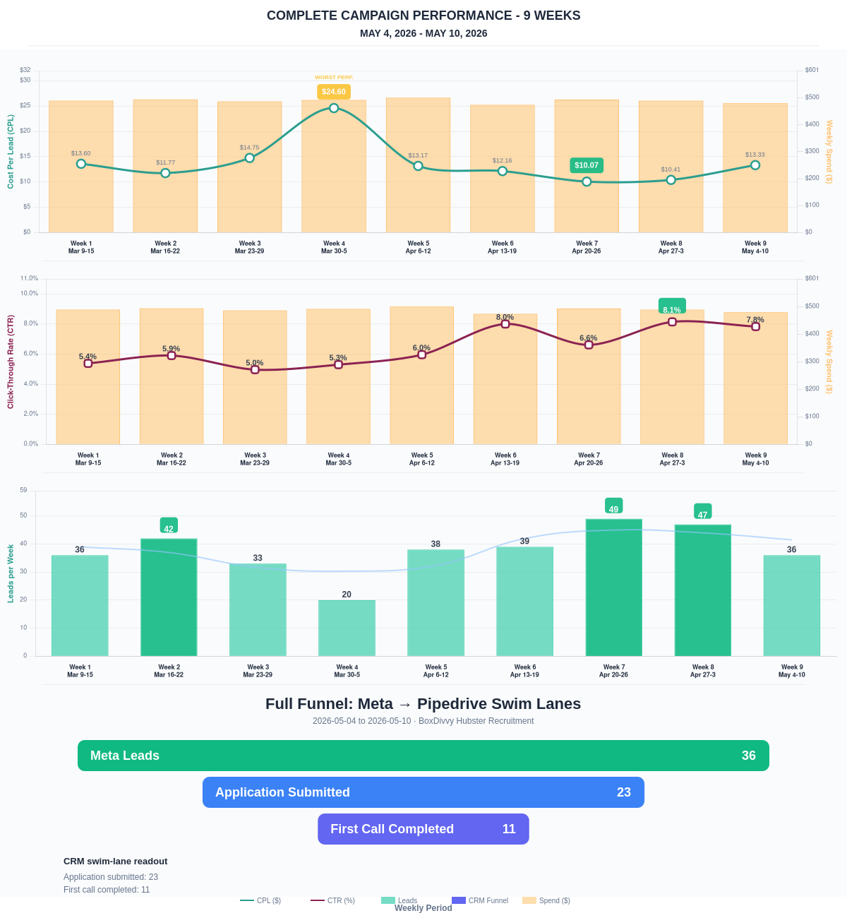

Questions? Let's chat about scaling these results.
Lead → Completed Application Dropoff
Meta lead aliases are not summed. This compares the canonical Meta Lead event against completed applications from complete_registration.
Period | Meta Leads | Completed Applications | Dropoff | Completion Rate | Cost / Completed
This Week | 36 | 23 | 13 | 63.89% | $20.87
Last 30 Days | 187 | 113 | 74 | 60.43% | $18.51
Campaign to Date | 879 | 305 | 574 | 34.70% | $27.14
Full Funnel — Meta → Pipedrive Swim Lanes
Direct Pipedrive pull from BoxDivvy Hubster Recruitment, Hub in Progress, and Hub Handovers. This shows application-stage CRM reality beside Meta attribution.
Funnel Stage | Count | Source | Notes
Meta Leads | 36 | Meta canonical lead | Top-funnel ad-attributed leads
Application Submitted | 23 | Meta complete_registration | Ad-attributed submitted applications
First Call Completed | 11 | Pipedrive swim lane | CRM deals that reached the first-call-completed lane during the period
Current open CRM funnel: 256 deals
Open Swim Lane | Open Deals
Application Submitted | 132
First Call Completed | 81
On Hold | 13
Building Members | 6
Waiting for delivery day | 6
Waiting on marketing call | 5
Joined hub | 5
Hub pack complete | 3
Brisbane Campaign Drill-down
Separate view of the Brisbane campaign so it can be reviewed independently from Melbourne and Bendigo.
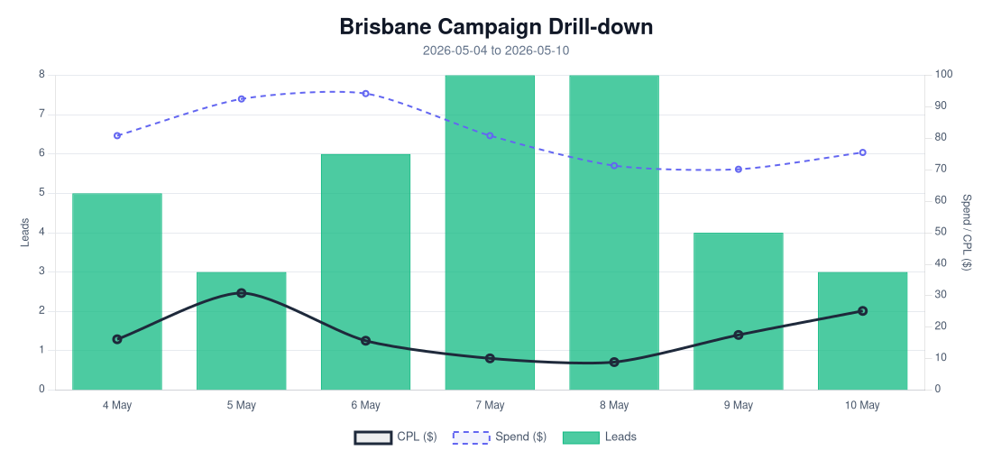
Period | Spend | Leads | Completed Applications | Completion Rate | CPL | CTR
Selected Period | $565.49 | 37 | 16 | 43.24% | $15.28 | 6.87%
Last 30 Days | $565.49 | 37 | 16 | 43.24% | $15.28 | 6.87%
Campaign to Date | $565.49 | 37 | 16 | 43.24% | $15.28 | 6.87%
Top Brisbane Ads
Ad | Spend | Leads | CPL | CTR
BD-BNE TOF - DEC-29-2025 - copy_B9ECFAD4-F5C2-4F45-8561-0BD4477D7E0E | $88.56 | 14 | $6.33 | 5.33%
BD-BNE TOF - Jan-12-26 - copy_61BC4AF8-4B02-4882-A36C-5089A05D079E | $59.81 | 5 | $11.96 | 5.15%
BD-BNE TOF - Mar-5-26 - copy_779A87A3 - Ad4 | $33.48 | 2 | $16.74 | 4.97%
BD-BNE TOF - DEC-22-2025 - copy_9B8E5707-E50A-4DAD-94BB-138C32A34A9B | $382.83 | 16 | $23.93 | 7.66%

