

Meta Ads Performance Audit
Client: Box Divvy
Campaign: Hubster Lead Gen
Period: 11 May 2026 – 17 May 2026

Executive Summary
The Box Divvy campaign is delivering solid results with a blended CPL of $13.03 across 39 leads. Total ad spend for the period was $508.26 with an average CTR of 5.81%. The top performer achieved a CPL of $2.40 (DEC-15-2025 - copy_08771CC1-D4C9-4210-BE). High CTR indicates strong creative-audience fit.

Key Metrics
Period | Spend | Leads | CPL | CTR
This Week | $508.26 | 39 | $13.03 | 5.81%
This Month | $2,107.72 | 178 | $11.84 | 7.13%
Since Starting | $8,787.24 | 918 | $9.57 | 6.63%

Latest Batch — Top Performers
# | Release Lot | CPL | Leads | CTR | Ad ID | Preview
🔥 | Mar-12 | $9.79 | 1 | 7.17% | ...256180360 | 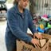
2 | Mar-5 | $11.35 | 1 | 6.79% | ...609950360 | 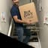
⭐ | Mar-5 | $13.21 | 7 | 5.73% | ...610630360 | 
4 | Mar-5 | $30.15 | 1 | 5.56% | ...515360360
5 | Mar-5 | $49.16 | 1 | 5.47% | ...136080360 | 

Top 5 Performers by CPL — All Time
# | Release Lot | CPL | Leads | CTR | Ad ID | Preview
🔥 | Feb-6 | $2.40 | 2 | 2.29% | ...917610360 | 
2 | Feb-6 | $3.23 | 1 | 6.52% | ...917210360 | 
⭐ | Feb-6 | $3.95 | 3 | 4.51% | ...917220360 | 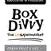
4 | Jan-29 | $4.03 | 11 | 6.22% | ...743430360 | 
5 | Jan-12 | $4.07 | 12 | 6.18% | ...985710360 | 
🔥 = Top performer | ⭐ = Volume star | Sorted by cost per conversion (lowest first)

Release Lot Performance
• DEC-15 Release: 5 conversions from 2 ad(s) – Best cost: $2.40
• DEC-29 Release: 1 conversions from 1 ad(s) – Best cost: $3.23
• Jan-17 Release: 11 conversions from 1 ad(s) – Best cost: $4.03
• Dec-15 Release: 12 conversions from 1 ad(s) – Best cost: $4.07

Creative Insights
Top Performer:
DEC-15-2025 - copy_08771CC1-D4C9-4210-BE7C-B4582E8D0709 - Copy – 2 conversions at $2.40 cost, 2.29% CTR
Runner Up:
DEC-29-2025 - copy_E5D9847D-795E-4D9C-A9E6-1F25D6F4D5D1 - Copy – 1 conversions at $3.23 cost, 6.52% CTR

Demographic Sweet Spot
• Female 35-44: 22 leads, $17.44 CPL, 4.60% CTR
• Female 45-54: 16 leads, $18.44 CPL, 6.03% CTR
• Female 25-34: 11 leads, $17.64 CPL, 3.42% CTR

Key Insights
What's Working:
✓ 39 leads generated from $508.26 spend
✓ CTR of 5.81% indicates strong ad relevance
✓ Cost per lead of $13.03 is within viable range
✓ Top performer "DEC-15-2025 - copy_08771CC1-D4C9-4210-BE7C-B4582E8D0709 - Copy" driving 2 leads

Opportunities:
→ Reduce CPL by pausing ads with CTR below 5.8% average
→ Scale spend on winning ad creatives to increase volume
→ Create new ad variations based on top-performing creative patterns
→ Expand audience targeting based on demographic insights

Recommended Next Steps
▸ Increase budget on top 2 performers by 20-30%
▸ Review underperforming ads and pause or refresh creative
▸ Set up A/B experiment for new headline or creative variation
▸ Monitor frequency caps to avoid ad fatigue

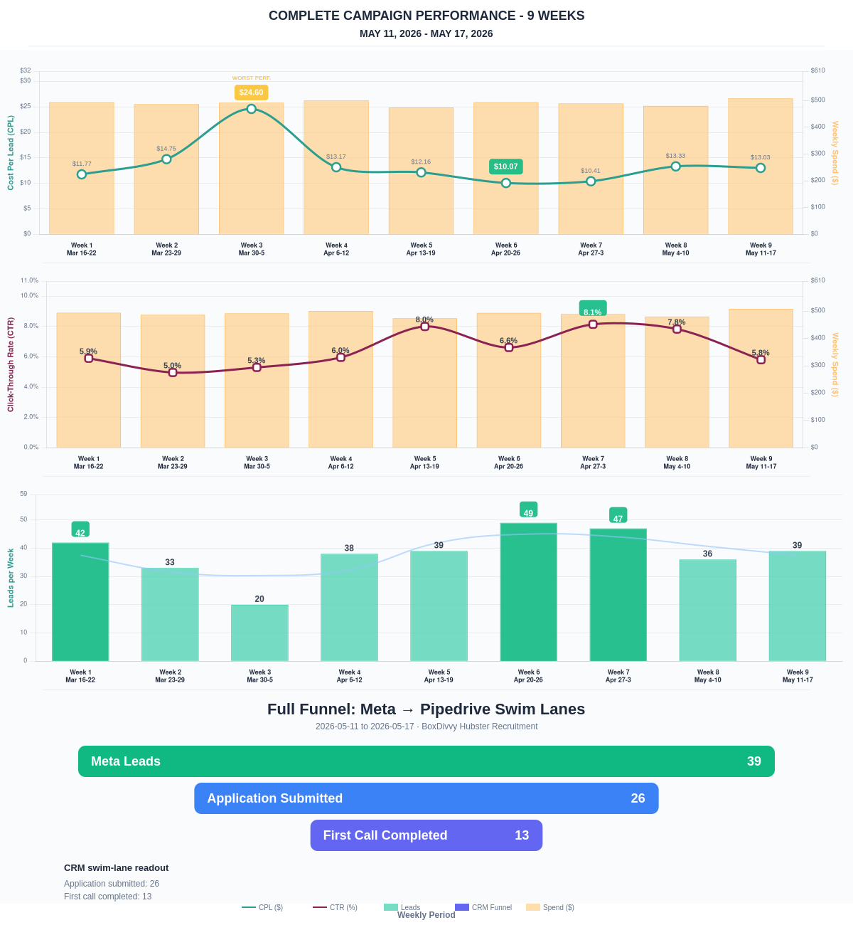

Questions? Let's chat about scaling these results.
Lead → Completed Application Dropoff
Meta lead aliases are not summed. This compares the canonical Meta Lead event against completed applications from complete_registration.
Period | Meta Leads | Completed Applications | Dropoff | Completion Rate | Cost / Completed
This Week | 39 | 26 | 13 | 66.67% | $19.55
Last 30 Days | 178 | 106 | 72 | 59.55% | $19.88
Campaign to Date | 918 | 331 | 587 | 36.06% | $26.55
Full Funnel — Meta → Pipedrive Swim Lanes
Direct Pipedrive pull from BoxDivvy Hubster Recruitment, Hub in Progress, and Hub Handovers. This shows application-stage CRM reality beside Meta attribution.
Funnel Stage | Count | Source | Notes
Meta Leads | 39 | Meta canonical lead | Top-funnel ad-attributed leads
Application Submitted | 26 | Meta complete_registration | Ad-attributed submitted applications
First Call Completed | 13 | Pipedrive swim lane | CRM deals that reached the first-call-completed lane during the period
Current open CRM funnel: 273 deals
Open Swim Lane | Open Deals
Application Submitted | 134
First Call Completed | 89
On Hold | 16
Waiting on marketing call | 8
Waiting for delivery day | 8
Joined hub | 5
To be added to socials | 4
Hub pack complete | 3
Brisbane Campaign Drill-down
Separate view of the Brisbane campaign so it can be reviewed independently from Melbourne and Bendigo.
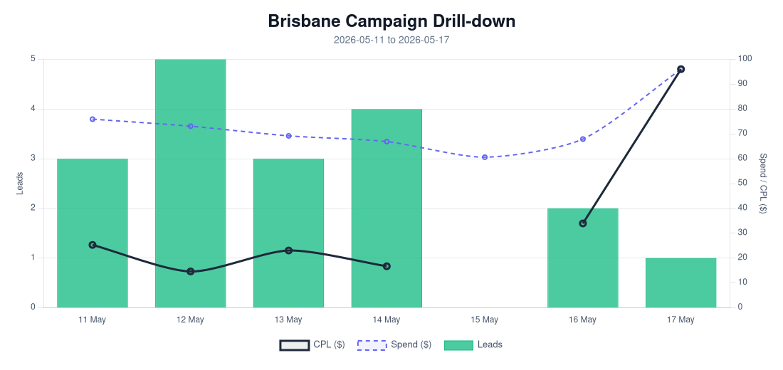
Period | Spend | Leads | Completed Applications | Completion Rate | CPL | CTR
Selected Period | $510.01 | 18 | 11 | 61.11% | $28.33 | 4.75%
Last 30 Days | $1,075.63 | 55 | 27 | 49.09% | $19.56 | 5.91%
Campaign to Date | $1,075.63 | 55 | 27 | 49.09% | $19.56 | 5.91%
Top Brisbane Ads
Ad | Spend | Leads | CPL | CTR
BD-BNE TOF - 20260512-ROOT - 07 - km-BD-Reel-Ad-8-0-Redesigned-1080p-60f-20260511-025336 | $6.16 | 1 | $6.16 | 0.59%
BD-BNE TOF - 20260512-ROOT - 08 - km-BD-Reel-Ad-9-0-Redesigned-1080p-60f-20260511-025745 | $7.63 | 1 | $7.63 | 2.25%
BD-BNE TOF - DEC-29-2025 - copy_B9ECFAD4-F5C2-4F45-8561-0BD4477D7E0E | $74.73 | 6 | $12.46 | 5.27%
BD-BNE TOF - Jan-12-26 - copy_61BC4AF8-4B02-4882-A36C-5089A05D079E | $27.44 | 2 | $13.72 | 3.90%
BD-BNE TOF - 20260512-ROOT - 01 - km-BD-Reel-Ad-10-Redesigned-1080p-60f-20260511-030516 | $35.53 | 1 | $35.53 | 3.71%

