

Meta Ads Performance Audit
Client: Box Divvy
Campaign: Hubster Lead Gen
Period: 18 May 2026 – 24 May 2026

Executive Summary
The Box Divvy campaign is delivering strong performance with a blended CPL of $8.90 across 53 leads. Total ad spend for the period was $471.80 with an average CTR of 5.82%. The top performer achieved a CPL of $2.55 (DEC-15-2025 - copy_08771CC1-D4C9-4210-BE). High CTR indicates strong creative-audience fit.

Key Metrics
Period | Spend | Leads | CPL | CTR
This Week | $471.80 | 53 | $8.90 | 5.82%
This Month | $2,097.02 | 187 | $11.21 | 6.95%
Since Starting | $9,259.35 | 971 | $9.54 | 6.60%

Latest Batch — Top Performers
# | Release Lot | CPL | Leads | CTR | Ad ID | Preview
🔥 | Jan-29 | $4.62 | 92 | 5.89% | ...681010360 | 
2 | Jan-29 | $5.84 | 1 | 3.41% | ...696440360 | 
⭐ | Jan-29 | $7.26 | 2 | 4.38% | ...673170360 | 

Top 5 Performers by CPL — All Time
# | Release Lot | CPL | Leads | CTR | Ad ID | Preview
🔥 | Feb-6 | $2.55 | 2 | 2.14% | ...917610360 | 
2 | Feb-6 | $3.23 | 1 | 6.45% | ...917210360 | 
⭐ | Feb-6 | $3.95 | 3 | 4.51% | ...917220360 | 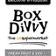
4 | Jan-29 | $4.03 | 11 | 6.22% | ...743430360 | 
5 | Jan-12 | $4.07 | 12 | 6.18% | ...985710360 | 
🔥 = Top performer | ⭐ = Volume star | Sorted by cost per conversion (lowest first)

Release Lot Performance
• DEC-15 Release: 5 conversions from 2 ad(s) – Best cost: $2.55
• DEC-29 Release: 1 conversions from 1 ad(s) – Best cost: $3.23
• Jan-17 Release: 11 conversions from 1 ad(s) – Best cost: $4.03
• Dec-15 Release: 12 conversions from 1 ad(s) – Best cost: $4.07

Creative Insights
Top Performer:
DEC-15-2025 - copy_08771CC1-D4C9-4210-BE7C-B4582E8D0709 - Copy – 2 conversions at $2.55 cost, 2.14% CTR
Runner Up:
DEC-29-2025 - copy_E5D9847D-795E-4D9C-A9E6-1F25D6F4D5D1 - Copy – 1 conversions at $3.23 cost, 6.45% CTR

Demographic Sweet Spot
• Female 45-54: 20 leads, $13.97 CPL, 5.67% CTR
• Female 25-34: 19 leads, $10.55 CPL, 3.91% CTR
• Female 35-44: 16 leads, $21.58 CPL, 4.27% CTR

Key Insights
What's Working:
✓ Strong overall CTR of 5.82% indicates highly engaging creative and targeting - well above industry benchmarks
✓ Copy variant 08771CC1 is consistently delivering quality leads at low costs ($2.55-$3.95 per lead) across multiple placements
✓ High click-to-lead conversion suggests strong landing page alignment with ad messaging and audience intent
✓ Cost per lead of $8.90 is competitive for lead generation campaigns, indicating efficient budget allocation

Opportunities:
→ Scale successful copy variant 08771CC1 by increasing budget allocation to maximise its proven performance
→ Test additional creative variations based on the winning copy elements to expand reach whilst maintaining quality
→ Analyse audience segments driving the highest CTRs to refine targeting and reduce cost per lead further
→ Investigate underperforming ad variants consuming budget without generating leads to reallocate spend

Recommended Next Steps
▸ Increase daily budget by 30-50% on copy variant 08771CC1 to capitalise on its consistent low-cost lead generation
▸ Pause or reduce spend on ad variants with CTR below 3% and cost per lead above $10 to improve overall efficiency
▸ Create 2-3 new ad variations using similar messaging and visual elements from the top-performing copy
▸ Implement conversion tracking optimisation to focus delivery on audience segments most likely to convert to qualified leads

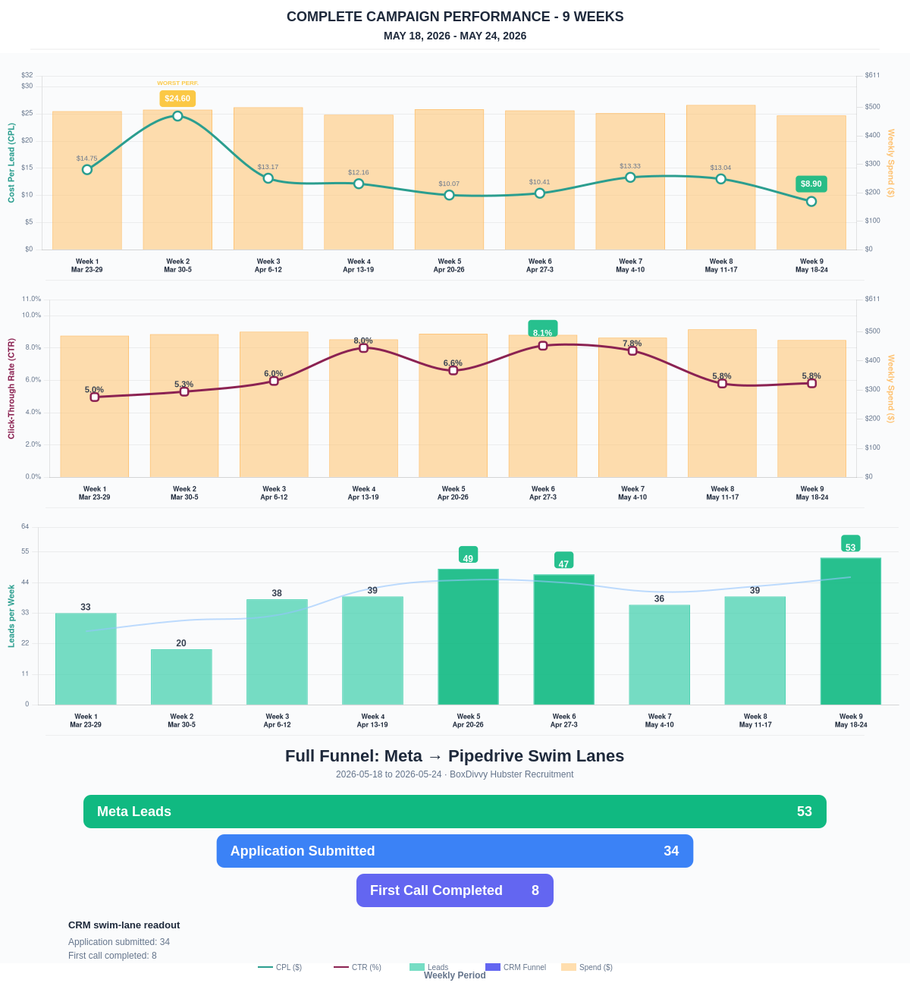

Questions? Let's chat about scaling these results.
Lead → Completed Application Dropoff
Meta lead aliases are not summed. This compares the canonical Meta Lead event against completed applications from complete_registration.
Period | Meta Leads | Completed Applications | Dropoff | Completion Rate | Cost / Completed
This Week | 53 | 34 | 19 | 64.15% | $13.88
Last 30 Days | 187 | 116 | 71 | 62.03% | $18.08
Campaign to Date | 971 | 365 | 606 | 37.59% | $25.37
Full Funnel — Meta → Pipedrive Swim Lanes
Direct Pipedrive pull from BoxDivvy Hubster Recruitment, Hub in Progress, and Hub Handovers. This shows application-stage CRM reality beside Meta attribution.
Funnel Stage | Count | Source | Notes
Meta Leads | 53 | Meta canonical lead | Top-funnel ad-attributed leads
Application Submitted | 34 | Meta complete_registration | Ad-attributed submitted applications
First Call Completed | 8 | Pipedrive swim lane | CRM deals that reached the first-call-completed lane during the period
Current open CRM funnel: 284 deals
Open Swim Lane | Open Deals
Application Submitted | 134
First Call Completed | 101
On Hold | 13
Waiting on marketing call | 8
To be added to socials | 8
Waiting for delivery day | 7
Hub pack complete | 4
Joined hub | 4
Brisbane Campaign Drill-down
Separate view of the Brisbane campaign so it can be reviewed independently from Melbourne and Bendigo.
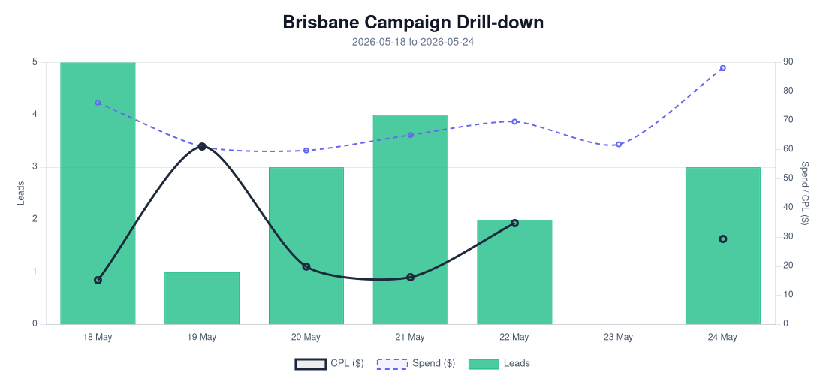
Period | Spend | Leads | Completed Applications | Completion Rate | CPL | CTR
Selected Period | $482.08 | 18 | 8 | 44.44% | $26.78 | 3.97%
Last 30 Days | $1,557.71 | 73 | 35 | 47.95% | $21.34 | 5.35%
Campaign to Date | $1,557.71 | 73 | 35 | 47.95% | $21.34 | 5.35%
Top Brisbane Ads
Ad | Spend | Leads | CPL | CTR
BD-BNE TOF - 20260512-ROOT - 09 - km-BD-Ad-2-0-Redesigned-1080p-60f-20260511-023045 | $3.43 | 1 | $3.43 | 1.39%
BD-BNE TOF - 20260512-ROOT - 04 - km-BD-Reel-Ad-13-1080p-60f-20260503-080616 | $8.35 | 2 | $4.17 | 3.45%
BD-BNE TOF - 20260512-ROOT - 03 - km-BD-Reel-Ad-13-Redesigned-1080p-60f-20260511-031415 | $17.00 | 1 | $17.00 | 2.24%
BD-BNE TOF - DEC-29-2025 - copy_B9ECFAD4-F5C2-4F45-8561-0BD4477D7E0E | $52.51 | 3 | $17.50 | 3.97%
BD-BNE TOF - Mar-5-26 - copy_779A87A3 - Ad4 | $24.76 | 1 | $24.76 | 1.87%

