

Meta Ads Performance Audit
Client: Box Divvy
Campaign: Hubster Lead Gen
Period: 25 May 2026 – 31 May 2026

Executive Summary
The Box Divvy campaign is delivering strong performance with a blended CPL of $8.77 across 56 leads. Total ad spend for the period was $491.03 with an average CTR of 5.91%. The top performer achieved a CPL of $2.71 (DEC-15-2025 - copy_08771CC1-D4C9-4210-BE). High CTR indicates strong creative-audience fit.

Key Metrics
Period | Spend | Leads | CPL | CTR
This Week | $491.03 | 56 | $8.77 | 5.91%
This Month | $2,097.40 | 200 | $10.49 | 6.57%
Since Starting | $9,750.43 | 1027 | $9.49 | 6.56%

Latest Batch — Top Performers
# | Release Lot | CPL | Leads | CTR | Ad ID | Preview
🔥 | May-28 | $26.54 | 1 | 2.67% | ...351600360 | 

Top 5 Performers by CPL — All Time
# | Release Lot | CPL | Leads | CTR | Ad ID | Preview
🔥 | Feb-6 | $2.71 | 2 | 2.48% | ...917610360 | 
2 | Feb-6 | $3.23 | 1 | 6.45% | ...917210360 | 
⭐ | Feb-6 | $4.02 | 3 | 4.42% | ...917220360 | 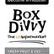
4 | Jan-29 | $4.03 | 11 | 6.22% | ...743430360 | 
5 | Jan-12 | $4.07 | 12 | 6.18% | ...985710360 | 
🔥 = Top performer | ⭐ = Volume star | Sorted by cost per conversion (lowest first)

Release Lot Performance
• DEC-15 Release: 5 conversions from 2 ad(s) – Best cost: $2.71
• DEC-29 Release: 1 conversions from 1 ad(s) – Best cost: $3.23
• Jan-17 Release: 11 conversions from 1 ad(s) – Best cost: $4.03
• Dec-15 Release: 12 conversions from 1 ad(s) – Best cost: $4.07

Creative Insights
Top Performer:
DEC-15-2025 - copy_08771CC1-D4C9-4210-BE7C-B4582E8D0709 - Copy – 2 conversions at $2.71 cost, 2.48% CTR
Runner Up:
DEC-29-2025 - copy_E5D9847D-795E-4D9C-A9E6-1F25D6F4D5D1 - Copy – 1 conversions at $3.23 cost, 6.45% CTR

Demographic Sweet Spot
• Female 35-44: 29 leads, $13.56 CPL, 4.47% CTR
• Female 25-34: 19 leads, $11.92 CPL, 3.49% CTR
• Female 45-54: 15 leads, $20.83 CPL, 5.52% CTR

Key Insights
What's Working:
✓ Strong overall CTR of 5.91% indicates compelling ad creative and audience targeting are resonating well with the target market
✓ Copy variant 08771CC1 is consistently delivering quality leads at low costs ($2.71-$4.02 per lead), performing 69-54% better than campaign average
✓ Copy variant E5D9847D achieved exceptional 6.45% CTR, demonstrating strong creative messaging that drives engagement
✓ Campaign is generating solid lead volume with 56 leads in 7 days, showing good market demand for Box Divvy's offering

Opportunities:
→ Cost per lead variance is significant (ranging from $2.71 to campaign average of $8.77), indicating underperforming ad variants are inflating overall costs
→ Only analysing top 3 performers suggests other ad variants may be drastically underperforming and requiring immediate attention
→ High-performing copy variants appear limited in volume, with top performer only generating 1-3 leads each - scaling these could improve overall efficiency
→ CTR variance between top performers (2.48% to 6.45%) indicates opportunity to identify and replicate the highest-engaging creative elements

Recommended Next Steps
▸ Immediately pause underperforming ad variants that are driving cost per lead above $8.77 to reduce overall campaign costs
▸ Increase budget allocation to copy variants 08771CC1 and E5D9847D to scale the low-cost, high-performing creative approaches
▸ Analyse the creative elements and messaging in variant E5D9847D (6.45% CTR) to replicate successful components in new ad variants
▸ Create additional ad variants based on the successful copy 08771CC1 framework to expand reach whilst maintaining sub-$5 cost per lead performance

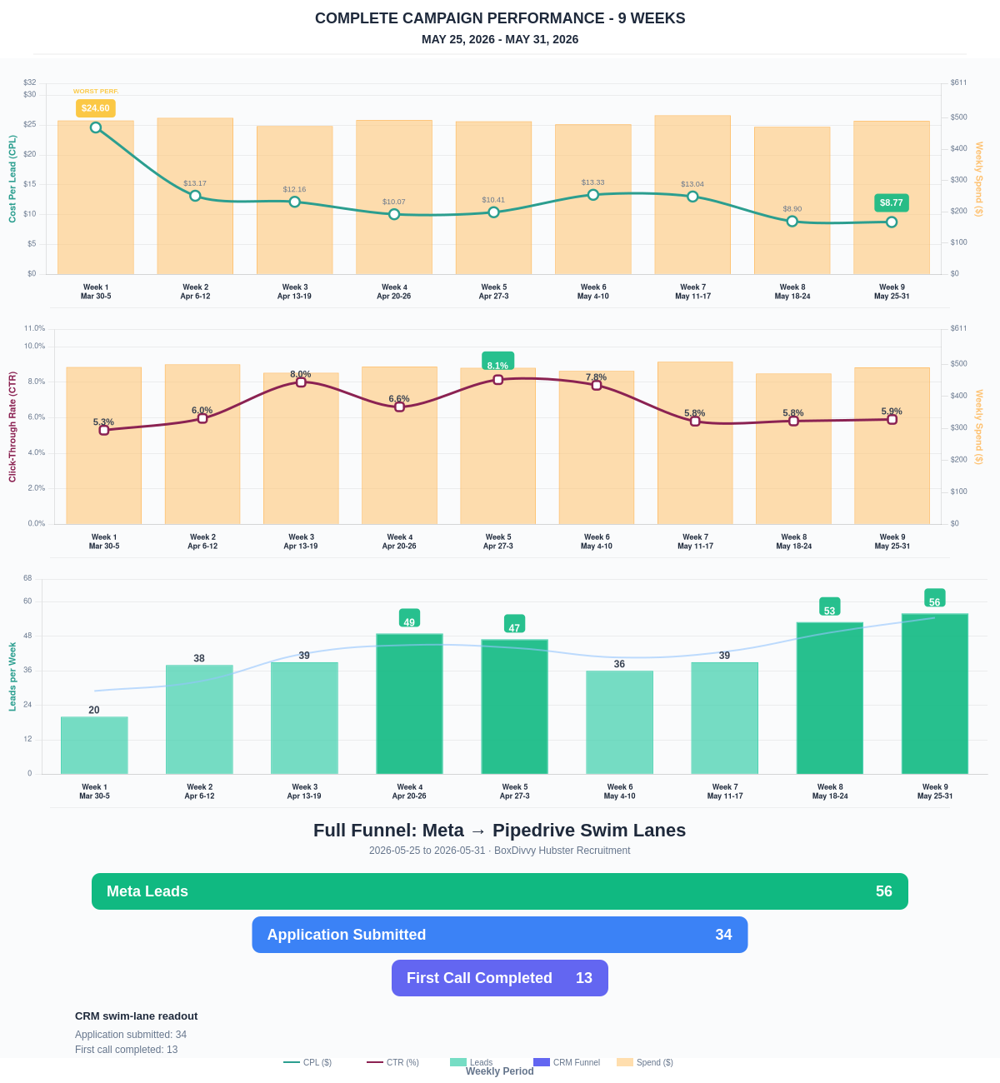

Questions? Let's chat about scaling these results.
Lead → Completed Application Dropoff
Meta lead aliases are not summed. This compares the canonical Meta Lead event against completed applications from complete_registration.
Period | Meta Leads | Completed Applications | Dropoff | Completion Rate | Cost / Completed
This Week | 56 | 34 | 22 | 60.71% | $14.44
Last 30 Days | 200 | 126 | 74 | 63.00% | $16.65
Campaign to Date | 1027 | 399 | 628 | 38.85% | $24.44
Full Funnel — Meta → Pipedrive Swim Lanes
Direct Pipedrive pull from BoxDivvy Hubster Recruitment, Hub in Progress, and Hub Handovers. This shows application-stage CRM reality beside Meta attribution.
Funnel Stage | Count | Source | Notes
Meta Leads | 56 | Meta canonical lead | Top-funnel ad-attributed leads
Application Submitted | 34 | Meta complete_registration | Ad-attributed submitted applications
First Call Completed | 13 | Pipedrive swim lane | CRM deals that reached the first-call-completed lane during the period
Current open CRM funnel: 283 deals
Open Swim Lane | Open Deals
Application Submitted | 118
First Call Completed | 107
On Hold | 19
Waiting for delivery day | 12
Building Members | 7
Waiting on marketing call | 4
To be added to socials | 4
Hub pack complete | 4
Brisbane Campaign Drill-down
Separate view of the Brisbane campaign so it can be reviewed independently from Melbourne and Bendigo.
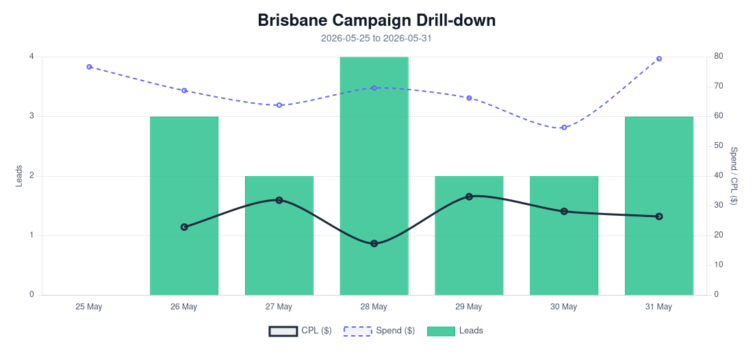
Period | Spend | Leads | Completed Applications | Completion Rate | CPL | CTR
Selected Period | $481.03 | 16 | 10 | 62.50% | $30.06 | 4.30%
Last 30 Days | $2,038.80 | 89 | 45 | 50.56% | $22.91 | 5.09%
Campaign to Date | $2,038.80 | 89 | 45 | 50.56% | $22.91 | 5.09%
Top Brisbane Ads
Ad | Spend | Leads | CPL | CTR
BD-BNE TOF - Jan-12-26 - copy_61BC4AF8-4B02-4882-A36C-5089A05D079E | $4.63 | 1 | $4.63 | 3.14%
BD-BNE TOF - 20260512-ROOT - 03 - km-BD-Reel-Ad-13-Redesigned-1080p-60f-20260511-031415 | $41.66 | 3 | $13.89 | 2.77%
BD-BNE TOF - Mar-5-26 - copy_779A87A3 - Ad4 | $37.78 | 2 | $18.89 | 2.68%
BD-BNE TOF - DEC-22-2025 - copy_9B8E5707-E50A-4DAD-94BB-138C32A34A9B | $336.78 | 10 | $33.68 | 4.94%

