

Meta Ads Performance Audit
Client: Box Divvy
Campaign: Hubster Lead Gen
Period: 1 June 2026 – 7 June 2026

Executive Summary
The Box Divvy campaign is delivering strong performance with a blended CPL of $7.64 across 63 leads. Total ad spend for the period was $481.43 with an average CTR of 5.90%. The top performer achieved a CPL of $3.31 (DEC-15-2025 - copy_08771CC1-D4C9-4210-BE). High CTR indicates strong creative-audience fit.

Key Metrics
Period | Spend | Leads | CPL | CTR
This Week | $481.43 | 63 | $7.64 | 5.90%
This Month | $2,090.27 | 220 | $9.50 | 5.91%
Since Starting | $10,231.87 | 1090 | $9.39 | 6.53%

Latest Batch — Top Performers
# | Release Lot | CPL | Leads | CTR | Ad ID | Preview
🔥 | May-28 | $26.54 | 1 | 2.67% | ...351600360 | 

Top 5 Performers by CPL — All Time
# | Release Lot | CPL | Leads | CTR | Ad ID | Preview
🔥 | Feb-6 | $3.31 | 2 | 2.49% | ...917610360 | 
2 | Feb-6 | $3.86 | 1 | 6.25% | ...917210360 | 
⭐ | Jan-29 | $4.03 | 11 | 6.22% | ...743430360 | 
4 | Feb-6 | $4.05 | 3 | 4.35% | ...917220360 | 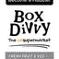
5 | Jan-12 | $4.07 | 12 | 6.18% | ...985710360 | 
🔥 = Top performer | ⭐ = Volume star | Sorted by cost per conversion (lowest first)

Release Lot Performance
• DEC-15 Release: 5 conversions from 2 ad(s) – Best cost: $3.31
• DEC-29 Release: 1 conversions from 1 ad(s) – Best cost: $3.86
• Jan-17 Release: 11 conversions from 1 ad(s) – Best cost: $4.03
• Dec-15 Release: 12 conversions from 1 ad(s) – Best cost: $4.07

Creative Insights
Top Performer:
DEC-15-2025 - copy_08771CC1-D4C9-4210-BE7C-B4582E8D0709 - Copy – 2 conversions at $3.31 cost, 2.49% CTR
Runner Up:
DEC-29-2025 - copy_E5D9847D-795E-4D9C-A9E6-1F25D6F4D5D1 - Copy – 1 conversions at $3.86 cost, 6.25% CTR

Demographic Sweet Spot
• Female 35-44: 25 leads, $14.34 CPL, 4.82% CTR
• Female 45-54: 20 leads, $13.66 CPL, 5.35% CTR
• Female 25-34: 13 leads, $15.15 CPL, 3.86% CTR

Key Insights
What's Working:
✓ Exceptional click-through rate of 5.90% indicates highly engaging ad creative and targeting resonating with Box Divvy's audience
✓ Strong cost per lead at $7.64 demonstrates efficient budget allocation and competitive acquisition costs for the lead generation objective
✓ Top performing ads show consistent quality with CTRs above 6% (Jan-17-26 and Dec-29 variants), indicating scalable creative elements
✓ High conversion rate from clicks to leads (6.4%) suggests effective landing page alignment and qualified traffic generation

Opportunities:
→ Significant cost per lead variation between top performers ($3.31-$4.03) and campaign average ($7.64) suggests underperforming ad variants dragging down overall efficiency
→ Limited lead volume from individual top performers (1-11 leads each) indicates potential for scaling successful creative elements across broader audience segments
→ High impression volume (16,654) with room to optimise budget allocation towards proven high-CTR creative variants for improved overall performance
→ Opportunity to analyse and replicate the messaging and visual elements from the Jan-17-26 creative that generated 11 leads at strong efficiency

Recommended Next Steps
▸ Immediately increase budget allocation to the Jan-17-26 creative variant and pause underperforming ads with CPL above $10 to improve overall campaign efficiency
▸ Conduct A/B testing using the successful creative elements from top performers (copy_08771CC1 and Jan-17-26) to create new variants and expand reach
▸ Analyse audience segments and demographics of top performing ads to refine targeting parameters and exclude low-converting audience segments
▸ Implement automated rules to reallocate budget towards ads achieving CTR above 4% and CPL below $6 to maintain performance momentum

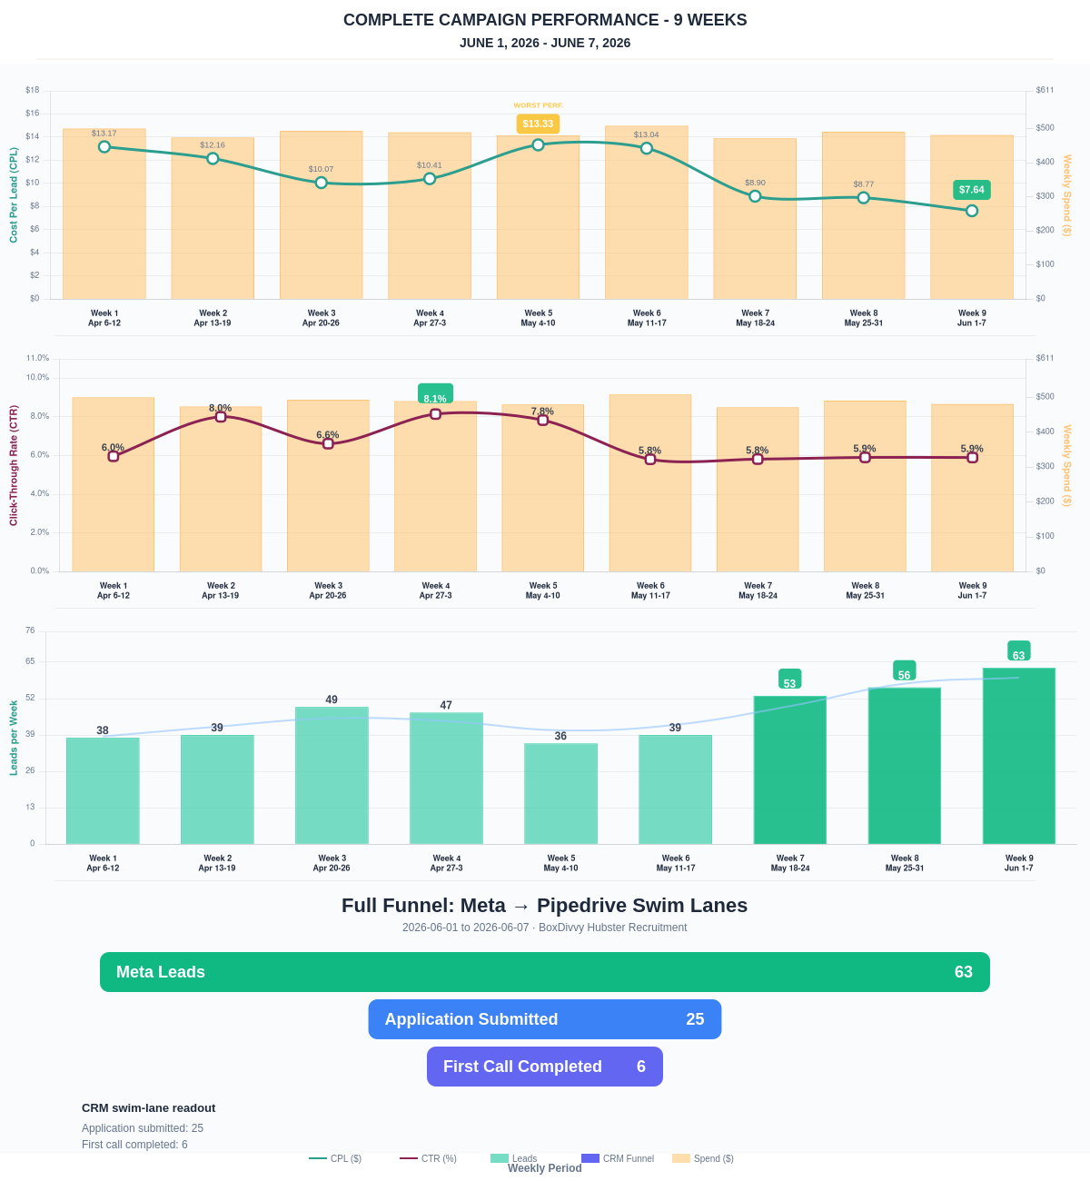

Questions? Let's chat about scaling these results.
Lead → Completed Application Dropoff
Meta lead aliases are not summed. This compares the canonical Meta Lead event against completed applications from complete_registration.
Period | Meta Leads | Completed Applications | Dropoff | Completion Rate | Cost / Completed
This Week | 63 | 25 | 38 | 39.68% | $19.26
Last 30 Days | 220 | 126 | 94 | 57.27% | $16.59
Campaign to Date | 1090 | 424 | 666 | 38.90% | $24.13
Full Funnel — Meta → Pipedrive Swim Lanes
Direct Pipedrive pull from BoxDivvy Hubster Recruitment, Hub in Progress, and Hub Handovers. This shows application-stage CRM reality beside Meta attribution.
Funnel Stage | Count | Source | Notes
Meta Leads | 63 | Meta canonical lead | Top-funnel ad-attributed leads
Application Submitted | 25 | Meta complete_registration | Ad-attributed submitted applications
First Call Completed | 6 | Pipedrive swim lane | CRM deals that reached the first-call-completed lane during the period
Current open CRM funnel: 296 deals
Open Swim Lane | Open Deals
Application Submitted | 130
First Call Completed | 107
On Hold | 22
Waiting for delivery day | 13
Hub pack complete | 6
Building Members | 6
To be added to socials | 4
Waiting on marketing call | 2
Brisbane Campaign Drill-down
Separate view of the Brisbane campaign so it can be reviewed independently from Melbourne and Bendigo.
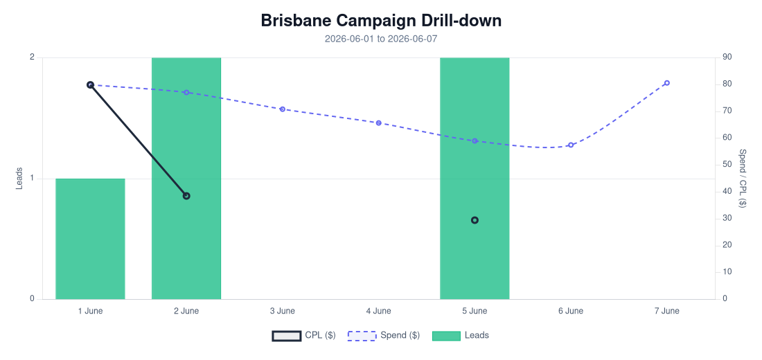
Period | Spend | Leads | Completed Applications | Completion Rate | CPL | CTR
Selected Period | $491.05 | 5 | 1 | 20.00% | $98.21 | 3.56%
Last 30 Days | $2,110.15 | 64 | 35 | 54.69% | $32.97 | 4.26%
Campaign to Date | $2,529.94 | 94 | 46 | 48.94% | $26.91 | 4.78%
Top Brisbane Ads
Ad | Spend | Leads | CPL | CTR
BD-BNE TOF - 20260512-ROOT - 03 - km-BD-Reel-Ad-13-Redesigned-1080p-60f-20260511-031415 | $40.85 | 2 | $20.43 | 1.70%
BD-BNE TOF - Jan-12-26 - copy_61BC4AF8-4B02-4882-A36C-5089A05D079E | $20.74 | 1 | $20.74 | 2.44%
BD-BNE TOF - DEC-22-2025 - copy_9B8E5707-E50A-4DAD-94BB-138C32A34A9B | $372.34 | 2 | $186.17 | 4.10%

