

Meta Ads Performance Audit
Client: Box Divvy
Campaign: Hubster Lead Gen
Period: 8 June 2026 – 14 June 2026

Executive Summary
The Box Divvy campaign is delivering strong performance with a blended CPL of $7.23 across 68 leads. Total ad spend for the period was $491.88 with an average CTR of 6.46%. The top performer achieved a CPL of $3.34 (DEC-15-2025 - copy_08771CC1-D4C9-4210-BE). High CTR indicates strong creative-audience fit.

Key Metrics
Period | Spend | Leads | CPL | CTR
This Week | $491.88 | 68 | $7.23 | 6.46%
This Month | $2,099.96 | 253 | $8.30 | 6.08%
Since Starting | $10,723.84 | 1158 | $9.26 | 6.53%

Latest Batch — Top Performers
# | Release Lot | CPL | Leads | CTR | Ad ID | Preview
🔥 | May-28 | $26.54 | 1 | 2.67% | ...351600360 | 

Top 5 Performers by CPL — All Time
# | Release Lot | CPL | Leads | CTR | Ad ID | Preview
🔥 | Feb-6 | $3.34 | 2 | 2.43% | ...917610360 | 
2 | Jan-29 | $4.03 | 11 | 6.22% | ...743430360 | 
⭐ | Jan-12 | $4.07 | 12 | 6.18% | ...985710360 | 
4 | Feb-6 | $4.12 | 3 | 4.25% | ...917220360 | 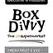
5 | Feb-6 | $4.17 | 1 | 5.56% | ...917210360 | 
🔥 = Top performer | ⭐ = Volume star | Sorted by cost per conversion (lowest first)

Release Lot Performance
• DEC-15 Release: 5 conversions from 2 ad(s) – Best cost: $3.34
• Jan-17 Release: 11 conversions from 1 ad(s) – Best cost: $4.03
• Dec-15 Release: 12 conversions from 1 ad(s) – Best cost: $4.07
• DEC-29 Release: 1 conversions from 1 ad(s) – Best cost: $4.17

Creative Insights
Top Performer:
DEC-15-2025 - copy_08771CC1-D4C9-4210-BE7C-B4582E8D0709 - Copy – 2 conversions at $3.34 cost, 2.43% CTR
Runner Up:
Jan-17-26 - Copy – 11 conversions at $4.03 cost, 6.22% CTR

Demographic Sweet Spot
• Female 35-44: 29 leads, $11.91 CPL, 4.73% CTR
• Female 45-54: 21 leads, $13.45 CPL, 6.23% CTR
• Female 25-34: 13 leads, $15.08 CPL, 3.60% CTR

Key Insights
What's Working:
✓ Strong overall CTR of 6.46% indicates compelling ad creative and targeting is resonating well with the audience
✓ Cost per lead of $7.23 is competitive for lead generation campaigns, showing efficient budget allocation
✓ Top performing ads (Jan-17-26 and Dec-15-Dec-22-25) are generating leads at excellent rates of $4.03-$4.07 with CTRs above 6%
✓ Campaign is generating consistent volume with 68 leads across 7 days, demonstrating scalable performance

Opportunities:
→ Significant cost per lead variance between top performer ($3.34) and average ($7.23) suggests underperforming ads are dragging down efficiency
→ Low lead volume on best performing ad (DEC-15-2025) with only 2 leads indicates potential budget reallocation needed
→ Conversion rate optimisation opportunity exists as high CTR (6.46%) should potentially yield more than 68 leads from 1,152 clicks
→ Creative testing gaps evident with inconsistent performance across ad variations - need more systematic A/B testing

Recommended Next Steps
▸ Immediately increase budget allocation to Jan-17-26 and Dec-15-Dec-22-25 ads whilst pausing or reducing spend on underperforming variations
▸ Analyse and replicate the copy elements from the $3.34 CPL ad (DEC-15-2025) into new creative variations for broader testing
▸ Implement landing page optimisation review to improve lead conversion rate from the current click-to-lead performance
▸ Set up automated rules to pause ads when CPL exceeds $8.00 to prevent budget waste on poor performers

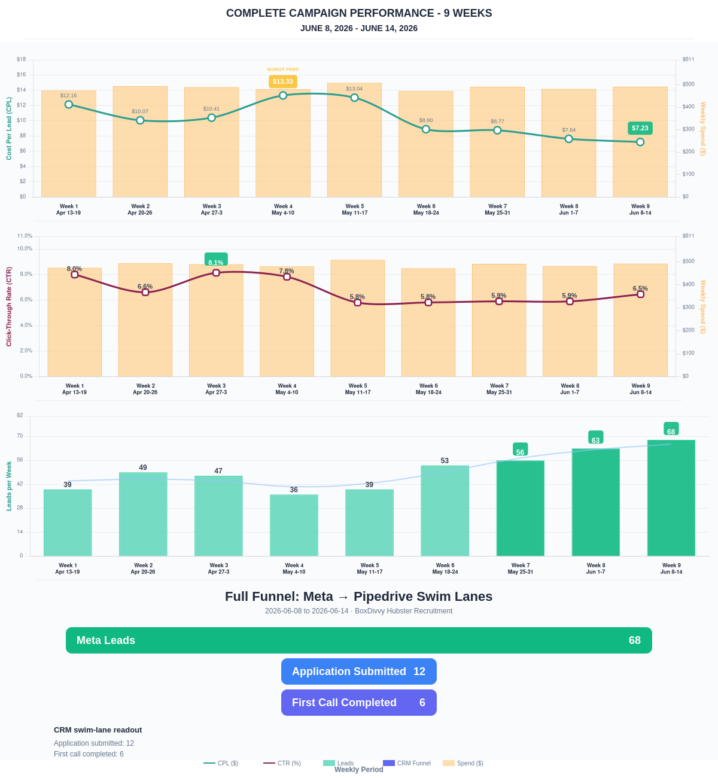

Questions? Let's chat about scaling these results.
Lead → Completed Application Dropoff
Meta lead aliases are not summed. This compares the canonical Meta Lead event against completed applications from complete_registration.
Period | Meta Leads | Completed Applications | Dropoff | Completion Rate | Cost / Completed
This Week | 68 | 12 | 56 | 17.65% | $40.99
Last 30 Days | 253 | 115 | 138 | 45.45% | $18.26
Campaign to Date | 1158 | 436 | 722 | 37.65% | $24.60
Full Funnel — Meta → Pipedrive Swim Lanes
Direct Pipedrive pull from BoxDivvy Hubster Recruitment, Hub in Progress, and Hub Handovers. This shows application-stage CRM reality beside Meta attribution.
Funnel Stage | Count | Source | Notes
Meta Leads | 68 | Meta canonical lead | Top-funnel ad-attributed leads
Application Submitted | 12 | Meta complete_registration | Ad-attributed submitted applications
First Call Completed | 6 | Pipedrive swim lane | CRM deals that reached the first-call-completed lane during the period
Current open CRM funnel: 265 deals
Open Swim Lane | Open Deals
Application Submitted | 105
First Call Completed | 94
On Hold | 24
Waiting for delivery day | 14
Building Members | 12
Hub pack complete | 4
Hub to be listed | 4
Joined hub | 4
Brisbane Campaign Drill-down
Separate view of the Brisbane campaign so it can be reviewed independently from Melbourne and Bendigo.
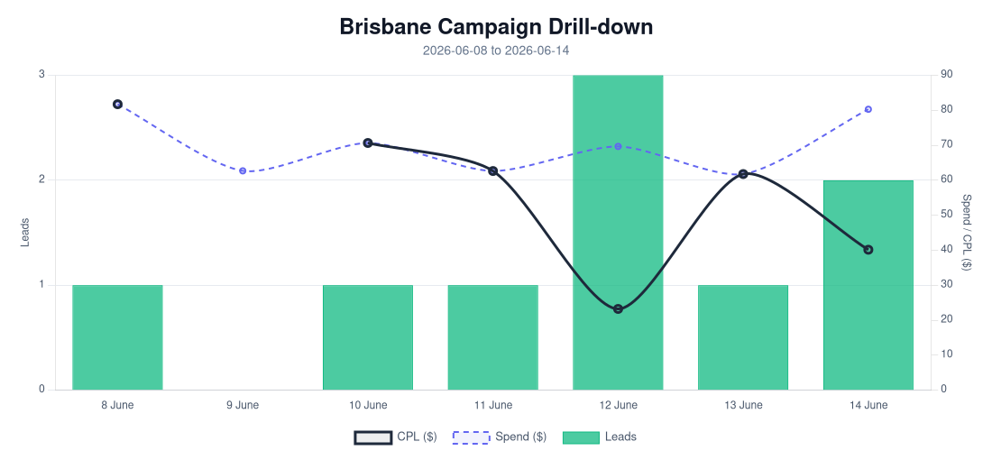
Period | Spend | Leads | Completed Applications | Completion Rate | CPL | CTR
Selected Period | $489.60 | 9 | 6 | 66.67% | $54.40 | 4.23%
Last 30 Days | $2,107.97 | 51 | 26 | 50.98% | $41.33 | 4.03%
Campaign to Date | $3,019.54 | 103 | 52 | 50.49% | $29.32 | 4.69%
Top Brisbane Ads
Ad | Spend | Leads | CPL | CTR
BD-BNE MOF - 20260512-ROOT - 06 - km-BD-Reel-Ad-6-0-Redesigned-1080p-60f-20260511-024521 | $1.63 | 1 | $1.63 | 8.33%
BD-BNE TOF - 20260512-ROOT - 09 - km-BD-Ad-2-0-Redesigned-1080p-60f-20260511-023045 | $4.86 | 1 | $4.86 | 2.55%
BD-BNE TOF - Jan-12-26 - copy_61BC4AF8-4B02-4882-A36C-5089A05D079E | $10.73 | 1 | $10.73 | 2.75%
BD-BNE TOF - DEC-22-2025 - copy_9B8E5707-E50A-4DAD-94BB-138C32A34A9B | $403.20 | 6 | $67.20 | 4.61%

