

Meta Ads Performance Audit
Client: Box Divvy
Campaign: Hubster Lead Gen
Period: 15 June 2026 – 21 June 2026

Executive Summary
The Box Divvy campaign is delivering strong performance with a blended CPL of $6.16 across 81 leads. Total ad spend for the period was $498.71 with an average CTR of 8.31%. The top performer achieved a CPL of $3.00 (DEC-29-2025 - copy_EE96AA98-791D-40C6-98). High CTR indicates strong creative-audience fit.

Key Metrics
Period | Spend | Leads | CPL | CTR
This Week | $498.71 | 81 | $6.16 | 8.31%
This Month | $2,106.09 | 282 | $7.47 | 6.71%
Since Starting | $11,222.55 | 1239 | $9.06 | 6.63%

Latest Batch — Top Performers
# | Release Lot | CPL | Leads | CTR | Ad ID | Preview
🔥 | May-28 | $26.54 | 1 | 2.67% | ...351600360 | 

Top 5 Performers by CPL — All Time
# | Release Lot | CPL | Leads | CTR | Ad ID | Preview
🔥 | Feb-6 | $3.00 | 2 | 5.29% | ...917370360 | 
2 | Feb-6 | $3.54 | 2 | 2.26% | ...917610360 | 
⭐ | Jan-29 | $4.03 | 11 | 6.22% | ...743430360 | 
4 | Jan-12 | $4.07 | 12 | 6.18% | ...985710360 | 
5 | Feb-6 | $4.14 | 3 | 4.44% | ...917220360 | 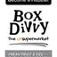
🔥 = Top performer | ⭐ = Volume star | Sorted by cost per conversion (lowest first)

Release Lot Performance
• DEC-29 Release: 2 conversions from 1 ad(s) – Best cost: $3.00
• DEC-15 Release: 5 conversions from 2 ad(s) – Best cost: $3.54
• Jan-17 Release: 11 conversions from 1 ad(s) – Best cost: $4.03
• Dec-15 Release: 12 conversions from 1 ad(s) – Best cost: $4.07

Creative Insights
Top Performer:
DEC-29-2025 - copy_EE96AA98-791D-40C6-98E3-428C29F68F42 - Copy – 2 conversions at $3.00 cost, 5.29% CTR
Runner Up:
DEC-15-2025 - copy_08771CC1-D4C9-4210-BE7C-B4582E8D0709 - Copy – 2 conversions at $3.54 cost, 2.26% CTR

Demographic Sweet Spot
• Female 35-44: 32 leads, $11.98 CPL, 6.22% CTR
• Female 45-54: 29 leads, $9.54 CPL, 7.48% CTR
• Female 25-34: 27 leads, $8.64 CPL, 5.12% CTR

Key Insights
What's Working:
✓ Exceptional click-through rate of 8.31% indicates highly engaging ad creative and strong audience targeting resonance
✓ Cost per lead of $6.16 demonstrates efficient lead acquisition, particularly for B2B services
✓ Strong conversion performance from clicks to leads with consistent delivery across different ad copies
✓ Top-performing creative (DEC-29-2025) achieving $3.00 cost per lead with 5.29% CTR shows scalable winning elements

Opportunities:
→ Scale successful creative elements from top performers, particularly the DEC-29-2025 copy format and messaging
→ Investigate why DEC-15-2025 copy has lower CTR (2.26%) despite good cost per lead to optimise underperforming variants
→ Expand audience reach whilst maintaining quality - current performance suggests room for increased budget allocation
→ Test additional creative variations based on the successful Jan-17-26 copy which generated the highest lead volume (11 leads)

Recommended Next Steps
▸ Increase budget allocation to the DEC-29-2025 creative by 40% to capitalise on its $3.00 cost per lead performance
▸ Create 2-3 new ad variations using the messaging framework and visual elements from the top-performing creatives
▸ Analyse audience insights from highest-performing ads to identify expansion opportunities and create lookalike audiences
▸ Pause or significantly reduce spend on the DEC-15-2025 creative and reallocate budget to proven performers

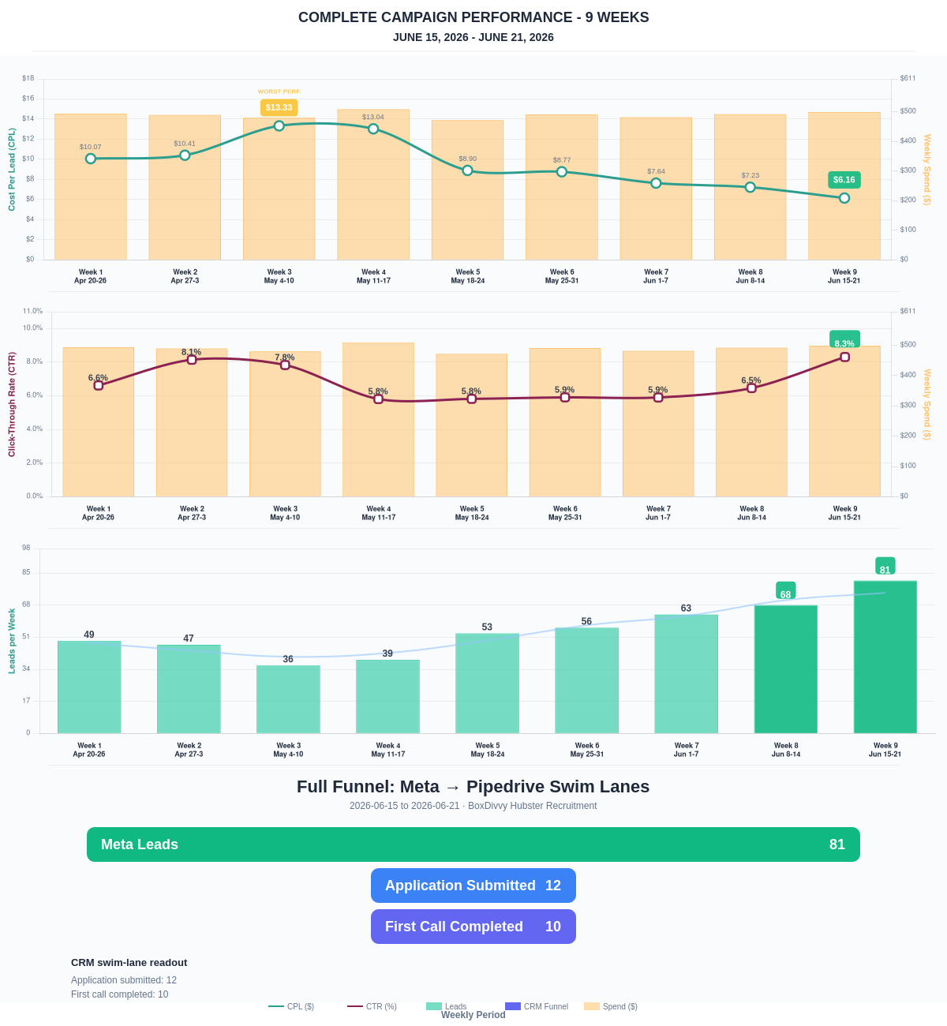

Questions? Let's chat about scaling these results.
Lead → Completed Application Dropoff
Meta lead aliases are not summed. This compares the canonical Meta Lead event against completed applications from complete_registration.
Period | Meta Leads | Completed Applications | Dropoff | Completion Rate | Cost / Completed
This Week | 81 | 12 | 69 | 14.81% | $41.56
Last 30 Days | 282 | 92 | 190 | 32.62% | $22.89
Campaign to Date | 1239 | 448 | 791 | 36.16% | $25.05
Full Funnel — Meta → Pipedrive Swim Lanes
Direct Pipedrive pull from BoxDivvy Hubster Recruitment, Hub in Progress, and Hub Handovers. This shows application-stage CRM reality beside Meta attribution.
Funnel Stage | Count | Source | Notes
Meta Leads | 81 | Meta canonical lead | Top-funnel ad-attributed leads
Application Submitted | 12 | Meta complete_registration | Ad-attributed submitted applications
First Call Completed | 10 | Pipedrive swim lane | CRM deals that reached the first-call-completed lane during the period
Current open CRM funnel: 237 deals
Open Swim Lane | Open Deals
First Call Completed | 93
Application Submitted | 76
On Hold | 29
Waiting for delivery day | 11
Building Members | 10
Waiting on marketing call | 6
Hub pack complete | 5
Waiting for app training | 3
Brisbane Campaign Drill-down
Separate view of the Brisbane campaign so it can be reviewed independently from Melbourne and Bendigo.
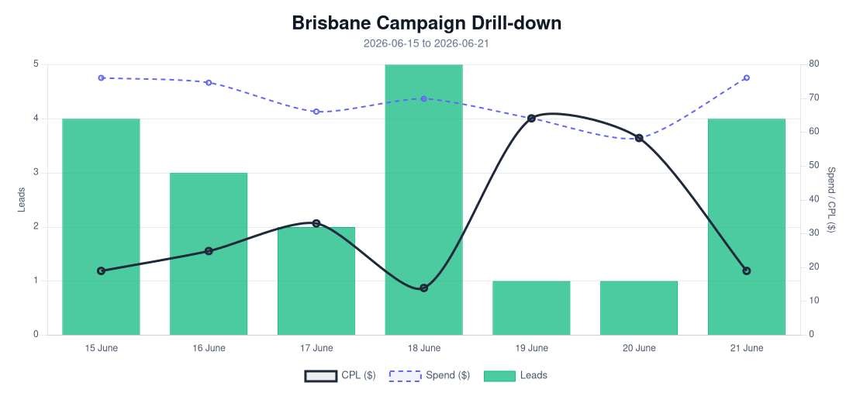
Period | Spend | Leads | Completed Applications | Completion Rate | CPL | CTR
Selected Period | $485.57 | 20 | 11 | 55.00% | $24.28 | 4.65%
Last 30 Days | $2,097.77 | 53 | 30 | 56.60% | $39.58 | 4.15%
Campaign to Date | $3,505.37 | 123 | 63 | 51.22% | $28.50 | 4.68%
Top Brisbane Ads
Ad | Spend | Leads | CPL | CTR
BD-BNE TOF - 20260512-ROOT - 04 - km-BD-Reel-Ad-13-1080p-60f-20260503-080616 | $3.34 | 1 | $3.34 | 1.65%
BD-BNE TOF - DEC-29-2025 - copy_B9ECFAD4-F5C2-4F45-8561-0BD4477D7E0E | $30.17 | 2 | $15.09 | 3.61%
BD-BNE TOF - Mar-5-26 - copy_779A87A3 - Ad4 | $19.99 | 1 | $19.99 | 2.79%
BD-BNE TOF - DEC-22-2025 - copy_9B8E5707-E50A-4DAD-94BB-138C32A34A9B | $377.16 | 16 | $23.57 | 5.25%

