

Meta Ads Performance Audit
Client: NeedleFree (Comfort-In)
Campaign: PA - Sales - LP - All - CBO - 17.1
Period: 6 April 2026 – 12 April 2026

Executive Summary
The NeedleFree (Comfort-In) campaign is delivering results with a blended CPP of $22.89 across 24 purchases. Total ad spend for the period was $549.26 with an average CTR of 4.98%. The top performer achieved a CPP of $0.39 ((22-12-2025) - (5)). CTR is within healthy range for e-commerce campaigns.

Key Metrics
Period | Spend | Purchases | CPP | CTR
This Week | $549.26 | 24 | $22.89 | 4.98%
This Month | $2,382.38 | 90 | $26.47 | 4.01%
Since Starting | $8,124.20 | 544 | $14.93 | 3.86%

Latest Batch — Top Metrics
# | Release Lot | Spend | CPM | CTR | Ad ID | Preview
🔥 | Mar-26 | $8.29 | $22.28 | 3.49% | ...408311971 | 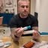
2 | Mar-26 | $6.68 | $27.72 | 1.24% | ...408269971 | 
⭐ | Mar-26 | $6.11 | $23.23 | 1.14% | ...408308971 | 
4 | Mar-26 | $5.79 | $22.18 | 0.38% | ...408224971 | 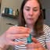
5 | Mar-28 | $5.22 | $23.84 | 2.74% | ...860842171

Top 5 Performers by CPP — All Time
# | Release Lot | CPP | Purchases | CTR | Ad ID | Preview
🔥 | Dec-22 | $0.39 | 22 | 2.65% | ...434619171 | 
2 | Jan-20 | $0.76 | 4 | 1.13% | ...245221971 | 
⭐ | Feb-10 | $0.88 | 6 | 0.85% | ...790733771 | 
4 | Jan-7 | $0.90 | 6 | 2.24% | ...925871771 | 
5 | Mar-12 | $1.26 | 4 | 2.70% | ...675335171 | 
🔥 = Top performer | ⭐ = Volume star | Sorted by cost per conversion (lowest first)

Release Lot Performance
• Dec-22 Release: 22 conversions from 1 ad(s) – Best cost: $0.39
• Jan-20 Release: 4 conversions from 1 ad(s) – Best cost: $0.76
• Feb-10 Release: 6 conversions from 1 ad(s) – Best cost: $0.88
• Jan-07 Release: 6 conversions from 1 ad(s) – Best cost: $0.90
• Feb-28 Release: 4 conversions from 1 ad(s) – Best cost: $1.26

Creative Insights
Top Performer:
(22-12-2025) - (5) – 22 conversions at $0.39 cost, 2.65% CTR
Runner Up:
(20-01-2026) - (3) – 4 conversions at $0.76 cost, 1.13% CTR

Demographic Sweet Spot
• Male 35-44: 24 purchases, $9.32 CPP, 4.72% CTR
• Male 25-34: 10 purchases, $16.19 CPP, 4.77% CTR
• Male 45-54: 10 purchases, $10.28 CPP, 5.67% CTR

Key Insights
What's Working:
✓ Exceptional click-through rate of 4.98% indicates highly engaging creative and strong audience targeting resonance
✓ Top performing ad (22-12-2025) delivered 92% of total purchases with an outstanding $0.39 cost per purchase - 98% below campaign average
✓ Strong conversion volume with 24 purchases demonstrates healthy demand for NeedleFree products
✓ Campaign is generating significant traffic with 1,890 clicks, showing good audience interest and reach

Opportunities:
→ Cost per purchase at $22.89 is significantly elevated by underperforming ads - optimise budget allocation to reduce overall acquisition costs
→ Large performance gap between top performer ($0.39 CPA) and other ads ($0.76-$0.88) suggests creative and targeting optimisation potential
→ High CTR but varied conversion performance indicates landing page or product page optimisation opportunities
→ Two lower-performing ads are consuming budget inefficiently - reallocate spend to scale the winning creative

Recommended Next Steps
▸ Immediately increase budget allocation to the 22-12-2025 ad set by 150% whilst it maintains sub-$1 cost per purchase
▸ Analyse the winning creative elements (copy, imagery, audience targeting) and create 2-3 similar variations to test
▸ Pause or significantly reduce budget on ads with cost per purchase above $0.75 to improve overall campaign efficiency
▸ Implement conversion tracking analysis to identify any checkout funnel drop-off points affecting the underperforming ads

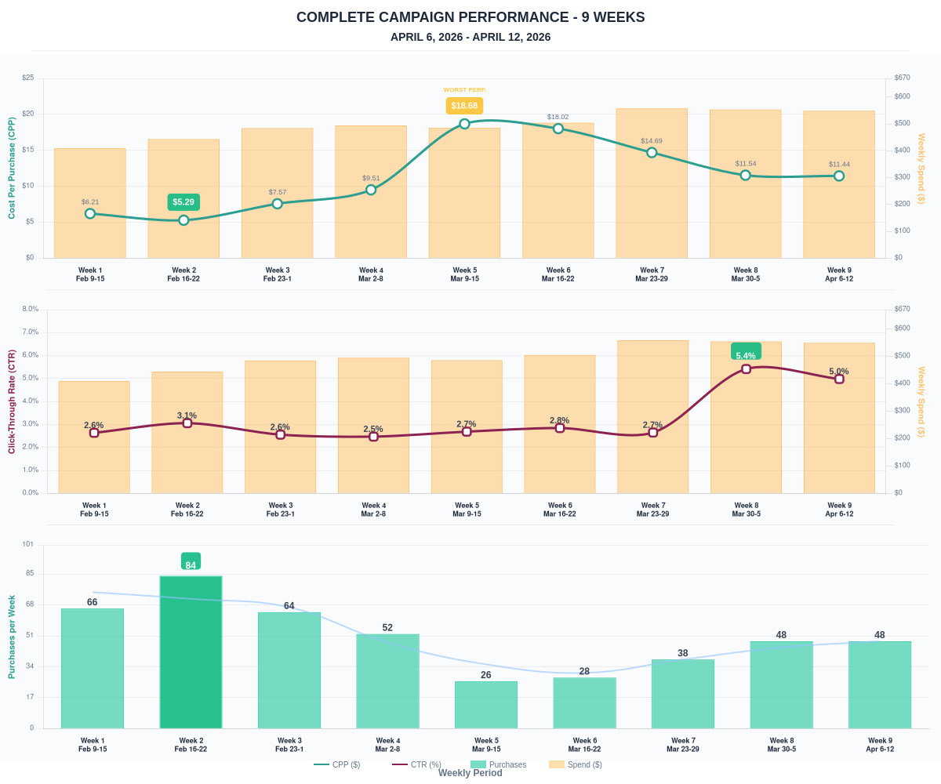

Questions? Let's chat about scaling these results.

