

Meta Ads Performance Audit
Client: NeedleFree (Comfort-In)
Campaign: PA - Sales - LP - All - CBO - 17.1
Period: 12 April 2026 – 18 April 2026

Executive Summary
The NeedleFree (Comfort-In) campaign is delivering strong performance with a blended CPP of $8.52 across 52 purchases. Total ad spend for the period was $443.00 with an average CTR of 3.55%. The top performer achieved a CPP of $0.39 ((22-12-2025) - (5)). CTR is within healthy range for e-commerce campaigns.

Key Metrics
Period | Spend | Purchases | CPP | CTR
This Week | $443.00 | 52 | $8.52 | 3.55%
This Month | $2,309.85 | 123 | $18.78 | 4.09%
Since Starting | $8,481.99 | 592 | $14.33 | 3.84%

Latest Batch — Top Metrics
# | Release Lot | Spend | CPM | CTR | Ad ID | Preview
🔥 | Apr-16 | $2.41 | $22.95 | 3.81% | ...802858771 | 
2 | Apr-16 | $1.46 | $18.02 | 1.23% | ...802903571 | 
⭐ | Apr-16 | $0.85 | $29.31 | 0.00% | ...803114971 | 
4 | Apr-16 | $0.61 | $17.43 | 0.00% | ...802998371 | 
5 | Apr-16 | $0.59 | $32.78 | 0.00% | ...802970571 | 

Top 5 Performers by CPP — All Time
# | Release Lot | CPP | Purchases | CTR | Ad ID | Preview
🔥 | Dec-22 | $0.39 | 22 | 2.65% | ...434619171 | 
2 | Jan-20 | $0.76 | 4 | 1.13% | ...245221971 | 
⭐ | Feb-10 | $0.88 | 6 | 0.85% | ...790733771 | 
4 | Jan-7 | $0.99 | 6 | 2.08% | ...925871771 | 
5 | Mar-12 | $1.26 | 4 | 2.70% | ...675335171 | 
🔥 = Top performer | ⭐ = Volume star | Sorted by cost per conversion (lowest first)

Release Lot Performance
• Dec-22 Release: 22 conversions from 1 ad(s) – Best cost: $0.39
• Jan-20 Release: 4 conversions from 1 ad(s) – Best cost: $0.76
• Feb-10 Release: 6 conversions from 1 ad(s) – Best cost: $0.88
• Jan-07 Release: 6 conversions from 1 ad(s) – Best cost: $0.99
• Feb-28 Release: 4 conversions from 1 ad(s) – Best cost: $1.26

Creative Insights
Top Performer:
(22-12-2025) - (5) – 22 conversions at $0.39 cost, 2.65% CTR
Runner Up:
(20-01-2026) - (3) – 4 conversions at $0.76 cost, 1.13% CTR

Demographic Sweet Spot
• Male 35-44: 70 purchases, $2.73 CPP, 3.44% CTR
• Male 25-34: 20 purchases, $7.08 CPP, 3.26% CTR
• Female 35-44: 4 purchases, $1.40 CPP, 6.13% CTR

Key Insights
What's Working:
✓ 52 purchases generated from $443.00 spend
✓ CTR of 3.55% indicates strong ad relevance
✓ Cost per purchase of $8.52 is within viable range
✓ Top performer "(22-12-2025) - (5)" driving 22 purchases

Opportunities:
→ Reduce CPL by pausing ads with CTR below 3.6% average
→ Test new ad variations based on top-performing creative patterns
→ Expand audience targeting based on demographic insights

Recommended Next Steps
▸ Increase budget on top 2 performers by 20-30%
▸ Review underperforming ads and pause or refresh creative
▸ Set up A/B test for new headline or creative variation
▸ Monitor frequency caps to avoid ad fatigue

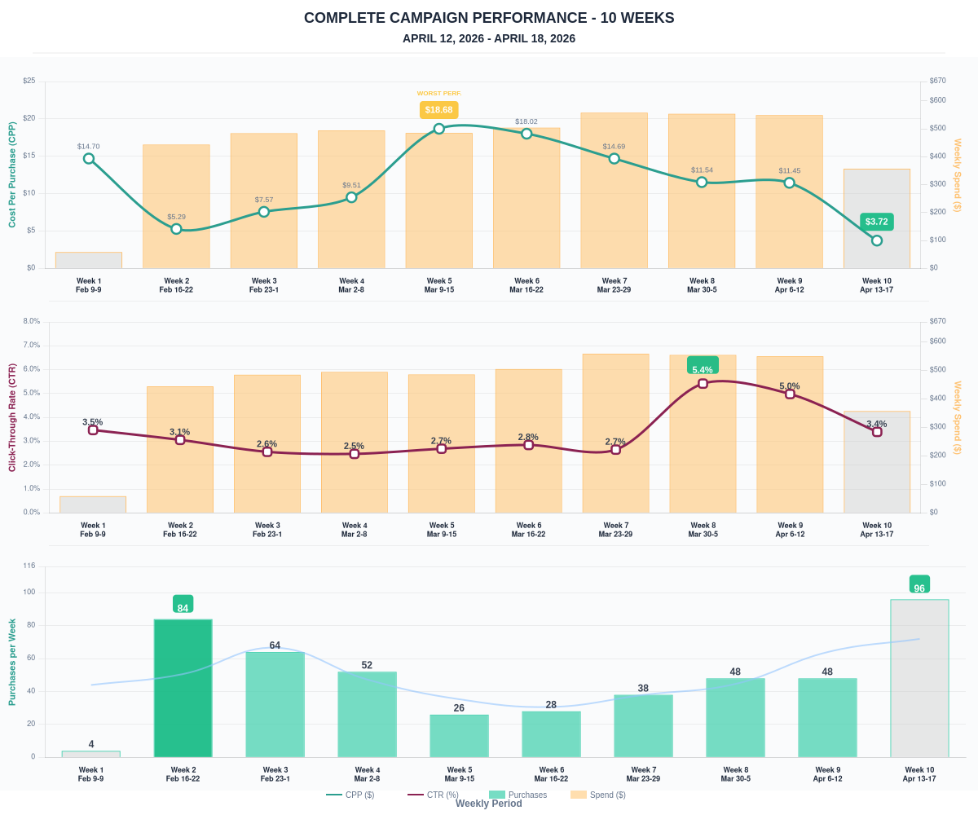

Questions? Let's chat about scaling these results.

