

Meta Ads Performance Audit
Client: NeedleFree (Comfort-In)
Campaign: PA - Sales - LP - All - CBO - 17.1
Period: 20 April 2026 – 26 April 2026

Executive Summary
The NeedleFree (Comfort-In) campaign is delivering results with a blended CPP of $23.81 across 23 purchases. Total ad spend for the period was $547.58 with an average CTR of 3.37%. The top performer achieved a CPP of $0.39 ((22-12-2025) - (5)). CTR is within healthy range for e-commerce campaigns.

Key Metrics
Period | Spend | Purchases | CPP | CTR
This Week | $547.58 | 23 | $23.81 | 3.37%
This Month | $2,436.29 | 134 | $18.18 | 4.29%
Since Starting | $9,228.06 | 627 | $14.72 | 3.82%

Latest Batch — Top Performers
# | Release Lot | CPP | Purchases | CTR | Ad ID | Preview
🔥 | Apr-16 | $1.35 | 4 | 0.00% | ...803114971 | 
2 | Apr-16 | $1.78 | 4 | 2.29% | ...802970571 | 

Top 5 Performers by CPP — All Time
# | Release Lot | CPP | Purchases | CTR | Ad ID | Preview
🔥 | Dec-22 | $0.39 | 22 | 2.65% | ...434619171 | 
2 | Jan-20 | $0.76 | 4 | 1.13% | ...245221971 | 
⭐ | Feb-10 | $0.88 | 6 | 0.85% | ...790733771 | 
4 | Jan-7 | $1.04 | 6 | 1.95% | ...925871771 | 
5 | Mar-12 | $1.26 | 4 | 2.70% | ...675335171 | 
🔥 = Top performer | ⭐ = Volume star | Sorted by cost per conversion (lowest first)

Release Lot Performance
• Dec-22 Release: 22 conversions from 1 ad(s) – Best cost: $0.39
• Jan-20 Release: 4 conversions from 1 ad(s) – Best cost: $0.76
• Feb-10 Release: 6 conversions from 1 ad(s) – Best cost: $0.88
• Jan-07 Release: 6 conversions from 1 ad(s) – Best cost: $1.04
• Feb-28 Release: 4 conversions from 1 ad(s) – Best cost: $1.26

Creative Insights
Top Performer:
(22-12-2025) - (5) – 22 conversions at $0.39 cost, 2.65% CTR
Runner Up:
(20-01-2026) - (3) – 4 conversions at $0.76 cost, 1.13% CTR

Demographic Sweet Spot
• Male 35-44: 22 purchases, $10.66 CPP, 3.27% CTR
• Male 25-34: 20 purchases, $8.41 CPP, 2.86% CTR
• Male 45-54: 4 purchases, $20.66 CPP, 3.87% CTR

Key Insights
What's Working:
✓ Ad set (22-12-2025) - (5) is delivering exceptional performance with 22 purchases at only $0.39 cost per purchase and strong 2.65% CTR - significantly outperforming other ad sets
✓ Overall CTR of 3.37% is well above industry benchmarks, indicating strong creative resonance and audience targeting effectiveness
✓ Campaign is generating consistent purchase volume with 23 conversions over 7 days, demonstrating good market demand for NeedleFree products
✓ Strong impression volume of 32,867 shows good reach and campaign scalability potential

Opportunities:
→ Significant performance disparity between top ad set ($0.39 CPA) and others ($0.76-$0.88 CPA) suggests budget reallocation could improve overall efficiency
→ Two underperforming ad sets show lower CTRs (1.13% and 0.85%) indicating creative or audience optimisation opportunities
→ Overall cost per purchase of $23.81 could be reduced by scaling the winning ad set and pausing or refreshing poor performers
→ Click-to-purchase conversion rate appears low based on 1,107 clicks generating only 23 purchases, suggesting landing page or checkout optimisation needed

Recommended Next Steps
▸ Immediately increase budget allocation to ad set (22-12-2025) - (5) by 50-100% to capitalise on its superior $0.39 cost per purchase performance
▸ Analyse the winning ad set's creative elements, audience targeting, and placement settings to replicate success in new ad sets
▸ Conduct landing page and checkout flow analysis to improve the 2.1% click-to-purchase conversion rate through UX optimisation
▸ Test new creative variations for underperforming ad sets or consider pausing them if performance doesn't improve within 48 hours

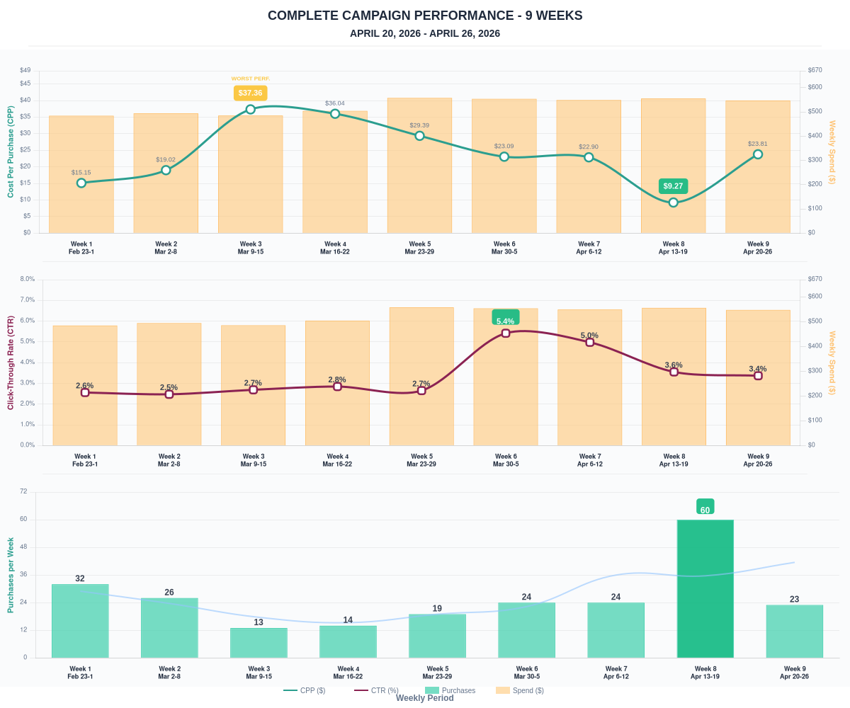

Questions? Let's chat about scaling these results.

