

Meta Ads Performance Audit
Client: NeedleFree (Comfort-In)
Campaign: PA - Sales - LP - All - CBO - 17.1
Period: 27 April 2026 – 3 May 2026

Executive Summary
The NeedleFree (Comfort-In) campaign is delivering solid results with a blended CPP of $16.96 across 33 purchases. Total ad spend for the period was $559.84 with an average CTR of 4.18%. The top performer achieved a CPP of $0.39 ((22-12-2025) - (5)). CTR is within healthy range for e-commerce campaigns.

Key Metrics
Period | Spend | Purchases | CPP | CTR
This Week | $559.84 | 33 | $16.96 | 4.18%
This Month | $2,430.60 | 153 | $15.89 | 4.25%
Since Starting | $9,787.94 | 660 | $14.83 | 3.84%

Latest Batch — Top Metrics
# | Release Lot | Spend | CPM | CTR | Ad ID | Preview
🔥 | Apr-28 | $24.18 | $18.79 | 1.94% | ...530221771 | 
2 | Apr-28 | $5.84 | $23.64 | 0.81% | ...530243571
⭐ | Apr-28 | $5.02 | $22.92 | 5.48% | ...512115771 | 
4 | Apr-28 | $4.29 | $22.34 | 1.04% | ...512085571
5 | Apr-28 | $3.28 | $16.99 | 1.55% | ...512049371 | 

Top 5 Performers by CPP — All Time
# | Release Lot | CPP | Purchases | CTR | Ad ID | Preview
🔥 | Dec-22 | $0.39 | 22 | 2.65% | ...434619171 | 
2 | Jan-20 | $0.76 | 4 | 1.13% | ...245221971 | 
⭐ | Feb-18 | $0.87 | 6 | 0.88% | ...620572971 | 
4 | Feb-10 | $0.88 | 6 | 0.85% | ...790733771 | 
5 | Jan-7 | $1.19 | 6 | 1.99% | ...925871771 | 
🔥 = Top performer | ⭐ = Volume star | Sorted by cost per conversion (lowest first)

Release Lot Performance
• Dec-22 Release: 22 conversions from 1 ad(s) – Best cost: $0.39
• Jan-20 Release: 4 conversions from 1 ad(s) – Best cost: $0.76
• Feb-18 Release: 6 conversions from 1 ad(s) – Best cost: $0.87
• Feb-10 Release: 6 conversions from 1 ad(s) – Best cost: $0.88
• Jan-07 Release: 6 conversions from 1 ad(s) – Best cost: $1.19

Creative Insights
Top Performer:
(22-12-2025) - (5) – 22 conversions at $0.39 cost, 2.65% CTR
Runner Up:
(20-01-2026) - (3) – 4 conversions at $0.76 cost, 1.13% CTR

Demographic Sweet Spot
• Male 35-44: 36 purchases, $6.53 CPP, 4.17% CTR
• Male 65+: 12 purchases, $0.32 CPP, 3.51% CTR
• Male 25-34: 10 purchases, $18.58 CPP, 3.67% CTR

Key Insights
What's Working:
✓ 33 purchases generated from $559.84 spend
✓ CTR of 4.18% indicates strong ad relevance
✓ Cost per purchase of $16.96 is within viable range
✓ Top performer "(22-12-2025) - (5)" driving 22 purchases

Opportunities:
→ Reduce CPL by pausing ads with CTR below 4.2% average
→ Scale spend on winning ad creatives to increase volume
→ Create new ad variations based on top-performing creative patterns
→ Expand audience targeting based on demographic insights

Recommended Next Steps
▸ Increase budget on top 2 performers by 20-30%
▸ Review underperforming ads and pause or refresh creative
▸ Set up A/B experiment for new headline or creative variation
▸ Monitor frequency caps to avoid ad fatigue

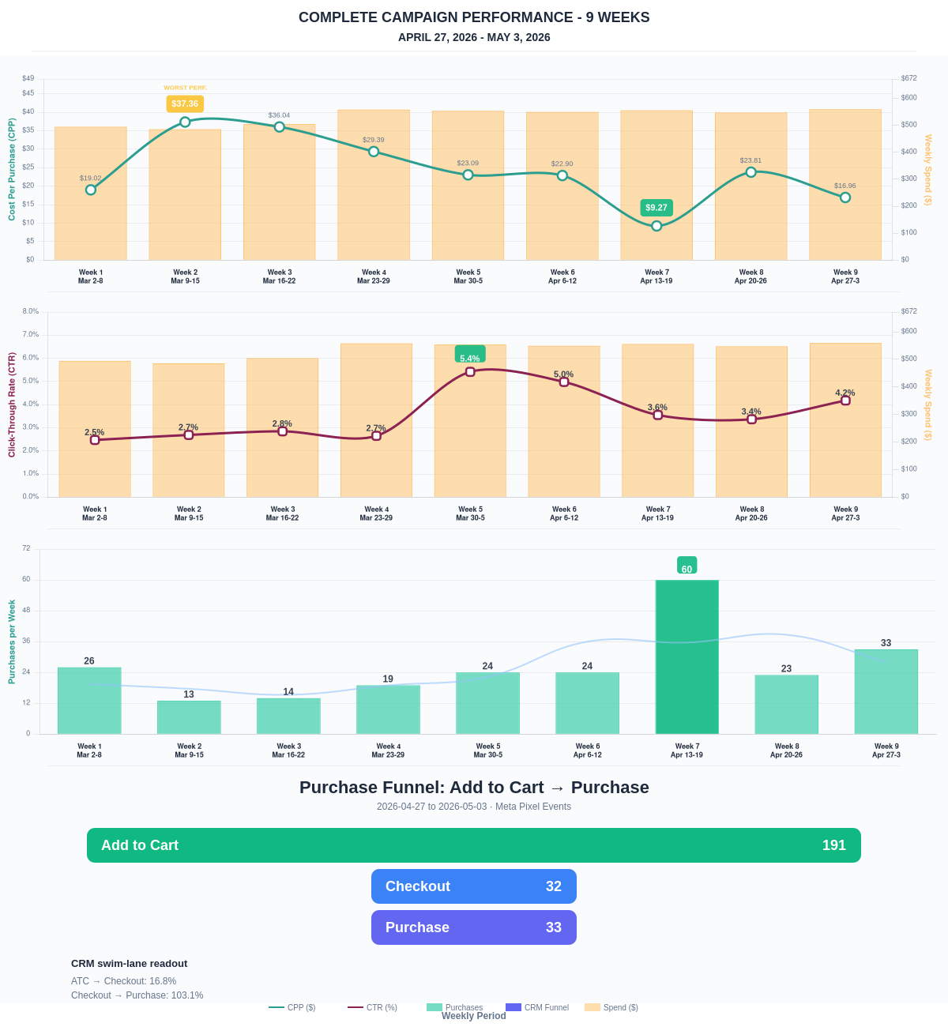

Questions? Let's chat about scaling these results.
E-Commerce Purchase Funnel
Meta Pixel events: Add to Cart → Initiate Checkout → Purchase. Conversion rates show funnel efficiency at each stage.
Period | Add to Cart | Checkout | Purchase | ATC→Chkout | ATC→Purchase
This Week | 191 | 32 | 33 | 16.75% | 17.28%
Last 30 Days | 798 | 161 | 153 | 20.18% | 19.17%
Campaign to Date | 3551 | 899 | 660 | 25.32% | 18.59%
Note: Purchase count exceeds Checkout because Meta attributes some purchases to ad clicks across sessions (e.g., return visitors who checked out earlier or purchased directly), even when no Initiate Checkout event fired for that session.
Purchase Funnel — Add to Cart → Checkout → Purchase
Meta Pixel events showing the full e-commerce purchase journey. ATC → Checkout rate and Checkout → Purchase rate indicate funnel health.
Stage | This Week | ATC→Checkout | Checkout→Purchase
Add to Cart | 191 | 16.8% | —
Checkout | 32 | — | 103.1%
Purchase | 33 | — | —

