

Meta Ads Performance Audit
Client: NeedleFree (Comfort-In)
Campaign: PA - Sales - LP - All - CBO - 17.1
Period: 11 May 2026 – 17 May 2026

Executive Summary
NeedleFree (Comfort-In) generated 13 deduped WooCommerce paid kit orders and $6,174.68 in backend revenue for the period. Meta attributed 18 purchase events and $8,168.11 in purchase value, giving 138.46% purchase capture and 132.28% value capture against Woo truth. Backend CPP was $39.80 with backend ROAS of 11.93x; Meta events remain the attribution lens while Woo order IDs are the business result. Average CTR was 3.56%.

Key Metrics
Period | Spend | Purchases | CPP | CTR
This Week | $517.42 | 18 | $28.75 | 3.56%
This Month | $2,336.65 | 93 | $25.13 | 3.78%
Since Starting | $10,860.39 | 691 | $15.72 | 3.83%

Latest Batch — Top Metrics
# | Release Lot | Spend | CPM | CTR | Ad ID | Preview
🔥 | May-16 | $9.97 | $41.89 | 10.50% | ...915451371 | 
2 | May-16 | $8.49 | $23.58 | 1.11% | ...852672971 | 
⭐ | May-16 | $7.62 | $5.85 | 1.92% | ...915958771 | 
4 | May-16 | $7.31 | $42.75 | 8.19% | ...915464571
5 | May-16 | $6.91 | $2.84 | 2.30% | ...915945971

Top 5 Performers by CPP — All Time
# | Release Lot | CPP | Purchases | CTR | Ad ID | Preview
🔥 | Dec-22 | $0.39 | 22 | 2.65% | ...434619171 | 
2 | Jan-20 | $0.76 | 4 | 1.13% | ...245221971 | 
⭐ | Feb-10 | $0.88 | 6 | 0.85% | ...790733771 | 
4 | Feb-18 | $0.90 | 6 | 0.83% | ...620572971 | 
5 | Mar-12 | $1.26 | 4 | 2.70% | ...675335171 | 
🔥 = Top performer | ⭐ = Volume star | Sorted by cost per conversion (lowest first)

Release Lot Performance
• Dec-22 Release: 22 conversions from 1 ad(s) – Best cost: $0.39
• Jan-20 Release: 4 conversions from 1 ad(s) – Best cost: $0.76
• Feb-10 Release: 6 conversions from 1 ad(s) – Best cost: $0.88
• Feb-18 Release: 6 conversions from 1 ad(s) – Best cost: $0.90
• Feb-28 Release: 4 conversions from 1 ad(s) – Best cost: $1.26

Creative Insights
Top Performer:
(22-12-2025) - (5) – 22 conversions at $0.39 cost, 2.65% CTR
Runner Up:
(20-01-2026) - (3) – 4 conversions at $0.76 cost, 1.13% CTR

Demographic Sweet Spot
• Male 25-34: 16 purchases, $9.74 CPP, 3.00% CTR
• Male 55-64: 8 purchases, $3.56 CPP, 4.15% CTR
• Female 35-44: 4 purchases, $3.74 CPP, 6.26% CTR

Key Insights
What's Working:
✓ 18 purchases generated from $517.42 spend
✓ CTR of 3.56% indicates strong ad relevance
✓ Cost per purchase of $28.75 is within viable range
✓ Top performer "(22-12-2025) - (5)" driving 22 purchases

Opportunities:
→ Reduce CPL by pausing ads with CTR below 3.6% average
→ Scale spend on winning ad creatives to increase volume
→ Create new ad variations based on top-performing creative patterns
→ Expand audience targeting based on demographic insights

Recommended Next Steps
▸ Increase budget on top 2 performers by 20-30%
▸ Review underperforming ads and pause or refresh creative
▸ Set up A/B experiment for new headline or creative variation
▸ Monitor frequency caps to avoid ad fatigue

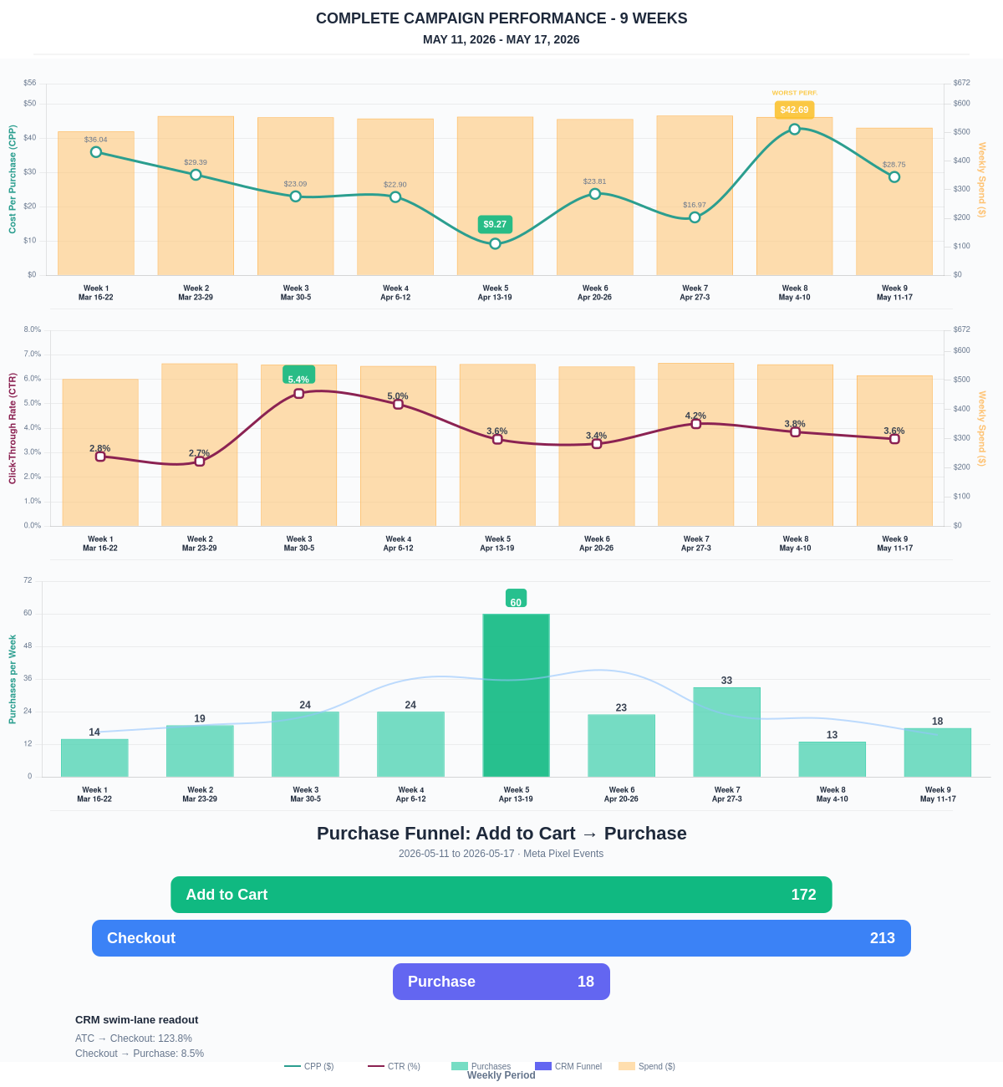

Questions? Let's chat about scaling these results.
Purchase Journey
Meta Pixel funnel showing how shoppers moved from Add to Cart through checkout and purchase.
Period | Add to Cart | Checkout | Purchase | ATC→Checkout | ATC→Purchase
This Week | 172 | 213 | 18 | 123.84% | 10.47%
Last 30 Days | 664 | 318 | 93 | 47.89% | 14.01%
Campaign to Date | 3855 | 1145 | 691 | 29.70% | 17.92%
The biggest opportunity is improving the Checkout → Purchase step.
Sales Confirmation
WooCommerce confirms the paid orders that landed. Meta Ads Manager shows the ad platform’s reported purchase performance.
Sales Check | Value
WooCommerce paid kit orders | 13
WooCommerce revenue | $6,174.68
Meta reported purchases | 18
Meta reported purchase value | $8,168.11
Backend ROAS | 11.93x
Meta Ads Performance
Metric | Value
Meta spend | $517.42
Meta reported purchases | 18
Cost per purchase | $28.75
Meta reported ROAS | 15.79x
Website Revenue Mix
GA4 view of revenue by website channel for context around Meta campaign performance.
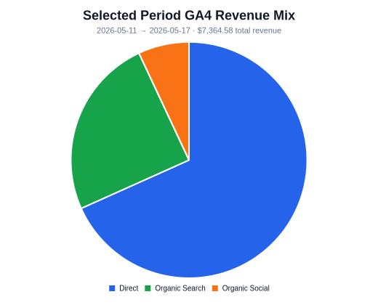 | 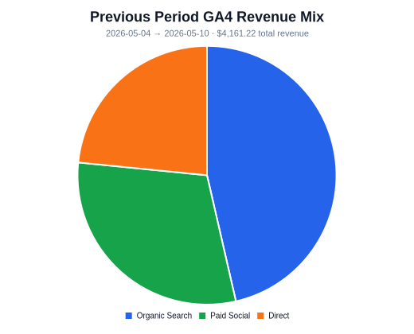 | 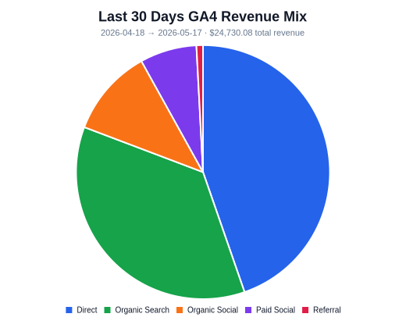
Organic Search revenue: $1,822.46 this period. GA4 Paid Social revenue: $0.00 this period.

