

Meta Ads Performance Audit
Client: NeedleFree (Comfort-In)
Campaign: All NeedleFree funnel campaigns
Period: 11 May 2026 – 17 May 2026

Executive Summary
NeedleFree (Comfort-In) generated 13 deduped WooCommerce paid kit orders and $6,174.68 in backend revenue for the period. Meta attributed 18 purchase events and $8,168.11 in purchase value, giving 138.46% purchase capture and 132.28% value capture against Woo truth. Backend CPP was $42.34 with backend ROAS of 11.22x; Meta events remain the attribution lens while Woo order IDs are the business result. Average CTR was 3.49%.

Key Metrics
Period | Spend | Purchases | CPP | CTR
This Week | $550.40 | 18 | $30.58 | 3.49%
This Month | $2,369.63 | 93 | $25.48 | 3.76%
Since Starting | $10,893.37 | 691 | $15.76 | 3.82%

Latest Batch — Top Metrics
# | Release Lot | Spend | CPM | CTR | Ad ID | Preview
🔥 | May-16 | $9.97 | $41.89 | 10.50% | ...915451371 | 
2 | May-16 | $8.49 | $23.58 | 1.11% | ...852672971 | 
⭐ | May-16 | $7.62 | $5.85 | 1.92% | ...915958771 | 
4 | May-16 | $7.31 | $42.75 | 8.19% | ...915464571
5 | May-16 | $6.91 | $2.83 | 2.30% | ...915945971

Top 5 Performers by CPP — All Time
# | Release Lot | CPP | Purchases | CTR | Ad ID | Preview
🔥 | Dec-22 | $0.39 | 22 | 2.65% | ...434619171 | 
2 | Jan-20 | $0.76 | 4 | 1.13% | ...245221971 | 
⭐ | Feb-10 | $0.88 | 6 | 0.85% | ...790733771 | 
4 | Feb-18 | $0.90 | 6 | 0.83% | ...620572971 | 
5 | Mar-12 | $1.26 | 4 | 2.70% | ...675335171 | 
🔥 = Top performer | ⭐ = Volume star | Sorted by cost per conversion (lowest first)

Release Lot Performance
• Dec-22 Release: 22 conversions from 1 ad(s) – Best cost: $0.39
• Jan-20 Release: 4 conversions from 1 ad(s) – Best cost: $0.76
• Feb-10 Release: 6 conversions from 1 ad(s) – Best cost: $0.88
• Feb-18 Release: 6 conversions from 1 ad(s) – Best cost: $0.90
• Feb-28 Release: 4 conversions from 1 ad(s) – Best cost: $1.26

Creative Insights
Top Performer:
(22-12-2025) - (5) – 22 conversions at $0.39 cost, 2.65% CTR
Runner Up:
(20-01-2026) - (3) – 4 conversions at $0.76 cost, 1.13% CTR

Demographic Sweet Spot
• Male 25-34: 16 purchases, $9.74 CPP, 3.00% CTR
• Male 55-64: 8 purchases, $3.56 CPP, 4.15% CTR
• Female 35-44: 4 purchases, $3.74 CPP, 6.25% CTR

Key Insights
What's Working:
✓ Exceptional CTR of 3.49% indicates highly engaging creative and strong audience targeting - well above industry benchmarks
✓ Top performing ad (22-12-2025) delivering outstanding results with 22 purchases at only $0.39 cost per purchase and strong 2.65% CTR
✓ Strong click-to-purchase conversion rate of 1.32% demonstrates effective landing page experience and product-market fit
✓ Consistent purchase volume across multiple ad variants shows diversified creative approach is resonating with audience

Opportunities:
→ Cost per purchase of $30.58 appears high for e-commerce - focus on scaling top performers to reduce overall acquisition costs
→ Significant performance gap between top ad ($0.39 CPA) and others ($0.76-$0.88) suggests untapped potential in creative optimisation
→ Two lower-performing ads show declining CTRs (1.13% and 0.85%) indicating possible creative fatigue or audience saturation
→ Limited ad variants tested - expand creative testing to identify more high-performing combinations

Recommended Next Steps
▸ Immediately increase budget allocation to top performing ad (22-12-2025) by 40-50% to capitalise on low $0.39 cost per purchase
▸ Analyse creative elements of winning ad (copy, imagery, format) and create 3-4 new variants incorporating these successful components
▸ Pause or refresh underperforming ads with CTRs below 1.5% and test new creative angles or audience segments
▸ Implement dynamic product ads or catalogue campaigns to expand reach while maintaining the strong conversion rate performance

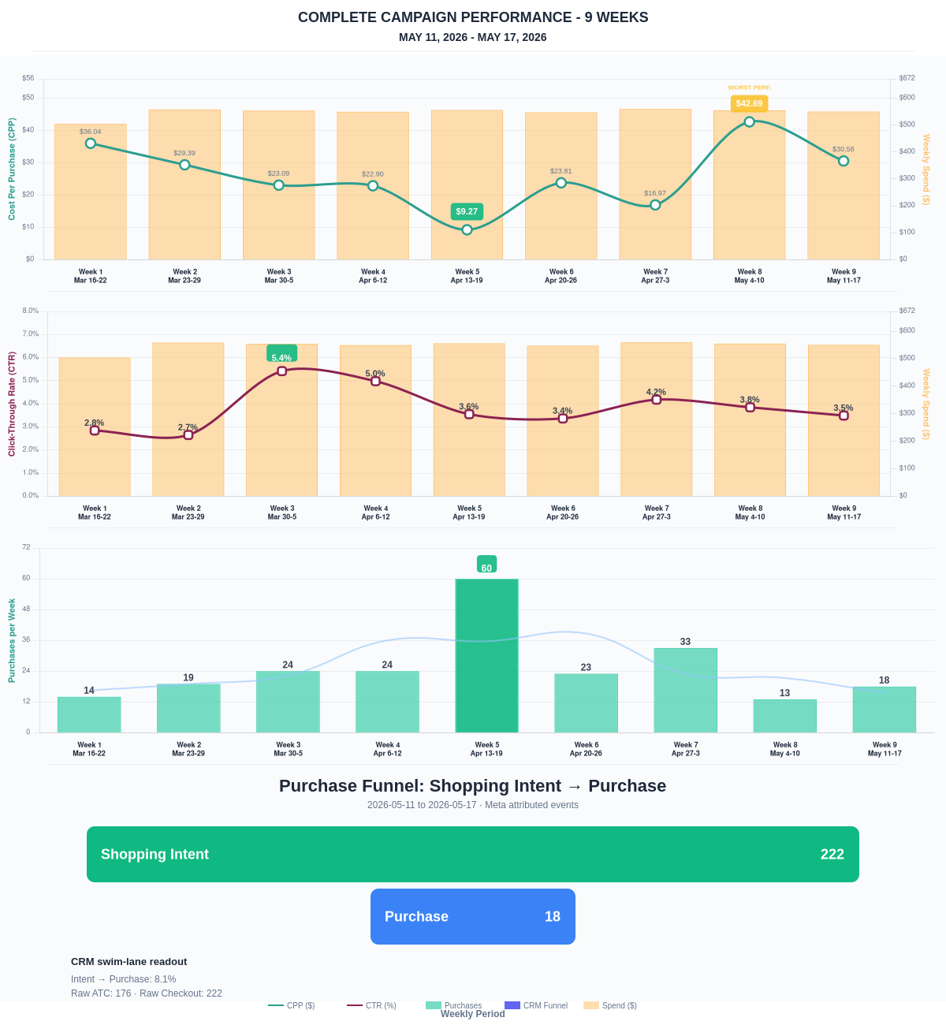

Questions? Let's chat about scaling these results.
Purchase Journey
Client-facing funnel based on Meta-attributed shopping intent and confirmed purchase events. This avoids presenting Add to Cart and Checkout as a strict sequence when retargeting and return visits make the raw event counts non-sequential.
Period | Shopping Intent | Purchase | Intent → Purchase | ATC → Purchase
This Week | 222 | 18 | 8.11% | 10.23%
Last 30 Days | 668 | 93 | 13.92% | 13.92%
Campaign to Date | 3859 | 691 | 17.91% | 17.91%
Use this as the client-facing purchase-intent funnel. Raw Add to Cart and Checkout are kept for internal diagnostics because Meta attribution can make those event counts non-sequential.
Sales Confirmation
WooCommerce confirms the paid orders that landed. Meta Ads Manager shows the ad platform’s reported purchase performance.
Sales Check | Value
WooCommerce paid kit orders | 13
WooCommerce revenue | $6,174.68
Meta reported purchases | 18
Meta reported purchase value | $8,168.11
Backend ROAS | 11.22x
Meta Ads Performance
Metric | Value
Meta spend | $550.40
Meta reported purchases | 18
Cost per purchase | $30.58
Meta reported ROAS | 14.84x
Website Revenue Mix
GA4 view of revenue by website channel for context around Meta campaign performance.
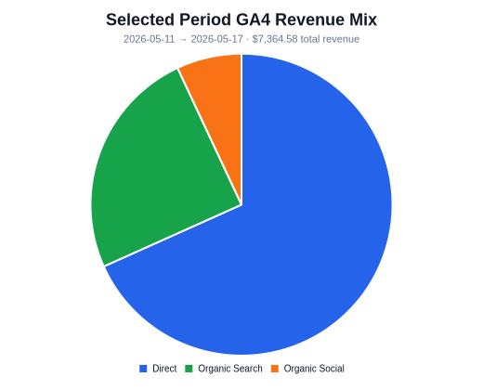 | 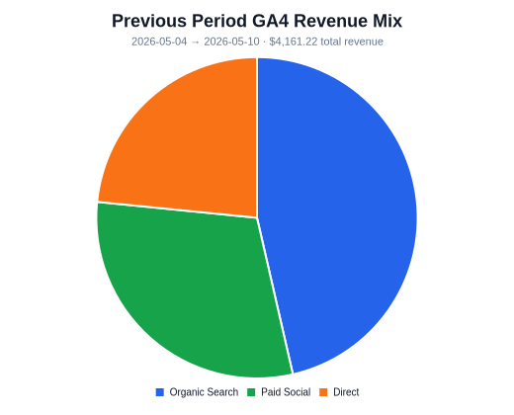 | 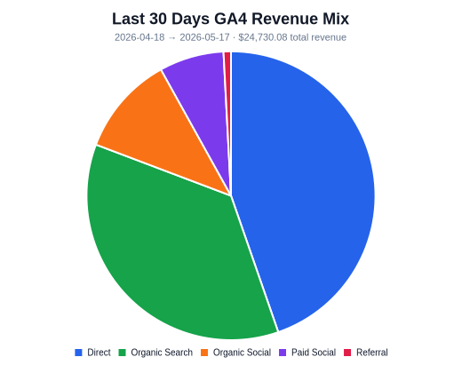
Organic Search revenue: $1,822.46 this period. GA4 Paid Social revenue: $0.00 this period.

