

Meta Ads Performance Audit
Client: NeedleFree (Comfort-In)
Campaign: All NeedleFree funnel campaigns
Period: 18 May 2026 – 24 May 2026

Executive Summary
NeedleFree (Comfort-In) generated 6 deduped WooCommerce paid kit orders and $2,465.20 in backend revenue for the period. Meta attributed 13 purchase events and $4,547.54 in purchase value, giving 216.67% purchase capture and 184.47% value capture against Woo truth. Backend CPP was $50.10 with backend ROAS of 8.20x; Meta events remain the attribution lens while Woo order IDs are the business result. Average CTR was 2.67%.

Key Metrics
Period | Spend | Purchases | CPP | CTR
This Week | $300.59 | 13 | $23.12 | 2.67%
This Month | $2,128.55 | 81 | $26.28 | 3.67%
Since Starting | $11,193.97 | 704 | $15.90 | 3.79%

Latest Batch — Top Metrics
# | Release Lot | Spend | CPM | CTR | Ad ID | Preview
🔥 | May-19 | $29.25 | $49.66 | 3.23% | ...536781971 | 

Top 5 Performers by CPP — All Time
# | Release Lot | CPP | Purchases | CTR | Ad ID | Preview
Data from the reporting period

Release Lot Performance
• All: Performance data aggregated across all release lots

Creative Insights
Analysis pending
More data needed for creative insights

Demographic Sweet Spot
• Male 35-44: 8 purchases, $13.34 CPP, 2.33% CTR
• Male 25-34: 6 purchases, $12.77 CPP, 1.74% CTR
• Male 18-24: 4 purchases, $0.82 CPP, 1.68% CTR

Key Insights
What's Working:
✓ Strong click-through rate of 2.67% indicates compelling ad creative and messaging that resonates with the target audience
✓ Solid conversion rate of 2.15% (13 purchases from 605 clicks) demonstrates effective landing page experience and product appeal
✓ Cost per purchase of $23.12 is reasonable for the healthcare/medical device category, showing efficient budget allocation

Opportunities:
→ Increase daily budget to capture more high-intent traffic during peak performance periods and scale successful campaigns
→ Test additional ad creative variations focusing on pain points and comfort benefits to improve CTR beyond the current 2.67%
→ Implement retargeting campaigns for the 592 users who clicked but didn't convert to recover potential lost sales
→ Analyse demographic and placement performance data to identify and exclude underperforming segments

Recommended Next Steps
▸ Launch lookalike audiences based on the 13 recent purchasers to expand reach to similar high-converting prospects
▸ Create video testimonials or demonstration content showcasing the comfort benefits of NeedleFree technology
▸ Set up dynamic retargeting ads with special offers for cart abandoners and previous website visitors
▸ Implement conversion tracking optimisation by switching to 'Maximise Conversions' bidding strategy to improve cost per purchase

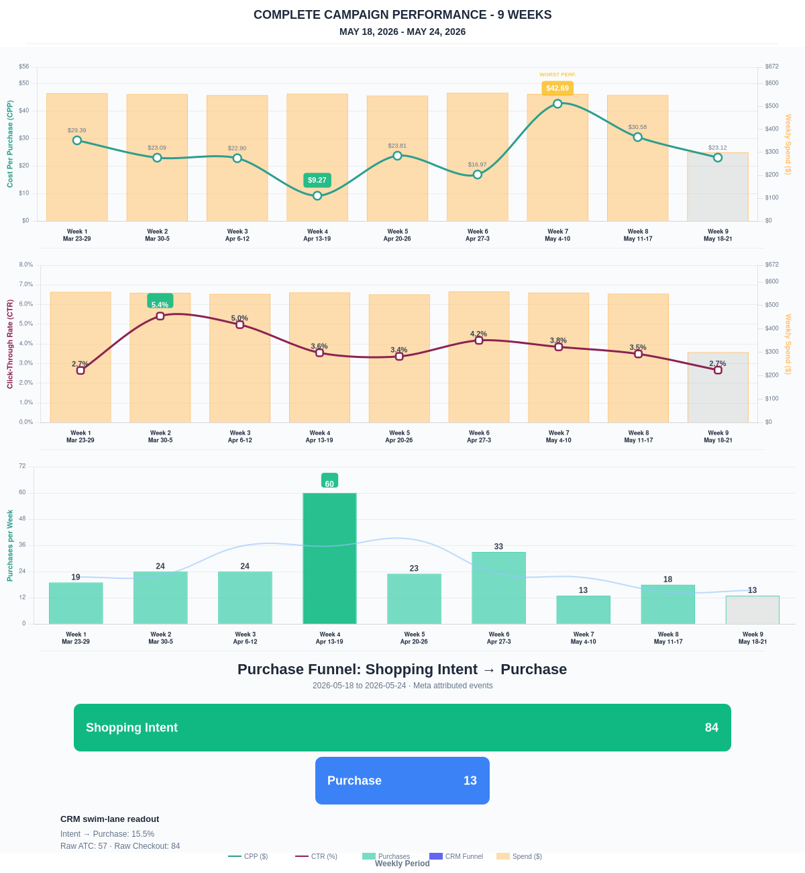

Questions? Let's chat about scaling these results.
Purchase Journey
Client-facing funnel based on Meta-attributed shopping intent and confirmed purchase events. This avoids presenting Add to Cart and Checkout as a strict sequence when retargeting and return visits make the raw event counts non-sequential.
Period | Shopping Intent | Purchase | Intent → Purchase | ATC → Purchase
This Week | 84 | 13 | 15.48% | 22.81%
Last 30 Days | 586 | 81 | 13.82% | 13.82%
Campaign to Date | 3916 | 704 | 17.98% | 17.98%
Use this as the client-facing purchase-intent funnel. Raw Add to Cart and Checkout are kept for internal diagnostics because Meta attribution can make those event counts non-sequential.
Sales Confirmation
WooCommerce confirms the paid orders that landed. Meta Ads Manager shows the ad platform’s reported purchase performance.
Sales Check | Value
WooCommerce paid kit orders | 6
WooCommerce revenue | $2,465.20
Meta reported purchases | 13
Meta reported purchase value | $4,547.54
Backend ROAS | 8.20x
Meta Ads Performance
Metric | Value
Meta spend | $300.59
Meta reported purchases | 13
Cost per purchase | $23.12
Meta reported ROAS | 15.13x
Website Revenue Mix
GA4 view of revenue by website channel for context around Meta campaign performance.
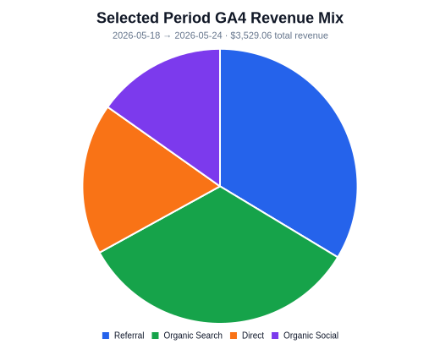 | 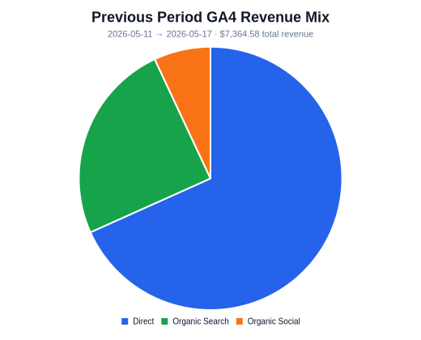 | 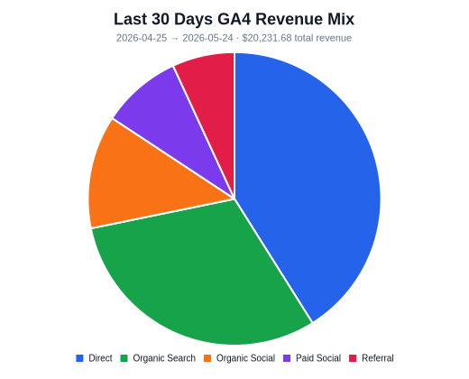
Organic Search revenue: $1,176.89 this period. GA4 Paid Social revenue: $0.00 this period.

