

Meta Ads Performance Audit
Client: NeedleFree (Comfort-In)
Campaign: All NeedleFree funnel campaigns
Period: 18 May 2026 – 24 May 2026

Executive Summary
NeedleFree (Comfort-In) generated 10 deduped WooCommerce paid kit orders and $4,156.89 in backend revenue for the period. Meta attributed 17 purchase events and $5,849.35 in purchase value, giving 170.00% purchase capture and 140.71% value capture against Woo truth. Backend CPP was $57.71 with backend ROAS of 7.20x; Meta events remain the attribution lens while Woo order IDs are the business result. Average CTR was 3.00%.

Key Metrics
Period | Spend | Purchases | CPP | CTR
This Week | $577.12 | 17 | $33.95 | 3.00%
This Month | $2,405.08 | 85 | $28.30 | 3.62%
Since Starting | $11,470.50 | 708 | $16.20 | 3.78%

Latest Batch — Top Performers
# | Release Lot | CPP | Purchases | CTR | Ad ID | Preview
🔥 | Nov-23 | $9.25 | 74 | 0.96% | ...051358971 | 
2 | Nov-23 | $14.39 | 66 | 1.12% | ...051360371 | 

Top 5 Performers by CPP — All Time
# | Release Lot | CPP | Purchases | CTR | Ad ID | Preview
🔥 | Dec-22 | $0.39 | 22 | 2.65% | ...434619171 | 
2 | Jan-20 | $0.76 | 4 | 1.13% | ...245221971 | 
⭐ | Feb-10 | $0.88 | 6 | 0.85% | ...790733771 | 
4 | Feb-18 | $0.92 | 6 | 0.79% | ...620572971 | 
5 | Mar-12 | $1.26 | 4 | 2.70% | ...675335171 | 
🔥 = Top performer | ⭐ = Volume star | Sorted by cost per conversion (lowest first)

Release Lot Performance
• Dec-22 Release: 22 conversions from 1 ad(s) – Best cost: $0.39
• Jan-20 Release: 4 conversions from 1 ad(s) – Best cost: $0.76
• Feb-10 Release: 6 conversions from 1 ad(s) – Best cost: $0.88
• Feb-18 Release: 6 conversions from 1 ad(s) – Best cost: $0.92
• Feb-28 Release: 4 conversions from 1 ad(s) – Best cost: $1.26

Creative Insights
Top Performer:
(22-12-2025) - (5) – 22 conversions at $0.39 cost, 2.65% CTR
Runner Up:
(20-01-2026) - (3) – 4 conversions at $0.76 cost, 1.13% CTR

Demographic Sweet Spot
• Male 35-44: 12 purchases, $17.25 CPP, 2.54% CTR
• Male 25-34: 10 purchases, $14.11 CPP, 2.17% CTR
• Male 18-24: 4 purchases, $1.00 CPP, 1.67% CTR

Key Insights
What's Working:
✓ Exceptional CTR of 3.00% indicates strong creative resonance and audience targeting - well above industry benchmarks
✓ Top performing ad (22-12-2025) demonstrates powerful conversion efficiency at $0.39 cost per purchase with 2.65% CTR
✓ Strong overall engagement with 1,354 clicks from 45,171 impressions showing effective audience reach
✓ Consistent purchase volume across multiple ad variations indicates scalable creative concepts

Opportunities:
→ Cost per purchase at $33.95 needs optimisation - significant gap between top performer ($0.39) and account average suggests budget redistribution potential
→ Lower performing ads (20-01-2026 and 10-02-2026) with sub-1.5% CTRs are driving up average costs and reducing efficiency
→ Purchase conversion rate appears low relative to high CTR, indicating potential landing page or checkout process friction
→ Budget allocation not optimised towards the highest performing creative which is delivering 22x better cost efficiency

Recommended Next Steps
▸ Immediately reallocate 60-70% of budget towards the top performing ad (22-12-2025) to capitalise on $0.39 cost per purchase efficiency
▸ Pause or significantly reduce spend on underperforming ads with CTRs below 1.5% to improve overall account efficiency
▸ Analyse landing page and checkout flow for the high-CTR but lower-converting traffic to identify conversion barriers
▸ Create 2-3 new ad variations using elements from the top performer (22-12-2025) to scale successful creative concepts

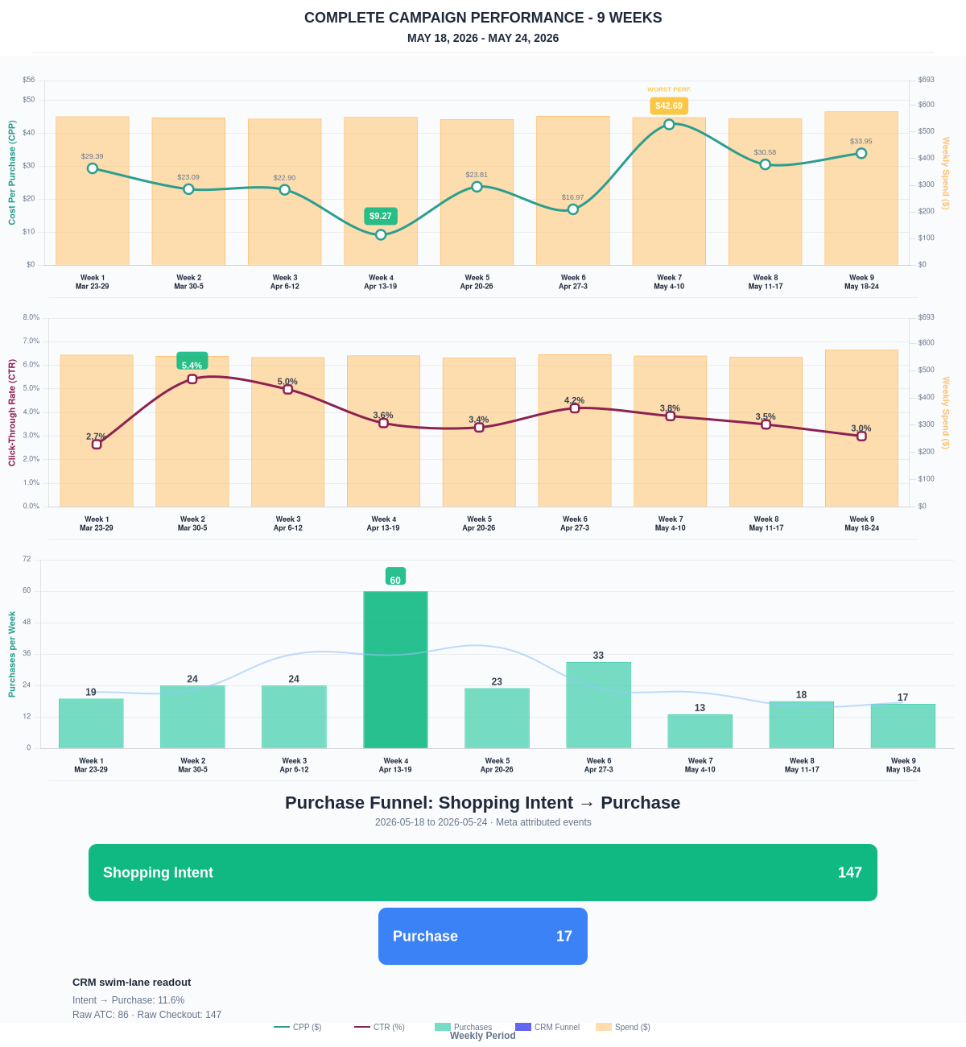

Questions? Let's chat about scaling these results.
Purchase Journey
Client-facing funnel based on Meta-attributed shopping intent and confirmed purchase events. This avoids presenting Add to Cart and Checkout as a strict sequence when retargeting and return visits make the raw event counts non-sequential.
Period | Shopping Intent | Purchase | Intent → Purchase | ATC → Purchase
This Week | 147 | 17 | 11.56% | 19.77%
Last 30 Days | 615 | 85 | 13.82% | 13.82%
Campaign to Date | 3945 | 708 | 17.95% | 17.95%
Use this as the client-facing purchase-intent funnel. Raw Add to Cart and Checkout are kept for internal diagnostics because Meta attribution can make those event counts non-sequential.
Sales Confirmation
WooCommerce confirms the paid orders that landed. Meta Ads Manager shows the ad platform’s reported purchase performance.
Sales Check | Value
WooCommerce paid kit orders | 10
WooCommerce revenue | $4,156.89
Meta reported purchases | 17
Meta reported purchase value | $5,849.35
Backend ROAS | 7.20x
Meta Ads Performance
Metric | Value
Meta spend | $577.12
Meta reported purchases | 17
Cost per purchase | $33.95
Meta reported ROAS | 10.14x
Website Revenue Mix
GA4 view of revenue by website channel for context around Meta campaign performance.
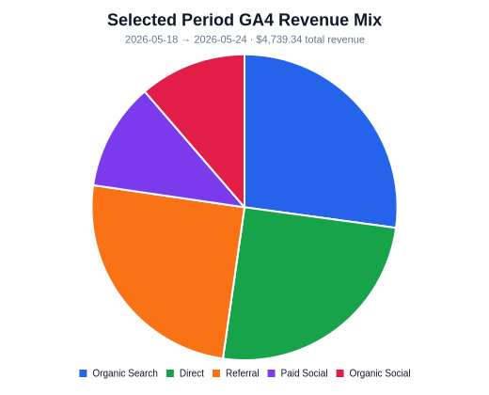 | 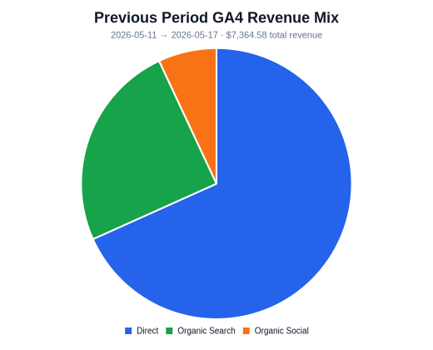 | 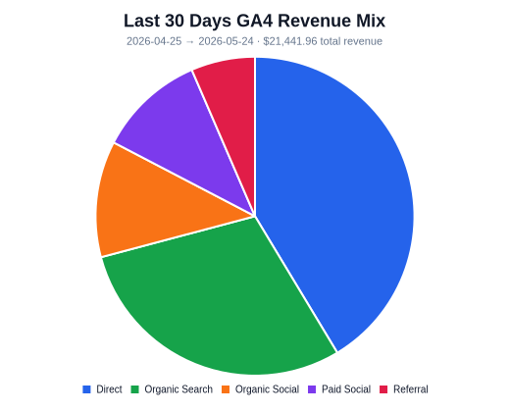
Organic Search revenue: $1,286.83 this period. GA4 Paid Social revenue: $538.84 this period.

