

Meta Ads Performance Audit
Client: NeedleFree (Comfort-In)
Campaign: All NeedleFree funnel campaigns
Period: 31 May 2026 – 6 June 2026

Executive Summary
NeedleFree (Comfort-In) generated 10 deduped WooCommerce paid kit orders and $4,826.14 in backend revenue for the period. Meta attributed 9 purchase events and $2,255.12 in purchase value, giving 90.00% purchase capture and 46.73% value capture against Woo truth. Backend CPP was $25.41 with backend ROAS of 18.99x; Meta events remain the attribution lens while Woo order IDs are the business result. Average CTR was 4.50%.

Key Metrics
Period | Spend | Purchases | CPP | CTR
This Week | $254.12 | 9 | $28.24 | 4.50%
This Month | $254.12 | 9 | $28.24 | 4.50%
Since Starting | $254.12 | 9 | $28.24 | 4.50%

Latest Batch — Top Metrics
# | Release Lot | Spend | CPM | CTR | Ad ID | Preview
🔥 | Jun-3 | $11.02 | $17.75 | 2.09% | ...193242792 | 

Top 5 Performers by CPP — All Time
# | Release Lot | CPP | Purchases | CTR | Ad ID | Preview
🔥 | May-31 | $2.64 | 4 | 3.45% | ...639363792 | 
2 | Jun-2 | $5.59 | 10 | 6.77% | ...213104992 | 
⭐ | May-31 | $9.20 | 4 | 6.78% | ...639305792 | 
🔥 = Top performer | ⭐ = Volume star | Sorted by cost per conversion (lowest first)

Release Lot Performance
• Nov-8 Release: 8 conversions from 2 ad(s) – Best cost: $2.64
• Nov-10 Release: 10 conversions from 1 ad(s) – Best cost: $5.59

Creative Insights
Top Performer:
NF Static Approved | 04-2_top_right | Nov-8 MOF TRT | 20260526 – 4 conversions at $2.64 cost, 3.45% CTR
Runner Up:
(10-11-2025) - (9) - Copy – 10 conversions at $5.59 cost, 6.77% CTR

Demographic Sweet Spot
• Male 35-44: 18 purchases, $5.34 CPP, 4.99% CTR

Key Insights
What's Working:
✓ Strong click-through rate of 4.50% indicates compelling ad creative and messaging is resonating with the target audience
✓ Top performing ad '(10-11-2025) - (9) - Copy' delivering exceptional results with $5.59 cost per purchase and 6.77% CTR - significantly outperforming campaign average
✓ Static approved creatives with 'top_right' placement are consistently driving conversions across multiple ad variations
✓ Middle-of-funnel (MOF) targeting strategy is effectively capturing purchase intent with multiple ads achieving 3.45-6.78% CTR

Opportunities:
→ Cost per purchase at $28.24 appears high for e-commerce - analyse profit margins to ensure campaign profitability and optimise for better conversion efficiency
→ Conversion rate needs improvement with only 9 purchases from 1,246 clicks (0.72%) - investigate landing page experience and checkout process
→ Significant performance variance between top and bottom performing ads suggests budget reallocation opportunities to maximise ROAS
→ Limited purchase volume of 9 conversions may indicate audience size constraints or bidding strategy requiring adjustment

Recommended Next Steps
▸ Immediately increase budget allocation to top performer '(10-11-2025) - (9) - Copy' and pause underperforming variations to improve overall campaign efficiency
▸ Conduct landing page audit focusing on mobile experience, page load speed, and checkout flow optimisation to improve the 0.72% conversion rate
▸ Create additional ad variations using successful elements from top performers (copy style, creative format, placement strategy) to scale winning approaches
▸ Implement conversion tracking analysis to identify where users drop off in the purchase funnel and A/B test different audience segments within MOF strategy

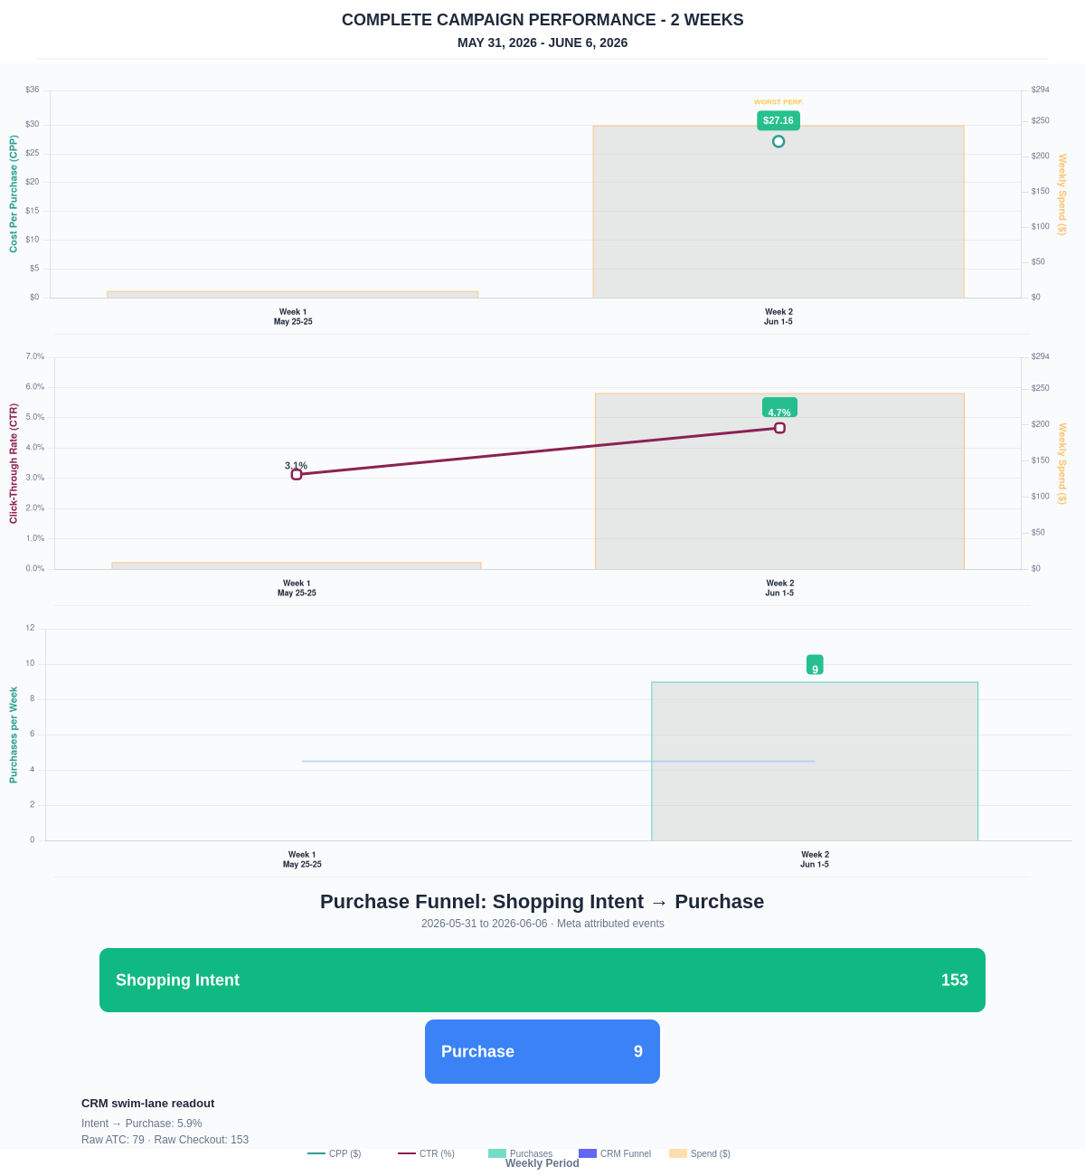

Questions? Let's chat about scaling these results.
Purchase Journey
Client-facing funnel based on Meta-attributed shopping intent and confirmed purchase events. This avoids presenting Add to Cart and Checkout as a strict sequence when retargeting and return visits make the raw event counts non-sequential.
Period | Shopping Intent | Purchase | Intent → Purchase | ATC → Purchase
This Week | 153 | 9 | 5.88% | 11.39%
Last 30 Days | 153 | 9 | 5.88% | 11.39%
Campaign to Date | 153 | 9 | 5.88% | 11.39%
Use this as the client-facing purchase-intent funnel. Raw Add to Cart and Checkout are kept for internal diagnostics because Meta attribution can make those event counts non-sequential.
Sales Confirmation
WooCommerce confirms the paid orders that landed. Meta Ads Manager shows the ad platform’s reported purchase performance.
Sales Check | Value
WooCommerce paid kit orders | 10
WooCommerce revenue | $4,826.14
Meta reported purchases | 9
Meta reported purchase value | $2,255.12
Backend ROAS | 18.99x
Meta Ads Performance
Metric | Value
Meta spend | $254.12
Meta reported purchases | 9
Cost per purchase | $28.24
Meta reported ROAS | 8.87x
Website Revenue Mix
GA4 view of revenue by website channel for context around Meta campaign performance.
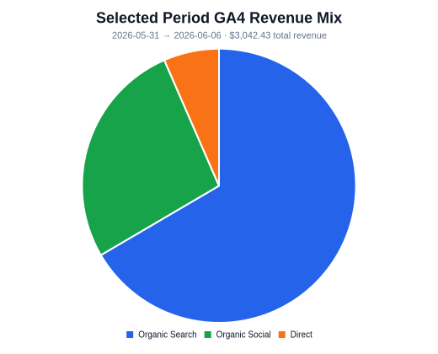 | 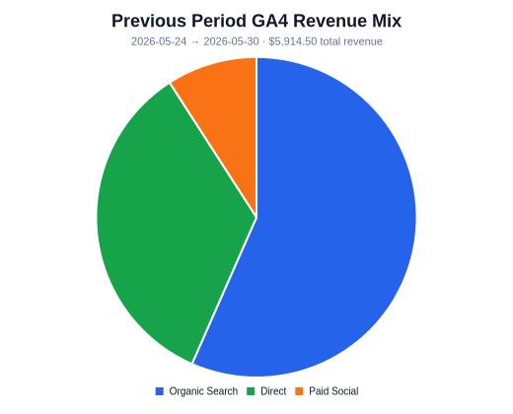 | 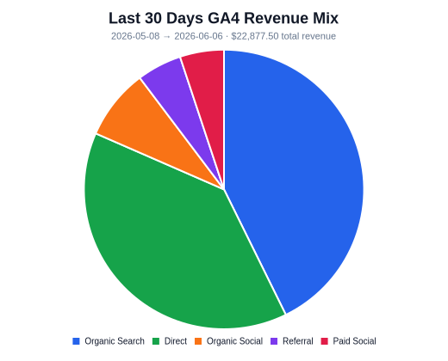
Organic Search revenue: $2,025.04 this period. GA4 Paid Social revenue: $0.00 this period.

