

Meta Ads Performance Audit
Client: NeedleFree (Comfort-In)
Campaign: All NeedleFree funnel campaigns
Period: 1 June 2026 – 7 June 2026

Executive Summary
NeedleFree (Comfort-In) generated 13 deduped WooCommerce paid kit orders and $6,181.89 in backend revenue for the period. Meta attributed 13 purchase events and $3,814.84 in purchase value, giving 100.00% purchase capture and 61.71% value capture against Woo truth. Backend CPP was $24.74 with backend ROAS of 19.22x; Meta events remain the attribution lens while Woo order IDs are the business result. Average CTR was 4.77%.

Key Metrics
Period | Spend | Purchases | CPP | CTR
This Week | $321.56 | 13 | $24.74 | 4.77%
This Month | $331.42 | 13 | $25.49 | 4.63%
Since Starting | $331.42 | 13 | $25.49 | 4.63%

Latest Batch — Top Metrics
# | Release Lot | Spend | CPM | CTR | Ad ID | Preview
🔥 | Jun-3 | $18.22 | $15.20 | 1.75% | ...193242792 | 

Top 5 Performers by CPP — All Time
# | Release Lot | CPP | Purchases | CTR | Ad ID | Preview
🔥 | May-31 | $2.65 | 4 | 3.44% | ...639363792 | 
2 | Jun-2 | $4.86 | 18 | 7.42% | ...213104992 | 
⭐ | May-31 | $9.25 | 4 | 6.76% | ...639305792 | 
🔥 = Top performer | ⭐ = Volume star | Sorted by cost per conversion (lowest first)

Release Lot Performance
• Nov-8 Release: 8 conversions from 2 ad(s) – Best cost: $2.65
• Nov-10 Release: 18 conversions from 1 ad(s) – Best cost: $4.86

Creative Insights
Top Performer:
NF Static Approved | 04-2_top_right | Nov-8 MOF TRT | 20260526 – 4 conversions at $2.65 cost, 3.44% CTR
Runner Up:
(10-11-2025) - (9) - Copy – 18 conversions at $4.86 cost, 7.42% CTR

Demographic Sweet Spot
• Male 35-44: 26 purchases, $4.74 CPP, 5.35% CTR

Key Insights
What's Working:
✓ Strong overall CTR of 4.77% indicates compelling creative messaging is resonating well with the target audience
✓ Ad variant '(10-11-2025) - (9) - Copy' is significantly outperforming with 7.42% CTR and lowest cost per purchase at $4.86
✓ Middle-of-funnel targeting (MOF TRT) campaigns are generating consistent conversions with reasonable costs
✓ Campaign is achieving solid conversion volume with 13 purchases, demonstrating effective audience targeting

Opportunities:
→ Cost per purchase of $24.74 could be optimised by reallocating budget towards the best-performing creative variants
→ Significant performance gap between top performer ($4.86 CPA) and underperforming ads suggests room for creative optimisation
→ High impression volume (32,430) with strong CTR indicates potential to scale budget on winning ad sets
→ Static creative formats showing mixed results - opportunity to test video or carousel formats for improved engagement

Recommended Next Steps
▸ Immediately increase budget allocation to '(10-11-2025) - (9) - Copy' creative by 40-50% to capitalise on its superior performance
▸ Pause or reduce spend on underperforming static creatives with CPA above $20 to improve overall campaign efficiency
▸ Conduct A/B tests on the top-performing copy variant to identify specific messaging elements driving success
▸ Scale total campaign budget by 25-30% given strong CTR performance and focus increased spend on proven MOF targeting segments

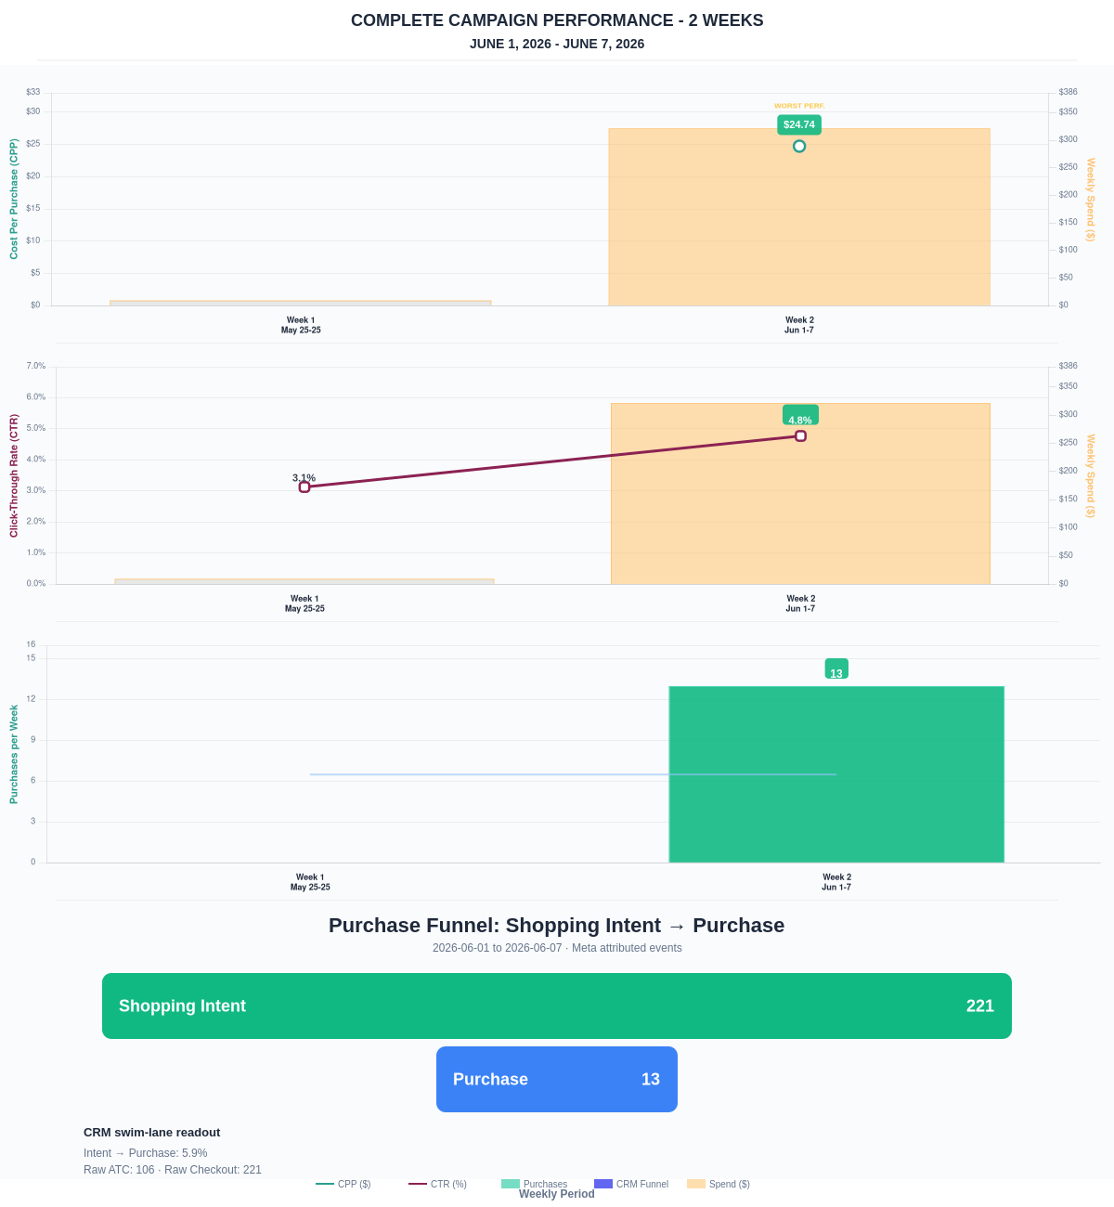

Questions? Let's chat about scaling these results.
Purchase Journey
Client-facing funnel based on Meta-attributed shopping intent and confirmed purchase events. This avoids presenting Add to Cart and Checkout as a strict sequence when retargeting and return visits make the raw event counts non-sequential.
Period | Shopping Intent | Purchase | Intent → Purchase | ATC → Purchase
This Week | 221 | 13 | 5.88% | 12.26%
Last 30 Days | 221 | 13 | 5.88% | 12.26%
Campaign to Date | 221 | 13 | 5.88% | 12.26%
Use this as the client-facing purchase-intent funnel. Raw Add to Cart and Checkout are kept for internal diagnostics because Meta attribution can make those event counts non-sequential.
Sales Confirmation
WooCommerce confirms the paid orders that landed. Meta Ads Manager shows the ad platform’s reported purchase performance.
Sales Check | Value
WooCommerce paid kit orders | 13
WooCommerce revenue | $6,181.89
Meta reported purchases | 13
Meta reported purchase value | $3,814.84
Backend ROAS | 19.22x
Meta Ads Performance
Metric | Value
Meta spend | $321.56
Meta reported purchases | 13
Cost per purchase | $24.74
Meta reported ROAS | 11.86x
Website Revenue Mix
GA4 view of revenue by website channel for context around Meta campaign performance.
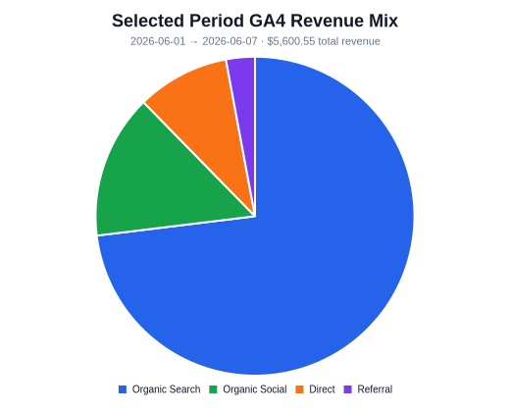 | 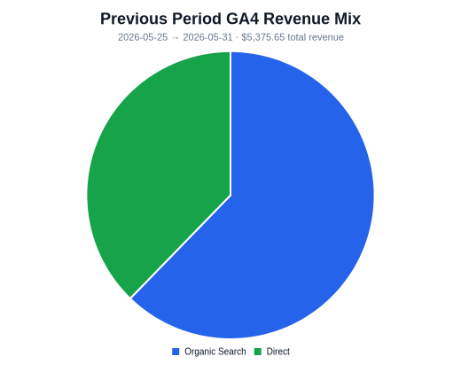 | 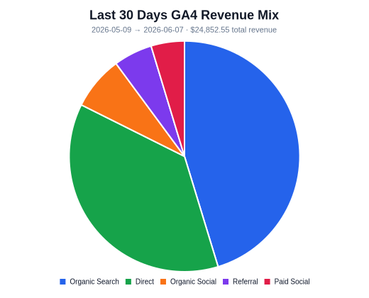
Organic Search revenue: $4,091.78 this period. GA4 Paid Social revenue: $0.00 this period.

