

Meta Ads Performance Audit
Client: NeedleFree (Comfort-In)
Campaign: All NeedleFree funnel campaigns
Period: 1 June 2026 – 7 June 2026

Executive Summary
NeedleFree (Comfort-In) generated 15 deduped WooCommerce paid kit orders and $7,103.61 in backend revenue for the period. Meta attributed 15 purchase events and $6,918.16 in purchase value, giving 100.00% purchase capture and 97.39% value capture against Woo truth. Backend CPP was $31.75 with backend ROAS of 14.92x; Meta events remain the attribution lens while Woo order IDs are the business result. Average CTR was 4.71%.

Key Metrics
Period | Spend | Purchases | CPP | CTR
This Week | $476.26 | 15 | $31.75 | 4.71%
This Month | $2,154.14 | 72 | $29.92 | 3.44%
Since Starting | $12,330.15 | 742 | $16.62 | 3.77%

Latest Batch — Top Metrics
# | Release Lot | Spend | CPM | CTR | Ad ID | Preview
🔥 | Jun-3 | $25.87 | $21.57 | 1.75% | ...193242792 | 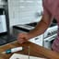

Top 5 Performers by CPP — All Time
# | Release Lot | CPP | Purchases | CTR | Ad ID | Preview
🔥 | Dec-22 | $0.77 | 11 | 2.65% | ...434619171 | 
2 | Jan-20 | $1.51 | 2 | 1.13% | ...245221971 | 
⭐ | Feb-10 | $1.75 | 3 | 0.85% | ...790733771 | 
4 | Feb-18 | $2.06 | 3 | 1.07% | ...620572971 | 
5 | Feb-28 | $2.52 | 2 | 2.70% | ...675335171 | 
🔥 = Top performer | ⭐ = Volume star | Sorted by cost per conversion (lowest first)

Release Lot Performance
• Dec-22 Release: 11 conversions from 1 ad(s) – Best cost: $0.77
• Jan-20 Release: 2 conversions from 1 ad(s) – Best cost: $1.51
• Feb-10 Release: 3 conversions from 1 ad(s) – Best cost: $1.75
• Feb-18 Release: 3 conversions from 1 ad(s) – Best cost: $2.06
• Feb-28 Release: 2 conversions from 1 ad(s) – Best cost: $2.52

Creative Insights
Top Performer:
(22-12-2025) - (5) – 11 conversions at $0.77 cost, 2.65% CTR
Runner Up:
(20-01-2026) - (3) – 2 conversions at $1.51 cost, 1.13% CTR

Demographic Sweet Spot
• Male 35-44: 15 purchases, $12.13 CPP, 5.31% CTR

Key Insights
What's Working:
✓ Strong overall CTR of 4.71% indicates compelling creative and audience targeting is resonating well with potential customers
✓ Top performing ad (22-12-2025) demonstrates exceptional efficiency with 11 purchases at only $0.77 CPA - significantly below the $31.75 average
✓ Consistent conversion performance across multiple ad variations shows the NeedleFree product messaging is connecting with the target audience
✓ High click volume of 1,608 from 34,158 impressions demonstrates strong audience engagement and interest in the Comfort-In product

Opportunities:
→ Significant CPA variance between top performer ($0.77) and campaign average ($31.75) suggests budget redistribution could dramatically improve efficiency
→ Lower performing ads are driving up overall costs - the bottom performers appear to be consuming budget without delivering proportional returns
→ CTR drops substantially from top performer (2.65%) to other variations, indicating creative optimisation potential
→ With only 15 purchases from 1,608 clicks, the 0.93% conversion rate suggests landing page or checkout process optimisation opportunities

Recommended Next Steps
▸ Immediately increase budget allocation to the top performing ad (22-12-2025) and pause or reduce spend on underperforming variations
▸ Analyse the creative elements and targeting of the $0.77 CPA ad to replicate these successful components across new ad variations
▸ Conduct landing page analysis and A/B test checkout flow improvements to increase the conversion rate from the strong click-through traffic
▸ Create 2-3 new ad variations based on the winning creative format and test against different audience segments to scale successful performance

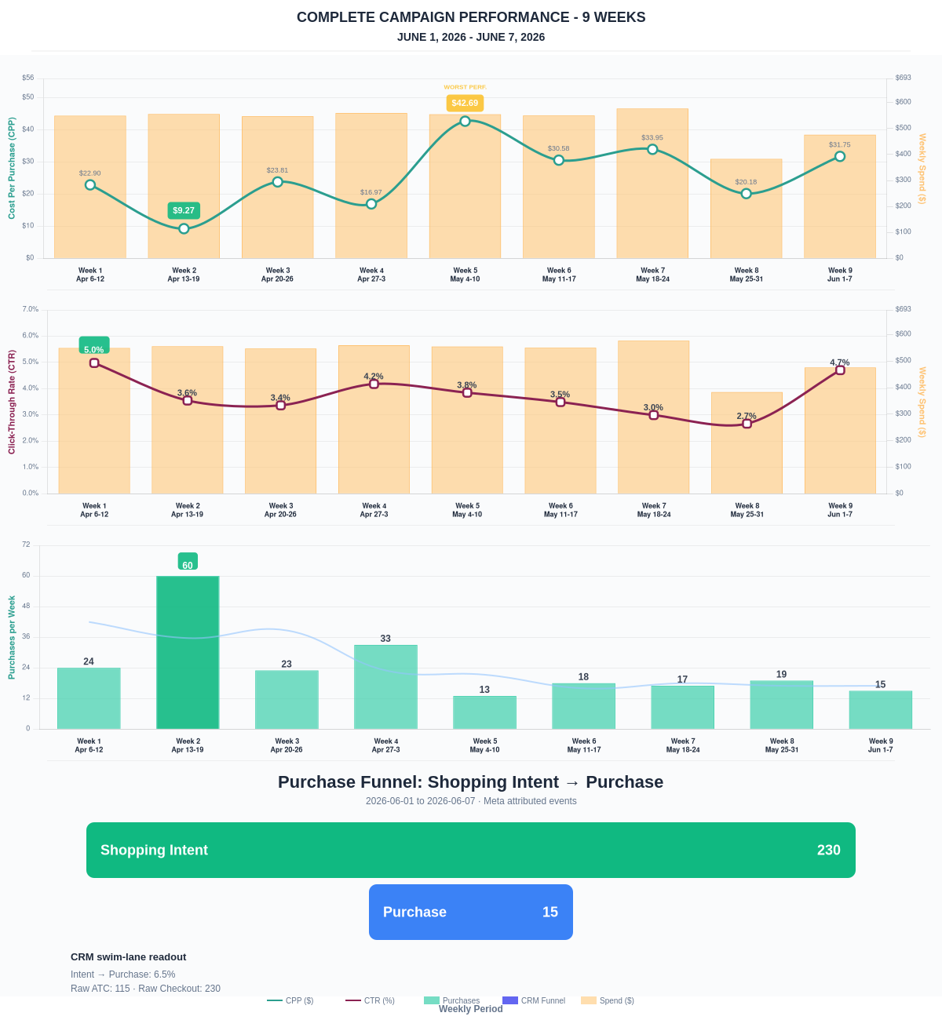

Questions? Let's chat about scaling these results.
Purchase Journey
Client-facing funnel based on Meta-attributed shopping intent and confirmed purchase events. This avoids presenting Add to Cart and Checkout as a strict sequence when retargeting and return visits make the raw event counts non-sequential.
Period | Shopping Intent | Purchase | Intent → Purchase | ATC → Purchase
This Week | 230 | 15 | 6.52% | 13.04%
Last 30 Days | 749 | 72 | 9.61% | 15.06%
Campaign to Date | 4117 | 742 | 18.02% | 18.02%
Use this as the client-facing purchase-intent funnel. Raw Add to Cart and Checkout are kept for internal diagnostics because Meta attribution can make those event counts non-sequential.
Sales Confirmation
WooCommerce confirms the paid orders that landed. Meta Ads Manager shows the ad platform’s reported purchase performance.
Sales Check | Value
WooCommerce paid kit orders | 15
WooCommerce revenue | $7,103.61
Meta reported purchases | 15
Meta reported purchase value | $6,918.16
Backend ROAS | 14.92x
Meta Ads Performance
Metric | Value
Meta spend | $476.26
Meta reported purchases | 15
Cost per purchase | $31.75
Meta reported ROAS | 14.53x
Website Revenue Mix
GA4 view of revenue by website channel for context around Meta campaign performance.
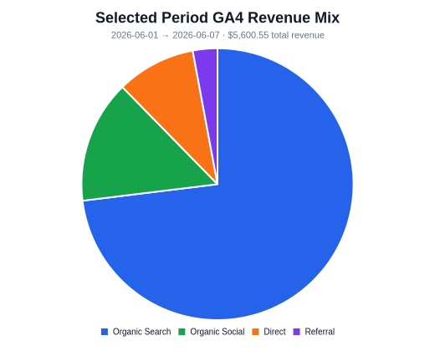 | 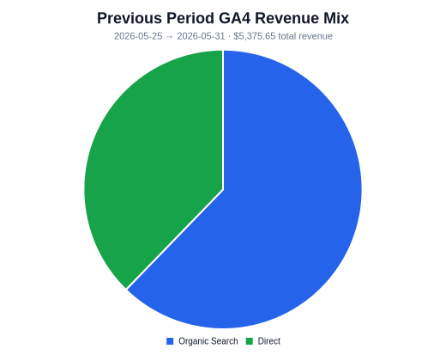 | 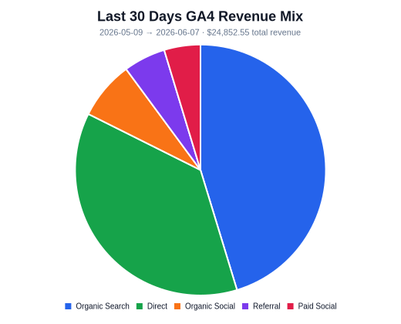
Organic Search revenue: $4,091.78 this period. GA4 Paid Social revenue: $0.00 this period.

