

Meta Ads Performance Audit
Client: NeedleFree (Comfort-In)
Campaign: All NeedleFree funnel campaigns
Period: 1 June 2026 – 7 June 2026

Executive Summary
NeedleFree (Comfort-In) generated 15 deduped WooCommerce paid kit orders and $7,103.61 in backend revenue for the period. Meta attributed 15 purchase events and $6,912.06 in purchase value, giving 100.00% purchase capture and 97.30% value capture against Woo truth. Backend CPP was $31.72 with backend ROAS of 14.93x; Meta events remain the attribution lens while Woo order IDs are the business result. Average CTR was 4.71%.

Key Metrics
Period | Spend | Purchases | CPP | CTR
This Week | $475.84 | 15 | $31.72 | 4.71%
This Month | $2,153.70 | 72 | $29.91 | 3.44%
Since Starting | $12,329.71 | 742 | $16.62 | 3.77%

Latest Batch — Top Performers
# | Release Lot | CPP | Purchases | CTR | Ad ID | Preview
🔥 | Mar-26 | $2.18 | 2 | 0.86% | ...408443371 | 
2 | Mar-26 | $4.79 | 3 | 1.84% | ...408270571 | 

Top 5 Performers by CPP — All Time
# | Release Lot | CPP | Purchases | CTR | Ad ID | Preview
🔥 | Dec-22 | $0.77 | 11 | 2.65% | ...434619171 | 
2 | Jan-20 | $1.51 | 2 | 1.13% | ...245221971 | 
⭐ | Feb-10 | $1.75 | 3 | 0.85% | ...790733771 | 
4 | Feb-18 | $2.06 | 3 | 1.07% | ...620572971 | 
5 | Feb-28 | $2.52 | 2 | 2.70% | ...675335171 | 
🔥 = Top performer | ⭐ = Volume star | Sorted by cost per conversion (lowest first)

Release Lot Performance
• Dec-22 Release: 11 conversions from 1 ad(s) – Best cost: $0.77
• Jan-20 Release: 2 conversions from 1 ad(s) – Best cost: $1.51
• Feb-10 Release: 3 conversions from 1 ad(s) – Best cost: $1.75
• Feb-18 Release: 3 conversions from 1 ad(s) – Best cost: $2.06
• Feb-28 Release: 2 conversions from 1 ad(s) – Best cost: $2.52

Creative Insights
Top Performer:
(22-12-2025) - (5) – 11 conversions at $0.77 cost, 2.65% CTR
Runner Up:
(20-01-2026) - (3) – 2 conversions at $1.51 cost, 1.13% CTR

Demographic Sweet Spot
• Male 35-44: 15 purchases, $12.12 CPP, 5.31% CTR

Key Insights
What's Working:
✓ Exceptional CTR of 4.71% indicates highly relevant ad creative and targeting that resonates with your comfort-focused audience
✓ Top performing ad (22-12-2025) delivers outstanding efficiency at $0.77 CPA with 2.65% CTR, demonstrating strong creative-audience fit
✓ Strong overall conversion rate from clicks to purchases shows effective landing page experience and product-market fit
✓ Consistent purchase volume across multiple ad variations indicates scalable creative approach

Opportunities:
→ High CPA of $31.72 suggests need to optimise bidding strategy and audience targeting to improve cost efficiency
→ Significant performance gap between top ad ($0.77 CPA) and others ($1.51-$1.75 CPA) indicates untapped creative optimisation potential
→ Lower CTRs on secondary ads (1.13% and 0.85%) suggest creative fatigue or suboptimal audience targeting
→ Current spend allocation may not be optimised towards the highest-performing creative variations

Recommended Next Steps
▸ Immediately increase budget allocation to the top-performing ad (22-12-2025) whilst it maintains strong efficiency metrics
▸ Analyse and replicate the winning creative elements from the $0.77 CPA ad across new variations to improve overall performance
▸ Implement automated rules to pause underperforming ads when CPA exceeds $25 to protect budget efficiency
▸ Test lookalike audiences based on recent purchasers to expand reach whilst maintaining the strong 4.71% CTR performance

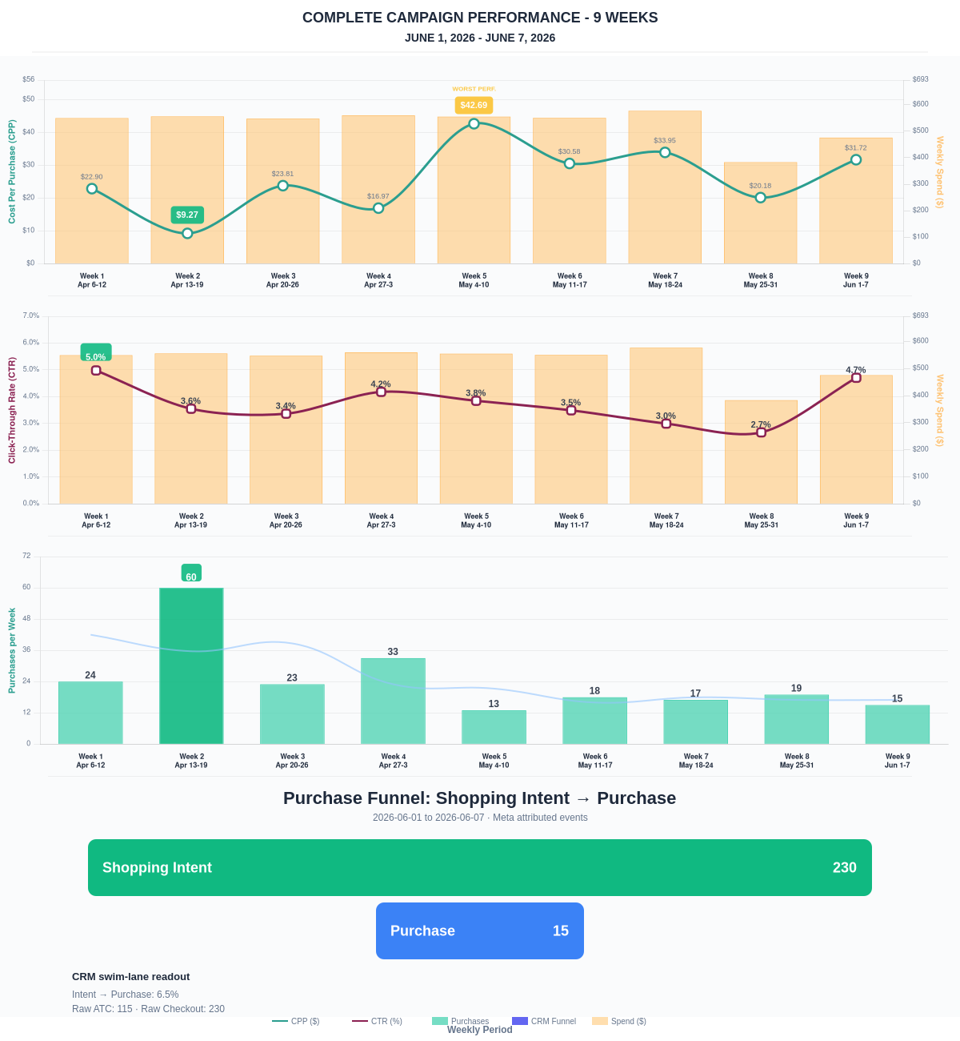

Questions? Let's chat about scaling these results.
Purchase Journey
Client-facing funnel based on Meta-attributed shopping intent and confirmed purchase events. This avoids presenting Add to Cart and Checkout as a strict sequence when retargeting and return visits make the raw event counts non-sequential.
Period | Shopping Intent | Purchase | Intent → Purchase | ATC → Purchase
This Week | 230 | 15 | 6.52% | 13.04%
Last 30 Days | 749 | 72 | 9.61% | 15.06%
Campaign to Date | 4117 | 742 | 18.02% | 18.02%
Use this as the client-facing purchase-intent funnel. Raw Add to Cart and Checkout are kept for internal diagnostics because Meta attribution can make those event counts non-sequential.
Sales Confirmation
WooCommerce confirms the paid orders that landed. Meta Ads Manager shows the ad platform’s reported purchase performance.
Sales Check | Value
WooCommerce paid kit orders | 15
WooCommerce revenue | $7,103.61
Meta reported purchases | 15
Meta reported purchase value | $6,912.06
Backend ROAS | 14.93x
Meta Ads Performance
Metric | Value
Meta spend | $475.84
Meta reported purchases | 15
Cost per purchase | $31.72
Meta reported ROAS | 14.53x
Website Revenue Mix
GA4 view of revenue by website channel for context around Meta campaign performance.
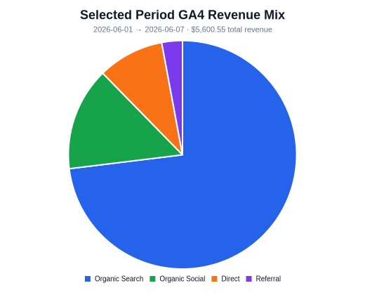 | 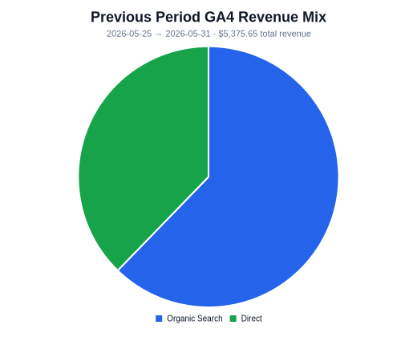 | 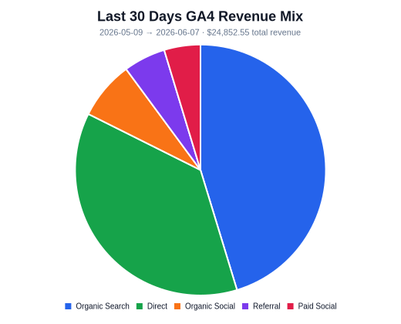
Organic Search revenue: $4,091.78 this period. GA4 Paid Social revenue: $0.00 this period.

