

Reconciled Ads Performance Audit
Client: NeedleFree (Comfort-In)
Campaign: All NeedleFree funnel campaigns
Period: 8 June 2026 – 14 June 2026

Executive Summary
NeedleFree (Comfort-In) generated 19 reconciled purchases and $8,467.45 in revenue for the period. Total spend was $584.82, producing a $30.78 cost per purchase and 14.48x ROAS. Average CTR was 6.98%, with strong click volume and confirmed paid kit sales through WooCommerce.

Key Metrics
Period | Spend | Purchases | CPP | CTR
This Week | $584.82 | 19 | $30.78 | 6.98%
This Month | $2,163.60 | 57 | $37.96 | 4.55%
Since Starting | $12,913.52 | 539 | $23.96 | 3.98%

Latest Batch — Top Performers
# | Release Lot | CPP | Purchases | CTR | Ad ID | Preview
🔥 | Jun-8 | $1.27 | 2 | 10.29% | ...907448792 | 
2 | Jun-8 | $5.43 | 2 | 4.13% | ...897906792

Top 5 Performers by CPP — All Time
# | Release Lot | CPP | Purchases | CTR | Ad ID | Preview
🔥 | Dec-22 | $0.77 | 11 | 2.65% | ...434619171 | 
2 | Jun-8 | $1.27 | 2 | 10.29% | ...907448792
⭐ | Jan-20 | $1.51 | 2 | 1.13% | ...245221971 | 
4 | Feb-10 | $1.75 | 3 | 0.85% | ...790733771 | 
5 | Feb-18 | $2.06 | 3 | 1.07% | ...620572971 | 
🔥 = Top performer | ⭐ = Volume star | Sorted by cost per conversion (lowest first)

Release Lot Performance
• Dec-22 Release: 13 conversions from 2 ad(s) – Best cost: $0.77
• Jan-20 Release: 2 conversions from 1 ad(s) – Best cost: $1.51
• Feb-10 Release: 3 conversions from 1 ad(s) – Best cost: $1.75
• Feb-18 Release: 3 conversions from 1 ad(s) – Best cost: $2.06

Creative Insights
Top Performer:
(22-12-2025) - (5) – 11 conversions at $0.77 cost, 2.65% CTR
Runner Up:
(22-12-2025) - (2) - Copy 2 – 2 conversions at $1.27 cost, 10.29% CTR

Demographic Sweet Spot
• Male 35-44: 5 purchases, $41.43 CPP, 7.49% CTR
• Male 45-54: 2 purchases, $58.27 CPP, 7.56% CTR
• Male 25-34: 2 purchases, $63.89 CPP, 7.51% CTR

Key Insights
What's Working:
✓ Strong overall click-through rate of 6.98% indicates compelling creative and messaging that resonates with your target audience
✓ Cost per purchase of $30.78 demonstrates viable unit economics for NeedleFree's acquisition strategy
✓ Top performing ad (22-12-2025) - (5) delivered exceptional efficiency at $0.77 CPP with solid 2.65% CTR, showing scalable creative potential
✓ High-CTR creative (22-12-2025) - (2) - Copy 2 achieved 10.29% engagement rate, indicating strong hook effectiveness

Opportunities:
→ Scale successful creative elements from top performers, particularly the messaging and visual approach from the $0.77 CPP winner
→ Investigate audience targeting refinements to improve conversion rates across underperforming ad sets
→ Test additional creative variations that combine the high engagement elements from the 10.29% CTR ad with conversion-focused messaging
→ Optimise budget allocation to prioritise top-performing ad sets and pause or refresh poor performers

Recommended Next Steps
▸ Increase budget allocation to the (22-12-2025) - (5) ad set to capitalise on its strong performance metrics
▸ Create 2-3 new creative variations using successful elements from top performers, focusing on similar messaging angles and visual styles
▸ Analyse audience insights from high-performing ads to refine targeting parameters for new campaigns
▸ Implement systematic creative testing schedule with weekly performance reviews to maintain momentum

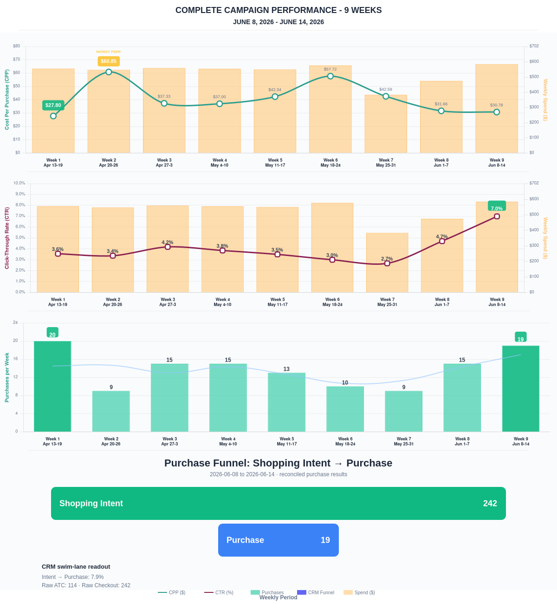

Questions? Let's chat about scaling these results.
Purchase Journey
Client-facing funnel based on shopping intent and reconciled purchase results.
Period | Shopping Intent | Purchase | Intent → Purchase | ATC → Purchase
This Week | 242 | 19 | 7.85% | 16.67%
Last 30 Days | 812 | 57 | 7.02% | 13.60%
Campaign to Date | 4231 | 539 | 12.74% | 12.74%
Use this as the client-facing purchase-intent funnel.
Sales Performance
Sales totals reconciled against WooCommerce paid kit orders.
Sales Check | Value
Reconciled purchases | 19
Reconciled revenue | $8,467.45
ROAS | 14.48x
Reconciled Ads Performance
Metric | Value
Meta spend | $584.82
Reconciled purchases | 19
Cost per purchase | $30.78
ROAS | 14.48x
Website Revenue Mix
GA4 view of revenue by website channel for context around Meta campaign performance.
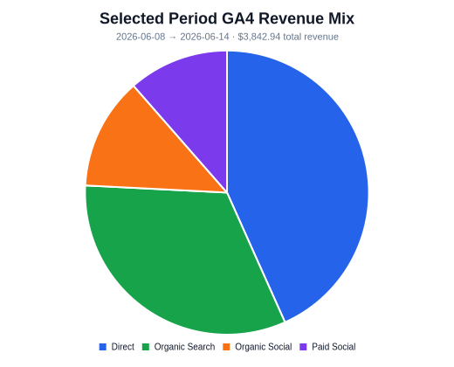 | 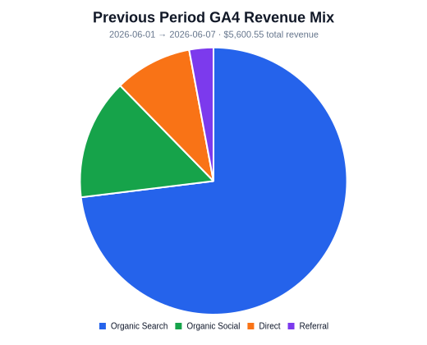 | 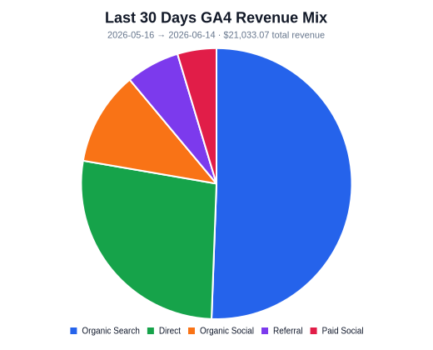
Organic Search revenue: $1,248.96 this period. GA4 Paid Social revenue: $439.95 this period.

