

Reconciled Ads Performance Audit
Client: NeedleFree (Comfort-In)
Campaign: All NeedleFree funnel campaigns
Period: 15 June 2026 – 21 June 2026

Executive Summary
NeedleFree (Comfort-In) generated 6 reconciled purchases and $2,727.86 in revenue for the period. Total spend was $434.29, producing a $72.38 cost per purchase and 6.28x ROAS. Average CTR was 7.26%, with strong click volume and confirmed paid kit sales through WooCommerce.

Key Metrics
Period | Spend | Purchases | CPP | CTR
This Week | $434.29 | 6 | $72.38 | 7.26%
This Month | $2,063.94 | 51 | $40.47 | 5.55%
Since Starting | $13,355.64 | 545 | $24.51 | 4.11%

Latest Batch — Top Performers
# | Release Lot | CPP | Purchases | CTR | Ad ID | Preview
🔥 | Jun-8 | $1.36 | 3 | 2.06% | ...904544992 | 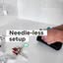
2 | Jun-8 | $1.85 | 2 | 7.29% | ...907448792 | 
⭐ | Jun-8 | $11.35 | 2 | 4.10% | ...904544592 | 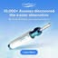
4 | Jun-8 | $24.27 | 2 | 4.19% | ...897906792

Top 5 Performers by CPP — All Time
# | Release Lot | CPP | Purchases | CTR | Ad ID | Preview
🔥 | Dec-22 | $0.77 | 11 | 2.65% | ...434619171 | 
2 | Jun-8 | $1.36 | 3 | 2.06% | ...904544992
⭐ | Jan-20 | $1.51 | 2 | 1.13% | ...245221971 | 
4 | Feb-10 | $1.75 | 3 | 0.85% | ...790733771 | 
5 | Jun-8 | $1.85 | 2 | 7.29% | ...907448792
🔥 = Top performer | ⭐ = Volume star | Sorted by cost per conversion (lowest first)

Release Lot Performance
• Dec-22 Release: 13 conversions from 2 ad(s) – Best cost: $0.77
• Feb-21 Release: 3 conversions from 1 ad(s) – Best cost: $1.36
• Jan-20 Release: 2 conversions from 1 ad(s) – Best cost: $1.51
• Feb-10 Release: 3 conversions from 1 ad(s) – Best cost: $1.75

Creative Insights
Top Performer:
(22-12-2025) - (5) – 11 conversions at $0.77 cost, 2.65% CTR
Runner Up:
(Feb-21-26) - (11) 781BB - Copy 2 – 3 conversions at $1.36 cost, 2.06% CTR

Demographic Sweet Spot
• Male 35-44: 3 purchases, $51.90 CPP, 7.43% CTR
• Unknown 35-44: 2 purchases, $2.42 CPP, 8.63% CTR
• Male 45-54: 2 purchases, $43.40 CPP, 7.54% CTR

Key Insights
What's Working:
✓ Exceptional click-through rate of 7.26% demonstrates highly engaging creative and targeting that resonates strongly with your audience
✓ Top-performing ad (22-12-2025) is delivering outstanding efficiency at $0.77 cost per purchase with 11 conversions, showing clear winning creative elements
✓ Strong audience engagement across campaigns with nearly 3,000 clicks generated from targeted impressions
✓ Multiple ads achieving consistent purchase volumes, indicating scalable creative formats and messaging approaches

Opportunities:
→ Current cost per purchase of $72.38 suggests room for optimisation through budget reallocation towards top-performing creatives
→ Significant performance gap between best performer ($0.77 CPP) and campaign average indicates potential for creative refresh on underperforming ads
→ High CTR combined with conversion data suggests audience targeting is strong but creative optimisation could improve conversion rates
→ Revenue scaling opportunity exists by increasing budget allocation to the standout performer generating 11 purchases

Recommended Next Steps
▸ Immediately increase budget allocation to the top-performing ad (22-12-2025) by 150-200% to capitalise on its $0.77 cost per purchase efficiency
▸ Analyse creative elements from the winning ad and create 3-4 new variations testing similar messaging, visuals, and format approaches
▸ Pause or significantly reduce spend on ads with cost per purchase above $50 to improve overall campaign efficiency
▸ Implement daily monitoring of the scaled top performer to ensure performance stability and adjust budgets accordingly

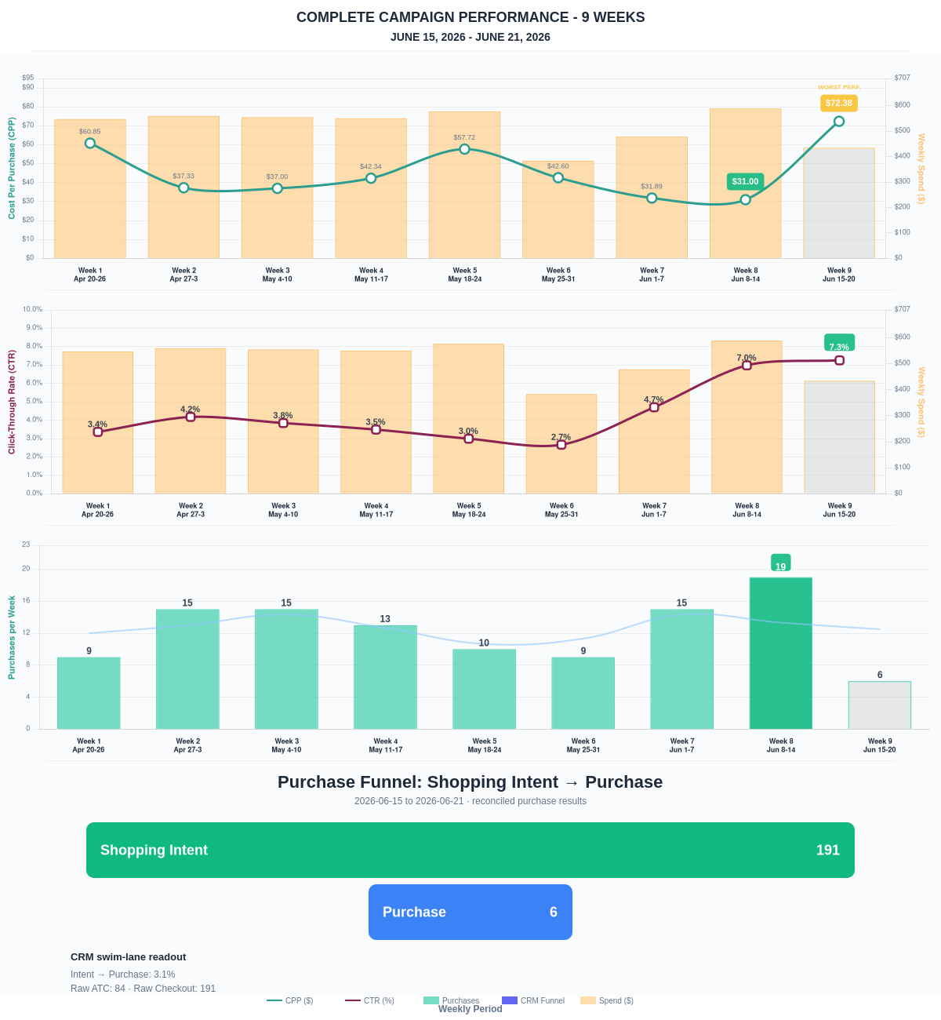

Questions? Let's chat about scaling these results.
Purchase Journey
Client-facing funnel based on shopping intent and reconciled purchase results.
Period | Shopping Intent | Purchase | Intent → Purchase | ATC → Purchase
This Week | 191 | 6 | 3.14% | 7.14%
Last 30 Days | 831 | 51 | 6.14% | 13.14%
Campaign to Date | 4315 | 545 | 12.63% | 12.63%
Use this as the client-facing purchase-intent funnel.
Sales Performance
Sales totals reconciled against WooCommerce paid kit orders.
Sales Check | Value
Reconciled purchases | 6
Reconciled revenue | $2,727.86
ROAS | 6.28x
Reconciled Ads Performance
Metric | Value
Meta spend | $434.29
Reconciled purchases | 6
Cost per purchase | $72.38
ROAS | 6.28x
Website Revenue Mix
GA4 view of revenue by website channel for context around Meta campaign performance.
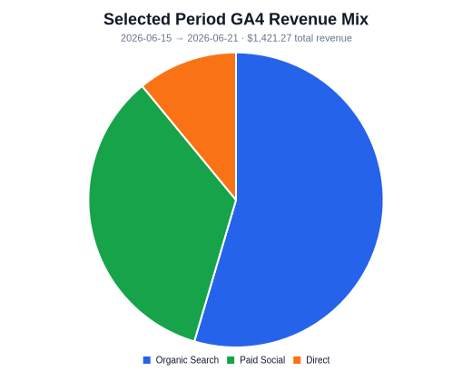 | 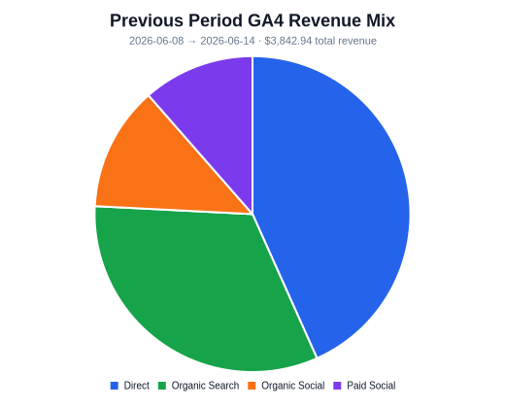 | 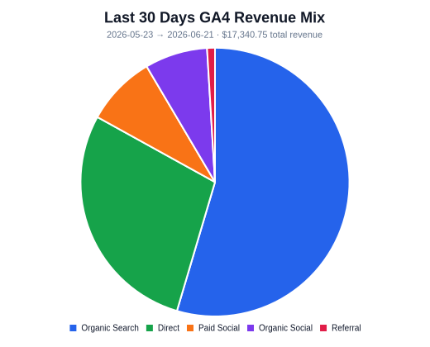
Organic Search revenue: $775.48 this period. GA4 Paid Social revenue: $489.95 this period.

