

Reconciled Ads Performance Audit
Client: NeedleFree (Comfort-In)
Campaign: All NeedleFree funnel campaigns
Period: 15 June 2026 – 21 June 2026

Executive Summary
NeedleFree (Comfort-In) generated 9 reconciled purchases and $3,873.04 in revenue for the period. Total spend was $569.47, producing a $63.27 cost per purchase and 6.80x ROAS. Average CTR was 6.89%, with strong click volume and confirmed paid kit sales through WooCommerce.

Key Metrics
Period | Spend | Purchases | CPP | CTR
This Week | $569.47 | 9 | $63.27 | 6.89%
This Month | $2,199.00 | 54 | $40.72 | 5.51%
Since Starting | $13,490.70 | 548 | $24.62 | 4.12%

Latest Batch — Top Performers
# | Release Lot | CPP | Purchases | CTR | Ad ID | Preview
🔥 | Jun-8 | $1.85 | 2 | 7.29% | ...907448792 | 
2 | Jun-8 | $2.49 | 3 | 1.86% | ...904544992 | 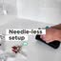
⭐ | Jun-8 | $4.33 | 2 | 3.91% | ...897907192 | 
4 | Jun-8 | $11.58 | 2 | 4.04% | ...904544592 | 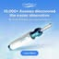
5 | Jun-8 | $25.07 | 2 | 4.17% | ...897906792

Top 5 Performers by CPP — All Time
# | Release Lot | CPP | Purchases | CTR | Ad ID | Preview
🔥 | Dec-22 | $0.77 | 11 | 2.65% | ...434619171 | 
2 | Jan-20 | $1.51 | 2 | 1.13% | ...245221971 | 
⭐ | Feb-10 | $1.75 | 3 | 0.85% | ...790733771 | 
4 | Jun-8 | $1.85 | 2 | 7.29% | ...907448792
5 | Feb-18 | $2.06 | 3 | 1.07% | ...620572971 | 
🔥 = Top performer | ⭐ = Volume star | Sorted by cost per conversion (lowest first)

Release Lot Performance
• Dec-22 Release: 13 conversions from 2 ad(s) – Best cost: $0.77
• Jan-20 Release: 2 conversions from 1 ad(s) – Best cost: $1.51
• Feb-10 Release: 3 conversions from 1 ad(s) – Best cost: $1.75
• Feb-18 Release: 3 conversions from 1 ad(s) – Best cost: $2.06

Creative Insights
Top Performer:
(22-12-2025) - (5) – 11 conversions at $0.77 cost, 2.65% CTR
Runner Up:
(20-01-2026) - (3) – 2 conversions at $1.51 cost, 1.13% CTR

Demographic Sweet Spot
• Male 35-44: 7 purchases, $29.36 CPP, 6.87% CTR
• Unknown 35-44: 2 purchases, $2.63 CPP, 7.73% CTR
• Male 45-54: 2 purchases, $57.08 CPP, 6.99% CTR

Key Insights
What's Working:
✓ Exceptional click-through rate of 6.89% demonstrates strong creative resonance and audience targeting, significantly outperforming industry benchmarks
✓ Top-performing ad set achieving 11 purchases at just $0.77 cost per purchase with 2.65% CTR shows scalable winning creative angle
✓ Strong overall engagement with 3,282 clicks from 47,647 impressions indicates compelling ad messaging that drives user action
✓ Cost per purchase of $63.27 represents viable acquisition economics for NeedleFree's product positioning in the comfort solution market

Opportunities:
→ Significant performance disparity between top ad set ($0.77 CPP) and campaign average ($63.27 CPP) suggests budget reallocation needed
→ Lower-performing ad sets with declining CTR rates (1.13% and 0.85%) are inflating overall acquisition costs and reducing efficiency
→ High impression volume (47,647) with strong CTR indicates potential to scale successful creative elements across broader audiences
→ Conversion rate optimisation needed to capitalise on strong traffic generation and turn more of the 3,282 clicks into purchases

Recommended Next Steps
▸ Immediately increase budget allocation to the top-performing ad set generating 11 purchases at $0.77 CPP to maximise efficient spend
▸ Pause or significantly reduce spend on underperforming ad sets with CTR below 1.5% to improve overall campaign efficiency
▸ Analyse and replicate creative elements, messaging, and targeting from the winning $0.77 CPP ad set across new test variations
▸ Implement landing page optimisation focused on the user journey from high-engagement ads to improve conversion rates from clicks to purchases

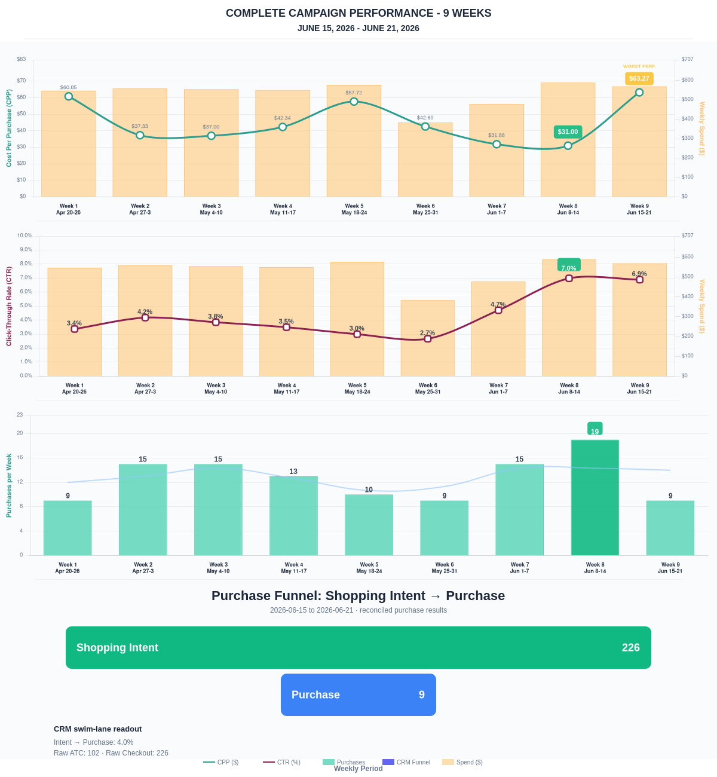

Questions? Let's chat about scaling these results.
Purchase Journey
Client-facing funnel based on shopping intent and reconciled purchase results.
Period | Shopping Intent | Purchase | Intent → Purchase | ATC → Purchase
This Week | 226 | 9 | 3.98% | 8.82%
Last 30 Days | 866 | 54 | 6.24% | 13.30%
Campaign to Date | 4333 | 548 | 12.65% | 12.65%
Use this as the client-facing purchase-intent funnel.
Sales Performance
Sales totals reconciled against WooCommerce paid kit orders.
Sales Check | Value
Reconciled purchases | 9
Reconciled revenue | $3,873.04
ROAS | 6.80x
Reconciled Ads Performance
Metric | Value
Meta spend | $569.47
Reconciled purchases | 9
Cost per purchase | $63.27
ROAS | 6.80x
Website Revenue Mix
GA4 view of revenue by website channel for context around Meta campaign performance.
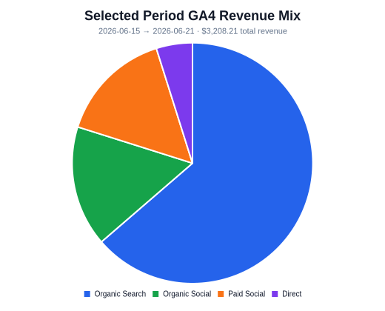 | 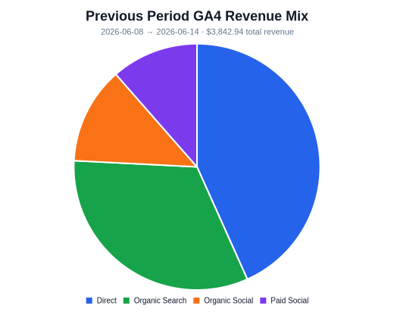 | 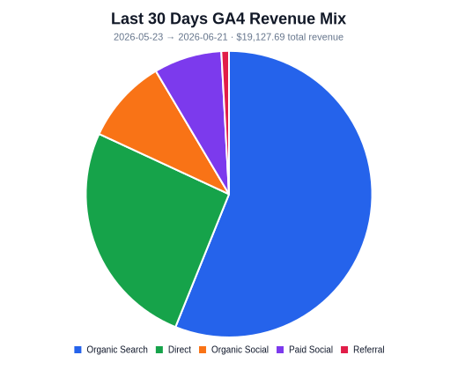
Organic Search revenue: $2,042.52 this period. GA4 Paid Social revenue: $489.95 this period.

