

Meta Ads Performance Audit
Client: Box Divvy
Campaign: Hubster Lead Gen – Melbourne
Period: 30 January 2026 – 5 February 2026

Executive Summary
The Box Divvy campaign is delivering strong performance with a blended CPL of $4.30 across 112 leads. Total ad spend for the period was $482.01 with an average CTR of 6.01%. The top performer achieved a CPL of $1.26 (Jan-17-26 - Copy 3). High CTR indicates strong creative-audience fit.

Key Metrics
Period | Spend | Leads | CPL | CTR
This Week | $482.01 | 112 | $4.30 | 6.01%
This Month | $1,713.69 | 345 | $4.97 | 6.69%
Since Starting | $1,713.69 | 345 | $4.97 | 6.69%

Latest Batch — Top Performers
# | Release Lot | CPL | Leads | CTR | Ad ID | Preview
🔥 | Jan-17 | $4.54 | 82 | 5.97% | ...681010360 | 
2 | Jan-17 | $5.84 | 1 | 3.41% | ...696440360 | 
⭐ | Jan-17 | $6.87 | 2 | 4.21% | ...673170360 | 

Top 5 Performers by CPL — All Time
# | Release Lot | CPL | Leads | CTR | Ad ID | Preview
🔥 | Jan-17 | $1.26 | 1 | 6.67% | ...696440360
2 | Dec-15 | $1.92 | 8 | 7.15% | ...900370360 | 
⭐ | Dec-15 | $2.37 | 3 | 6.81% | ...968670360 | 
4 | Dec-15 | $3.00 | 4 | 7.78% | ...906450360 | 
5 | Dec-15 | $3.85 | 8 | 6.88% | ...702980360 | 
🔥 = Top performer | ⭐ = Volume star | Sorted by CPL (lowest first)

Release Lot Performance
• Jan-17 Release: 1 leads from 1 ad(s) – Best CPL: $1.26
• Dec-15 Release: 23 leads from 4 ad(s) – Best CPL: $1.92

Creative Insights
Top Performer:
Jan-17-26 - Copy 3 – 1 leads at $1.26 CPL, 6.67% CTR
Runner Up:
Dec-15-Dec-22-25 – 8 leads at $1.92 CPL, 7.15% CTR

Demographic Sweet Spot
• Female 35-44: 30 leads, $4.70 CPL, 5.35% CTR
• Female 45-54: 30 leads, $3.76 CPL, 7.76% CTR
• Female 25-34: 17 leads, $3.96 CPL, 3.33% CTR

Key Insights
What's Working:
✓ High CTR of 6.01% indicates strong creative-audience fit
✓ CPL of $4.30 is well below typical lead gen benchmarks
✓ Top performer achieving $1.26 CPL – exceptional efficiency
✓ Strong volume with 112 leads delivered in period

Opportunities:
→ Scale top-performing creatives while momentum is strong
→ Test new creative variations based on top performer themes
→ Consider budget reallocation toward best-performing ads

Recommended Next Steps
▸ Monitor top performers closely over the next reporting period
▸ Continue A/B testing creative hooks and formats
▸ Analyze landing page conversion rates to optimize full funnel
▸ Scale winning combinations and pause underperformers

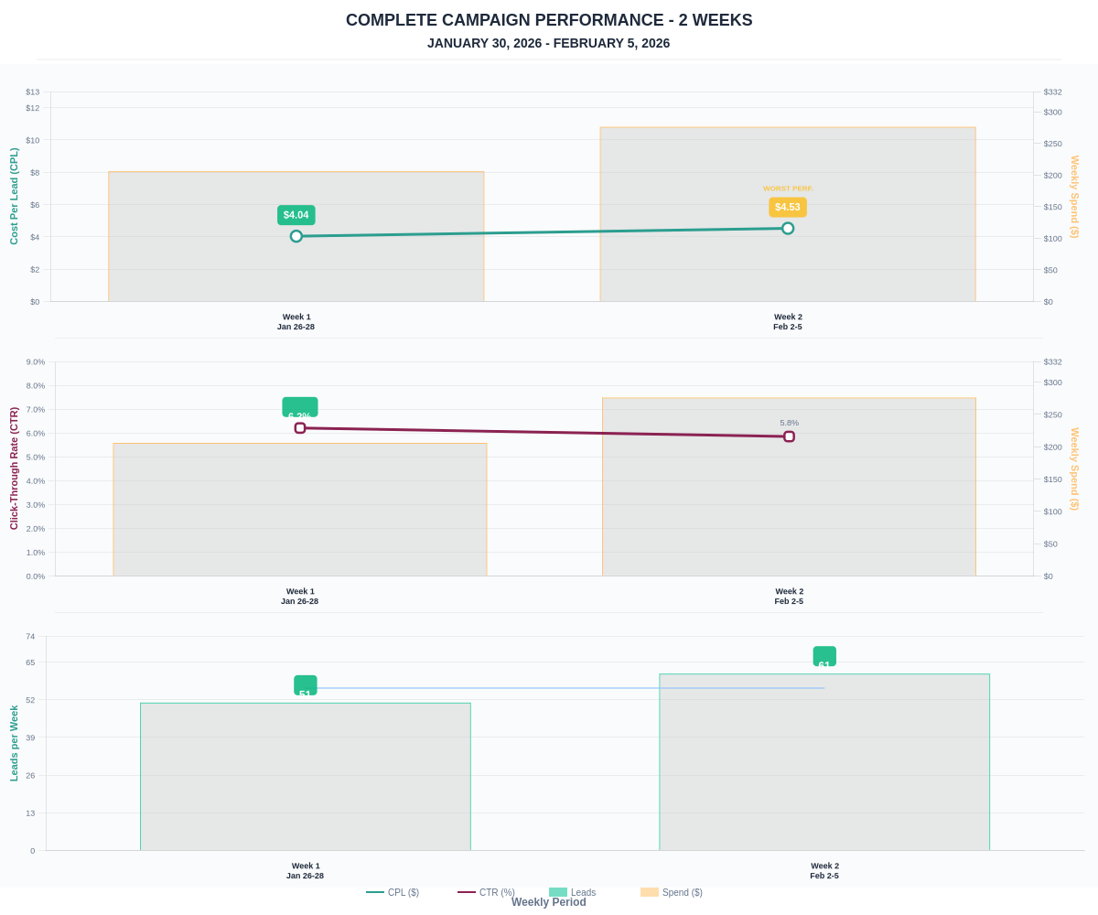

Questions? Let's chat about scaling these results.

