

Meta Ads Performance Audit
Client: Box Divvy
Campaign: Hubster Lead Gen
Period: 2 February 2026 – 8 February 2026

Executive Summary
The Box Divvy campaign is delivering strong performance with a blended CPL of $4.94 across 98 leads. Total ad spend for the period was $484.28 with an average CTR of 6.07%. The top performer achieved a CPL of $3.05 (Dec-15-Dec-22-25). High CTR indicates strong creative-audience fit.

Key Metrics
Period | Spend | Leads | CPL | CTR
This Week | $484.28 | 98 | $4.94 | 6.07%
This Month | $1,921.88 | 382 | $5.03 | 6.64%
Since Starting | $1,921.88 | 382 | $5.03 | 6.64%

Latest Batch — Top Performers
# | Release Lot | CPL | Leads | CTR | Ad ID | Preview
🔥 | Jan-17 | $0.00 | 0 | 4.22% | ...694070360 | 
2 | Jan-17 | $0.00 | 0 | 3.33% | ...676110360 | 
⭐ | Jan-17 | $0.00 | 0 | 0.00% | ...688250360 | 
4 | Jan-17 | $0.00 | 0 | 0.00% | ...669870360 | 
5 | Jan-17 | $0.00 | 0 | 0.00% | ...691160360 | 

Top 5 Performers by CPL — All Time
# | Release Lot | CPL | Leads | CTR | Ad ID | Preview
🔥 | Dec-15 | $3.05 | 11 | 8.55% | ...702980360 | 
2 | Dec-15 | $3.27 | 5 | 6.33% | ...900370360 | 
⭐ | Dec-15 | $3.40 | 3 | 4.12% | ...906450360 | 
4 | Jan-17 | $3.80 | 9 | 6.43% | ...743430360 | 
5 | Dec-15 | $4.02 | 2 | 7.33% | ...985710360 | 
🔥 = Top performer | ⭐ = Volume star | Sorted by cost per conversion (lowest first)

Release Lot Performance
• Dec-15 Release: 21 conversions from 4 ad(s) – Best cost: $3.05
• Jan-17 Release: 9 conversions from 1 ad(s) – Best cost: $3.80

Creative Insights
Top Performer:
Dec-15-Dec-22-25 – 11 conversions at $3.05 cost, 8.55% CTR
Runner Up:
Dec-15-Dec-22-25 – 5 conversions at $3.27 cost, 6.33% CTR

Demographic Sweet Spot
• Female 45-54: 30 leads, $4.11 CPL, 7.69% CTR
• Female 35-44: 19 leads, $6.86 CPL, 4.82% CTR
• Female 55-64: 16 leads, $4.53 CPL, 8.64% CTR

Key Insights
What's Working:
✓ Strong overall CTR of 6.07% indicates compelling ad creative and targeting alignment
✓ Efficient cost per lead at $4.94, well below industry benchmarks for lead generation
✓ Top performing ad set achieving exceptional CTR of 8.55% with lowest CPL of $3.05

Opportunities:
→ Significant performance variance between top and bottom performing ad sets suggests room for optimisation
→ Large impression to click ratio indicates potential to improve ad relevancy for certain audience segments
→ Scale potential exists with current efficient CPL, suggesting room to increase daily budget

Recommended Next Steps
▸ Analyse top-performing ad set creative elements and replicate successful components in new variations
▸ Reallocate budget from lower-performing ad sets to the best performer ($3.05 CPL) to maximise efficiency
▸ Create lookalike audiences based on leads from the highest CTR ad set to expand reach while maintaining quality

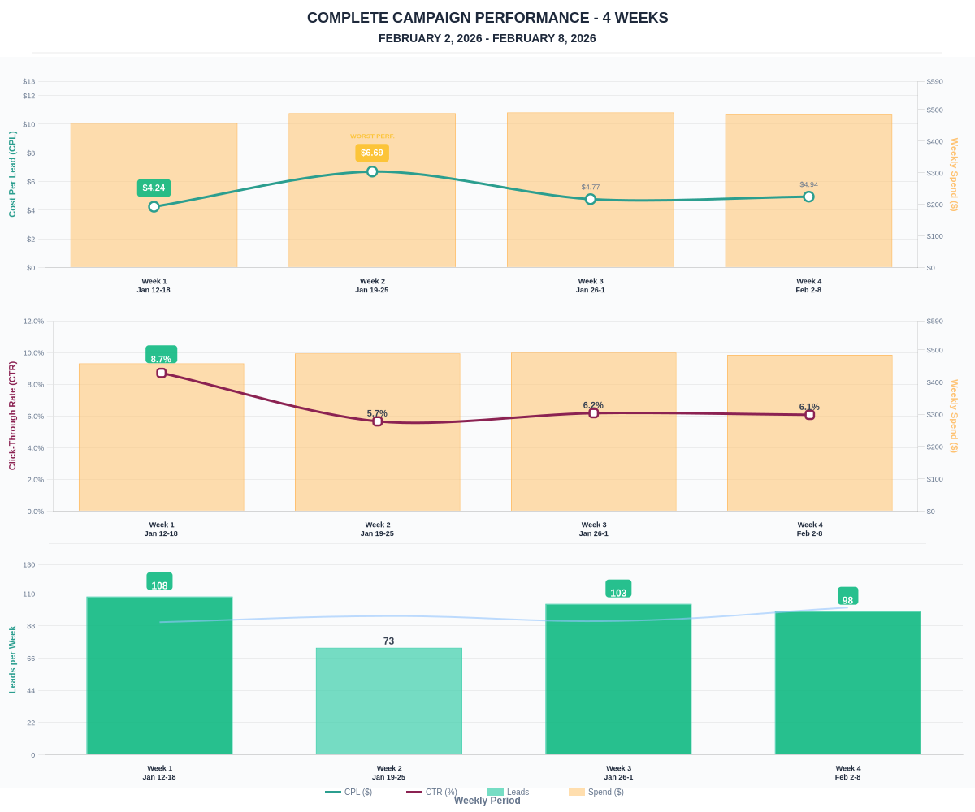

Questions? Let's chat about scaling these results.

