

Meta Ads Performance Audit
Client: Box Divvy
Campaign: Hubster Lead Gen
Period: 7 February 2026 – 13 February 2026

Executive Summary
The Box Divvy campaign is delivering strong performance with a blended CPL of $7.03 across 69 leads. Total ad spend for the period was $485.33 with an average CTR of 8.16%. The top performer achieved a CPL of $4.10 (Jan-17-26 - Copy). High CTR indicates strong creative-audience fit.

Key Metrics
Period | Spend | Leads | CPL | CTR
This Week | $485.33 | 69 | $7.03 | 8.16%
This Month | $2,076.97 | 380 | $5.47 | 6.86%
Since Starting | $2,266.24 | 428 | $5.29 | 7.04%

Latest Batch — Top Performers
# | Release Lot | CPL | Leads | CTR | Ad ID | Preview
🔥 | Jan-17 | $0.00 | 0 | 4.22% | ...694070360 | 
2 | Jan-17 | $0.00 | 0 | 3.33% | ...676110360 | 
⭐ | Jan-17 | $0.00 | 0 | 0.00% | ...688250360
4 | Jan-17 | $0.00 | 0 | 0.00% | ...669870360
5 | Jan-17 | $0.00 | 0 | 0.00% | ...691160360 | 

Top 5 Performers by CPL — All Time
# | Release Lot | CPL | Leads | CTR | Ad ID | Preview
🔥 | Jan-17 | $4.10 | 1 | 7.69% | ...743430360
2 | Dec-15 | $4.25 | 3 | 9.47% | ...702980360
⭐ | Dec-15 | $4.26 | 1 | 10.08% | ...900370360
4 | Jan-17 | $5.53 | 4 | 4.31% | ...681010360
🔥 = Top performer | ⭐ = Volume star | Sorted by cost per conversion (lowest first)

Release Lot Performance
• Jan-17 Release: 5 conversions from 2 ad(s) – Best cost: $4.10
• Dec-15 Release: 4 conversions from 2 ad(s) – Best cost: $4.25

Creative Insights
Top Performer:
Jan-17-26 - Copy – 1 conversions at $4.10 cost, 7.69% CTR
Runner Up:
Dec-15-Dec-22-25 – 3 conversions at $4.25 cost, 9.47% CTR

Demographic Sweet Spot
• Data pending: Demographic breakdown requires more data volume

Key Insights
What's Working:
✓ Strong overall CTR of 8.16% indicates compelling ad creative and targeting resonating with audience
✓ Cost per lead at $7.03 is performing efficiently for the Australian market, showing good campaign optimisation
✓ Top performing ads consistently achieving CTRs above 7.5%, demonstrating effective copywriting patterns

Opportunities:
→ Significant variance in lead costs between top performers ($4.10) and campaign average ($7.03) suggests room for budget optimisation
→ High click volume (1947) relative to leads (69) indicates potential landing page conversion improvements needed
→ Concentrated success in specific date ranges suggests opportunity to identify and replicate winning temporal factors

Recommended Next Steps
▸ Analyse top-performing ad copy elements and create 3-4 new variations incorporating successful patterns
▸ Conduct landing page A/B test focusing on form simplification and trust signals to improve lead conversion rate
▸ Reallocate budget towards top-performing time windows and gradually scale successful ad sets by 20-30%

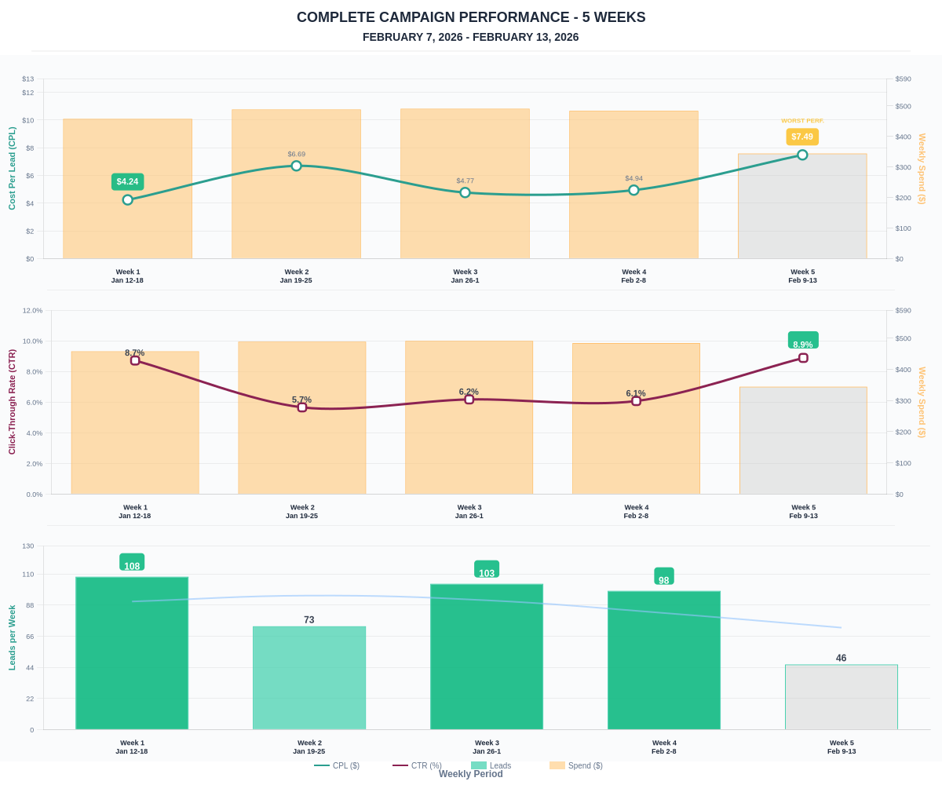

Questions? Let's chat about scaling these results.

