

Meta Ads Performance Audit
Client: Box Divvy
Campaign: Hubster Lead Gen
Period: 8 February 2026 – 14 February 2026

Executive Summary
The Box Divvy campaign is delivering strong performance with a blended CPL of $7.52 across 65 leads. Total ad spend for the period was $489.11 with an average CTR of 8.50%. The top performer achieved a CPL of $4.24 (Jan-17-26 - Copy 2). High CTR indicates strong creative-audience fit.

Key Metrics
Period | Spend | Leads | CPL | CTR
This Week | $489.11 | 65 | $7.52 | 8.50%
This Month | $2,082.12 | 369 | $5.64 | 6.85%
Since Starting | $2,334.00 | 434 | $5.38 | 7.06%

Latest Batch — Top Performers
# | Release Lot | CPL | Leads | CTR | Ad ID | Preview
🔥 | Jan-17 | $0.00 | 0 | 4.22% | ...694070360 | 
2 | Jan-17 | $0.00 | 0 | 3.33% | ...676110360 | 
⭐ | Jan-17 | $0.00 | 0 | 0.00% | ...688250360 | 
4 | Jan-17 | $0.00 | 0 | 0.00% | ...669870360 | 
5 | Jan-17 | $0.00 | 0 | 0.00% | ...691160360 | 

Top 5 Performers by CPL — All Time
# | Release Lot | CPL | Leads | CTR | Ad ID | Preview
🔥 | Jan-17 | $4.24 | 3 | 5.45% | ...681010360
2 | Dec-15 | $6.95 | 1 | 6.38% | ...702980360 | 
⭐ | DEC-15 | $10.57 | 1 | 4.13% | ...707200360
🔥 = Top performer | ⭐ = Volume star | Sorted by cost per conversion (lowest first)

Release Lot Performance
• Jan-17 Release: 3 conversions from 1 ad(s) – Best cost: $4.24
• Dec-15 Release: 1 conversions from 1 ad(s) – Best cost: $6.95
• DEC-15 Release: 1 conversions from 1 ad(s) – Best cost: $10.57

Creative Insights
Top Performer:
Jan-17-26 - Copy 2 – 3 conversions at $4.24 cost, 5.45% CTR
Runner Up:
Dec-15-Dec-22-25 – 1 conversions at $6.95 cost, 6.38% CTR

Demographic Sweet Spot
• Data pending: Demographic breakdown requires more data volume

Key Insights
What's Working:
✓ Strong overall CTR of 8.50% indicates compelling ad creative and targeting relevance
✓ Efficient cost per lead at $7.52 demonstrates good campaign optimisation
✓ Copy 2 variant showing excellent performance with lowest CPL of $4.24 and healthy 5.45% CTR
✓ High click volume (2,015) suggests strong audience engagement with the campaign

Opportunities:
→ Significant performance variance between top ad variants indicates room for creative optimisation
→ Higher CPL in some variants ($10.57) suggests potential targeting or messaging improvements needed
→ Lead volume distribution across variants shows potential for scaling top performers
→ CTR variation between 4.13% and 6.38% indicates opportunity to improve ad relevance

Recommended Next Steps
▸ Scale budget allocation towards Copy 2 variant while maintaining efficiency metrics
▸ Create new ad variations based on Copy 2's messaging approach and test against current top performer
▸ Analyse audience segments of top-performing ads to identify common characteristics for targeting refinement
▸ Pause underperforming variants with CPL above $8.50 to optimise budget efficiency

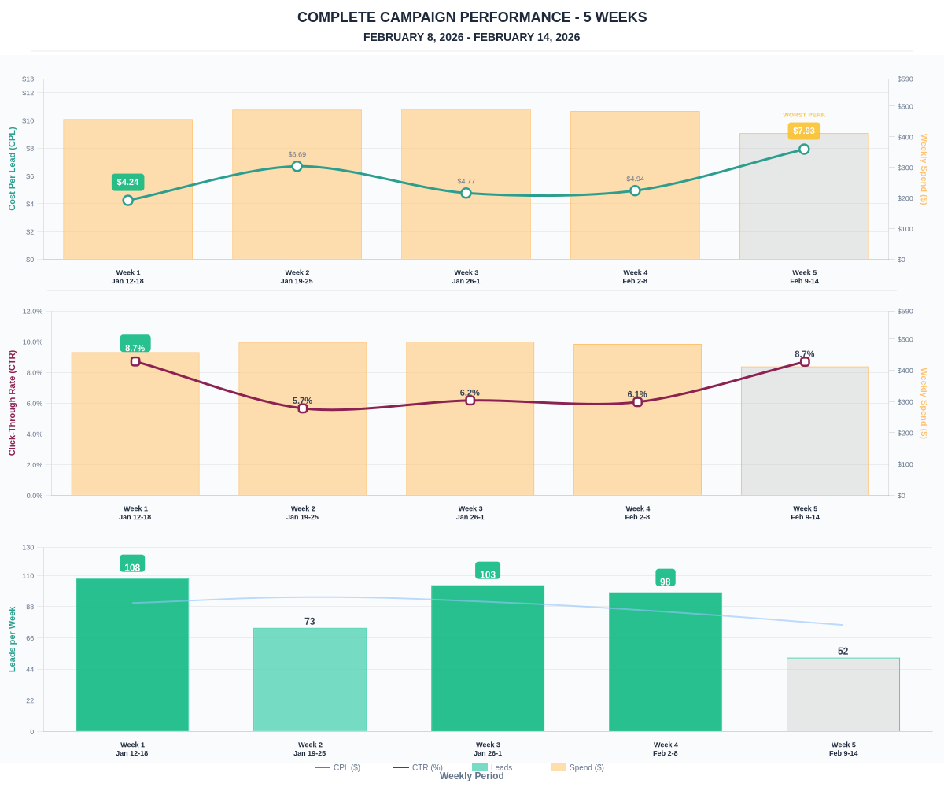

Questions? Let's chat about scaling these results.

