

Meta Ads Performance Audit
Client: Box Divvy
Campaign: Hubster Lead Gen
Period: 9 February 2026 – 15 February 2026

Executive Summary
The Box Divvy campaign is delivering strong performance with a blended CPL of $8.82 across 55 leads. Total ad spend for the period was $485.28 with an average CTR of 8.47%. The top performer achieved a CPL of $8.14 (DEC-15-2025 - copy_EF23460E-E3D8-4EDB-B5). High CTR indicates strong creative-audience fit.

Key Metrics
Period | Spend | Leads | CPL | CTR
This Week | $485.28 | 55 | $8.82 | 8.47%
This Month | $2,088.28 | 353 | $5.92 | 6.77%
Since Starting | $2,407.16 | 437 | $5.51 | 7.06%

Latest Batch — Top Performers
# | Release Lot | CPL | Leads | CTR | Ad ID | Preview
🔥 | Jan-17 | $4.62 | 92 | 5.89% | ...681010360 | 
2 | Jan-17 | $5.84 | 1 | 3.41% | ...696440360 | 
⭐ | Jan-17 | $7.26 | 2 | 4.38% | ...673170360 | 

Top 5 Performers by CPL — All Time
# | Release Lot | CPL | Leads | CTR | Ad ID | Preview
🔥 | DEC-15 | $8.14 | 1 | 3.93% | ...707200360 | 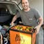
2 | DEC-22 | $8.40 | 41 | 9.59% | ...007560360 | 
🔥 = Top performer | ⭐ = Volume star | Sorted by cost per conversion (lowest first)

Release Lot Performance
• DEC-15 Release: 1 conversions from 1 ad(s) – Best cost: $8.14
• DEC-22 Release: 41 conversions from 1 ad(s) – Best cost: $8.40

Creative Insights
Top Performer:
DEC-15-2025 - copy_EF23460E-E3D8-4EDB-B5F6-59812B87B105 – 1 conversions at $8.14 cost, 3.93% CTR
Runner Up:
DEC-22-2025 - copy_9B8E5707-E50A-4DAD-94BB-138C32A34A9B – 41 conversions at $8.40 cost, 9.59% CTR

Demographic Sweet Spot
• Data pending: Demographic breakdown requires more data volume

Key Insights
What's Working:
✓ Strong overall CTR at 8.47%, well above the industry benchmark of 1-2% for lead generation campaigns
✓ Cost per lead of $8.82 is performing efficiently for the Australian market
✓ Ad copy variant DEC-22-2025 is delivering exceptional results with 41 leads and a high 9.59% CTR

Opportunities:
→ Significant performance gap between the two ad variants suggests room for copy optimisation
→ High number of clicks (1996) relative to leads (55) indicates potential landing page conversion improvements
→ First ad variant's lower CTR (3.93%) suggests potential targeting or creative refinement needs

Recommended Next Steps
▸ Analyse the successful elements of DEC-22-2025 variant and create 2-3 new variations incorporating these winning components
▸ Conduct a landing page audit to identify friction points and optimise the conversion path
▸ Reallocate budget to favour the better-performing ad variant while testing new iterations

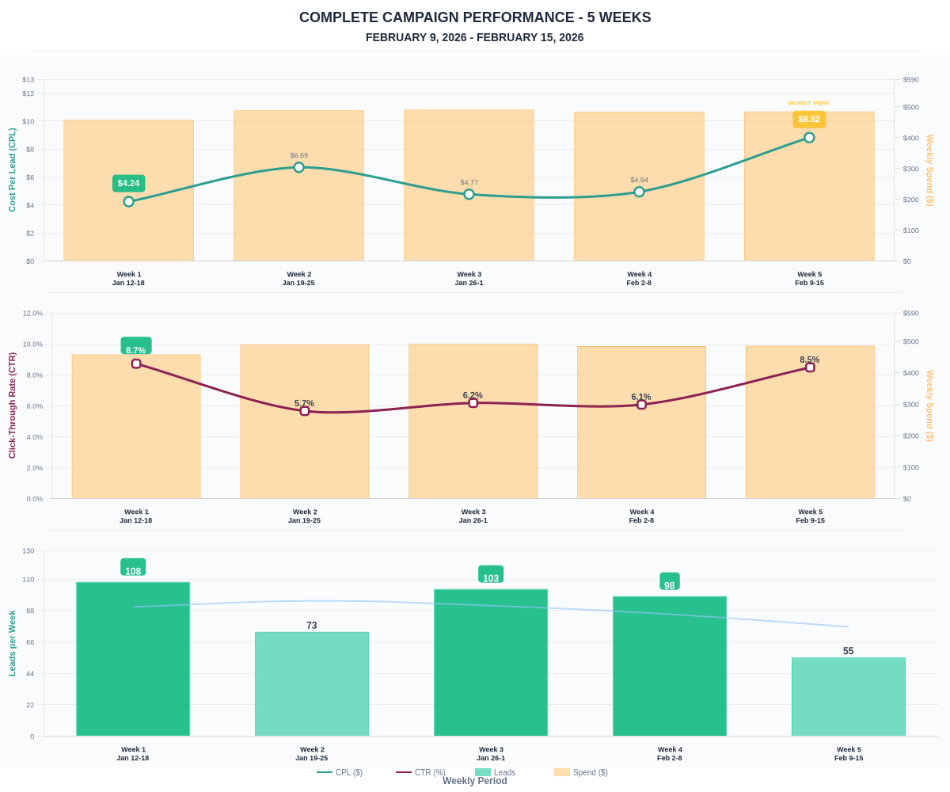

Questions? Let's chat about scaling these results.

