

Meta Ads Performance Audit
Client: Box Divvy
Campaign: Hubster Lead Gen
Period: 10 February 2026 – 16 February 2026

Executive Summary
The Box Divvy campaign is delivering strong performance with a blended CPL of $9.76 across 50 leads. Total ad spend for the period was $487.83 with an average CTR of 8.64%. The top performer achieved a CPL of $0.44 (DEC-15-2025 - copy_5D6B44AE-B8A8-42E9-A2). High CTR indicates strong creative-audience fit.

Key Metrics
Period | Spend | Leads | CPL | CTR
This Week | $487.83 | 50 | $9.76 | 8.64%
This Month | $2,098.20 | 346 | $6.06 | 6.80%
Since Starting | $2,477.93 | 444 | $5.58 | 7.13%

Latest Batch — Top Performers
# | Release Lot | CPL | Leads | CTR | Ad ID | Preview
🔥 | Jan-17 | $4.62 | 92 | 5.89% | ...681010360 | 
2 | Jan-17 | $5.84 | 1 | 3.41% | ...696440360 | 
⭐ | Jan-17 | $7.26 | 2 | 4.38% | ...673170360 | 

Top 5 Performers by CPL — All Time
# | Release Lot | CPL | Leads | CTR | Ad ID | Preview
🔥 | DEC-15 | $0.44 | 1 | 4.17% | ...628290360 | 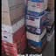
2 | DEC-22 | $9.98 | 33 | 9.89% | ...007560360 | 
⭐ | DEC-29 | $11.27 | 4 | 5.82% | ...153730360 | 
🔥 = Top performer | ⭐ = Volume star | Sorted by cost per conversion (lowest first)

Release Lot Performance
• DEC-15 Release: 1 conversions from 1 ad(s) – Best cost: $0.44
• DEC-22 Release: 33 conversions from 1 ad(s) – Best cost: $9.98
• DEC-29 Release: 4 conversions from 1 ad(s) – Best cost: $11.27

Creative Insights
Top Performer:
DEC-15-2025 - copy_5D6B44AE-B8A8-42E9-A2C5-79D5CB558FD4 – 1 conversions at $0.44 cost, 4.17% CTR
Runner Up:
DEC-22-2025 - copy_9B8E5707-E50A-4DAD-94BB-138C32A34A9B – 33 conversions at $9.98 cost, 9.89% CTR

Demographic Sweet Spot
• Data pending: Demographic breakdown requires more data volume

Key Insights
What's Working:
✓ Strong overall CTR of 8.64% indicates compelling ad creative and targeting resonating with audience
✓ Ad set 'DEC-22-2025' is delivering exceptional performance with 33 leads at efficient CPL and high CTR of 9.89%
✓ Cost per lead of $9.76 is maintaining good efficiency for lead generation in the Australian market
✓ High click volume (1,964) suggests strong audience engagement and effective ad placements

Opportunities:
→ Significant performance variance between ad sets indicates room for budget optimisation
→ Lower performing ad sets (DEC-29-2025) showing higher CPL could be refined for better efficiency
→ Scale potential exists with the successful DEC-22-2025 ad set given its strong metrics
→ Impression to click ratio suggests potential to expand reach while maintaining quality

Recommended Next Steps
▸ Reallocate budget towards the top-performing DEC-22-2025 ad set while maintaining CPL efficiency
▸ Analyse creative elements from the successful $0.44 CPL ad to replicate across other ad sets
▸ Create new ad variations based on DEC-22-2025's winning formula to scale performance
▸ Conduct audience overlap analysis to ensure efficient budget distribution across ad sets

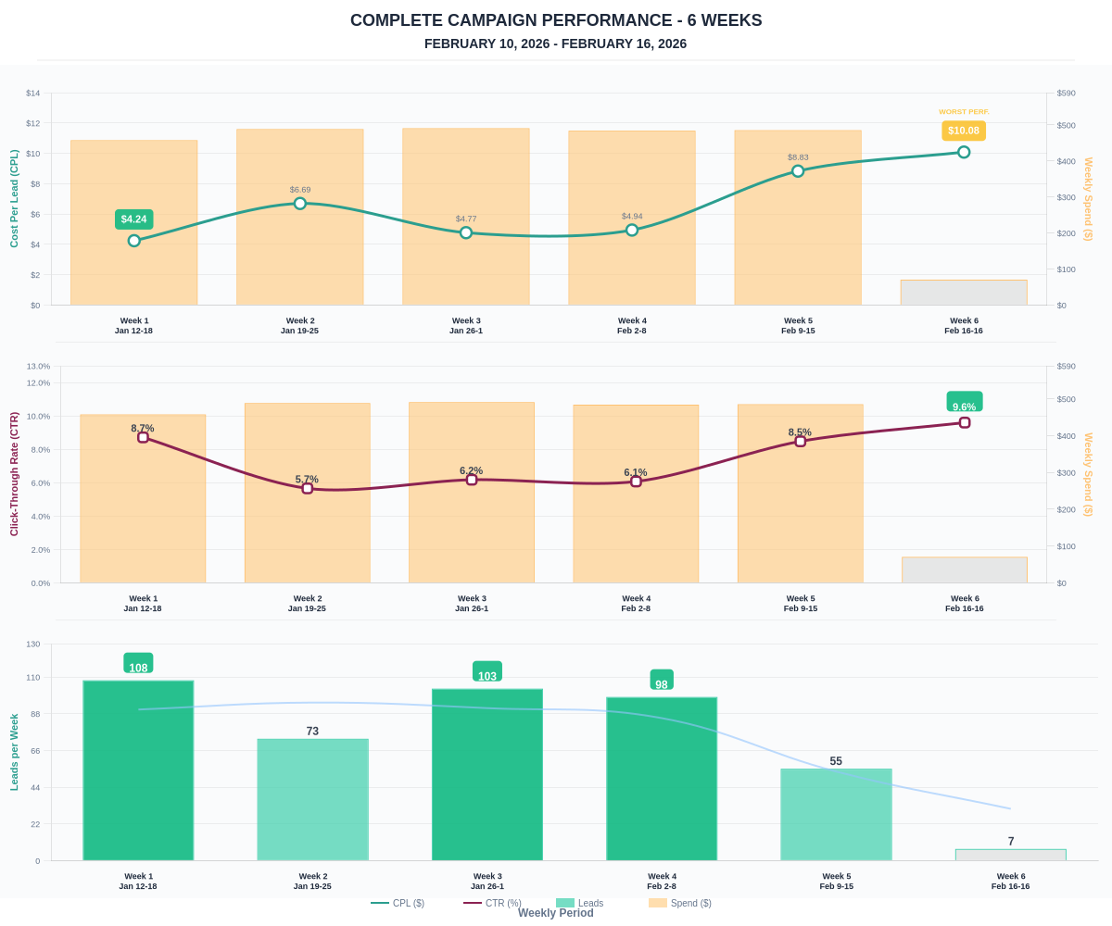

Questions? Let's chat about scaling these results.

