

Meta Ads Performance Audit
Client: Box Divvy
Campaign: Hubster Lead Gen
Period: 12 February 2026 – 18 February 2026

Executive Summary
The Box Divvy campaign is delivering solid results with a blended CPL of $12.22 across 40 leads. Total ad spend for the period was $488.89 with an average CTR of 8.06%. The top performer achieved a CPL of $1.69 (DEC-15-2025 - copy_5D6B44AE-B8A8-42E9-A2). High CTR indicates strong creative-audience fit.

Key Metrics
Period | Spend | Leads | CPL | CTR
This Week | $488.89 | 40 | $12.22 | 8.06%
This Month | $2,081.17 | 335 | $6.21 | 6.88%
Since Starting | $2,617.74 | 452 | $5.79 | 7.13%

Latest Batch — Top Performers
# | Release Lot | CPL | Leads | CTR | Ad ID | Preview
🔥 | Jan-17 | $4.62 | 92 | 5.89% | ...681010360 | 
2 | Jan-17 | $5.84 | 1 | 3.41% | ...696440360 | 
⭐ | Jan-17 | $7.26 | 2 | 4.38% | ...673170360 | 

Top 5 Performers by CPL — All Time
# | Release Lot | CPL | Leads | CTR | Ad ID | Preview
🔥 | DEC-15 | $1.69 | 2 | 2.76% | ...628290360 | 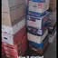
2 | DEC-22 | $2.36 | 1 | 9.86% | ...931880360 | 
⭐ | DEC-29 | $10.39 | 4 | 5.38% | ...153730360 | 
4 | DEC-22 | $13.26 | 20 | 9.88% | ...007560360 | 
🔥 = Top performer | ⭐ = Volume star | Sorted by cost per conversion (lowest first)

Release Lot Performance
• DEC-15 Release: 2 conversions from 1 ad(s) – Best cost: $1.69
• DEC-22 Release: 21 conversions from 2 ad(s) – Best cost: $2.36
• DEC-29 Release: 4 conversions from 1 ad(s) – Best cost: $10.39

Creative Insights
Top Performer:
DEC-15-2025 - copy_5D6B44AE-B8A8-42E9-A2C5-79D5CB558FD4 – 2 conversions at $1.69 cost, 2.76% CTR
Runner Up:
DEC-22-2025 - copy_6892C2FA-0426-41EB-BCF9-FF6E71EFBCE6 – 1 conversions at $2.36 cost, 9.86% CTR

Demographic Sweet Spot
• Data pending: Demographic breakdown requires more data volume

Key Insights
What's Working:
✓ Strong overall CTR of 8.06% indicates compelling ad creative and targeting resonating with audience
✓ Efficient lead generation with average cost per lead of $12.22, which is competitive for Australian market
✓ Top performing ad (DEC-15) achieved exceptional cost per lead of $1.69, demonstrating potential for highly efficient targeting
✓ High click volume (1,591) suggests strong audience engagement and campaign reach

Opportunities:
→ Wide variance in cost per lead ($1.69 to $10.39) indicates room for optimisation across ad sets
→ CTR variations between top performers (2.76% to 9.86%) suggest potential targeting improvements
→ Scale up budget allocation to best performing ad sets to maximise ROI
→ Analyse audience overlap between high and low performing ads to refine targeting

Recommended Next Steps
▸ Replicate successful elements from DEC-15 ad creative across other ad sets
▸ Increase budget allocation to top performing ad set by 25% to test scalability
▸ Create new ad variations using winning creative elements and CTR insights
▸ Conduct detailed audience analysis to identify most responsive demographics and interests

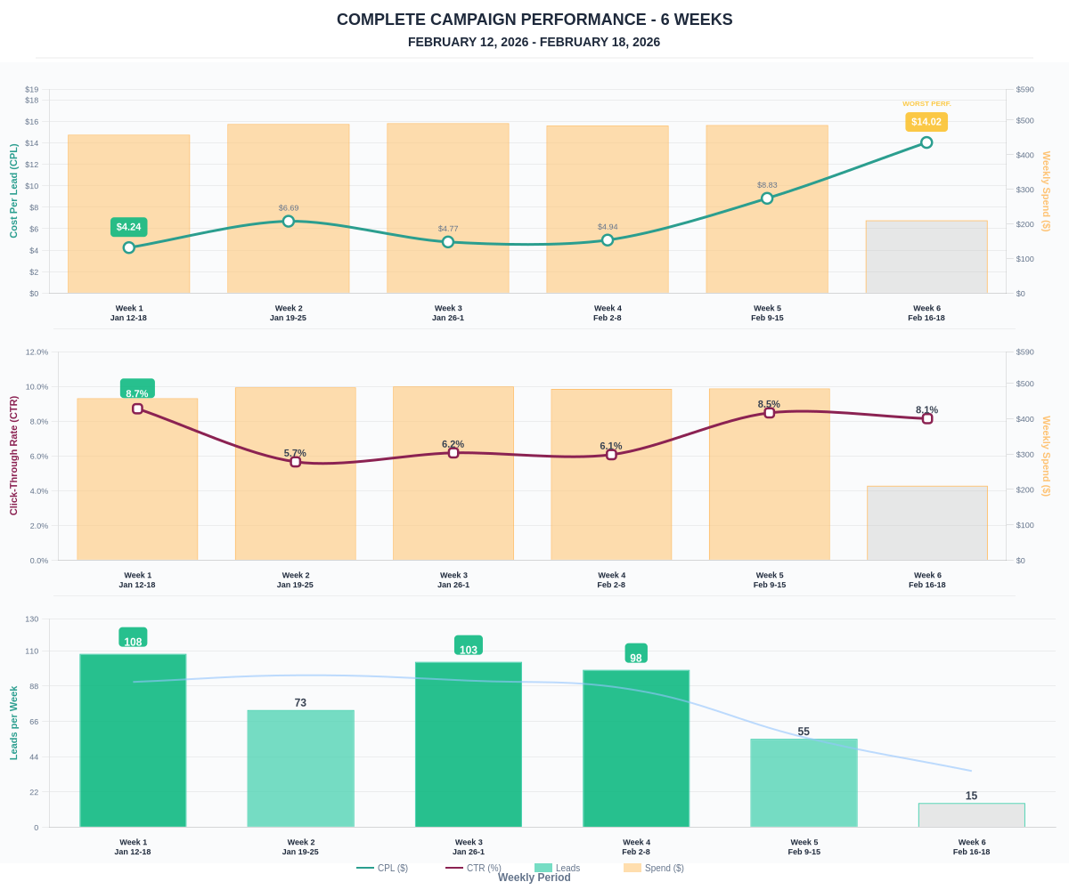

Questions? Let's chat about scaling these results.

