

Meta Ads Performance Audit
Client: Box Divvy
Campaign: Hubster Lead Gen
Period: 15 February 2026 – 21 February 2026

Executive Summary
The Box Divvy campaign is delivering solid results with a blended CPL of $12.56 across 39 leads. Total ad spend for the period was $489.87 with an average CTR of 7.76%. The top performer achieved a CPL of $1.93 (DEC-15-2025 - copy_5D6B44AE-B8A8-42E9-A2). High CTR indicates strong creative-audience fit.

Key Metrics
Period | Spend | Leads | CPL | CTR
This Week | $489.87 | 39 | $12.56 | 7.76%
This Month | $2,084.54 | 324 | $6.43 | 7.09%
Since Starting | $2,823.87 | 473 | $5.97 | 7.16%

Latest Batch — Top Performers
# | Release Lot | CPL | Leads | CTR | Ad ID | Preview
🔥 | Jan-17 | $4.62 | 92 | 5.89% | ...681010360 | 
2 | Jan-17 | $5.84 | 1 | 3.41% | ...696440360 | 
⭐ | Jan-17 | $7.26 | 2 | 4.38% | ...673170360 | 

Top 5 Performers by CPL — All Time
# | Release Lot | CPL | Leads | CTR | Ad ID | Preview
🔥 | DEC-15 | $1.93 | 2 | 2.52% | ...628290360 | 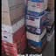
2 | DEC-22 | $3.57 | 1 | 7.92% | ...931880360 | 
⭐ | DEC-22 | $10.73 | 23 | 9.42% | ...007560360
🔥 = Top performer | ⭐ = Volume star | Sorted by cost per conversion (lowest first)

Release Lot Performance
• DEC-15 Release: 2 conversions from 1 ad(s) – Best cost: $1.93
• DEC-22 Release: 24 conversions from 2 ad(s) – Best cost: $3.57

Creative Insights
Top Performer:
DEC-15-2025 - copy_5D6B44AE-B8A8-42E9-A2C5-79D5CB558FD4 – 2 conversions at $1.93 cost, 2.52% CTR
Runner Up:
DEC-22-2025 - copy_6892C2FA-0426-41EB-BCF9-FF6E71EFBCE6 – 1 conversions at $3.57 cost, 7.92% CTR

Demographic Sweet Spot
• Data pending: Demographic breakdown requires more data volume

Key Insights
What's Working:
✓ Campaign is running with 39 conversions

Opportunities:
→ Continue optimising campaign performance

Recommended Next Steps
▸ Monitor performance and adjust as needed

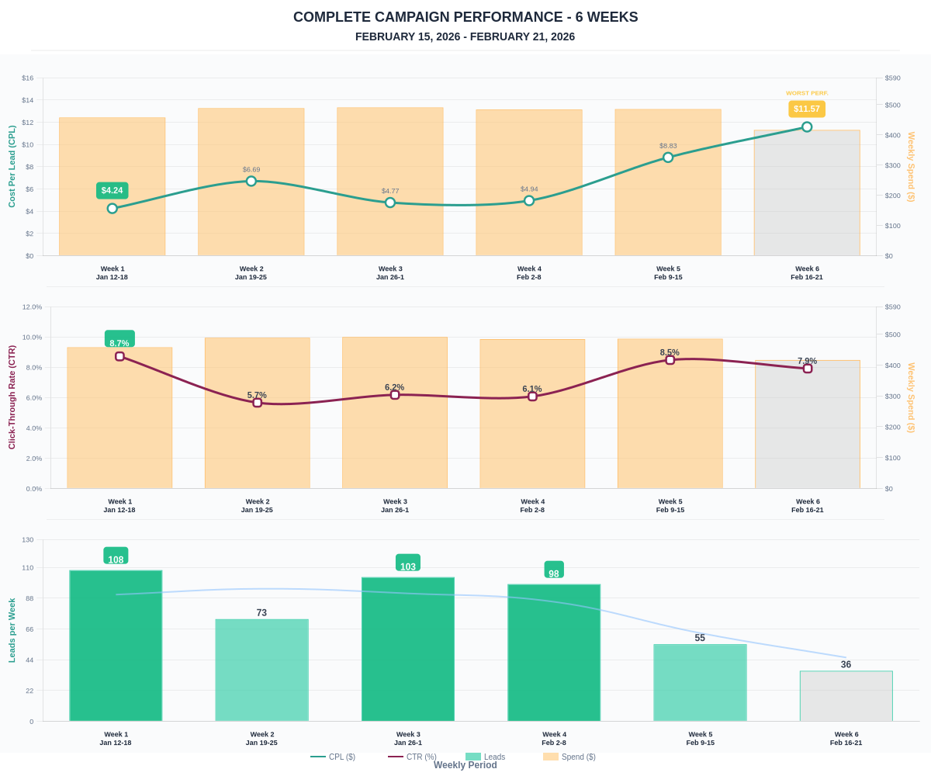

Questions? Let's chat about scaling these results.

