

Meta Ads Performance Audit
Client: Box Divvy
Campaign: Hubster Lead Gen
Period: 16 February 2026 – 22 February 2026

Executive Summary
The Box Divvy campaign is delivering solid results with a blended CPL of $11.05 across 45 leads. Total ad spend for the period was $497.26 with an average CTR of 7.72%. The top performer achieved a CPL of $2.13 (DEC-15-2025 - copy_5D6B44AE-B8A8-42E9-A2). High CTR indicates strong creative-audience fit.

Key Metrics
Period | Spend | Leads | CPL | CTR
This Week | $497.26 | 45 | $11.05 | 7.72%
This Month | $2,097.02 | 322 | $6.51 | 7.10%
Since Starting | $2,904.64 | 482 | $6.03 | 7.15%

Latest Batch — Top Performers
# | Release Lot | CPL | Leads | CTR | Ad ID | Preview
🔥 | Feb-18 | $21.31 | 1 | 5.85% | ...242060360 | 

Top 5 Performers by CPL — All Time
# | Release Lot | CPL | Leads | CTR | Ad ID | Preview
🔥 | Feb-6 | $2.13 | 3 | 3.73% | ...628290360 | 
2 | Feb-6 | $3.38 | 3 | 6.34% | ...917190360 | 
⭐ | Jan-29 | $4.03 | 11 | 6.22% | ...743430360 | 
4 | Jan-12 | $4.07 | 12 | 6.18% | ...985710360 | 
5 | Jan-12 | $4.37 | 104 | 8.66% | ...968670360 | 
🔥 = Top performer | ⭐ = Volume star | Sorted by cost per conversion (lowest first)

Release Lot Performance
• DEC-15 Release: 6 conversions from 2 ad(s) – Best cost: $2.13
• Jan-17 Release: 11 conversions from 1 ad(s) – Best cost: $4.03
• Dec-15 Release: 116 conversions from 2 ad(s) – Best cost: $4.07

Creative Insights
Top Performer:
DEC-15-2025 - copy_5D6B44AE-B8A8-42E9-A2C5-79D5CB558FD4 – 3 conversions at $2.13 cost, 3.73% CTR
Runner Up:
DEC-15-2025 - copy_A39C531E-49D2-4EB8-A792-6EFD81A734FB - Copy – 3 conversions at $3.38 cost, 6.34% CTR

Demographic Sweet Spot
• Female 35-44: 23 leads, $7.45 CPL, 7.82% CTR
• Female 45-54: 8 leads, $14.37 CPL, 9.18% CTR
• Female 25-34: 5 leads, $19.60 CPL, 5.38% CTR

Key Insights
What's Working:
✓ Strong overall CTR of 7.72% indicates compelling ad creative and targeting resonating with the audience
✓ Cost per lead at $11.05 is performing efficiently for the Australian market, showing good targeting optimisation
✓ Top performing ad 'Jan-17-26' generated 11 leads at an excellent CPL of $4.03, demonstrating strong creative execution

Opportunities:
→ Significant CPL variance between top performers ($2.13 vs $4.03) suggests room for budget reallocation
→ Scale potential exists with the strong CTR - could increase impression volume while maintaining efficiency
→ Performance disparity between similar ad copies indicates opportunity to standardise best practices across all creatives

Recommended Next Steps
▸ Analyse creative elements from the $2.13 CPL ad and apply these winning components to new variations
▸ Increase budget allocation to the top 3 performing ads while gradually reducing spend on lower performers
▸ Create 3-4 new ad variations incorporating the successful elements from 'Jan-17-26' creative to scale results

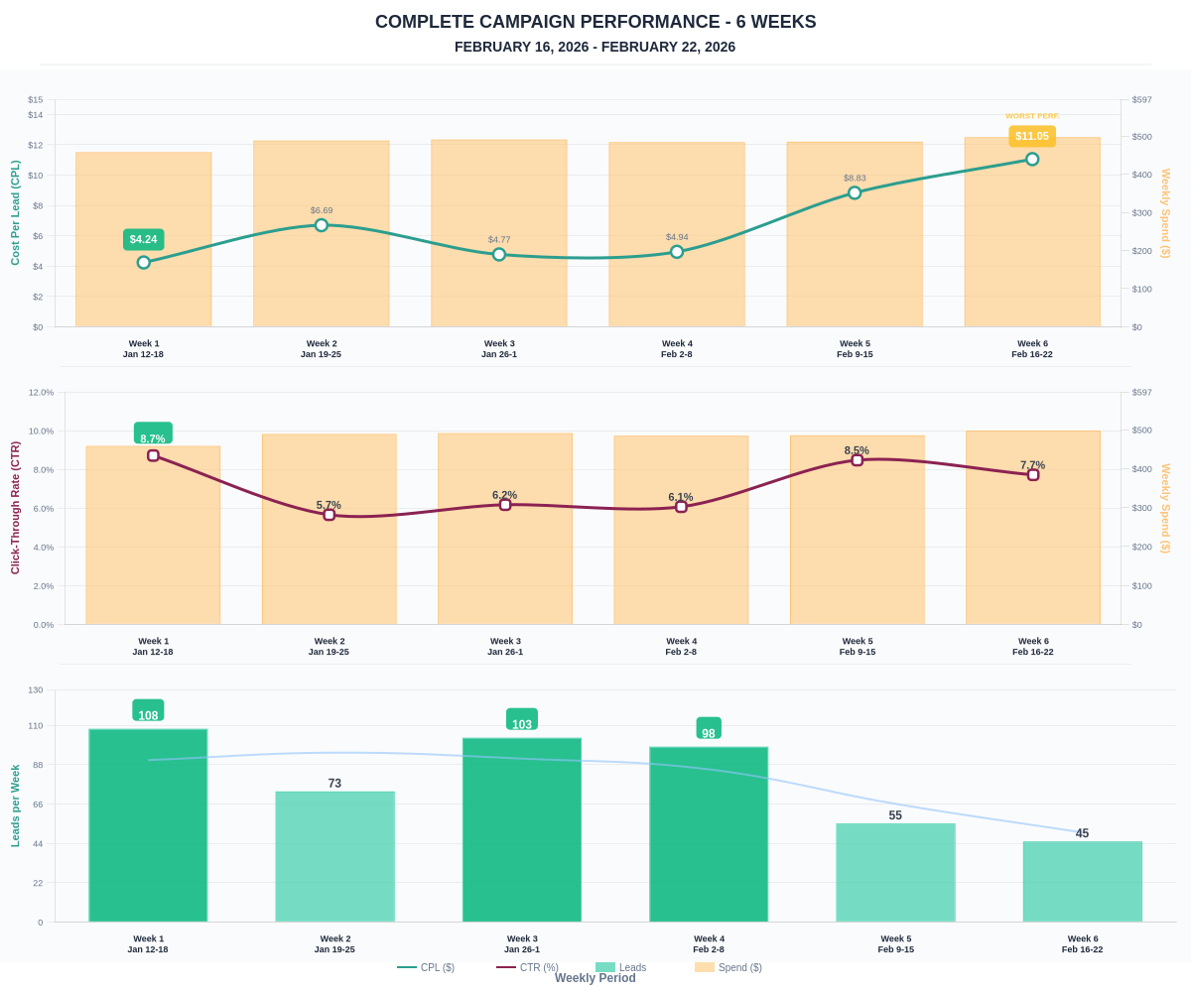

Questions? Let's chat about scaling these results.

