

Meta Ads Performance Audit
Client: Box Divvy
Campaign: Hubster Lead Gen
Period: 17 February 2026 – 23 February 2026

Executive Summary
The Box Divvy campaign is delivering solid results with a blended CPL of $12.53 across 40 leads. Total ad spend for the period was $501.13 with an average CTR of 6.99%. The top performer achieved a CPL of $3.14 (DEC-15-2025 - copy_5D6B44AE-B8A8-42E9-A2). High CTR indicates strong creative-audience fit.

Key Metrics
Period | Spend | Leads | CPL | CTR
This Week | $501.13 | 40 | $12.53 | 6.99%
This Month | $2,110.31 | 313 | $6.74 | 7.05%
Since Starting | $2,979.06 | 484 | $6.16 | 7.11%

Latest Batch — Top Performers
# | Release Lot | CPL | Leads | CTR | Ad ID | Preview
🔥 | Feb-18 | $21.52 | 1 | 5.81% | ...242060360 | 

Top 5 Performers by CPL — All Time
# | Release Lot | CPL | Leads | CTR | Ad ID | Preview
🔥 | Feb-6 | $3.14 | 3 | 4.47% | ...628290360 | 
2 | Feb-6 | $3.57 | 3 | 5.82% | ...917190360 | 
⭐ | Jan-29 | $4.03 | 11 | 6.22% | ...743430360
4 | Jan-12 | $4.07 | 12 | 6.18% | ...985710360
5 | Jan-12 | $4.37 | 104 | 8.66% | ...968670360 | 
🔥 = Top performer | ⭐ = Volume star | Sorted by cost per conversion (lowest first)

Release Lot Performance
• DEC-15 Release: 6 conversions from 2 ad(s) – Best cost: $3.14
• Jan-17 Release: 11 conversions from 1 ad(s) – Best cost: $4.03
• Dec-15 Release: 116 conversions from 2 ad(s) – Best cost: $4.07

Creative Insights
Top Performer:
DEC-15-2025 - copy_5D6B44AE-B8A8-42E9-A2C5-79D5CB558FD4 – 3 conversions at $3.14 cost, 4.47% CTR
Runner Up:
DEC-15-2025 - copy_A39C531E-49D2-4EB8-A792-6EFD81A734FB - Copy – 3 conversions at $3.57 cost, 5.82% CTR

Demographic Sweet Spot
• Female 35-44: 21 leads, $8.32 CPL, 7.15% CTR
• Female 45-54: 8 leads, $13.96 CPL, 8.19% CTR
• Female 25-34: 5 leads, $20.45 CPL, 5.19% CTR

Key Insights
What's Working:
✓ Strong overall CTR of 6.99% indicates compelling ad creative and targeting resonating with audience
✓ Top performing ad 'Jan-17-26' delivered 11 leads at efficient $4.03 CPL, suggesting effective messaging and placement
✓ Multiple ads achieving CPLs under $4 demonstrates good creative variation and optimisation
✓ High click volume (1,156) shows strong audience interest and engagement

Opportunities:
→ Significant CPL variance between top ($3.14) and average ($12.53) performers indicates room for budget optimisation
→ Some ads likely underperforming and consuming budget that could be reallocated to top performers
→ Could improve impression-to-lead conversion rate to lower overall campaign CPL
→ Potential to scale successful ad variations to reach larger audience

Recommended Next Steps
▸ Analyse common elements in top 3 performing ads and create new variations incorporating these winning features
▸ Reallocate budget from ads with CPL >$12.53 to top performing ads and new variations
▸ Create A/B tests using 'Jan-17-26' ad as control to optimise messaging further
▸ Review audience targeting settings from top performing ads to refine overall campaign targeting

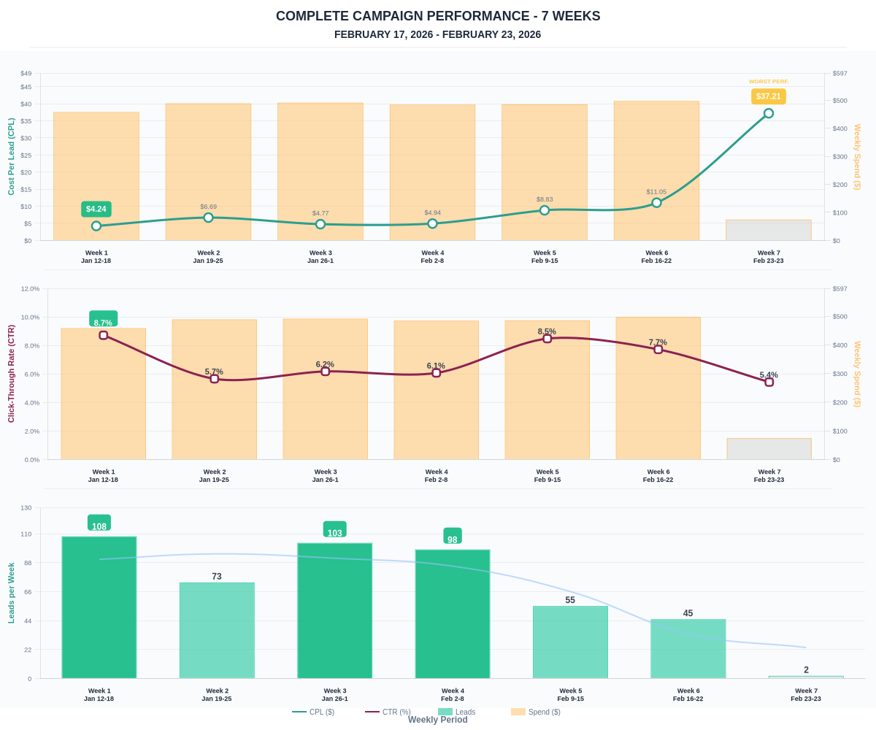

Questions? Let's chat about scaling these results.

