

Meta Ads Performance Audit
Client: Box Divvy
Campaign: Hubster Lead Gen
Period: 23 February 2026 – 1 March 2026

Executive Summary
The Box Divvy campaign is delivering solid results with a blended CPL of $11.93 across 41 leads. Total ad spend for the period was $489.04 with an average CTR of 5.74%. The top performer achieved a CPL of $3.38 (Jan-12-26 - copy_B3E46DC6-DC10-49E2-86EF). High CTR indicates strong creative-audience fit.

Key Metrics
Period | Spend | Leads | CPL | CTR
This Week | $489.04 | 41 | $11.93 | 5.74%
This Month | $2,099.75 | 276 | $7.61 | 6.99%
Since Starting | $3,393.68 | 523 | $6.49 | 6.96%

Latest Batch — Top Performers
# | Release Lot | CPL | Leads | CTR | Ad ID | Preview
🔥 | Feb-18 | $22.01 | 1 | 6.31% | ...242060360 | 

Top 5 Performers by CPL — All Time
# | Release Lot | CPL | Leads | CTR | Ad ID | Preview
🔥 | Feb-6 | $3.38 | 1 | 6.12% | ...917520360 | 
2 | Feb-6 | $3.85 | 3 | 5.81% | ...917190360 | 
⭐ | Jan-29 | $4.03 | 11 | 6.22% | ...743430360 | 
4 | Jan-12 | $4.07 | 12 | 6.18% | ...985710360 | 
5 | Jan-12 | $4.37 | 104 | 8.66% | ...968670360 | 
🔥 = Top performer | ⭐ = Volume star | Sorted by cost per conversion (lowest first)

Release Lot Performance
• Jan-12 Release: 1 conversions from 1 ad(s) – Best cost: $3.38
• DEC-15 Release: 3 conversions from 1 ad(s) – Best cost: $3.85
• Jan-17 Release: 11 conversions from 1 ad(s) – Best cost: $4.03
• Dec-15 Release: 116 conversions from 2 ad(s) – Best cost: $4.07

Creative Insights
Top Performer:
Jan-12-26 - copy_B3E46DC6-DC10-49E2-86EF-FCD787CF56D0 - Copy – 1 conversions at $3.38 cost, 6.12% CTR
Runner Up:
DEC-15-2025 - copy_A39C531E-49D2-4EB8-A792-6EFD81A734FB - Copy – 3 conversions at $3.85 cost, 5.81% CTR

Demographic Sweet Spot
• Female 35-44: 19 leads, $9.30 CPL, 5.40% CTR
• Female 25-34: 8 leads, $11.87 CPL, 4.78% CTR
• Female 45-54: 8 leads, $13.65 CPL, 6.82% CTR

Key Insights
What's Working:
✓ Strong overall CTR of 5.74% indicates compelling ad creative and targeting resonating with audience
✓ Top performing ad sets achieving CPL under $4, significantly below campaign average of $11.93
✓ Jan-17-26 copy variant showing excellent scalability with 11 leads while maintaining efficient CPL
✓ High click volume (1,086) suggesting strong initial audience interest and engagement

Opportunities:
→ Wide performance variance between top and bottom performing ad sets indicates optimisation potential
→ Campaign average CPL of $11.93 could be reduced by reallocating budget to top performers
→ Room to increase impression volume while maintaining strong CTR
→ Potential to test new creative variations based on successful Jan-17-26 copy elements

Recommended Next Steps
▸ Analyse creative elements from Jan-17-26 copy and create 3-4 new variations incorporating successful components
▸ Reallocate 60% of budget to top 3 performing ad sets to improve overall campaign efficiency
▸ Pause bottom performing ad sets with CPL >$15 to reduce wastage
▸ Increase daily budget by 20% for top performing ad set to test scalability while monitoring CPL

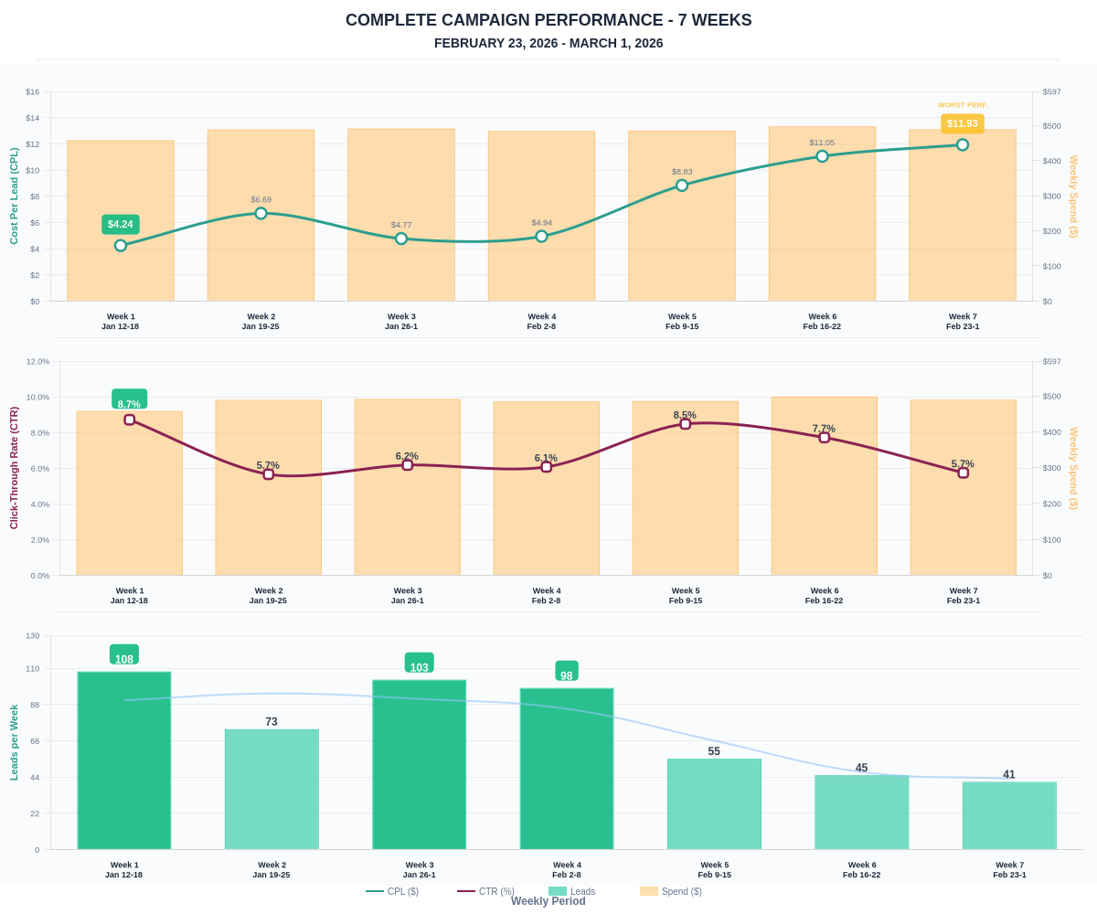

Questions? Let's chat about scaling these results.

