

Meta Ads Performance Audit
Client: Box Divvy
Campaign: Hubster Lead Gen
Period: 2 March 2026 – 8 March 2026

Executive Summary
The Box Divvy campaign is delivering results with a blended CPL of $30.33 across 16 leads. Total ad spend for the period was $485.25 with an average CTR of 5.36%. The top performer achieved a CPL of $0.29 (DEC-15-2025 - copy_08771CC1-D4C9-4210-BE). High CTR indicates strong creative-audience fit.

Key Metrics
Period | Spend | Leads | CPL | CTR
This Week | $485.25 | 16 | $30.33 | 5.36%
This Month | $2,098.02 | 180 | $11.66 | 6.87%
Since Starting | $3,878.93 | 539 | $7.20 | 6.78%

Latest Batch — Top Performers
# | Release Lot | CPL | Leads | CTR | Ad ID | Preview
🔥 | Mar-5 | $10.02 | 1 | 6.01% | ...609950360 | 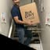
2 | Mar-5 | $43.23 | 1 | 5.61% | ...136080360 | 

Top 5 Performers by CPL — All Time
# | Release Lot | CPL | Leads | CTR | Ad ID | Preview
🔥 | Feb-6 | $0.29 | 1 | 4.76% | ...917610360 | 
2 | Feb-6 | $3.67 | 1 | 5.61% | ...917520360 | 
⭐ | Jan-29 | $4.03 | 11 | 6.22% | ...743430360 | 
4 | Jan-12 | $4.07 | 12 | 6.18% | ...985710360 | 
5 | Feb-6 | $4.08 | 1 | 3.23% | ...673730360 | 
🔥 = Top performer | ⭐ = Volume star | Sorted by cost per conversion (lowest first)

Release Lot Performance
• DEC-15 Release: 1 conversions from 1 ad(s) – Best cost: $0.29
• Jan-12 Release: 2 conversions from 2 ad(s) – Best cost: $3.67
• Jan-17 Release: 11 conversions from 1 ad(s) – Best cost: $4.03
• Dec-15 Release: 12 conversions from 1 ad(s) – Best cost: $4.07

Creative Insights
Top Performer:
DEC-15-2025 - copy_08771CC1-D4C9-4210-BE7C-B4582E8D0709 - Copy – 1 conversions at $0.29 cost, 4.76% CTR
Runner Up:
Jan-12-26 - copy_B3E46DC6-DC10-49E2-86EF-FCD787CF56D0 - Copy – 1 conversions at $3.67 cost, 5.61% CTR

Demographic Sweet Spot
• Female 35-44: 8 leads, $20.66 CPL, 5.02% CTR
• Female 25-34: 5 leads, $17.68 CPL, 4.35% CTR
• Female 45-54: 3 leads, $40.37 CPL, 5.50% CTR

Key Insights
What's Working:
✓ Strong overall CTR of 5.36% indicates compelling ad creative and targeting resonating with audience
✓ Jan-17-26 copy variant is performing exceptionally well with 11 leads and higher CTR of 6.22%
✓ Campaign is generating consistent leads with 16 conversions over 7 days at a sustainable CPL

Opportunities:
→ Wide variance in cost per lead ($0.29 to $4.03) suggests room for budget optimisation
→ Some ad variants are generating minimal leads despite decent CTR, indicating potential conversion path issues
→ Total impression count suggests potential to scale successful ad sets for broader reach

Recommended Next Steps
▸ Analyse Jan-17-26 copy elements and replicate successful messaging across new ad variants
▸ Reallocate budget from underperforming ads to the top-performing Jan-17 creative to maximise ROI
▸ Create A/B tests of landing pages using the best-performing ad copy to improve conversion rates
▸ Increase daily budget by 20% for the best-performing ad set to capture more leads at efficient CPL

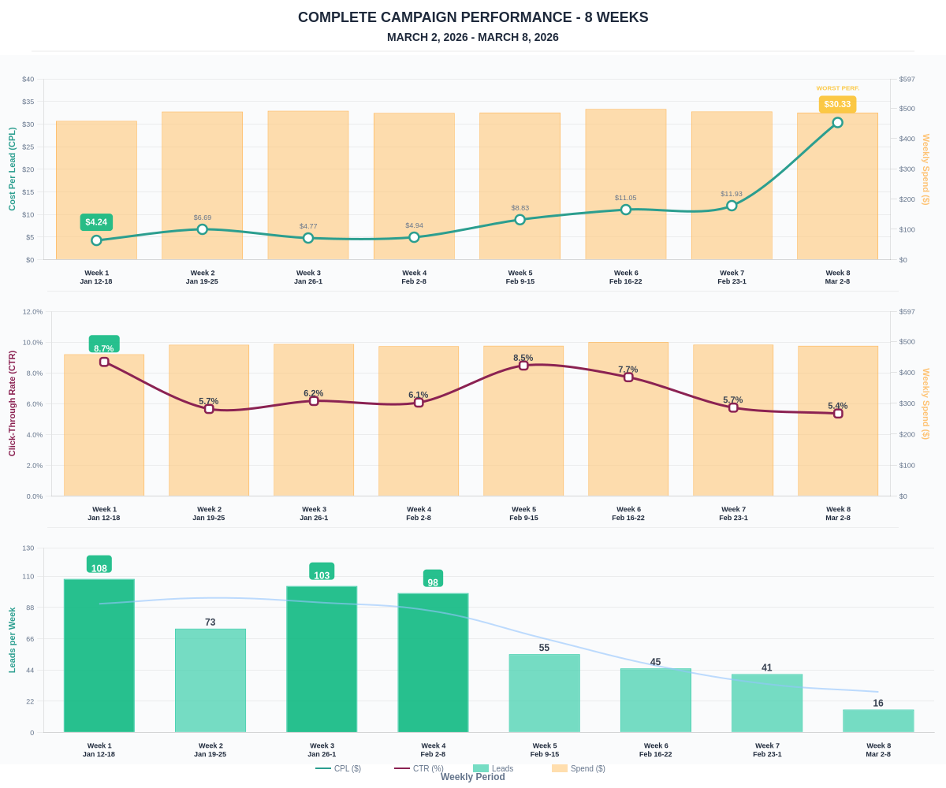

Questions? Let's chat about scaling these results.

