

Meta Ads Performance Audit
Client: Box Divvy
Campaign: Hubster Lead Gen
Period: 4 March 2026 – 10 March 2026

Executive Summary
The Box Divvy campaign is delivering results with a blended CPL of $35.21 across 14 leads. Total ad spend for the period was $492.93 with an average CTR of 5.37%. The top performer achieved a CPL of $0.45 (DEC-15-2025 - copy_08771CC1-D4C9-4210-BE). High CTR indicates strong creative-audience fit.

Key Metrics
Period | Spend | Leads | CPL | CTR
This Week | $492.93 | 14 | $35.21 | 5.37%
This Month | $2,102.60 | 164 | $12.82 | 6.78%
Since Starting | $4,024.48 | 546 | $7.37 | 6.71%

Latest Batch — Top Performers
# | Release Lot | CPL | Leads | CTR | Ad ID | Preview
🔥 | Mar-5 | $10.99 | 1 | 6.32% | ...609950360 | 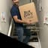
2 | Mar-5 | $20.20 | 1 | 5.41% | ...515360360 | 
⭐ | Mar-5 | $47.94 | 1 | 5.43% | ...136080360 | 

Top 5 Performers by CPL — All Time
# | Release Lot | CPL | Leads | CTR | Ad ID | Preview
🔥 | Feb-6 | $0.45 | 1 | 3.85% | ...917610360 | 
2 | Jan-29 | $4.03 | 11 | 6.22% | ...743430360 | 
⭐ | Jan-12 | $4.07 | 12 | 6.18% | ...985710360 | 
4 | Jan-12 | $4.37 | 104 | 8.66% | ...968670360 | 
5 | Feb-6 | $4.57 | 3 | 5.93% | ...917190360 | 
🔥 = Top performer | ⭐ = Volume star | Sorted by cost per conversion (lowest first)

Release Lot Performance
• DEC-15 Release: 4 conversions from 2 ad(s) – Best cost: $0.45
• Jan-17 Release: 11 conversions from 1 ad(s) – Best cost: $4.03
• Dec-15 Release: 116 conversions from 2 ad(s) – Best cost: $4.07

Creative Insights
Top Performer:
DEC-15-2025 - copy_08771CC1-D4C9-4210-BE7C-B4582E8D0709 - Copy – 1 conversions at $0.45 cost, 3.85% CTR
Runner Up:
Jan-17-26 - Copy – 11 conversions at $4.03 cost, 6.22% CTR

Demographic Sweet Spot
• Female 35-44: 5 leads, $32.05 CPL, 5.03% CTR
• Female 25-34: 3 leads, $29.67 CPL, 4.32% CTR
• Female 55-64: 3 leads, $18.39 CPL, 8.07% CTR

Key Insights
What's Working:
✓ Strong overall CTR of 5.37% indicates compelling ad creative and targeting resonating with audience
✓ Jan-17-26 copy variant delivering excellent lead volume (11) at efficient cost per lead ($4.03)
✓ Dec-15-Dec-22-25 campaign showing consistent performance with 12 leads at competitive $4.07 CPL
✓ High click volume (913) suggesting strong initial audience engagement

Opportunities:
→ Significant cost per lead variance between top performers ($0.45-$4.07) and overall average ($35.21) indicates room for optimisation
→ Large gap between clicks (913) and leads (14) suggests landing page conversion rate could be improved
→ Potential to scale successful ad copy variants to capture more volume at efficient costs

Recommended Next Steps
▸ Analyse landing page behaviour metrics and implement A/B tests to improve conversion rate
▸ Reallocate budget towards top-performing Jan-17-26 and Dec-15-Dec-22-25 campaigns while pausing underperforming variants
▸ Create new ad variants based on common elements from top-performing copy to maintain strong CTR while scaling

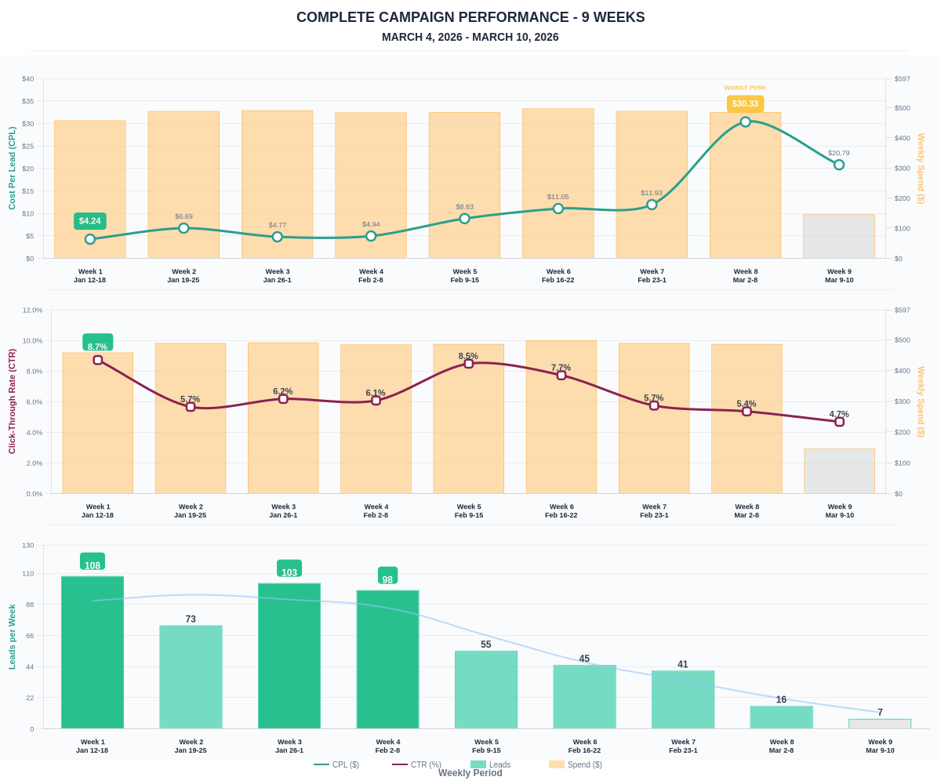

Questions? Let's chat about scaling these results.

