

Meta Ads Performance Audit
Client: Box Divvy
Campaign: Hubster Lead Gen
Period: 5 March 2026 – 11 March 2026

Executive Summary
The Box Divvy campaign is delivering results with a blended CPL of $24.50 across 20 leads. Total ad spend for the period was $489.91 with an average CTR of 5.20%. The top performer achieved a CPL of $0.45 (DEC-15-2025 - copy_08771CC1-D4C9-4210-BE). High CTR indicates strong creative-audience fit.

Key Metrics
Period | Spend | Leads | CPL | CTR
This Week | $489.91 | 20 | $24.50 | 5.20%
This Month | $2,100.84 | 159 | $13.21 | 6.68%
Since Starting | $4,090.94 | 553 | $7.40 | 6.70%

Latest Batch — Top Metrics
# | Release Lot | Spend | CPM | CTR | Ad ID | Preview

Top 5 Performers by CPL — All Time
# | Release Lot | CPL | Leads | CTR | Ad ID | Preview
🔥 | Feb-6 | $0.45 | 1 | 3.85% | ...917610360 | 
2 | Feb-6 | $1.47 | 1 | 5.19% | ...917220360
⭐ | Feb-6 | $2.93 | 1 | 3.43% | ...812870360
4 | Jan-29 | $4.03 | 11 | 6.22% | ...743430360
5 | Jan-12 | $4.07 | 12 | 6.18% | ...985710360
🔥 = Top performer | ⭐ = Volume star | Sorted by cost per conversion (lowest first)

Release Lot Performance
• DEC-15 Release: 2 conversions from 2 ad(s) – Best cost: $0.45
• DEC-22 Release: 1 conversions from 1 ad(s) – Best cost: $2.93
• Jan-17 Release: 11 conversions from 1 ad(s) – Best cost: $4.03
• Dec-15 Release: 12 conversions from 1 ad(s) – Best cost: $4.07

Creative Insights
Top Performer:
DEC-15-2025 - copy_08771CC1-D4C9-4210-BE7C-B4582E8D0709 - Copy – 1 conversions at $0.45 cost, 3.85% CTR
Runner Up:
DEC-15-2025 - copy_08771CC1-D4C9-4210-BE7C-B4582E8D0709 - Copy – 1 conversions at $1.47 cost, 5.19% CTR

Demographic Sweet Spot
• Female 35-44: 5 leads, $32.06 CPL, 4.81% CTR
• Female 25-34: 4 leads, $22.07 CPL, 4.29% CTR
• Female 55-64: 3 leads, $17.36 CPL, 7.32% CTR

Key Insights
What's Working:
✓ Strong overall CTR of 5.20% indicates compelling ad creative and targeting resonating with the audience
✓ Top performing ad variants achieving efficient cost per lead under $3, significantly below campaign average
✓ Healthy impression volume (16,643) suggesting good audience reach and campaign visibility
✓ Click volume of 865 demonstrates strong user interest and engagement with the ads

Opportunities:
→ High variance in cost per lead ($0.45 to $24.50) suggests room to optimise budget allocation
→ Limited number of high-performing ad variants indicates potential to expand successful creative approaches
→ Overall campaign cost per lead ($24.50) could be reduced by scaling top-performing ad sets
→ CTR variations between ads (3.43% to 5.19%) suggest opportunity to optimise ad copy elements

Recommended Next Steps
▸ Analyse creative elements of top-performing ads (CTR >3.8%) and create new variants incorporating these successful features
▸ Reallocate budget from underperforming ads to the top 3 performers with CPL under $3
▸ Conduct A/B testing on ad copy variations focusing on headlines and call-to-actions that drove highest CTR
▸ Review audience targeting settings of top-performing ads to identify optimal demographic and interest combinations

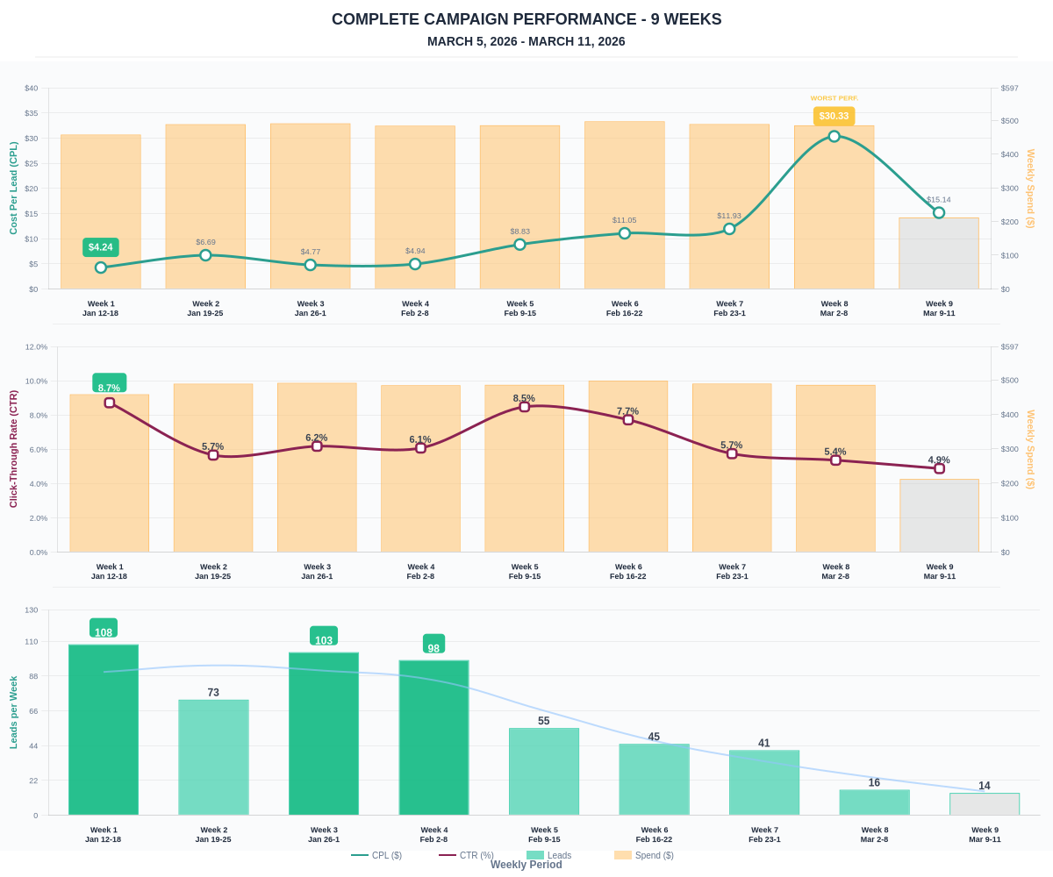

Questions? Let's chat about scaling these results.

