

Meta Ads Performance Audit
Client: Box Divvy
Campaign: Hubster Lead Gen
Period: 6 March 2026 – 12 March 2026

Executive Summary
The Box Divvy campaign is delivering results with a blended CPL of $20.37 across 24 leads. Total ad spend for the period was $488.78 with an average CTR of 5.36%. The top performer achieved a CPL of $0.45 (DEC-15-2025 - copy_08771CC1-D4C9-4210-BE). High CTR indicates strong creative-audience fit.

Key Metrics
Period | Spend | Leads | CPL | CTR
This Week | $488.78 | 24 | $20.37 | 5.36%
This Month | $2,095.65 | 157 | $13.35 | 6.57%
Since Starting | $4,158.64 | 559 | $7.44 | 6.68%

Latest Batch — Top Metrics
# | Release Lot | Spend | CPM | CTR | Ad ID | Preview
🔥 | Mar-12 | $0.15 | $10.00 | 6.67% | ...256170360 | 
2 | Mar-12 | $0.03 | $15.00 | 0.00% | ...256160360 | 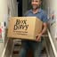
⭐ | Mar-12 | $0.03 | $4.29 | 0.00% | ...256140360 | 
4 | Mar-12 | $0.01 | $5.00 | 0.00% | ...256200360 | 
5 | Mar-12 | $0.01 | $5.00 | 0.00% | ...256210360 | 

Top 5 Performers by CPL — All Time
# | Release Lot | CPL | Leads | CTR | Ad ID | Preview
🔥 | Feb-6 | $0.45 | 1 | 3.85% | ...917610360 | 
2 | Feb-6 | $1.52 | 1 | 5.00% | ...917220360 | 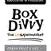
⭐ | Feb-6 | $2.93 | 1 | 3.43% | ...812870360 | 
4 | Jan-29 | $4.03 | 11 | 6.22% | ...743430360 | 
5 | Jan-12 | $4.07 | 12 | 6.18% | ...985710360 | 
🔥 = Top performer | ⭐ = Volume star | Sorted by cost per conversion (lowest first)

Release Lot Performance
• DEC-15 Release: 2 conversions from 2 ad(s) – Best cost: $0.45
• DEC-22 Release: 1 conversions from 1 ad(s) – Best cost: $2.93
• Jan-17 Release: 11 conversions from 1 ad(s) – Best cost: $4.03
• Dec-15 Release: 12 conversions from 1 ad(s) – Best cost: $4.07

Creative Insights
Top Performer:
DEC-15-2025 - copy_08771CC1-D4C9-4210-BE7C-B4582E8D0709 - Copy – 1 conversions at $0.45 cost, 3.85% CTR
Runner Up:
DEC-15-2025 - copy_08771CC1-D4C9-4210-BE7C-B4582E8D0709 - Copy – 1 conversions at $1.52 cost, 5.00% CTR

Demographic Sweet Spot
• Female 45-54: 6 leads, $20.29 CPL, 5.85% CTR
• Female 25-34: 4 leads, $22.71 CPL, 4.29% CTR
• Female 35-44: 4 leads, $40.46 CPL, 5.17% CTR

Key Insights
What's Working:
✓ Strong overall CTR of 5.36% indicates compelling ad creative and targeting resonating with audience
✓ Lead volume is healthy with 24 leads generated over 7 days at a sustainable CPL of $20.37
✓ Top performing ad variations are achieving excellent CPLs under $3, showing potential for scaling
✓ High click volume (880) suggests strong audience interest and engagement

Opportunities:
→ Significant CPL variance between top performers ($0.45-$2.93) and campaign average ($20.37) indicates room for optimisation
→ Could improve impression-to-lead conversion rate as only 0.15% of impressions are converting to leads
→ Potential to reduce wasted spend by identifying and pausing underperforming ad variations
→ Room to scale successful ad copies with CPL under $3 to drive more efficient lead generation

Recommended Next Steps
▸ Analyse top-performing ad copies to identify common elements and create new variations based on these insights
▸ Reallocate budget from ads with above-average CPL to the top 3 performing variations to improve overall efficiency
▸ Set up A/B tests focusing on headline and primary text variations of the best performing ads
▸ Review audience targeting settings to ensure budget is focused on highest-converting segments

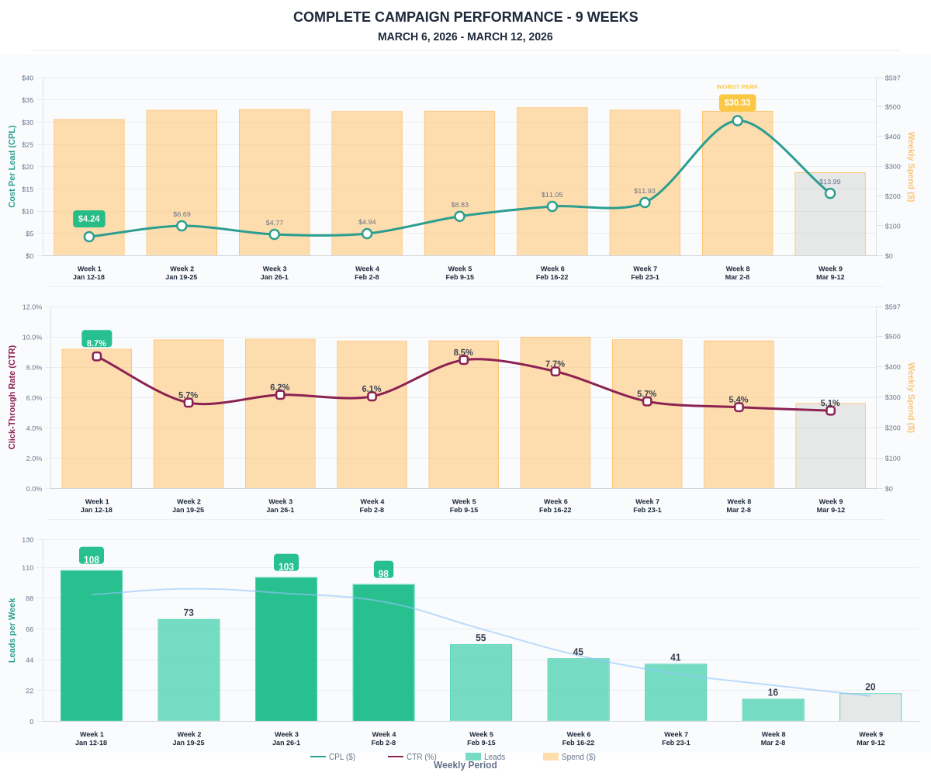

Questions? Let's chat about scaling these results.

