

Meta Ads Performance Audit
Client: Box Divvy
Campaign: Hubster Lead Gen
Period: 7 March 2026 – 13 March 2026

Executive Summary
The Box Divvy campaign is delivering solid results with a blended CPL of $17.54 across 28 leads. Total ad spend for the period was $491.15 with an average CTR of 5.46%. The top performer achieved a CPL of $0.52 (DEC-15-2025 - copy_08771CC1-D4C9-4210-BE). High CTR indicates strong creative-audience fit.

Key Metrics
Period | Spend | Leads | CPL | CTR
This Week | $491.15 | 28 | $17.54 | 5.46%
This Month | $2,098.36 | 154 | $13.63 | 6.36%
Since Starting | $4,227.21 | 566 | $7.47 | 6.67%

Latest Batch — Top Metrics
# | Release Lot | Spend | CPM | CTR | Ad ID | Preview
🔥 | Mar-12 | $3.49 | $22.66 | 6.49% | ...256180360 | 
2 | Mar-12 | $0.49 | $23.33 | 4.76% | ...256220360 | 
⭐ | Mar-12 | $0.28 | $16.47 | 0.00% | ...256210360 | 
4 | Mar-12 | $0.15 | $10.00 | 6.67% | ...256170360 | 
5 | Mar-12 | $0.07 | $14.00 | 0.00% | ...256200360 | 

Top 5 Performers by CPL — All Time
# | Release Lot | CPL | Leads | CTR | Ad ID | Preview
🔥 | Feb-6 | $0.52 | 1 | 3.45% | ...917610360 | 
2 | Feb-6 | $1.59 | 1 | 4.76% | ...917220360 | 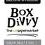
⭐ | Feb-6 | $2.93 | 1 | 3.43% | ...812870360 | 
4 | Jan-29 | $4.03 | 11 | 6.22% | ...743430360 | 
5 | Jan-12 | $4.07 | 12 | 6.18% | ...985710360 | 
🔥 = Top performer | ⭐ = Volume star | Sorted by cost per conversion (lowest first)

Release Lot Performance
• DEC-15 Release: 2 conversions from 2 ad(s) – Best cost: $0.52
• DEC-22 Release: 1 conversions from 1 ad(s) – Best cost: $2.93
• Jan-17 Release: 11 conversions from 1 ad(s) – Best cost: $4.03
• Dec-15 Release: 12 conversions from 1 ad(s) – Best cost: $4.07

Creative Insights
Top Performer:
DEC-15-2025 - copy_08771CC1-D4C9-4210-BE7C-B4582E8D0709 - Copy – 1 conversions at $0.52 cost, 3.45% CTR
Runner Up:
DEC-15-2025 - copy_08771CC1-D4C9-4210-BE7C-B4582E8D0709 - Copy – 1 conversions at $1.59 cost, 4.76% CTR

Demographic Sweet Spot
• Female 45-54: 10 leads, $12.15 CPL, 6.28% CTR
• Female 35-44: 5 leads, $33.48 CPL, 5.33% CTR
• Female 55-64: 3 leads, $15.87 CPL, 6.40% CTR

Key Insights
What's Working:
✓ Strong overall CTR at 5.46%, indicating compelling ad creative and targeting resonating with audience
✓ Efficient lead generation with 28 leads at a reasonable CPL of $17.54 for the Australian market
✓ Top performing ads achieving very low CPL ($0.52-$2.93), demonstrating potential for cost optimisation
✓ High click volume (898) showing strong audience interest and engagement

Opportunities:
→ Large variance in CPL between top performers ($0.52) and campaign average ($17.54) suggests room for performance optimisation
→ Some ad variations performing significantly better than others, indicating potential to scale winning creative elements
→ CTR variance between ads (3.43% to 4.76%) suggests opportunity to optimise ad copy and creative
→ High impression to lead conversion gap indicates potential to improve landing page conversion rate

Recommended Next Steps
▸ Analyse top-performing ad copy elements and create new variations incorporating these winning features
▸ Reallocate budget towards the best-performing ad sets with CPL under $3, gradually scaling successful campaigns
▸ Conduct A/B testing on landing page elements to improve conversion rate from clicks to leads
▸ Review audience targeting settings from top-performing ads and apply these insights to other ad sets

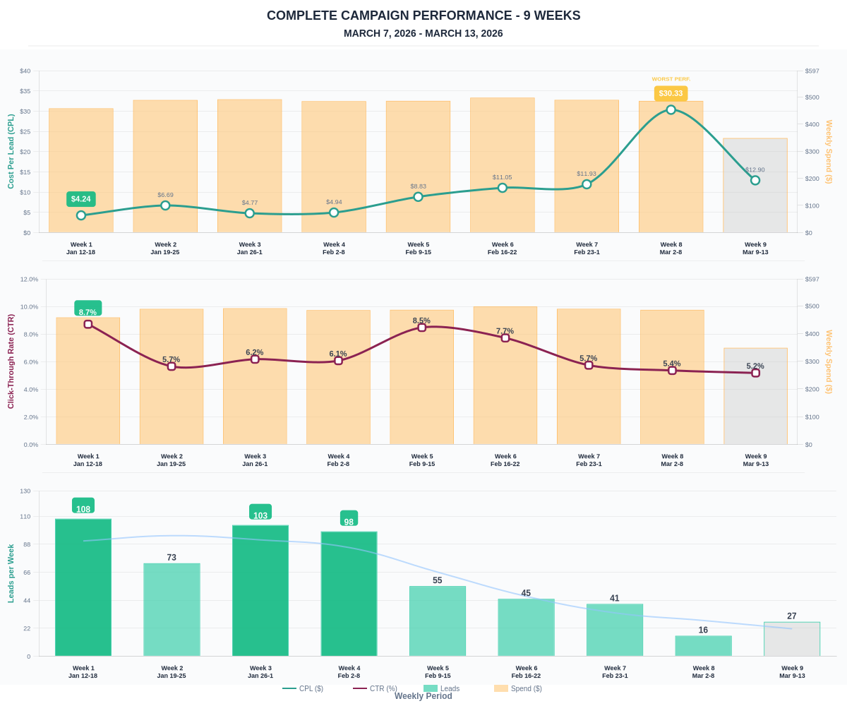

Questions? Let's chat about scaling these results.

