

Meta Ads Performance Audit
Client: Box Divvy
Campaign: Hubster Lead Gen
Period: 9 March 2026 – 15 March 2026

Executive Summary
The Box Divvy campaign is delivering solid results with a blended CPL of $13.59 across 36 leads. Total ad spend for the period was $489.29 with an average CTR of 5.38%. The top performer achieved a CPL of $0.52 (DEC-15-2025 - copy_08771CC1-D4C9-4210-BE). High CTR indicates strong creative-audience fit.

Key Metrics
Period | Spend | Leads | CPL | CTR
This Week | $489.29 | 36 | $13.59 | 5.38%
This Month | $2,101.98 | 147 | $14.30 | 6.15%
Since Starting | $4,368.22 | 575 | $7.60 | 6.65%

Latest Batch — Top Metrics
# | Release Lot | Spend | CPM | CTR | Ad ID | Preview
🔥 | Mar-12 | $3.52 | $22.42 | 6.37% | ...256180360 | 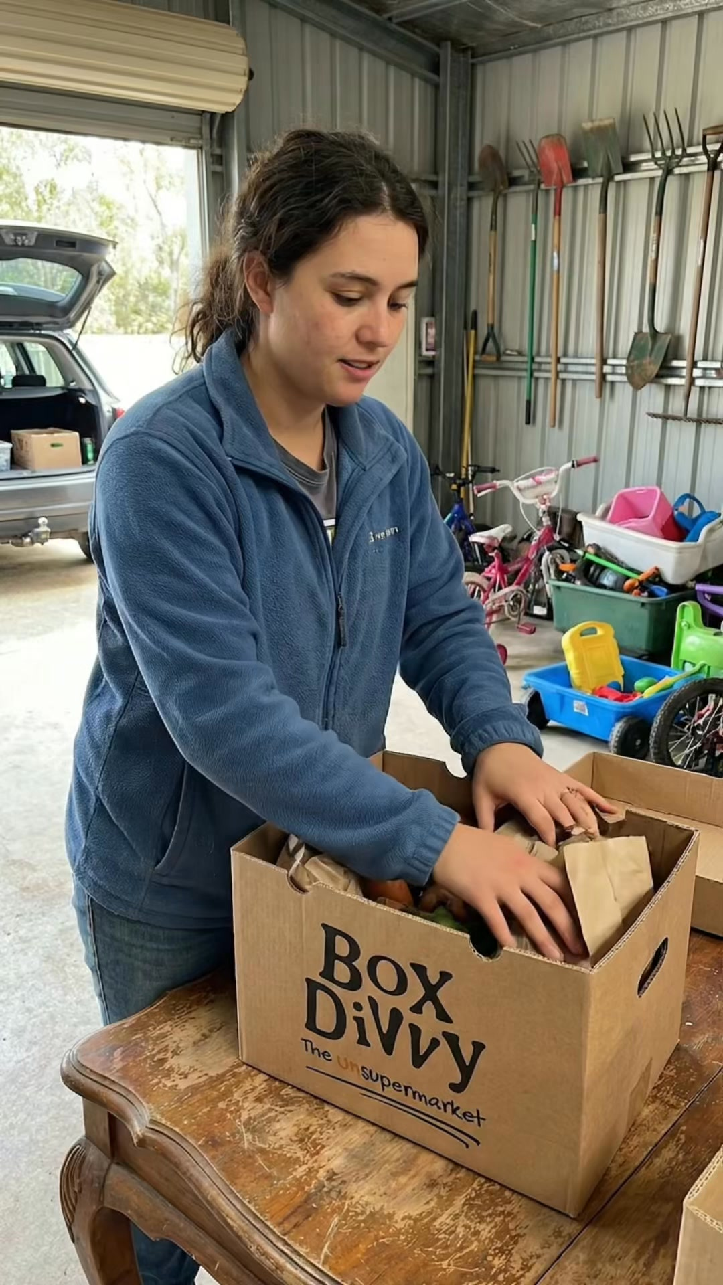
2 | Mar-12 | $0.66 | $24.44 | 3.70% | ...256220360 | 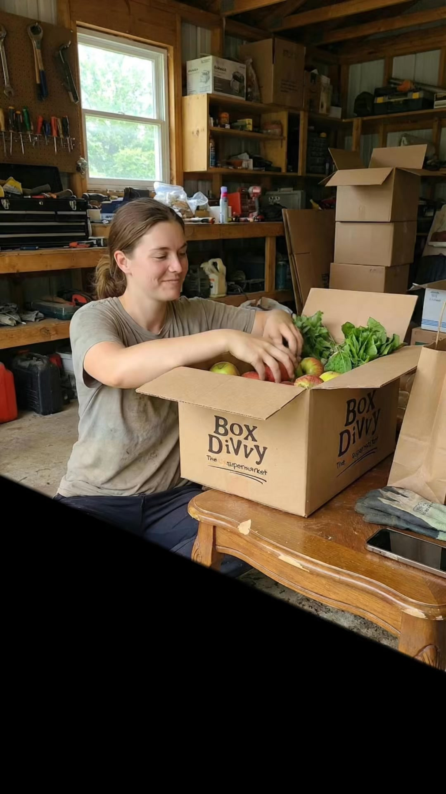
⭐ | Mar-12 | $0.40 | $22.22 | 22.22% | ...256190360 | 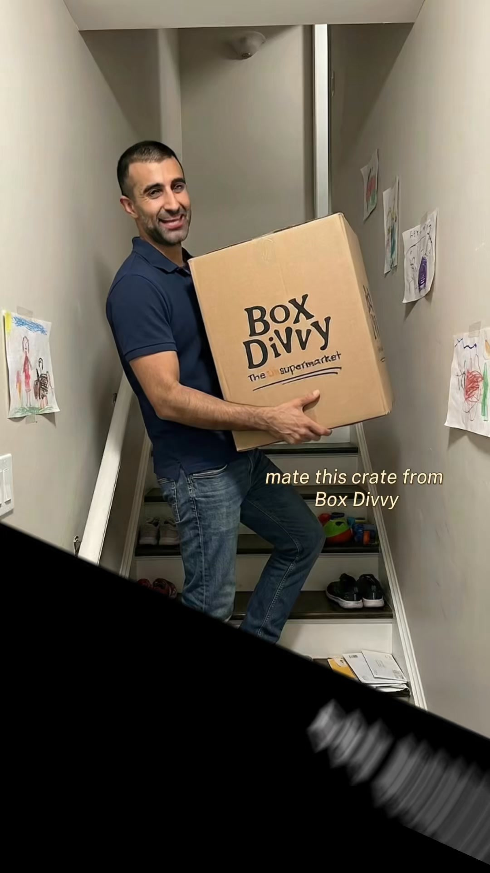
4 | Mar-12 | $0.33 | $14.35 | 0.00% | ...256210360 | 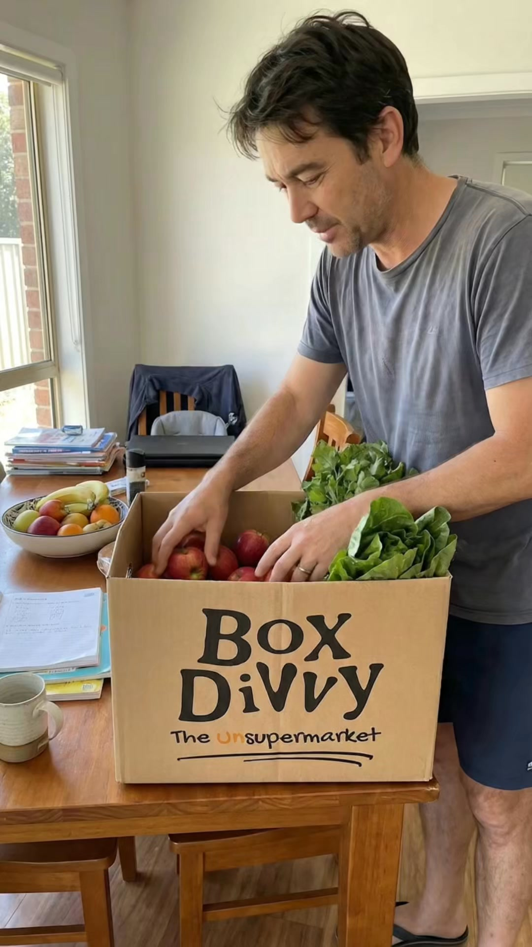
5 | Mar-12 | $0.18 | $10.59 | 5.88% | ...256170360 | 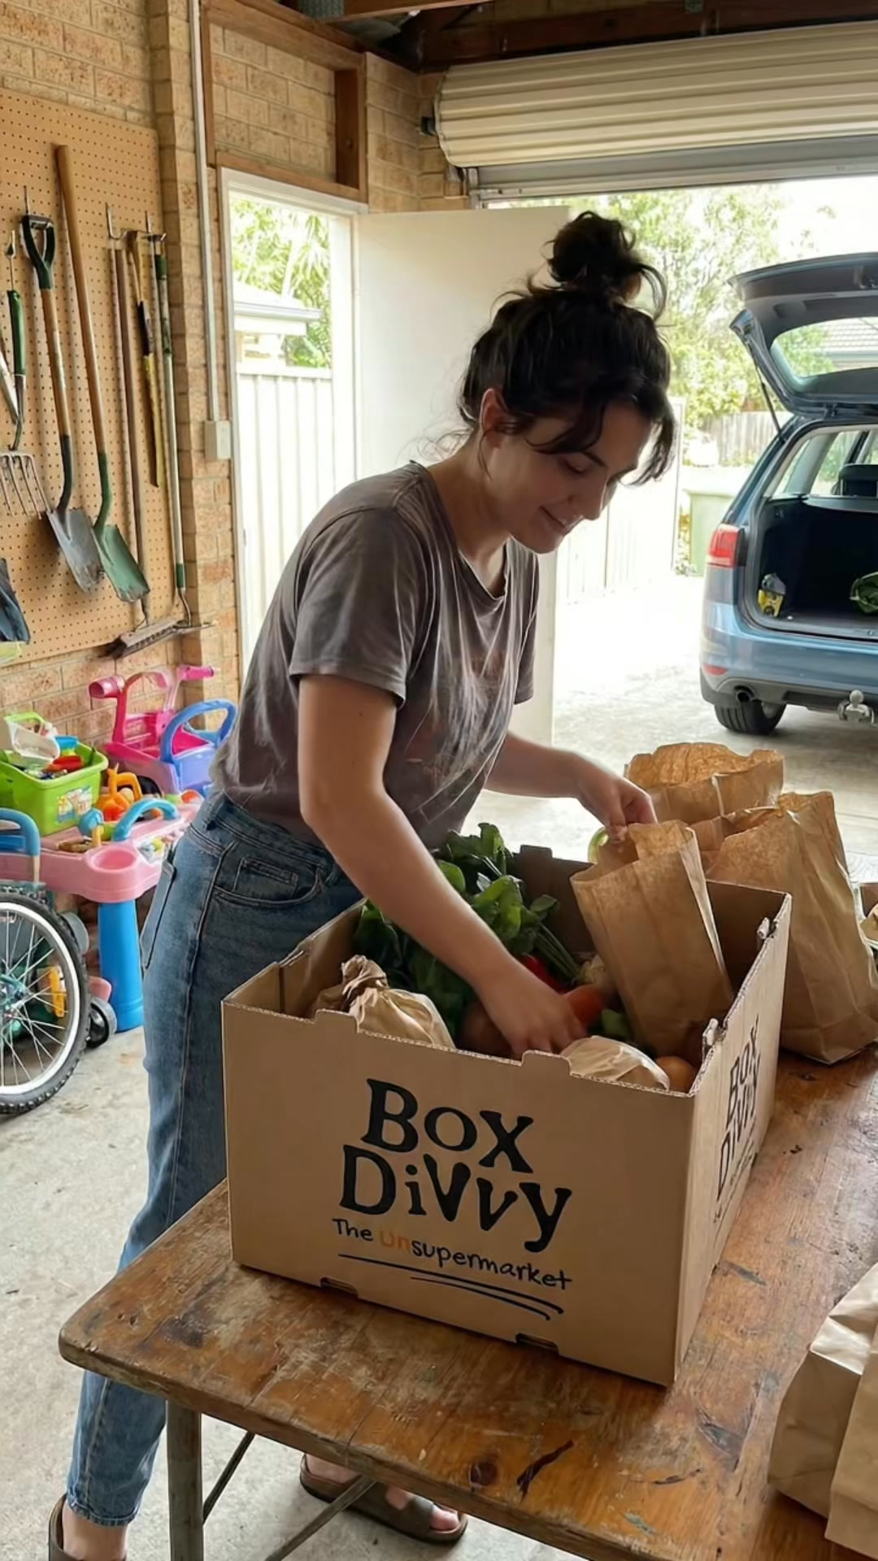

Top 5 Performers by CPL — All Time
# | Release Lot | CPL | Leads | CTR | Ad ID | Preview
🔥 | Feb-6 | $0.52 | 1 | 3.33% | ...917610360 | 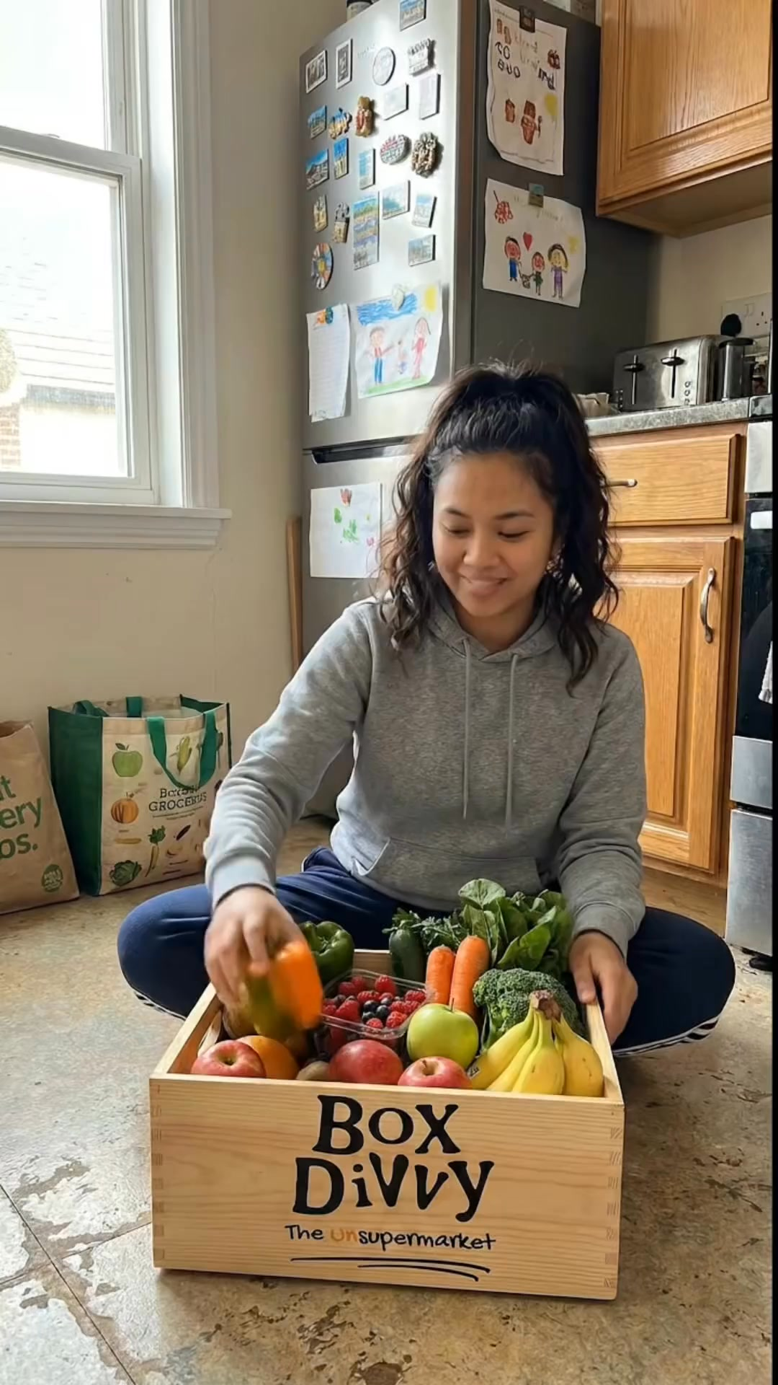
2 | Feb-6 | $1.59 | 1 | 4.76% | ...917220360 | 
⭐ | Feb-6 | $3.03 | 1 | 3.35% | ...812870360 | 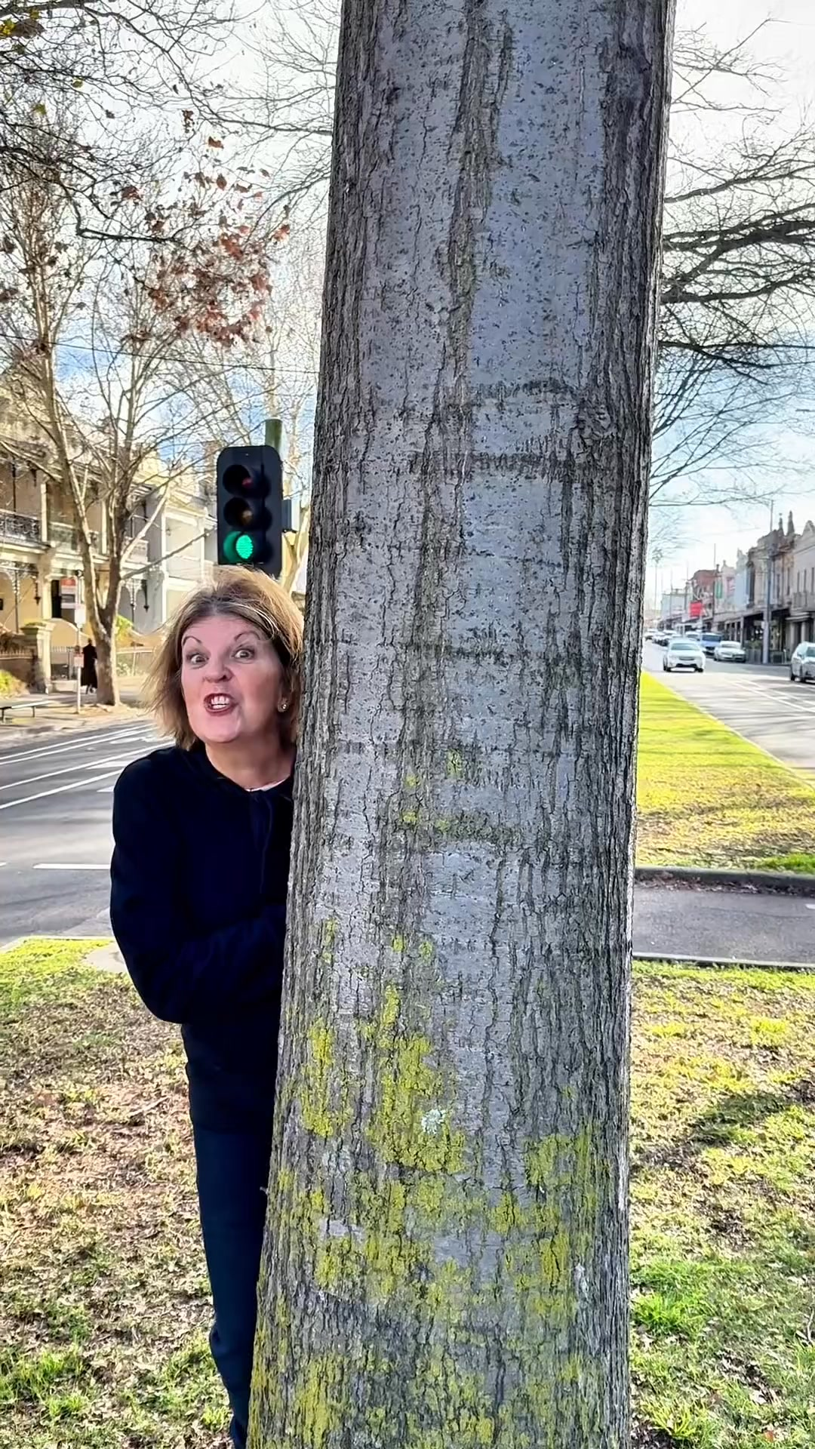
4 | Jan-29 | $4.03 | 11 | 6.22% | ...743430360 | 
5 | Jan-12 | $4.07 | 12 | 6.18% | ...985710360 | 
🔥 = Top performer | ⭐ = Volume star | Sorted by cost per conversion (lowest first)

Release Lot Performance
• DEC-15 Release: 2 conversions from 2 ad(s) – Best cost: $0.52
• DEC-22 Release: 1 conversions from 1 ad(s) – Best cost: $3.03
• Jan-17 Release: 11 conversions from 1 ad(s) – Best cost: $4.03
• Dec-15 Release: 12 conversions from 1 ad(s) – Best cost: $4.07

Creative Insights
Top Performer:
DEC-15-2025 - copy_08771CC1-D4C9-4210-BE7C-B4582E8D0709 - Copy – 1 conversions at $0.52 cost, 3.33% CTR
Runner Up:
DEC-15-2025 - copy_08771CC1-D4C9-4210-BE7C-B4582E8D0709 - Copy – 1 conversions at $1.59 cost, 4.76% CTR

Demographic Sweet Spot
• Female 45-54: 12 leads, $10.14 CPL, 6.59% CTR
• Female 35-44: 9 leads, $18.31 CPL, 4.93% CTR
• Female 18-24: 3 leads, $2.80 CPL, 4.17% CTR

Key Insights
What's Working:
✓ Strong overall CTR of 5.38% indicates compelling ad creative and targeting relevance
✓ Efficient cost per lead at $13.59, which is competitive for lead generation campaigns in Australia
✓ High click volume (868) from moderate impressions (16,126) suggests effective audience targeting
✓ Top performing ads achieving leads at very low costs ($0.52-$3.03) demonstrate potential for scaling

Opportunities:
→ Significant cost variance between top performers ($0.52 vs $13.59 average) indicates room for budget optimisation
→ Limited number of high-performing variations suggests need for more creative testing
→ Potential to increase impression volume while maintaining strong CTR
→ Room to improve conversion rate from clicks to leads (4.15% currently)

Recommended Next Steps
▸ Analyse top-performing ad copy elements and create 3-4 new variations incorporating successful messaging patterns
▸ Reallocate budget towards the best-performing ad sets (particularly those achieving leads under $3)
▸ Implement automated rules to scale spend on ads maintaining CTR above 4% and CPL below $10
▸ Create lookalike audiences based on converted leads to expand reach while maintaining quality

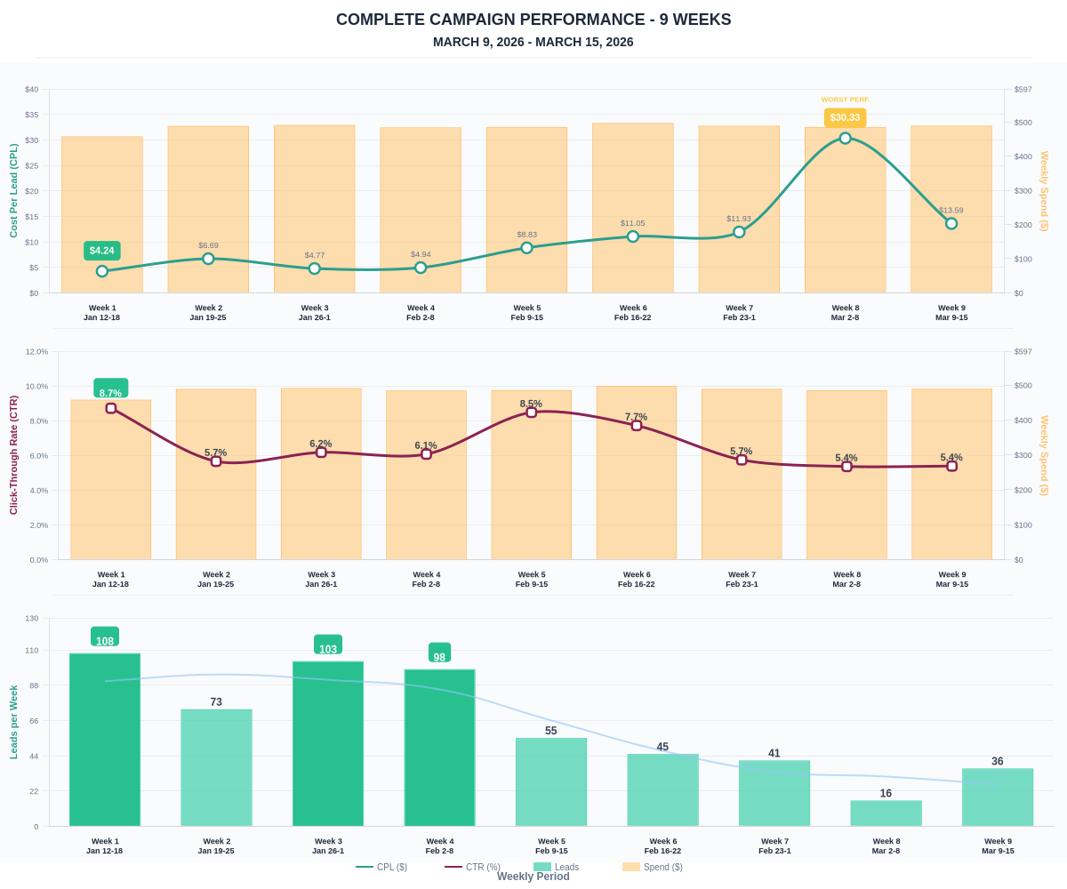

Questions? Let's chat about scaling these results.

