

Meta Ads Performance Audit
Client: Box Divvy
Campaign: Hubster Lead Gen
Period: 10 March 2026 – 16 March 2026

Executive Summary
The Box Divvy campaign is delivering solid results with a blended CPL of $11.78 across 42 leads. Total ad spend for the period was $494.84 with an average CTR of 5.54%. The top performer achieved a CPL of $0.52 (DEC-15-2025 - copy_08771CC1-D4C9-4210-BE). High CTR indicates strong creative-audience fit.

Key Metrics
Period | Spend | Leads | CPL | CTR
This Week | $494.84 | 42 | $11.78 | 5.54%
This Month | $2,111.52 | 149 | $14.17 | 6.09%
Since Starting | $4,445.52 | 583 | $7.63 | 6.64%

Latest Batch — Top Metrics
# | Release Lot | Spend | CPM | CTR | Ad ID | Preview
🔥 | Mar-12 | $3.53 | $22.34 | 6.33% | ...256180360 | 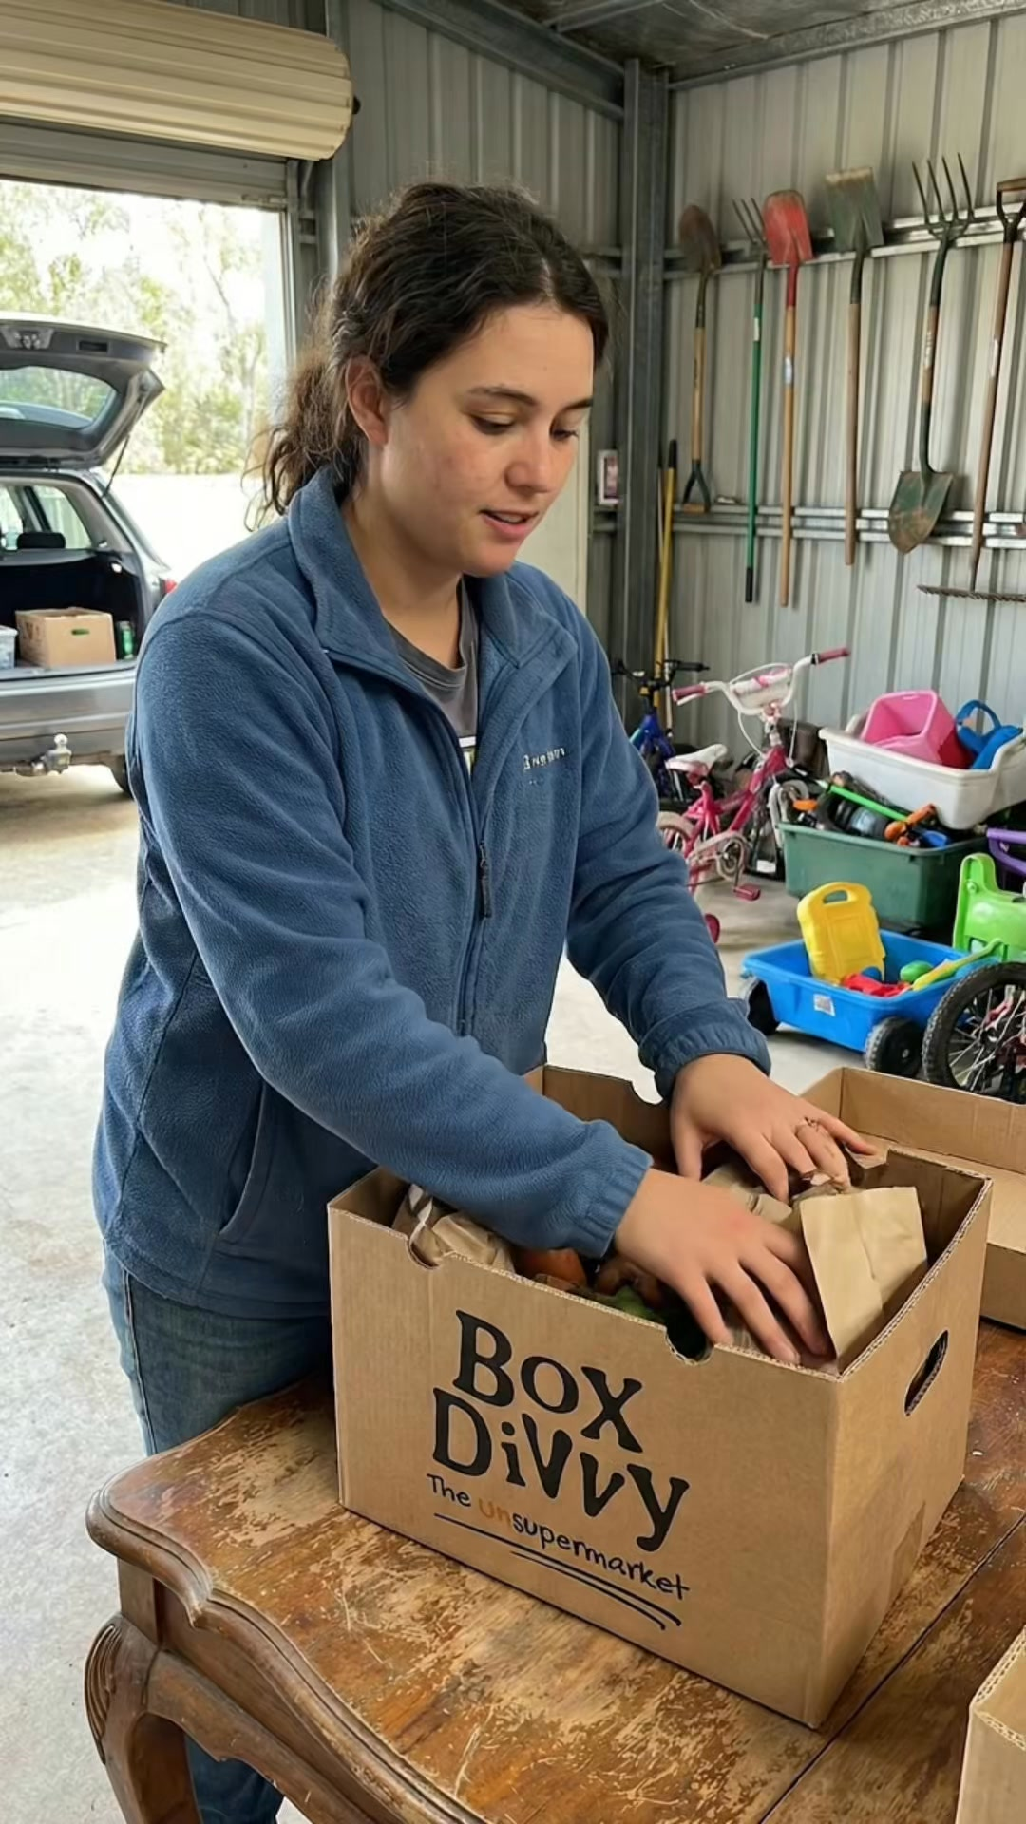
2 | Mar-12 | $0.66 | $24.44 | 3.70% | ...256220360 | 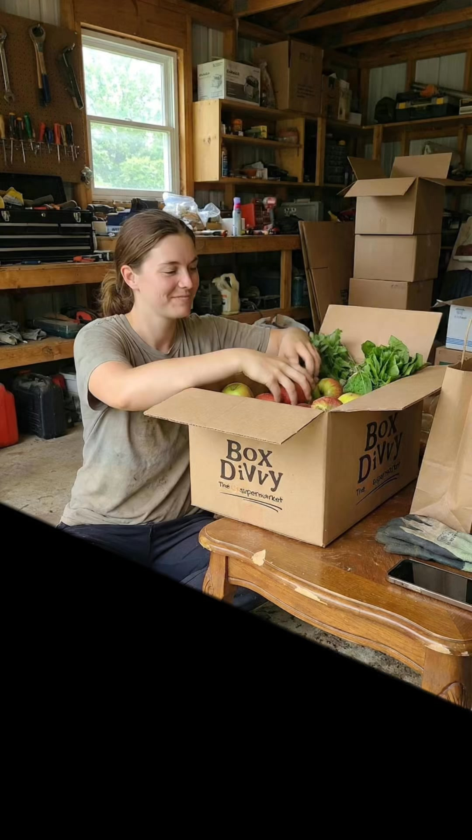
⭐ | Mar-12 | $0.40 | $22.22 | 22.22% | ...256190360 | 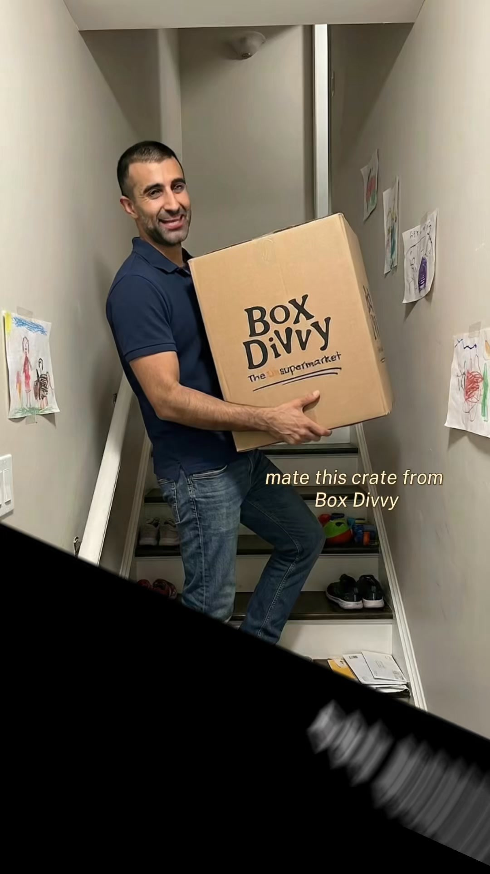
4 | Mar-12 | $0.33 | $14.35 | 0.00% | ...256210360 | 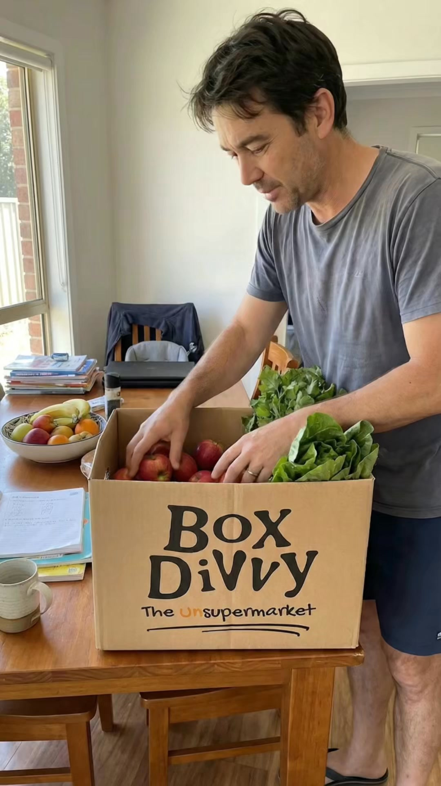
5 | Mar-12 | $0.18 | $10.59 | 5.88% | ...256170360 | 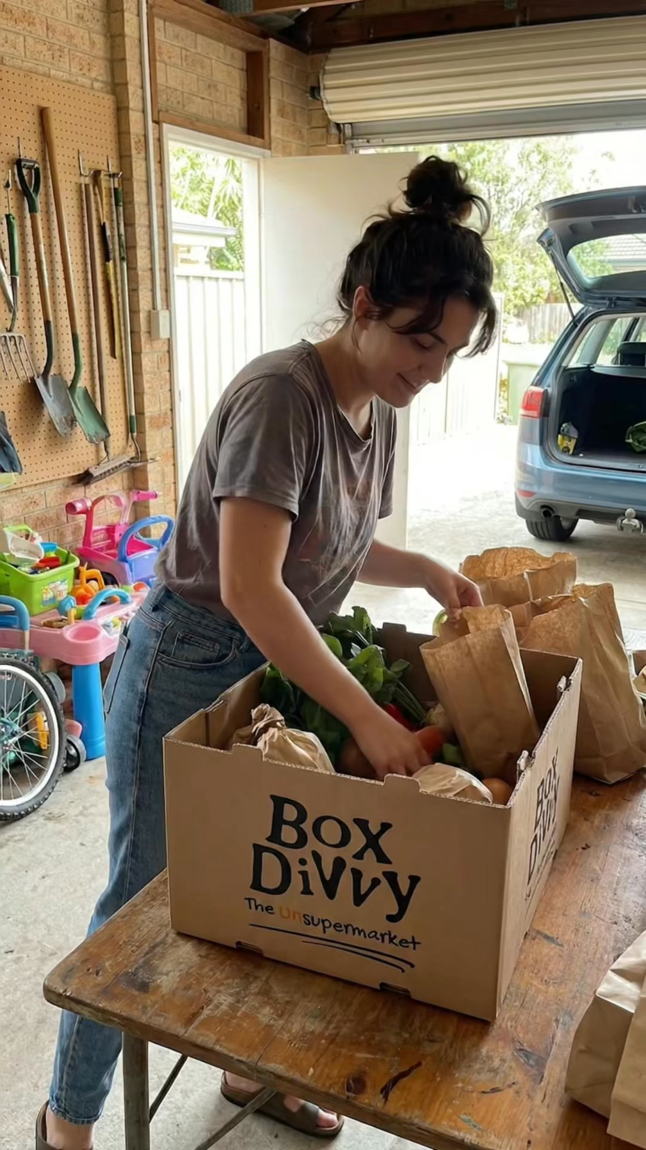

Top 5 Performers by CPL — All Time
# | Release Lot | CPL | Leads | CTR | Ad ID | Preview
🔥 | Feb-6 | $0.52 | 1 | 3.33% | ...917610360 | 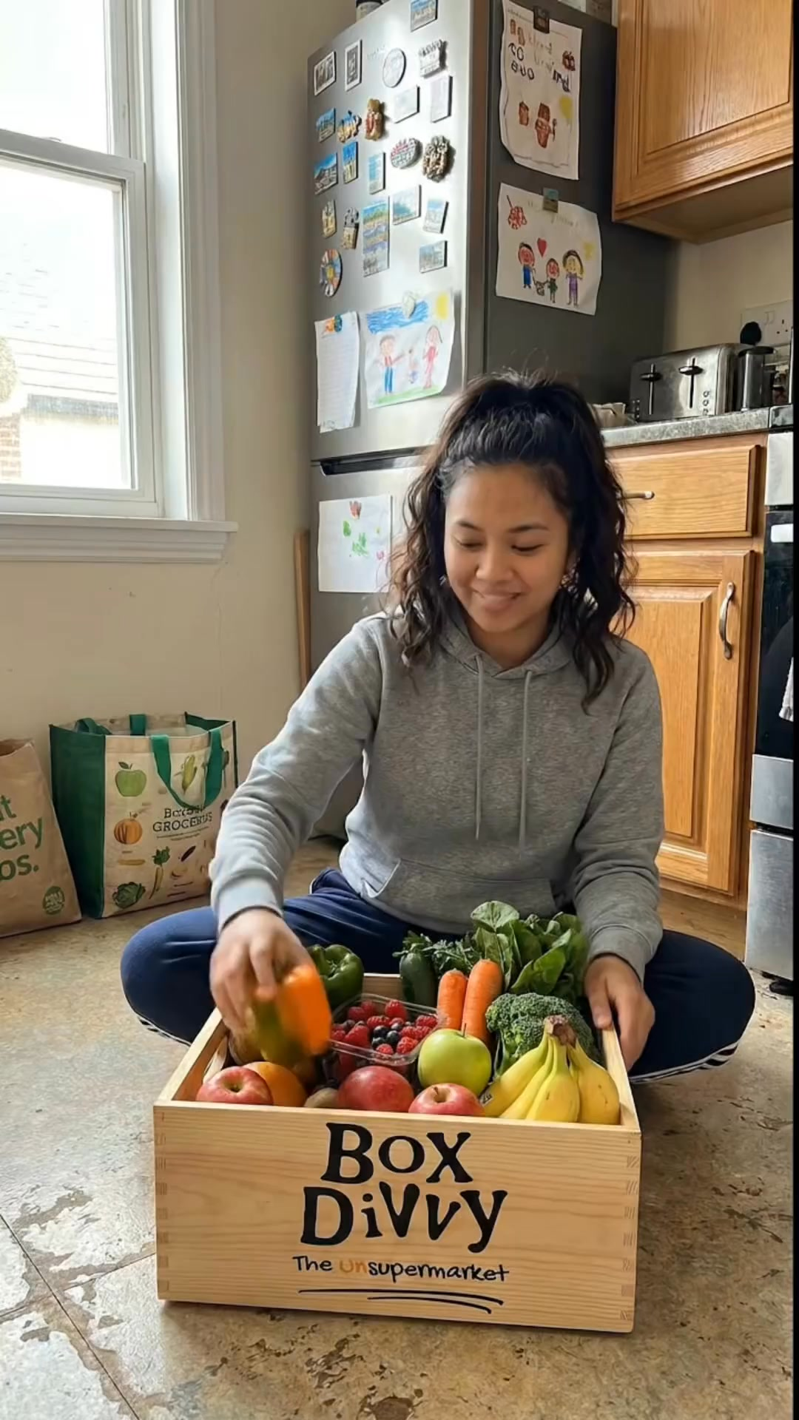
2 | Feb-6 | $1.66 | 1 | 4.65% | ...917220360 | 
⭐ | Feb-6 | $3.37 | 1 | 3.16% | ...812870360 | 
4 | Jan-29 | $4.03 | 11 | 6.22% | ...743430360 | 
5 | Jan-12 | $4.07 | 12 | 6.18% | ...985710360 | 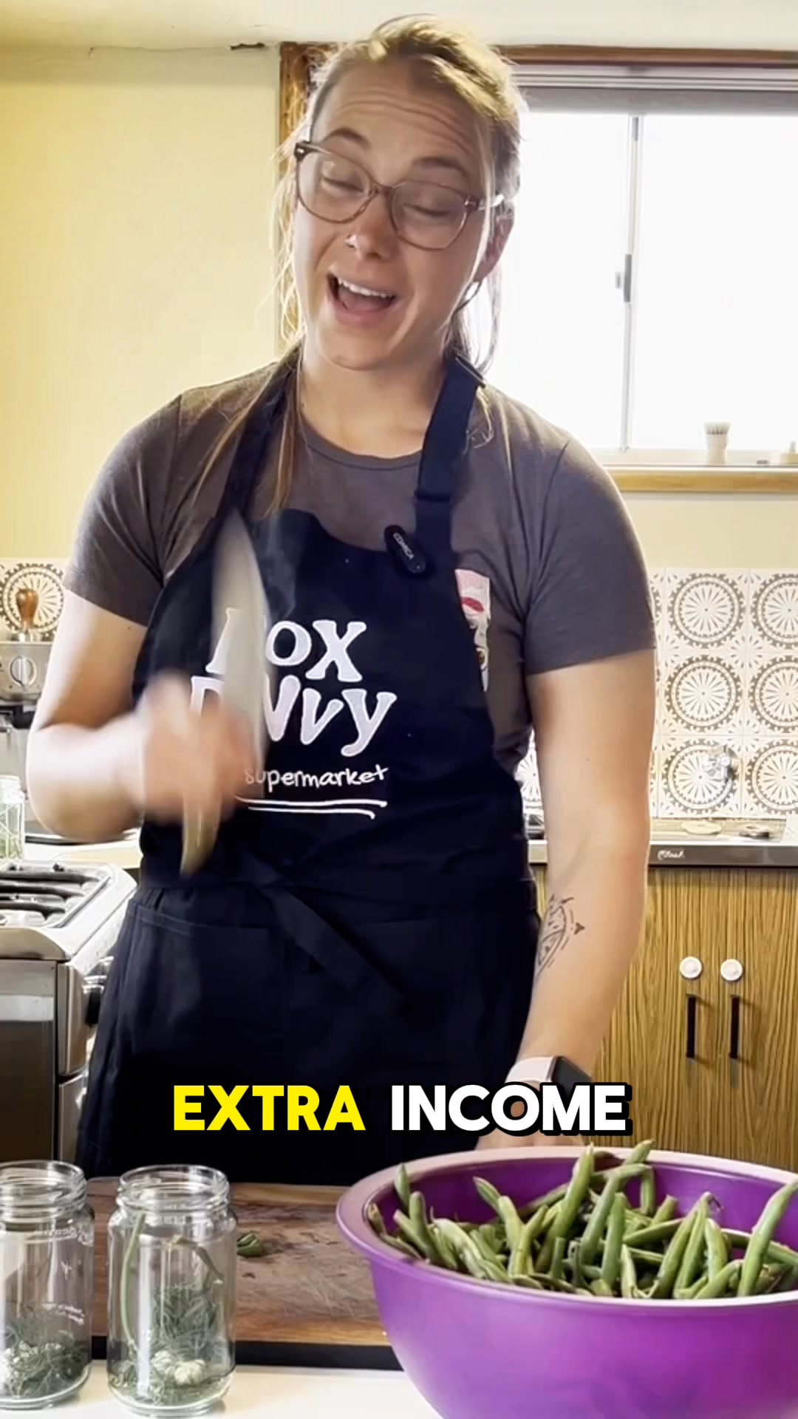
🔥 = Top performer | ⭐ = Volume star | Sorted by cost per conversion (lowest first)

Release Lot Performance
• DEC-15 Release: 2 conversions from 2 ad(s) – Best cost: $0.52
• DEC-22 Release: 1 conversions from 1 ad(s) – Best cost: $3.37
• Jan-17 Release: 11 conversions from 1 ad(s) – Best cost: $4.03
• Dec-15 Release: 12 conversions from 1 ad(s) – Best cost: $4.07

Creative Insights
Top Performer:
DEC-15-2025 - copy_08771CC1-D4C9-4210-BE7C-B4582E8D0709 - Copy – 1 conversions at $0.52 cost, 3.33% CTR
Runner Up:
DEC-15-2025 - copy_08771CC1-D4C9-4210-BE7C-B4582E8D0709 - Copy – 1 conversions at $1.66 cost, 4.65% CTR

Demographic Sweet Spot
• Female 45-54: 15 leads, $8.14 CPL, 7.03% CTR
• Female 35-44: 11 leads, $15.15 CPL, 5.15% CTR
• Female 18-24: 3 leads, $2.83 CPL, 4.42% CTR

Key Insights
What's Working:
✓ Campaign is running with 42 conversions

Opportunities:
→ Continue optimising campaign performance

Recommended Next Steps
▸ Monitor performance and adjust as needed

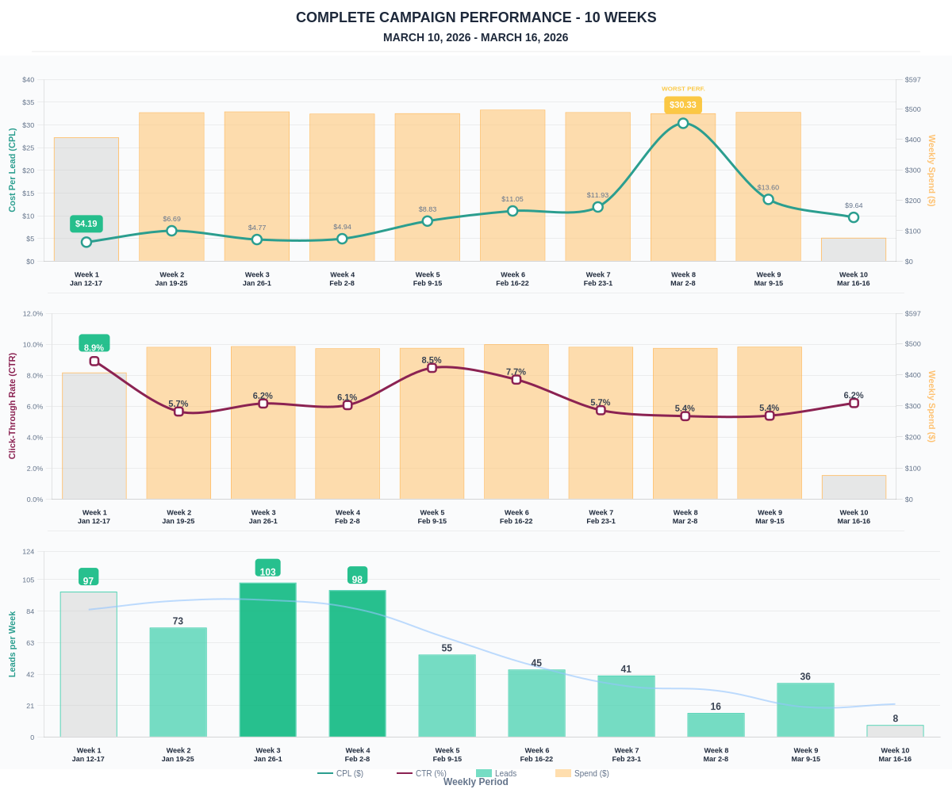

Questions? Let's chat about scaling these results.

