

Meta Ads Performance Audit
Client: Box Divvy
Campaign: Hubster Lead Gen
Period: 11 March 2026 – 17 March 2026

Executive Summary
The Box Divvy campaign is delivering strong performance with a blended CPL of $9.99 across 49 leads. Total ad spend for the period was $489.75 with an average CTR of 5.82%. The top performer achieved a CPL of $0.52 (DEC-15-2025 - copy_08771CC1-D4C9-4210-BE). High CTR indicates strong creative-audience fit.

Key Metrics
Period | Spend | Leads | CPL | CTR
This Week | $489.75 | 49 | $9.99 | 5.82%
This Month | $2,106.85 | 158 | $13.33 | 6.03%
Since Starting | $4,514.23 | 595 | $7.59 | 6.63%

Latest Batch — Top Metrics
# | Release Lot | Spend | CPM | CTR | Ad ID | Preview
🔥 | Mar-12 | $3.53 | $22.34 | 6.33% | ...256180360 | 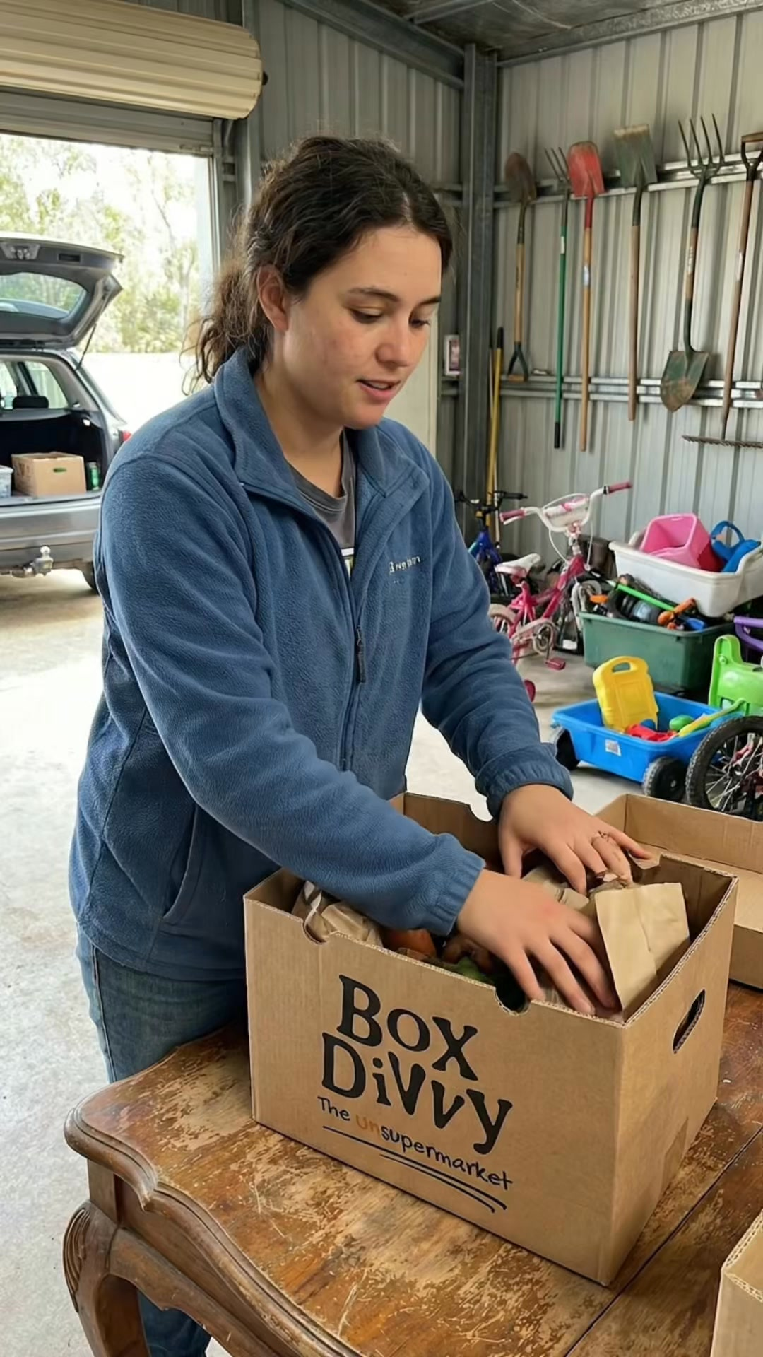
2 | Mar-12 | $0.87 | $22.89 | 5.26% | ...256220360 | 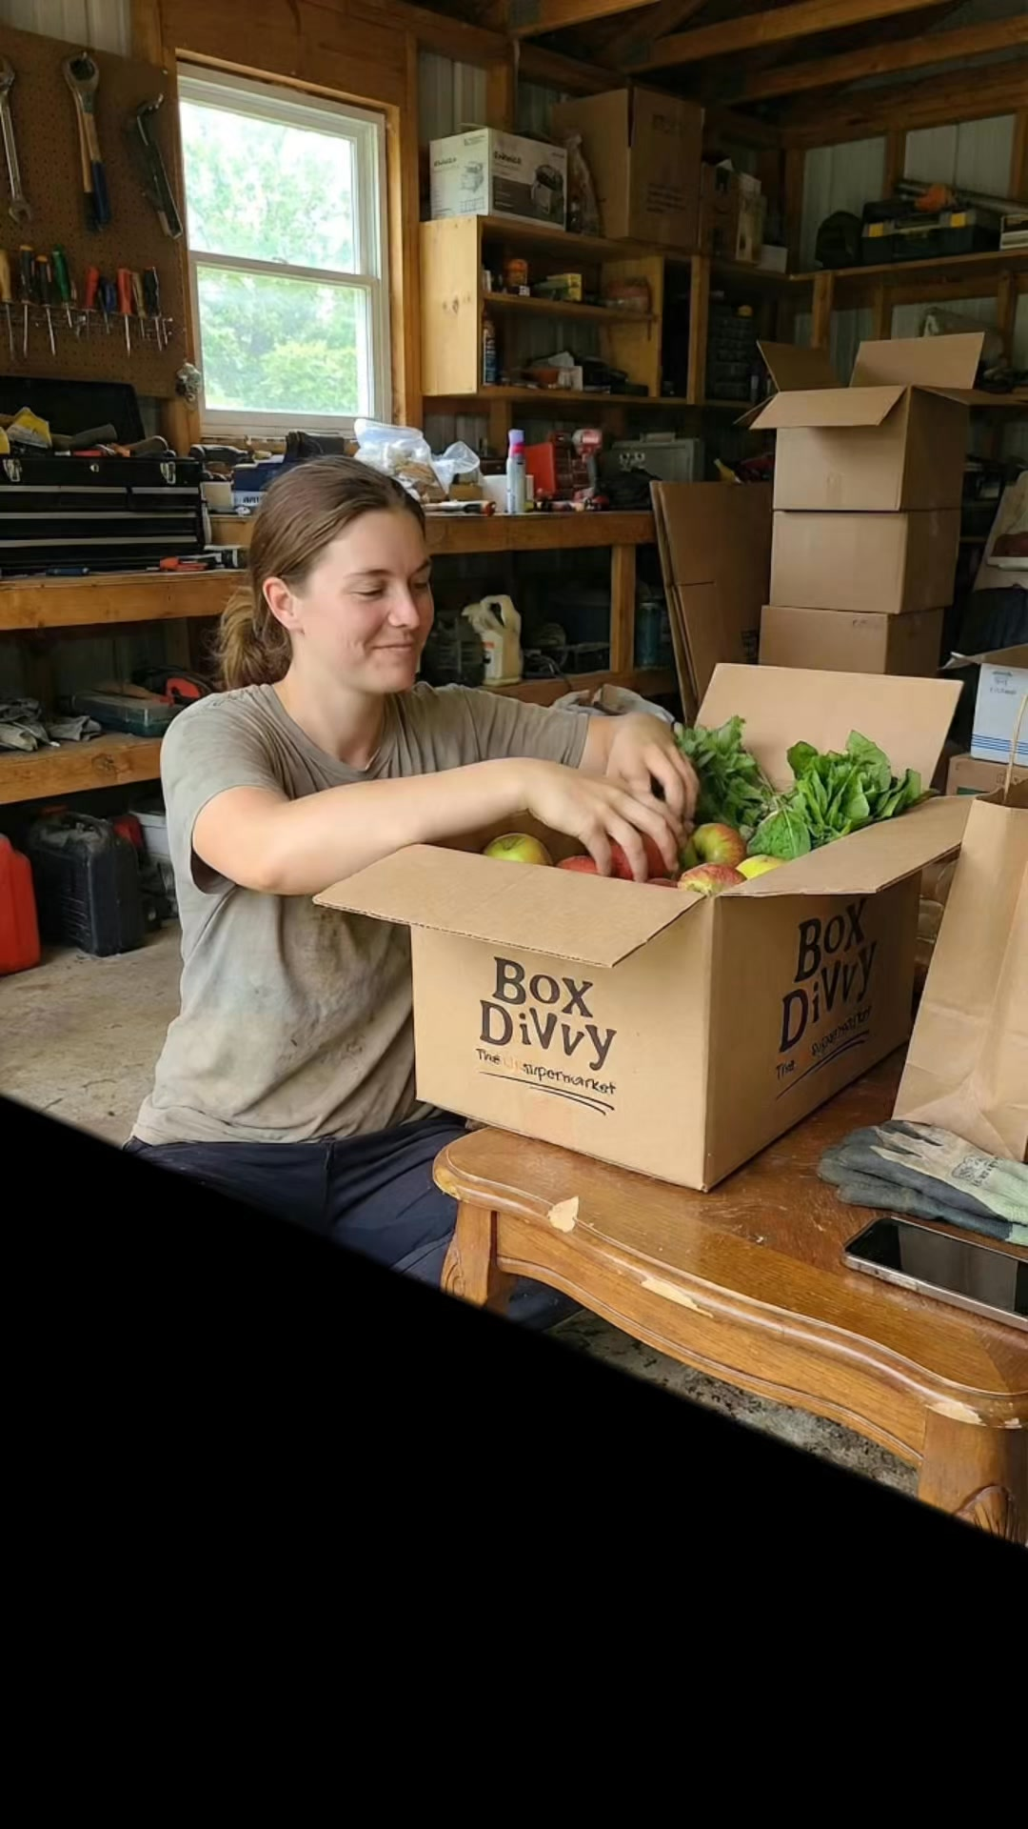
⭐ | Mar-12 | $0.41 | $20.50 | 25.00% | ...256190360 | 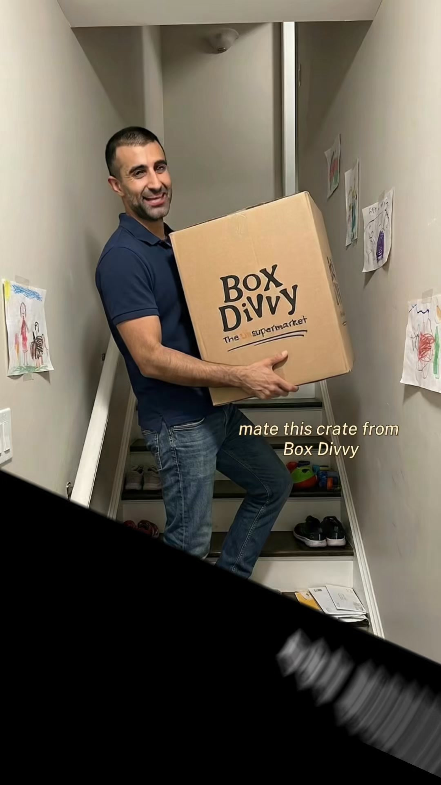
4 | Mar-12 | $0.35 | $14.00 | 0.00% | ...256210360 | 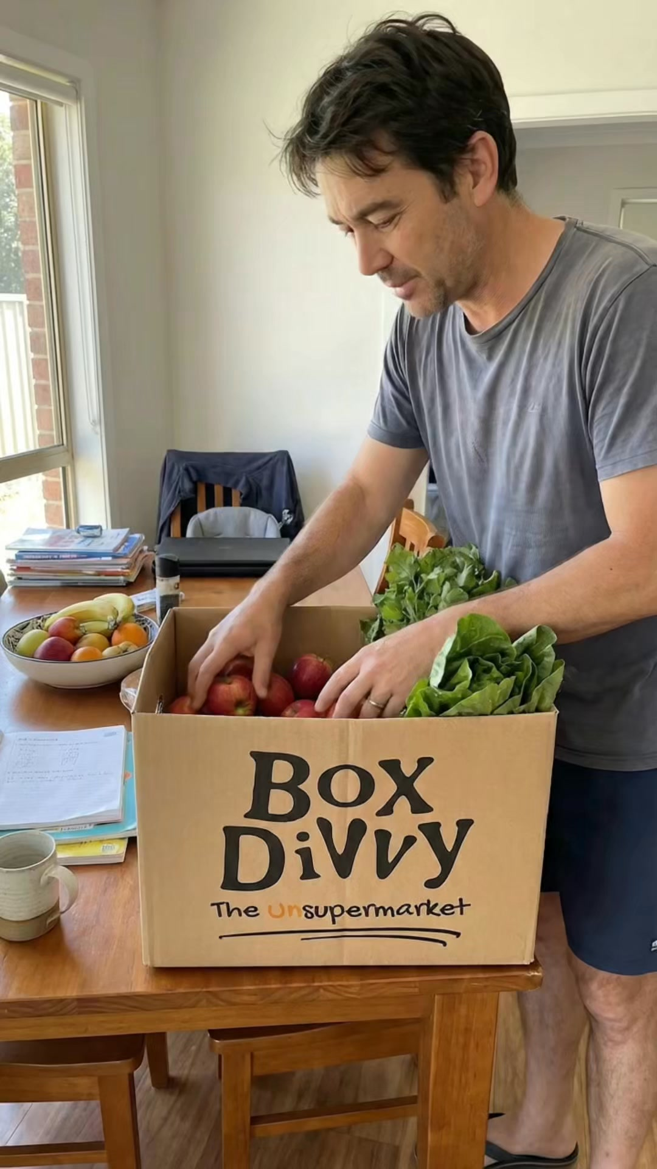
5 | Mar-12 | $0.18 | $10.59 | 5.88% | ...256170360 | 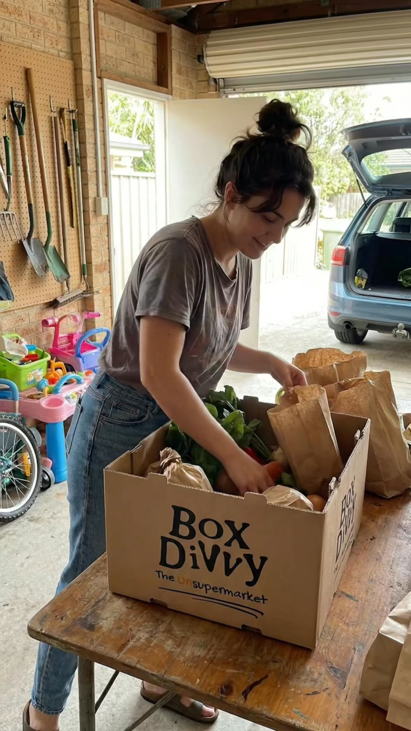

Top 5 Performers by CPL — All Time
# | Release Lot | CPL | Leads | CTR | Ad ID | Preview
🔥 | Feb-6 | $0.52 | 1 | 3.33% | ...917610360 | 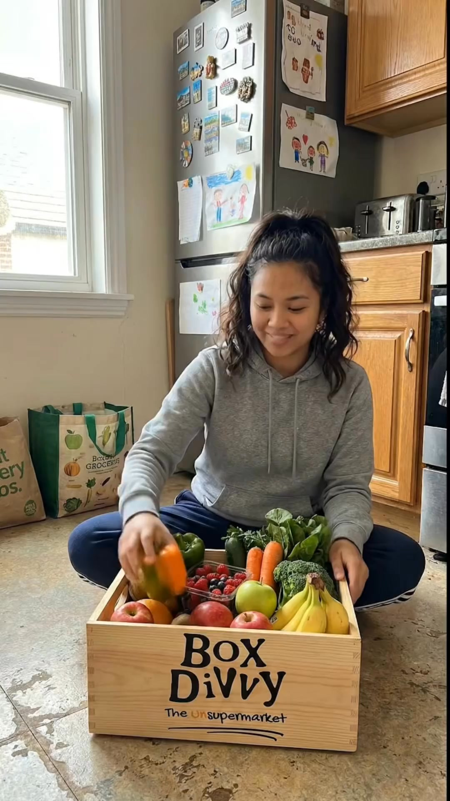
2 | Feb-6 | $1.66 | 1 | 4.60% | ...917220360 | 
⭐ | Feb-6 | $3.58 | 1 | 3.02% | ...812870360 | 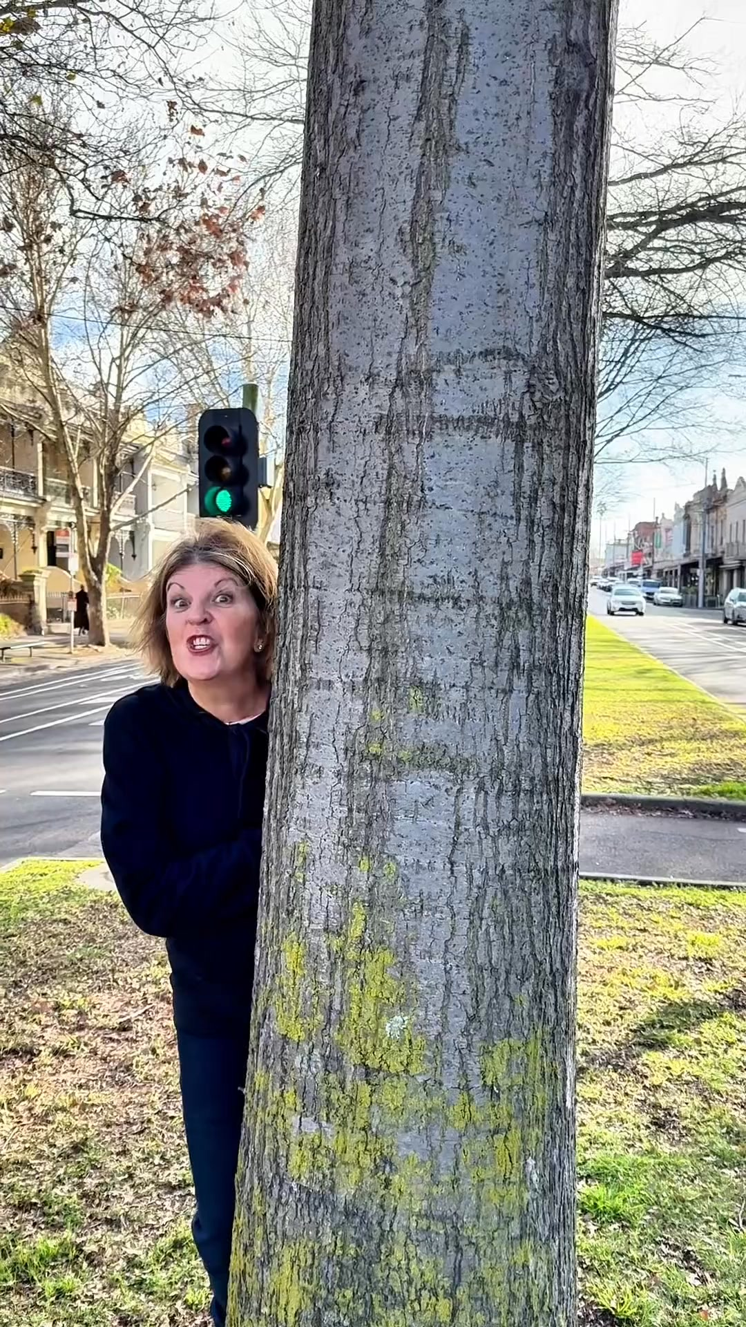
4 | Jan-29 | $4.03 | 11 | 6.22% | ...743430360 | 
5 | Jan-12 | $4.07 | 12 | 6.18% | ...985710360 | 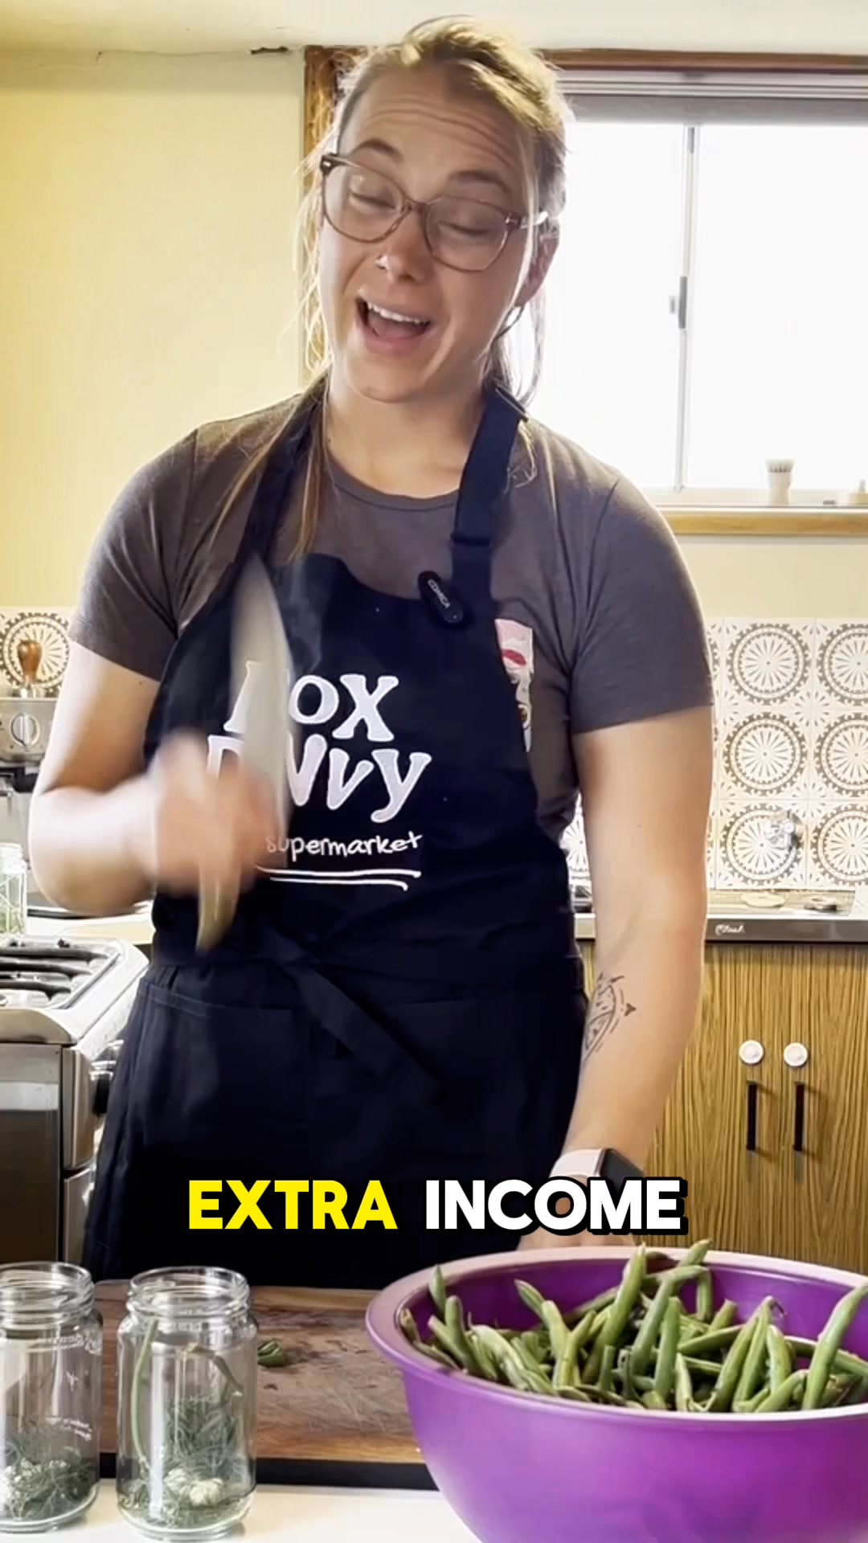
🔥 = Top performer | ⭐ = Volume star | Sorted by cost per conversion (lowest first)

Release Lot Performance
• DEC-15 Release: 2 conversions from 2 ad(s) – Best cost: $0.52
• DEC-22 Release: 1 conversions from 1 ad(s) – Best cost: $3.58
• Jan-17 Release: 11 conversions from 1 ad(s) – Best cost: $4.03
• Dec-15 Release: 12 conversions from 1 ad(s) – Best cost: $4.07

Creative Insights
Top Performer:
DEC-15-2025 - copy_08771CC1-D4C9-4210-BE7C-B4582E8D0709 - Copy – 1 conversions at $0.52 cost, 3.33% CTR
Runner Up:
DEC-15-2025 - copy_08771CC1-D4C9-4210-BE7C-B4582E8D0709 - Copy – 1 conversions at $1.66 cost, 4.60% CTR

Demographic Sweet Spot
• Female 45-54: 18 leads, $6.73 CPL, 7.44% CTR
• Female 35-44: 15 leads, $11.15 CPL, 5.47% CTR
• Female 25-34: 4 leads, $20.32 CPL, 4.03% CTR

Key Insights
What's Working:
✓ Strong overall CTR of 5.82% indicates compelling ad creative and targeting alignment
✓ Efficient cost per lead at $9.99 demonstrates good campaign optimisation and audience relevance
✓ High click volume (959) shows strong audience interest and engagement with the ads
✓ Top performing ad variations achieving CPLs under $4, showing potential for scaling

Opportunities:
→ Significant CPL variance between top performers ($0.52-$3.58) suggests room for budget reallocation
→ Limited number of high-performing ad variations indicates need for more creative testing
→ Current impression volume (16,470) suggests potential to expand reach while maintaining efficiency
→ Copy variations from December campaigns showing promise but need more data for optimisation

Recommended Next Steps
▸ Analyse top-performing ad copy elements and create 3-4 new variations incorporating these themes
▸ Reallocate budget towards the ad sets achieving sub-$4 CPL while maintaining performance
▸ Implement A/B tests focusing on headline variations to improve CTR across all ad sets
▸ Gradually increase daily budget by 20% for top-performing ad sets to scale results

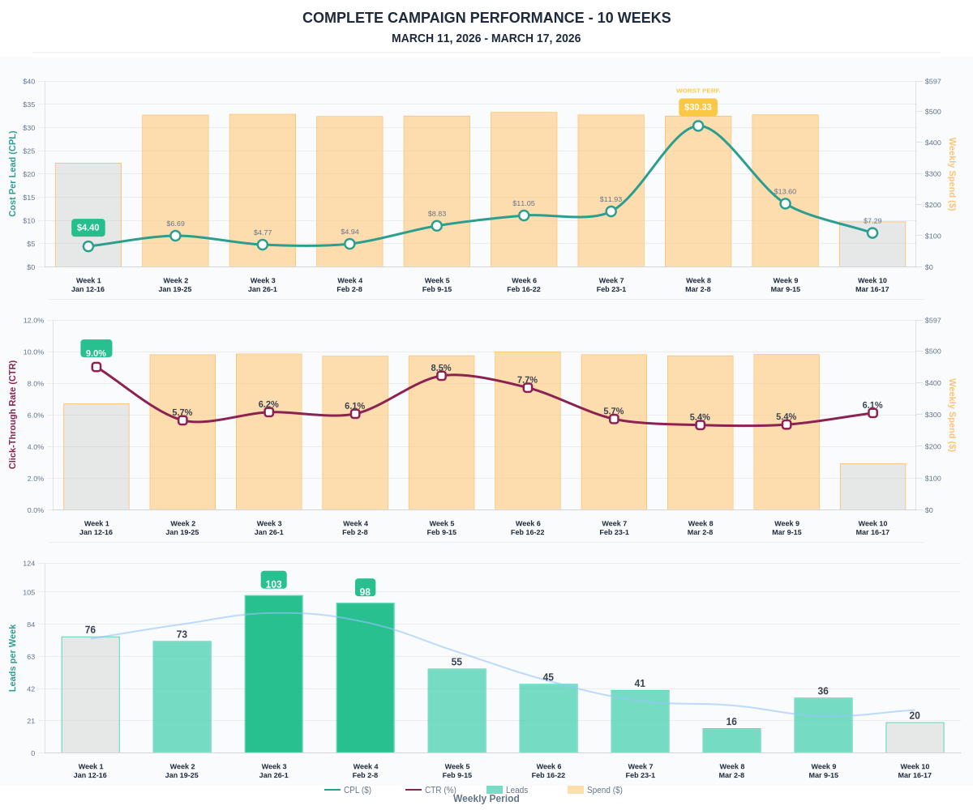

Questions? Let's chat about scaling these results.

