

Meta Ads Performance Audit
Client: Box Divvy
Campaign: Hubster Lead Gen
Period: 16 March 2026 – 22 March 2026

Executive Summary
The Box Divvy campaign is delivering solid results with a blended CPL of $11.76 across 42 leads. Total ad spend for the period was $494.10 with an average CTR of 5.90%. The top performer achieved a CPL of $0.69 (DEC-15-2025 - copy_08771CC1-D4C9-4210-BE). High CTR indicates strong creative-audience fit.

Key Metrics
Period | Spend | Leads | CPL | CTR
This Week | $494.10 | 42 | $11.76 | 5.90%
This Month | $2,107.89 | 148 | $14.24 | 5.71%
Since Starting | $4,862.51 | 617 | $7.88 | 6.58%

Latest Batch — Top Metrics
# | Release Lot | Spend | CPM | CTR | Ad ID | Preview
🔥 | Mar-12 | $3.56 | $21.98 | 6.17% | ...256180360 | 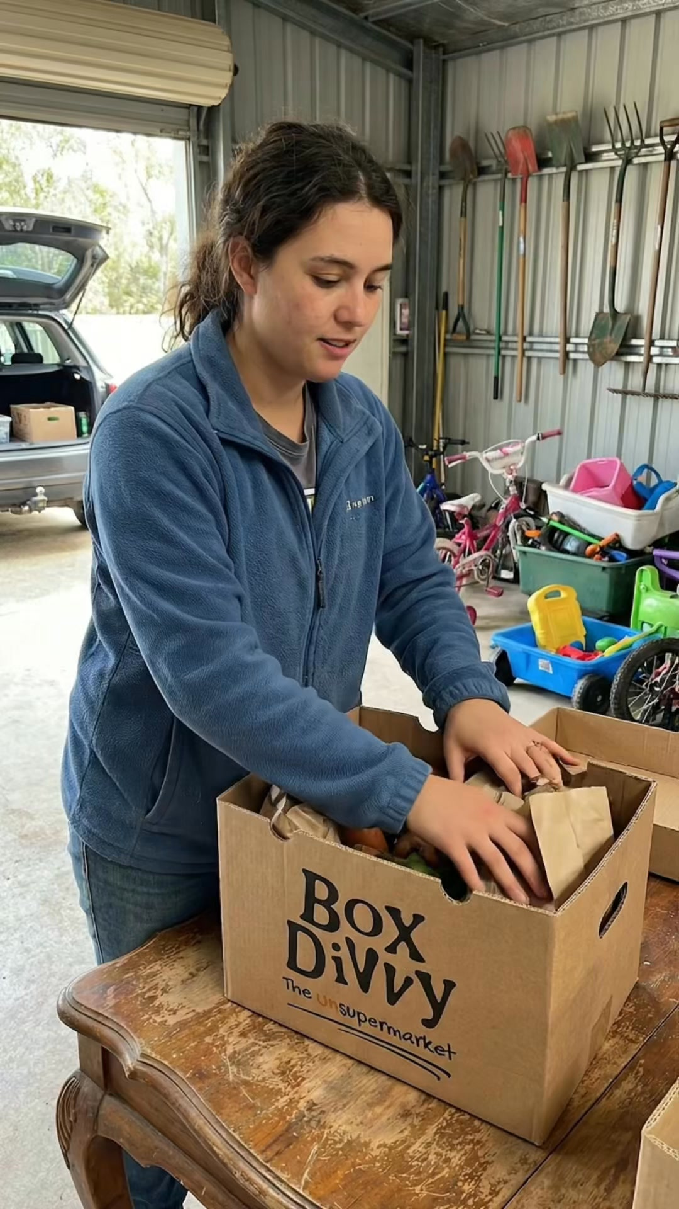
2 | Mar-12 | $0.95 | $21.59 | 4.55% | ...256220360 | 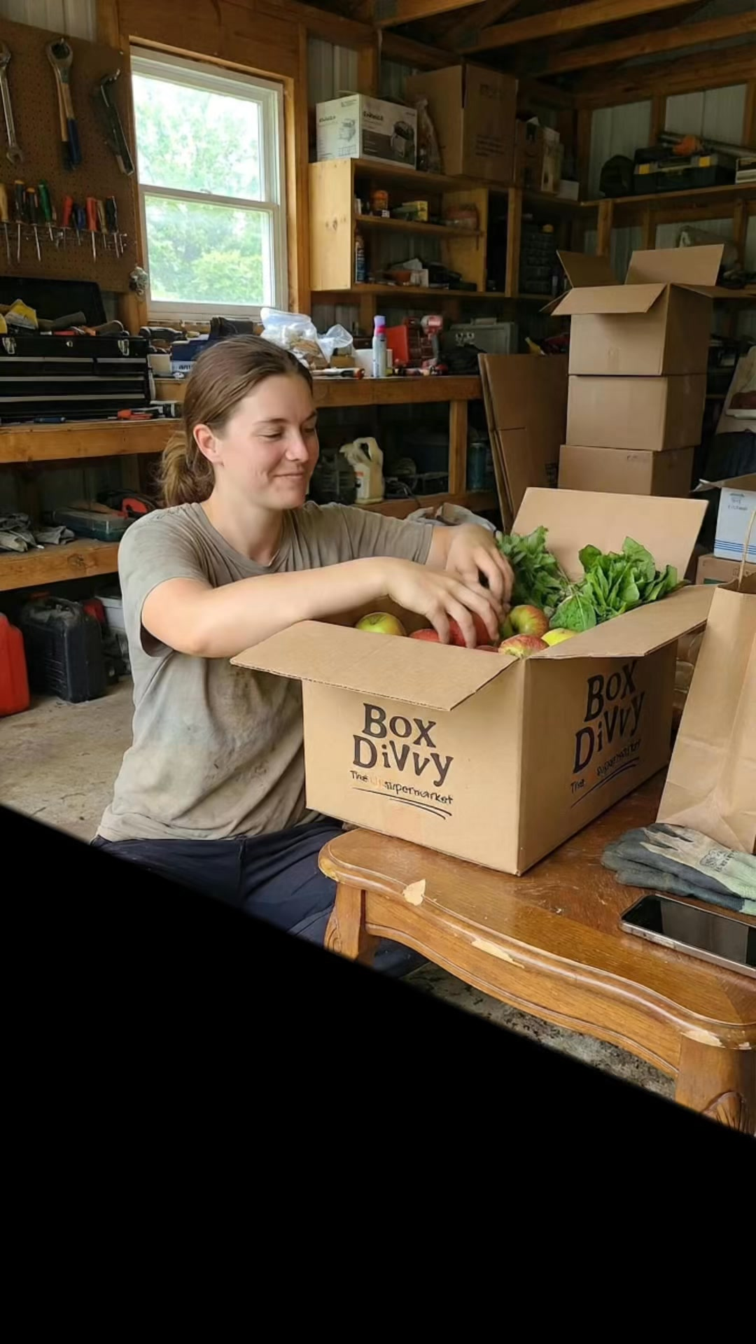
⭐ | Mar-12 | $0.45 | $19.57 | 26.09% | ...256190360 | 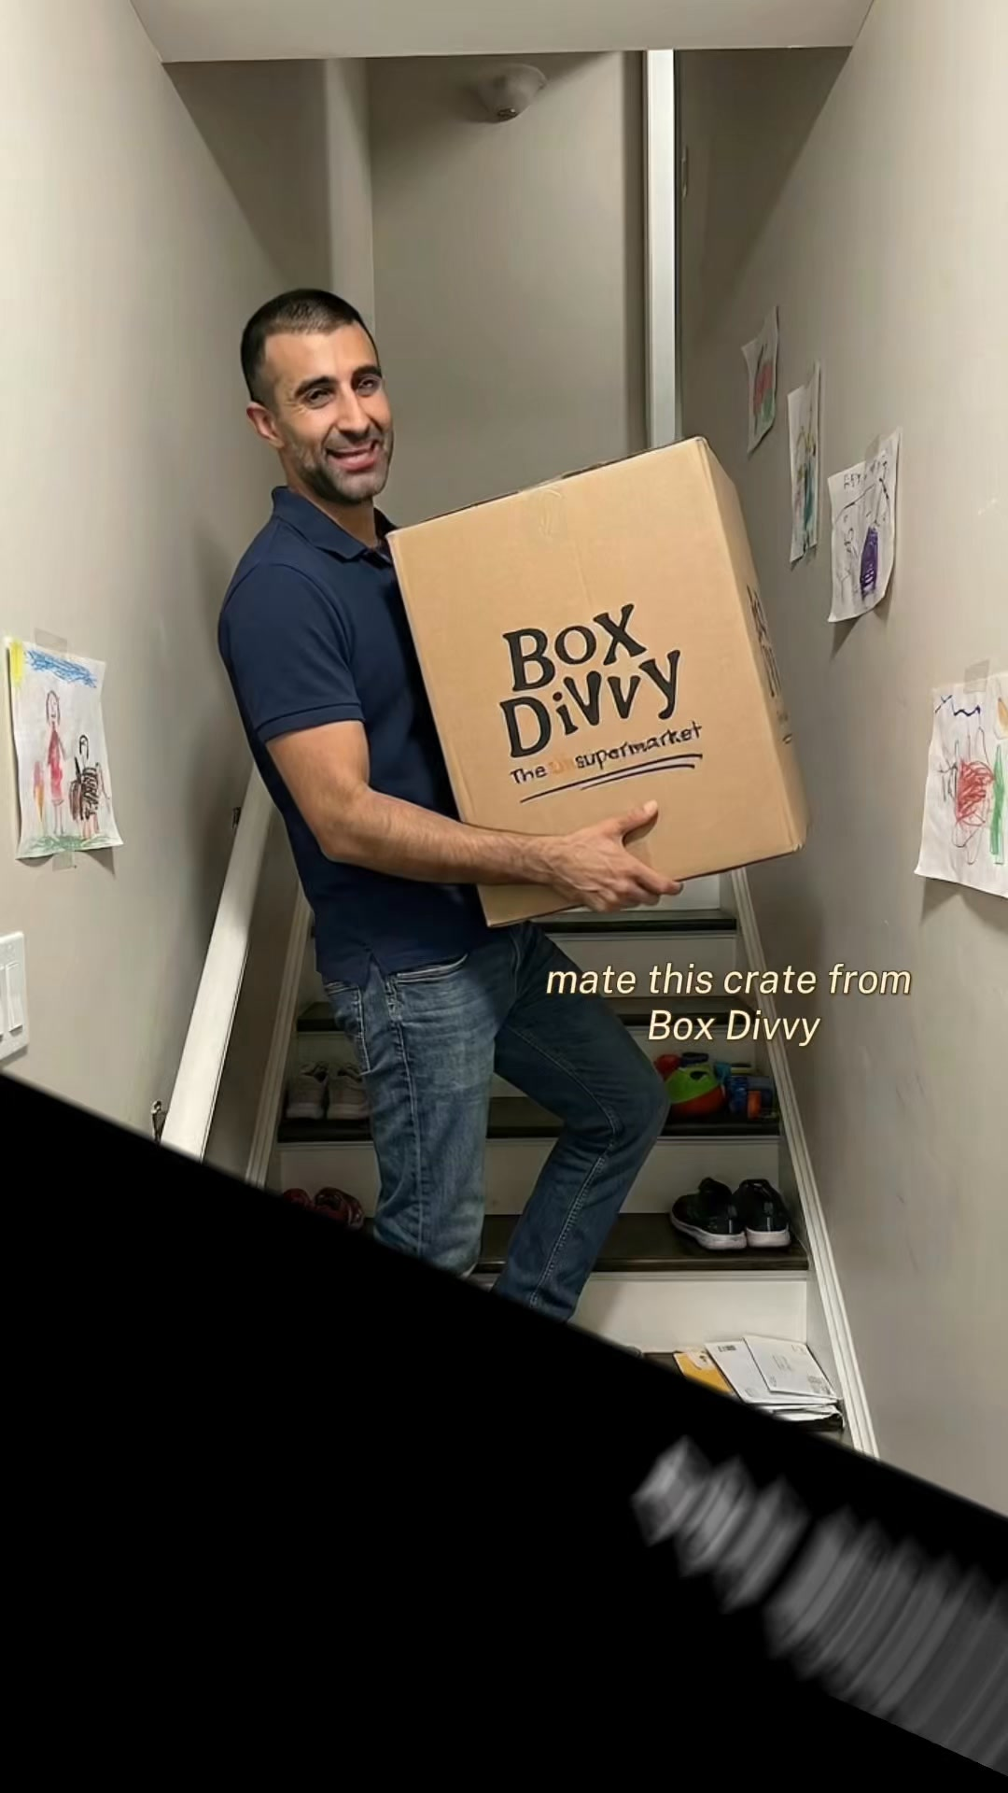
4 | Mar-12 | $0.38 | $13.10 | 0.00% | ...256210360 | 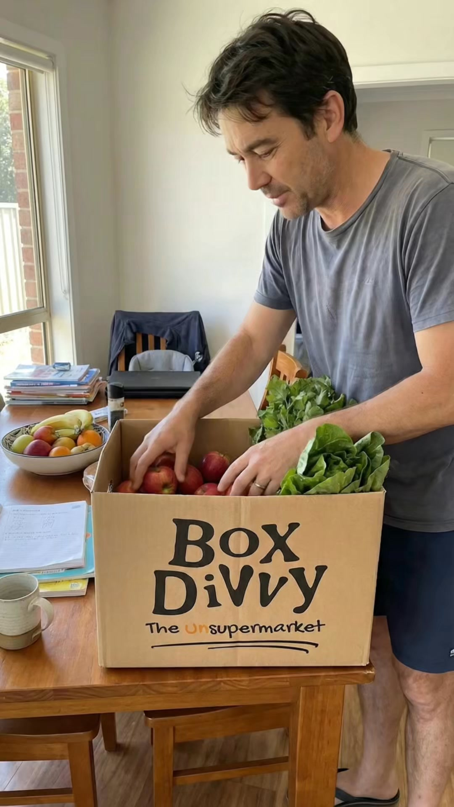
5 | Mar-12 | $0.36 | $16.36 | 4.55% | ...256200360 | 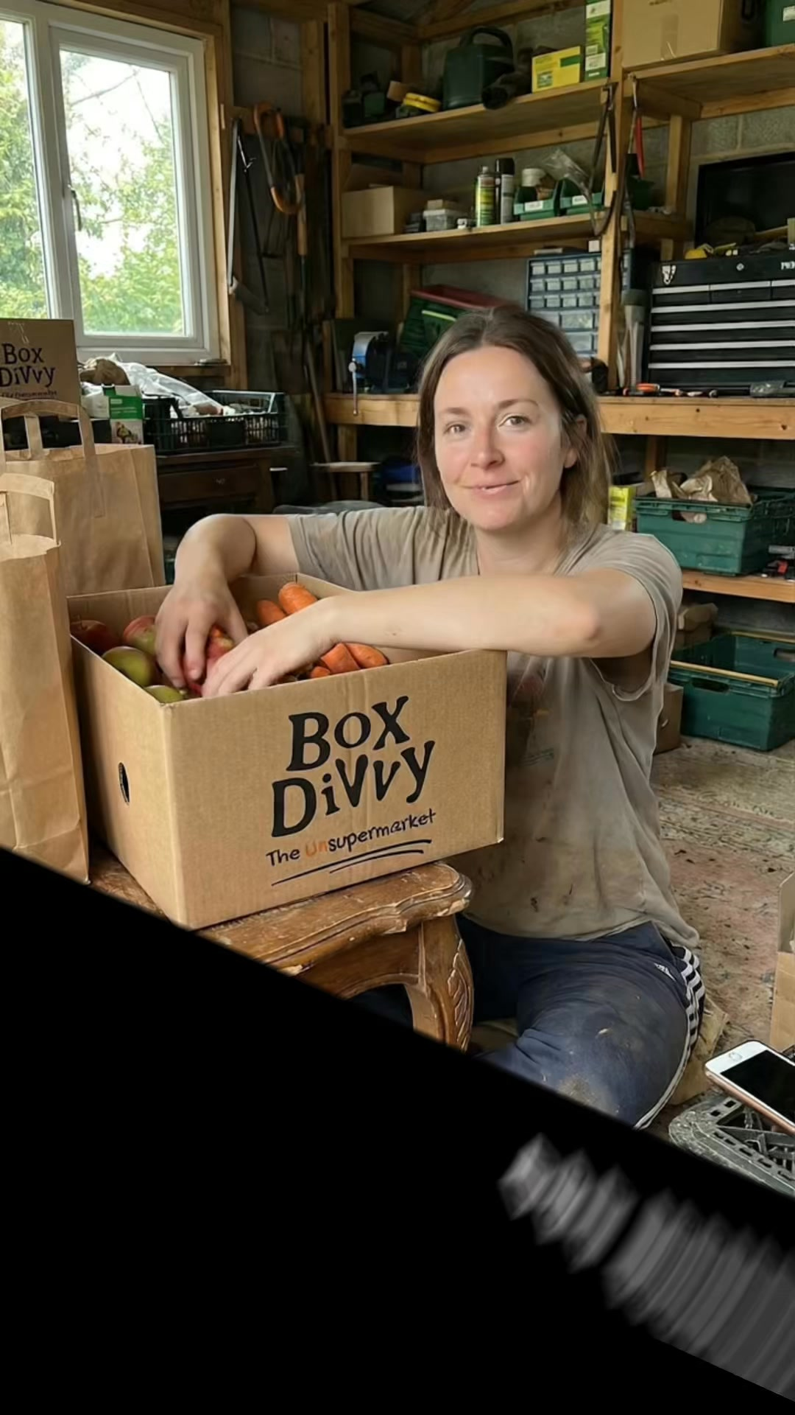

Top 5 Performers by CPL — All Time
# | Release Lot | CPL | Leads | CTR | Ad ID | Preview
🔥 | Feb-6 | $0.69 | 1 | 2.78% | ...917610360 | 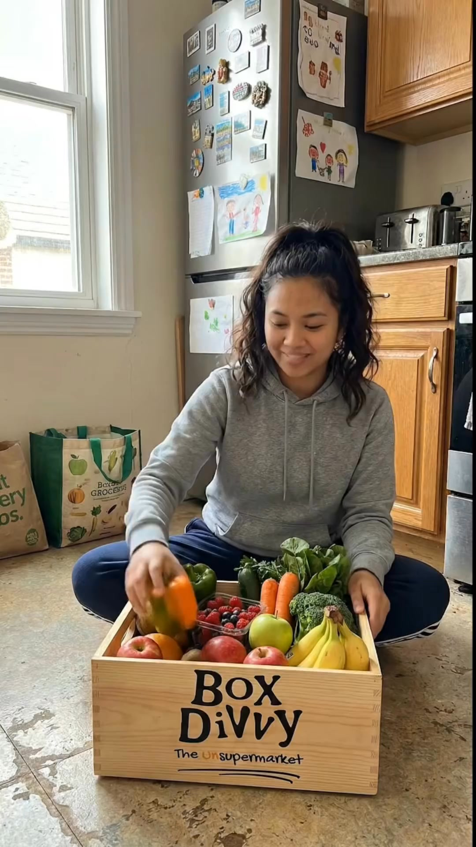
2 | Feb-6 | $1.74 | 1 | 5.56% | ...917220360 | 
⭐ | Jan-29 | $4.03 | 11 | 6.22% | ...743430360 | 
4 | Jan-12 | $4.07 | 12 | 6.18% | ...985710360 | 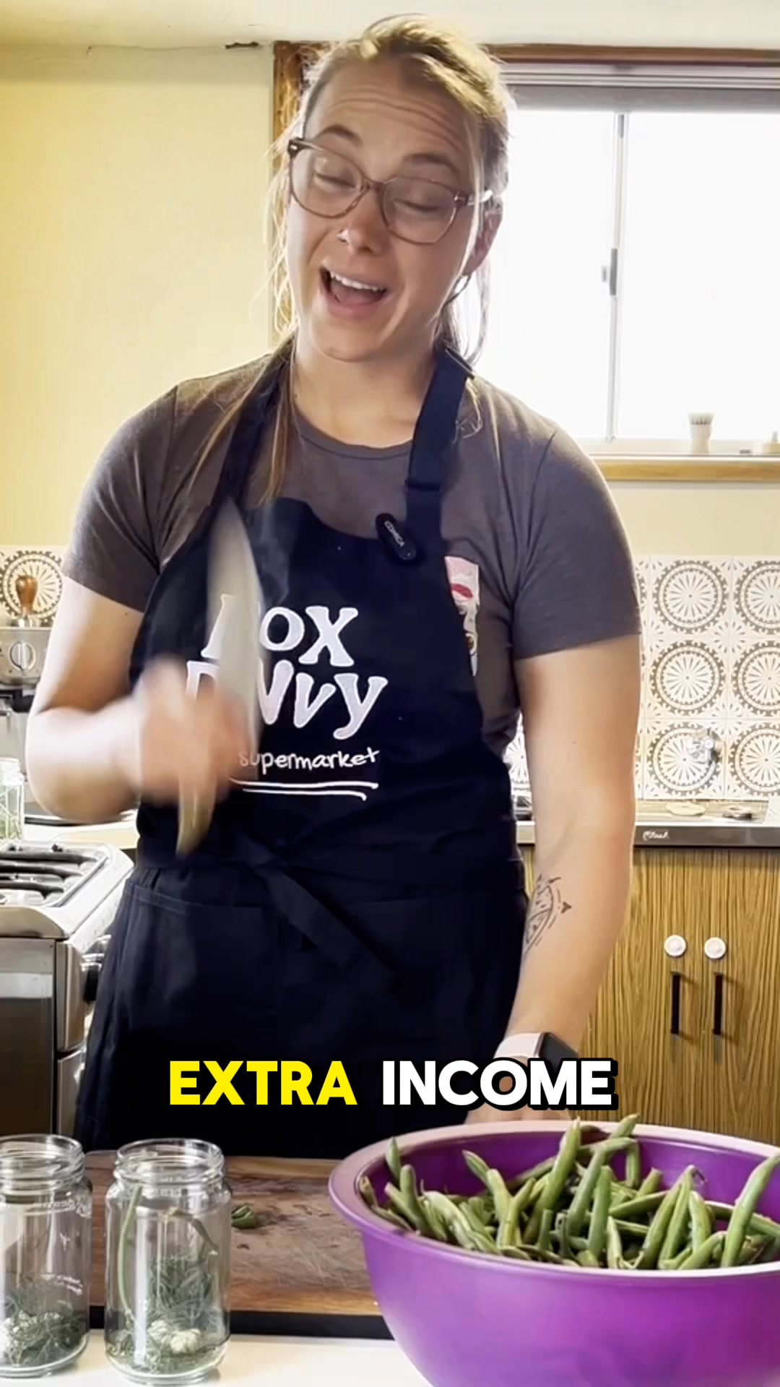
5 | Feb-6 | $4.15 | 1 | 2.61% | ...812870360 | 
🔥 = Top performer | ⭐ = Volume star | Sorted by cost per conversion (lowest first)

Release Lot Performance
• DEC-15 Release: 2 conversions from 2 ad(s) – Best cost: $0.69
• Jan-17 Release: 11 conversions from 1 ad(s) – Best cost: $4.03
• Dec-15 Release: 12 conversions from 1 ad(s) – Best cost: $4.07
• DEC-22 Release: 1 conversions from 1 ad(s) – Best cost: $4.15

Creative Insights
Top Performer:
DEC-15-2025 - copy_08771CC1-D4C9-4210-BE7C-B4582E8D0709 - Copy – 1 conversions at $0.69 cost, 2.78% CTR
Runner Up:
DEC-15-2025 - copy_08771CC1-D4C9-4210-BE7C-B4582E8D0709 - Copy – 1 conversions at $1.74 cost, 5.56% CTR

Demographic Sweet Spot
• Female 35-44: 18 leads, $9.45 CPL, 5.40% CTR
• Female 45-54: 12 leads, $10.68 CPL, 8.28% CTR
• Female 55-64: 5 leads, $9.92 CPL, 8.40% CTR

Key Insights
What's Working:
✓ Campaign is running with 42 conversions

Opportunities:
→ Continue optimising campaign performance

Recommended Next Steps
▸ Monitor performance and adjust as needed

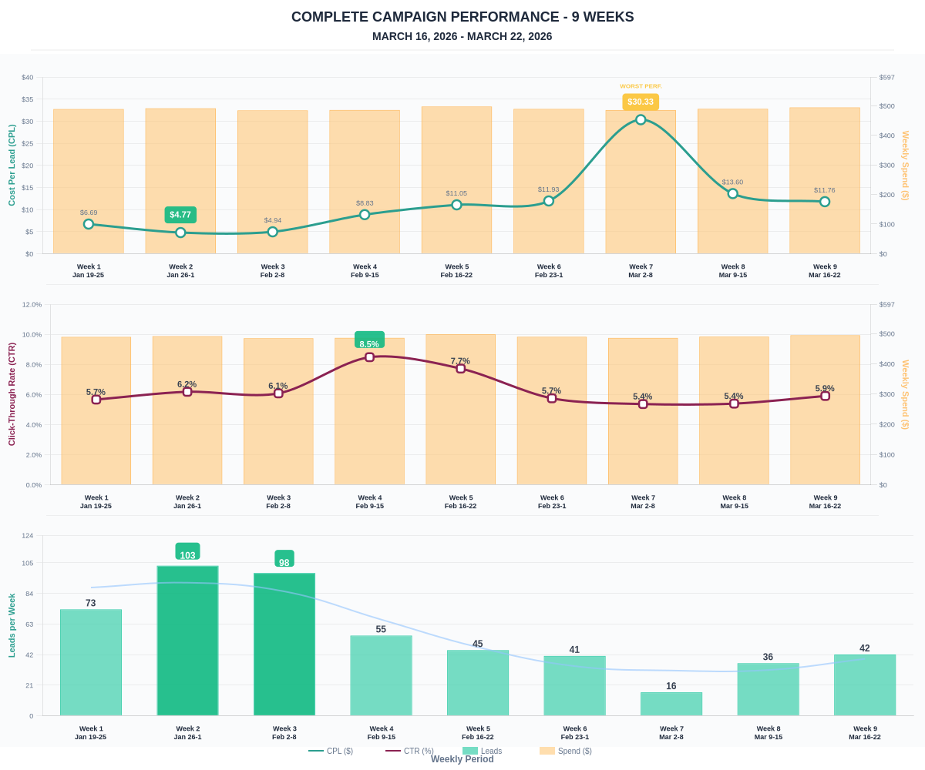

Questions? Let's chat about scaling these results.

