

Meta Ads Performance Audit
Client: Box Divvy
Campaign: Hubster Lead Gen
Period: 23 March 2026 – 29 March 2026

Executive Summary
The Box Divvy campaign is delivering solid results with a blended CPL of $14.75 across 33 leads. Total ad spend for the period was $486.60 with an average CTR of 4.97%. The top performer achieved a CPL of $0.84 (DEC-15-2025 - copy_08771CC1-D4C9-4210-BE). CTR is within healthy range for lead gen campaigns.

Key Metrics
Period | Spend | Leads | CPL | CTR
This Week | $486.60 | 33 | $14.75 | 4.97%
This Month | $2,105.40 | 135 | $15.60 | 5.40%
Since Starting | $5,349.20 | 650 | $8.23 | 6.47%

Latest Batch — Top Performers
# | Release Lot | CPL | Leads | CTR | Ad ID | Preview
🔥 | Mar-27 | $19.24 | 2 | 4.78% | ...457910360 | 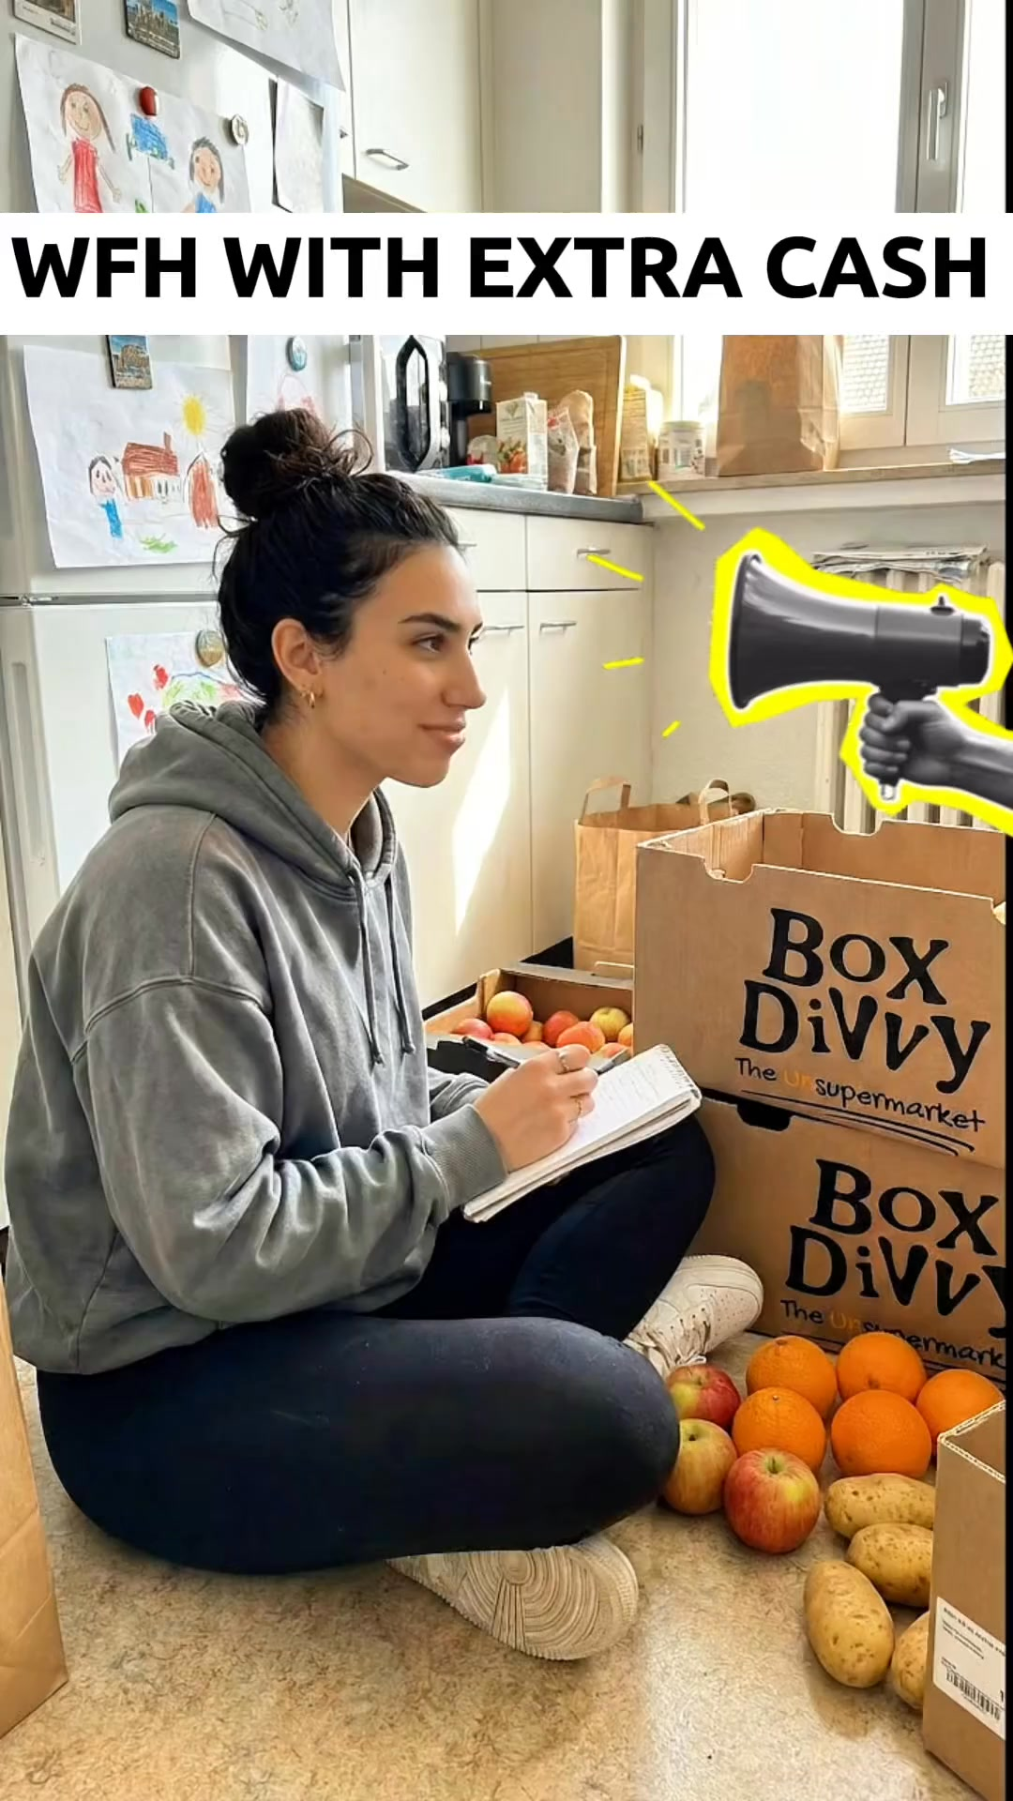

Top 5 Performers by CPL — All Time
# | Release Lot | CPL | Leads | CTR | Ad ID | Preview
🔥 | Feb-6 | $0.84 | 1 | 2.17% | ...917610360 | 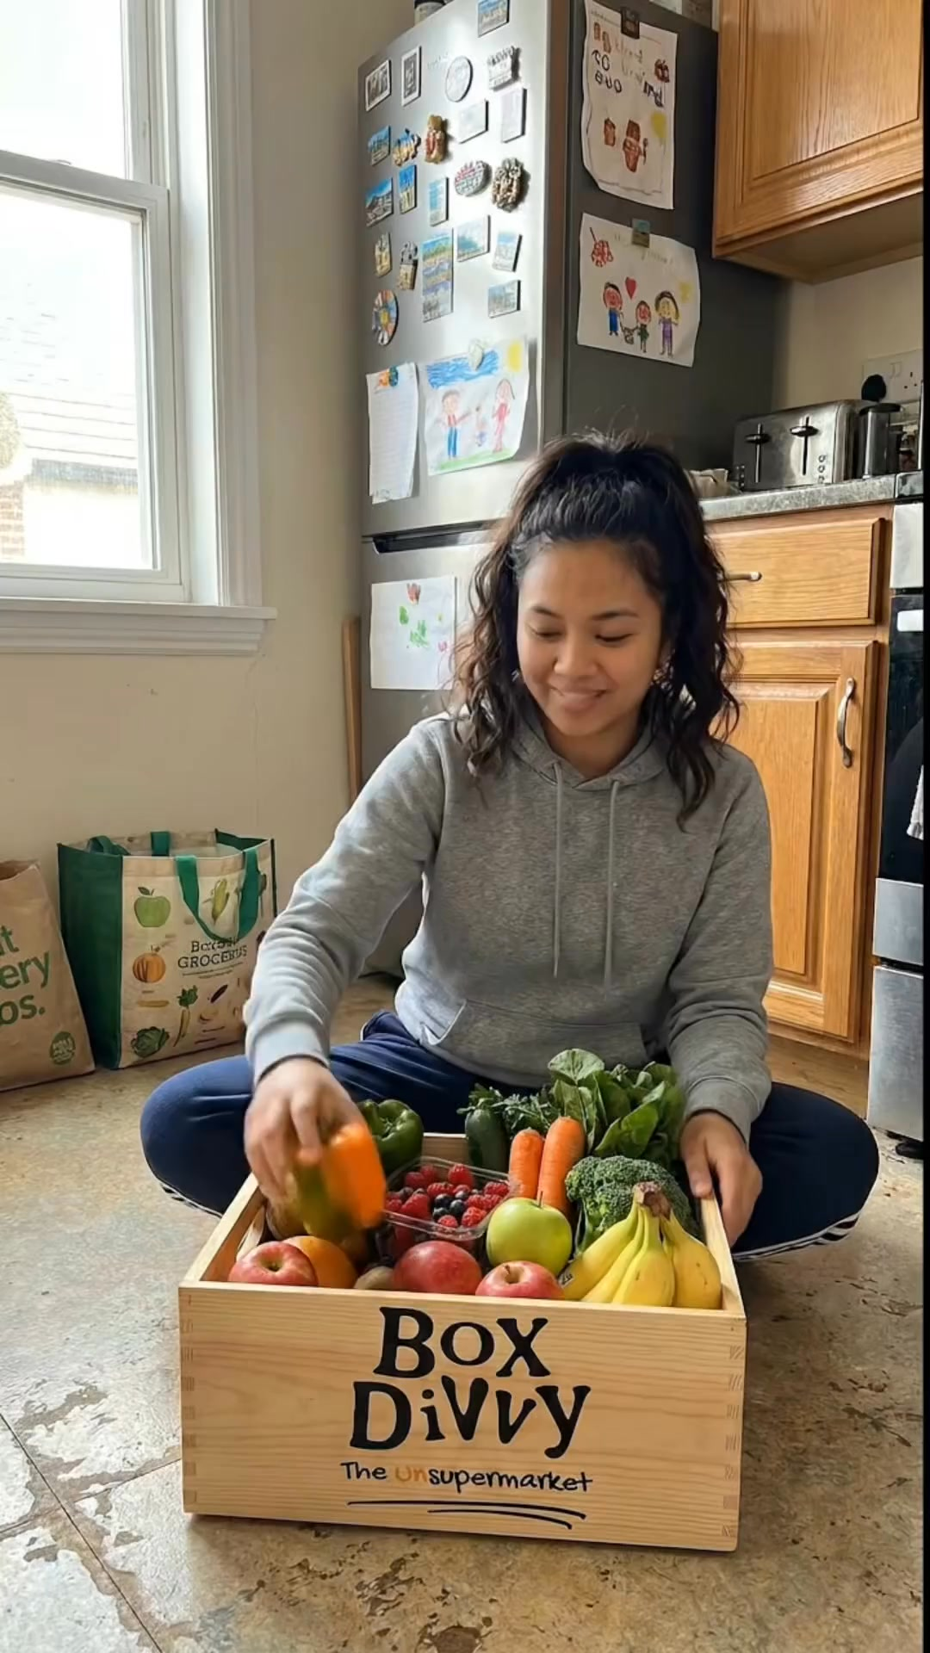
2 | Feb-6 | $1.86 | 1 | 7.07% | ...917220360 | 
⭐ | Jan-29 | $4.03 | 11 | 6.22% | ...743430360 | 
4 | Jan-12 | $4.07 | 12 | 6.18% | ...985710360 | 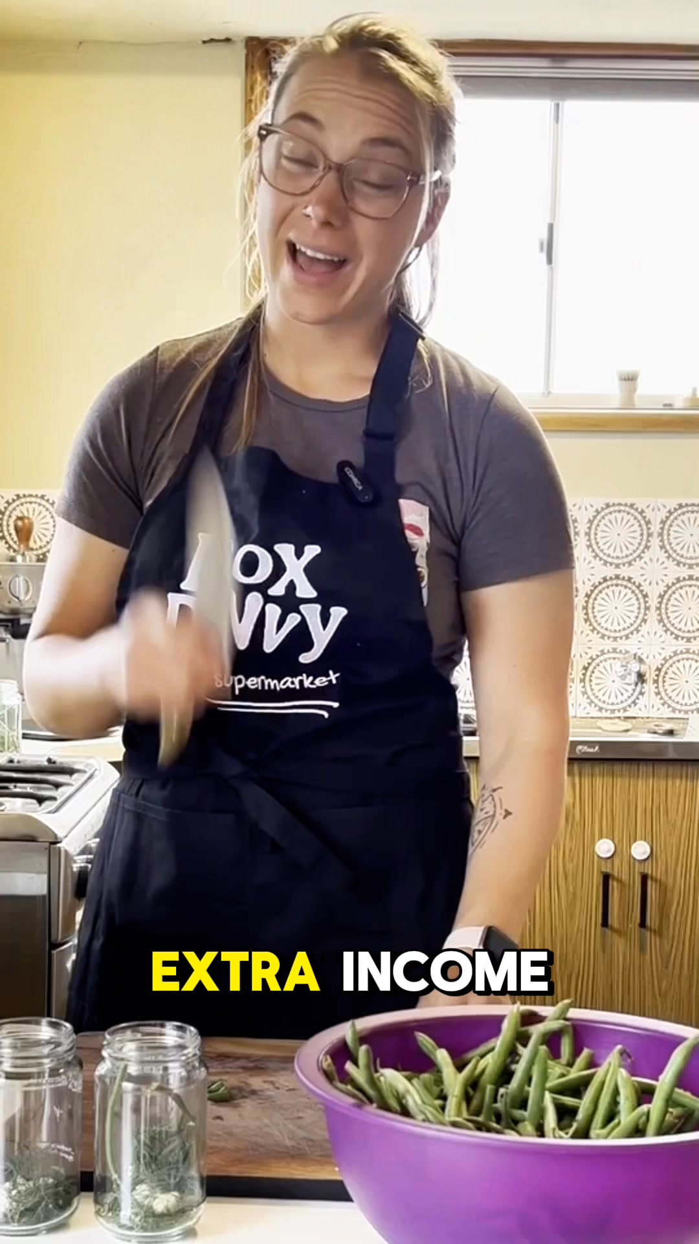
5 | Jan-12 | $4.37 | 104 | 8.66% | ...968670360 | 
🔥 = Top performer | ⭐ = Volume star | Sorted by cost per conversion (lowest first)

Release Lot Performance
• DEC-15 Release: 2 conversions from 2 ad(s) – Best cost: $0.84
• Jan-17 Release: 11 conversions from 1 ad(s) – Best cost: $4.03
• Dec-15 Release: 116 conversions from 2 ad(s) – Best cost: $4.07

Creative Insights
Top Performer:
DEC-15-2025 - copy_08771CC1-D4C9-4210-BE7C-B4582E8D0709 - Copy – 1 conversions at $0.84 cost, 2.17% CTR
Runner Up:
DEC-15-2025 - copy_08771CC1-D4C9-4210-BE7C-B4582E8D0709 - Copy – 1 conversions at $1.86 cost, 7.07% CTR

Demographic Sweet Spot
• Female 35-44: 11 leads, $16.64 CPL, 5.17% CTR
• Female 45-54: 10 leads, $13.22 CPL, 6.14% CTR
• Female 25-34: 5 leads, $18.66 CPL, 3.01% CTR

Key Insights
What's Working:
✓ Campaign is running with 33 conversions

Opportunities:
→ Continue optimising campaign performance

Recommended Next Steps
▸ Monitor performance and adjust as needed

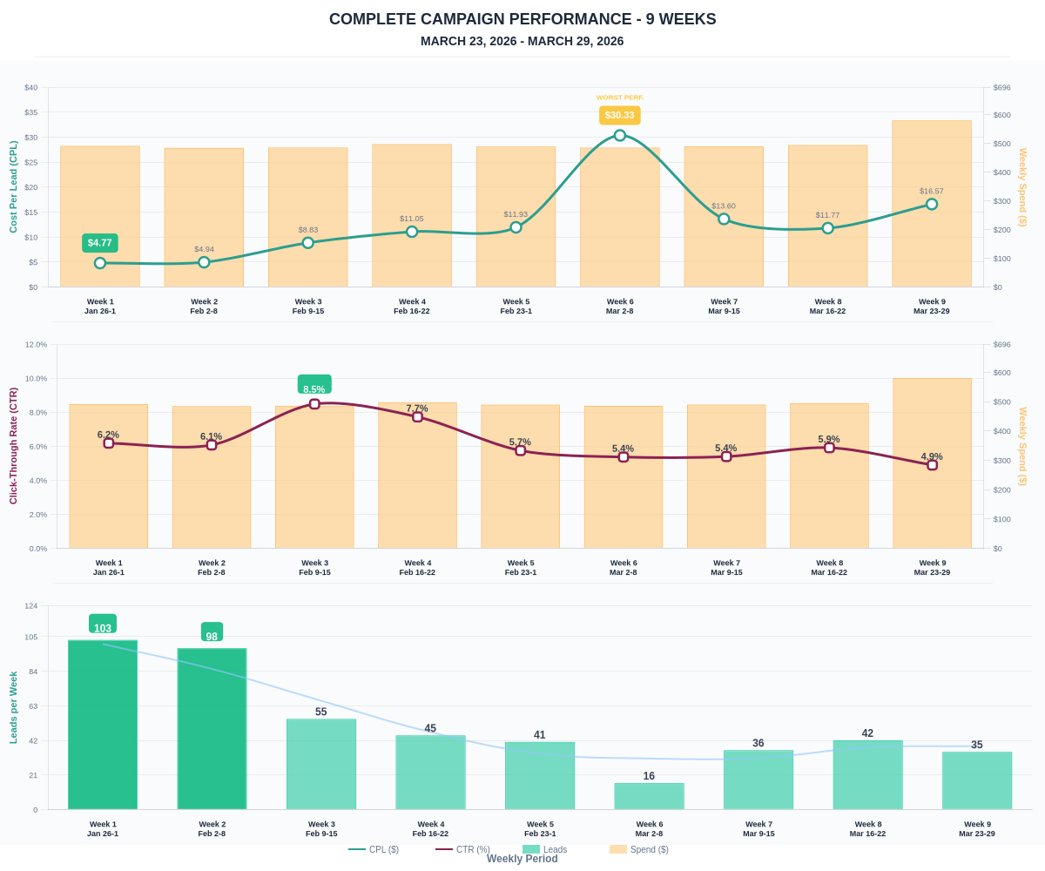

Questions? Let's chat about scaling these results.

