

Meta Ads Performance Audit
Client: NeedleFree (Comfort-In)
Campaign: PA - Sales - LP - All - CBO - 17.1
Period: 2 February 2026 – 8 February 2026

Executive Summary
The NeedleFree (Comfort-In) campaign is delivering solid results with a blended CPP of $15.99 across 26 purchases. Total ad spend for the period was $415.69 with an average CTR of 2.93%. The top performer achieved a CPP of $5.58 ((23-11-2025)). CTR is within healthy range for e-commerce campaigns.

Key Metrics
Period | Spend | Purchases | CPP | CTR
This Week | $415.69 | 26 | $15.99 | 2.93%
This Month | $1,649.98 | 146 | $11.30 | 3.94%
Since Starting | $3,639.26 | 317 | $11.48 | 4.52%

Latest Batch — Top Performers
# | Release Lot | CPP | Purchases | CTR | Ad ID | Preview
🔥 | 11-202 | $8.70 | 86 | 3.72% | ...632048571 | 
2 | 11-202 | $7.15 | 70 | 1.07% | ...051358971 | 
⭐ | 11-202 | $9.80 | 40 | 1.15% | ...051360371 | 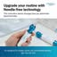
4 | 11-202 | $8.72 | 42 | 7.51% | ...141920571 | 
5 | 11-202 | $40.82 | 6 | 3.91% | ...141865771

Top 5 Performers by CPP — All Time
# | Release Lot | CPP | Purchases | CTR | Ad ID | Preview
🔥 | 11-202 | $5.58 | 4 | 0.84% | ...051358971
2 | 11-202 | $10.38 | 10 | 1.08% | ...051360371
⭐ | 11-202 | $29.63 | 2 | 3.18% | ...632048571
4 | 11-202 | $42.53 | 2 | 8.05% | ...632048971
🔥 = Top performer | ⭐ = Volume star | Sorted by cost per conversion (lowest first)

Release Lot Performance
• 11-202 Release: 18 conversions from 4 ad(s) – Best cost: $5.58

Creative Insights
Top Performer:
(23-11-2025) – 4 conversions at $5.58 cost, 0.84% CTR
Runner Up:
(23-11-2025) - (1) – 10 conversions at $10.38 cost, 1.08% CTR

Demographic Sweet Spot
• Male 25-34: 32 purchases, $4.66 CPP, 2.25% CTR
• Male 35-44: 12 purchases, $13.76 CPP, 3.10% CTR
• Male 55-64: 4 purchases, $4.04 CPP, 3.58% CTR

Key Insights
What's Working:
✓ Strong overall conversion rate with 26 purchases achieved at an efficient cost per purchase of $15.99
✓ Healthy CTR of 2.93% indicates compelling ad creative and targeting resonating with audience
✓ Top performing ad set from 23-11 delivered 10 purchases at an excellent CPA of $10.38, showing strong potential for scaling

Opportunities:
→ Significant CTR variation between ad sets (0.84% to 3.18%) suggests room for creative optimisation
→ Cost per purchase fluctuation ($5.58 to $29.63) indicates potential for better budget allocation
→ Total impression count of 33,074 suggests potential to expand reach while maintaining efficiency

Recommended Next Steps
▸ Analyse creative elements from the 3.18% CTR ad and apply these insights to lower-performing variations
▸ Reallocate budget towards the top-performing ad set from 23-11 while maintaining a minimum daily spend of $60
▸ Create 2-3 new ad variations based on the $5.58 CPA campaign creative to test against current top performers

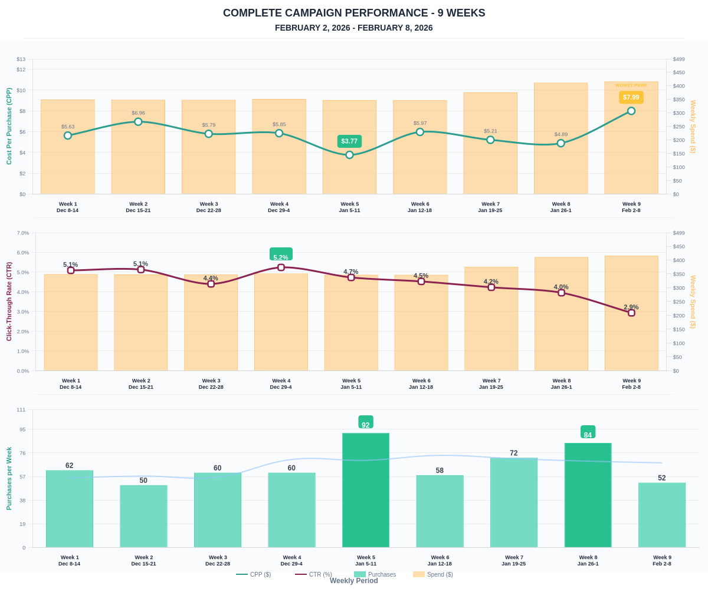

Questions? Let's chat about scaling these results.

