

Meta Ads Performance Audit
Client: NeedleFree (Comfort-In)
Campaign: PA - Sales - LP - All - CBO - 17.1
Period: 9 February 2026 – 15 February 2026

Executive Summary
The NeedleFree (Comfort-In) campaign is delivering solid results with a blended CPP of $13.10 across 22 purchases. Total ad spend for the period was $288.11 with an average CTR of 2.42%. The top performer achieved a CPP of $0.40 ((15-12-2025) - (4)). CTR is within healthy range for e-commerce campaigns.

Key Metrics
Period | Spend | Purchases | CPP | CTR
This Week | $288.11 | 22 | $13.10 | 2.42%
This Month | $1,588.29 | 135 | $11.77 | 3.57%
Since Starting | $3,927.44 | 339 | $11.59 | 4.36%

Latest Batch — Top Performers
# | Release Lot | CPP | Purchases | CTR | Ad ID | Preview
🔥 | 11-202 | $8.26 | 98 | 3.64% | ...632048571 | 
2 | 11-202 | $7.31 | 70 | 1.07% | ...051358971 | 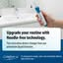
⭐ | 11-202 | $11.52 | 44 | 1.20% | ...051360371 | 
4 | 11-202 | $8.80 | 42 | 7.51% | ...141920571 | 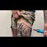
5 | 11-202 | $41.26 | 6 | 3.87% | ...141865771

Top 5 Performers by CPP — All Time
# | Release Lot | CPP | Purchases | CTR | Ad ID | Preview
🔥 | 12-202 | $0.40 | 4 | 0.00% | ...717929371
2 | 11-202 | $5.09 | 12 | 2.63% | ...632048571
⭐ | 11-202 | $28.74 | 4 | 1.37% | ...051360371
🔥 = Top performer | ⭐ = Volume star | Sorted by cost per conversion (lowest first)

Release Lot Performance
• 12-202 Release: 4 conversions from 1 ad(s) – Best cost: $0.40
• 11-202 Release: 16 conversions from 2 ad(s) – Best cost: $5.09

Creative Insights
Top Performer:
(15-12-2025) - (4) – 4 conversions at $0.40 cost, 0.00% CTR
Runner Up:
(10-11-2025) - (2) - Copy – 12 conversions at $5.09 cost, 2.63% CTR

Demographic Sweet Spot
• Data pending: Demographic breakdown requires more data volume

Key Insights
What's Working:
✓ Strong overall conversion rate with 22 purchases achieved at an efficient cost per purchase of $13.10
✓ Ad set (10-11-2025)-(2) showing excellent performance with 12 purchases and healthy 2.63% CTR
✓ Healthy click-through rate of 2.42% across the campaign indicating strong ad relevance to target audience

Opportunities:
→ High cost variance between top performers ($0.40 vs $28.74 cost per purchase) suggests room for budget optimisation
→ Inconsistent CTR performance across ad sets indicates potential targeting refinement needed
→ Some ad sets showing 0% CTR suggest creative or audience mismatch requiring investigation

Recommended Next Steps
▸ Analyse the successful copy elements from (10-11-2025)-(2) and apply these learnings to other ad sets
▸ Reallocate budget from higher CPA ad sets to the best performing ad set (15-12-2025)-(4) to maximise efficiency
▸ Review and refresh creative assets for low-performing ad sets, particularly those with 0% CTR
▸ Conduct audience overlap analysis to ensure proper segmentation and prevent audience fatigue

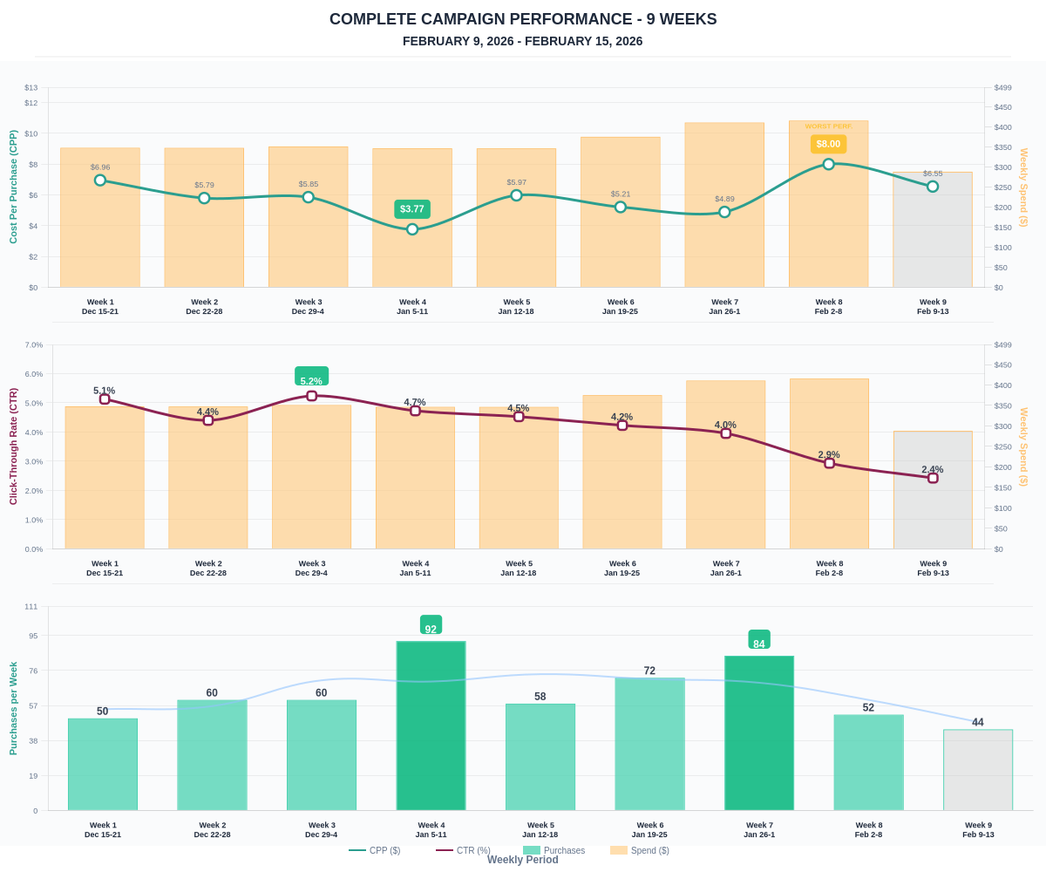

Questions? Let's chat about scaling these results.

