

Meta Ads Performance Audit
Client: NeedleFree (Comfort-In)
Campaign: PA - Sales - LP - All - CBO - 17.1
Period: 7 February 2026 – 13 February 2026

Executive Summary
The NeedleFree (Comfort-In) campaign is delivering solid results with a blended CPP of $14.03 across 30 purchases. Total ad spend for the period was $420.91 with an average CTR of 2.70%. The top performer achieved a CPP of $0.60 ((15-12-2025) - (4)). CTR is within healthy range for e-commerce campaigns.

Key Metrics
Period | Spend | Purchases | CPP | CTR
This Week | $420.91 | 30 | $14.03 | 2.70%
This Month | $1,692.61 | 142 | $11.92 | 3.61%
Since Starting | $3,938.95 | 339 | $11.62 | 4.35%

Latest Batch — Top Performers
# | Release Lot | CPP | Purchases | CTR | Ad ID | Preview
🔥 | 11-202 | $8.30 | 98 | 3.63% | ...632048571 | 
2 | 11-202 | $11.68 | 44 | 1.21% | ...051360371 | 
⭐ | 11-202 | $7.32 | 70 | 1.07% | ...051358971 | 
4 | 11-202 | $8.87 | 42 | 7.54% | ...141920571 | 
5 | 11-202 | $41.26 | 6 | 3.87% | ...141865771 | 

Top 5 Performers by CPP — All Time
# | Release Lot | CPP | Purchases | CTR | Ad ID | Preview
🔥 | 12-202 | $0.60 | 4 | 0.00% | ...717929371
2 | 11-202 | $6.44 | 12 | 2.91% | ...632048571
⭐ | 11-202 | $18.68 | 8 | 1.32% | ...051360371
🔥 = Top performer | ⭐ = Volume star | Sorted by cost per conversion (lowest first)

Release Lot Performance
• 12-202 Release: 4 conversions from 1 ad(s) – Best cost: $0.60
• 11-202 Release: 20 conversions from 2 ad(s) – Best cost: $6.44

Creative Insights
Top Performer:
(15-12-2025) - (4) – 4 conversions at $0.60 cost, 0.00% CTR
Runner Up:
(10-11-2025) - (2) - Copy – 12 conversions at $6.44 cost, 2.91% CTR

Demographic Sweet Spot
• Data pending: Demographic breakdown requires more data volume

Key Insights
What's Working:
✓ Strong overall conversion rate with 30 purchases achieved in just 7 days, indicating effective targeting and messaging
✓ Efficient cost per purchase at $14.03, demonstrating good return on ad spend for e-commerce in the medical supplies category
✓ Healthy CTR of 2.70% showing above-average ad relevance and creative engagement
✓ Ad set (10-11-2025) - (2) performing exceptionally well with 12 purchases at efficient $6.44 CPP

Opportunities:
→ Significant performance variance between ad sets suggests room for budget optimisation
→ Some ad sets showing very low CTR (0.00%) indicate potential creative or audience fatigue
→ Higher cost per purchase in ad set (23-11-2025) at $18.68 suggests need for efficiency improvements
→ Total impression count could be increased to capture more market share

Recommended Next Steps
▸ Reallocate budget towards the successful (10-11-2025) - (2) ad set and replicate its targeting and creative elements
▸ Pause or refresh creative for the 0.00% CTR ad set to improve engagement metrics
▸ Create new ad variations using the winning copy from the $6.44 CPP campaign to scale performance
▸ Analyse audience overlap between top-performing ad sets to identify most valuable customer segments

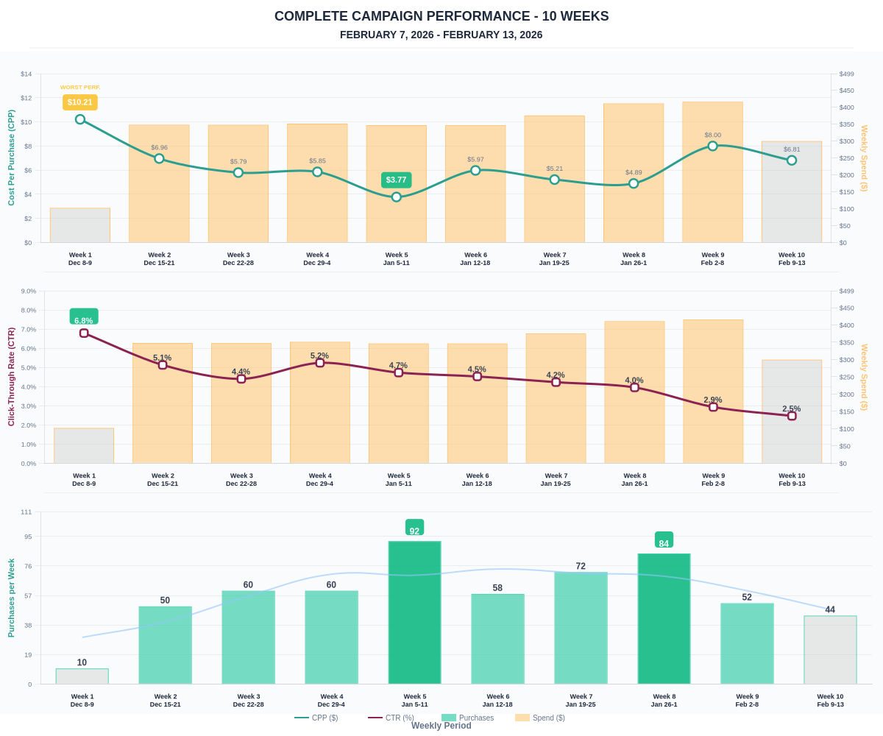

Questions? Let's chat about scaling these results.

