

Meta Ads Performance Audit
Client: NeedleFree (Comfort-In)
Campaign: PA - Sales - LP - All - CBO - 17.1
Period: 9 February 2026 – 15 February 2026

Executive Summary
The NeedleFree (Comfort-In) campaign is delivering solid results with a blended CPP of $12.41 across 33 purchases. Total ad spend for the period was $409.69 with an average CTR of 2.64%. The top performer achieved a CPP of $0.03 ((22-12-2025) - (5)). CTR is within healthy range for e-commerce campaigns.

Key Metrics
Period | Spend | Purchases | CPP | CTR
This Week | $409.69 | 33 | $12.41 | 2.64%
This Month | $1,709.87 | 146 | $11.71 | 3.55%
Since Starting | $4,049.02 | 350 | $11.57 | 4.32%

Latest Batch — Top Performers
# | Release Lot | CPP | Purchases | CTR | Ad ID | Preview
🔥 | 11-202 | $8.58 | 98 | 3.64% | ...632048571 | 
2 | 11-202 | $12.17 | 46 | 1.23% | ...051360371 | 
⭐ | 11-202 | $7.41 | 70 | 1.07% | ...051358971 | 
4 | 11-202 | $8.94 | 42 | 7.55% | ...141920571 | 
5 | 11-202 | $41.49 | 6 | 3.86% | ...141865771

Top 5 Performers by CPP — All Time
# | Release Lot | CPP | Purchases | CTR | Ad ID | Preview
🔥 | 12-202 | $0.03 | 20 | 14.29% | ...434619171 | 
2 | 12-202 | $0.52 | 4 | 1.43% | ...717929371 | 
⭐ | 11-202 | $7.72 | 12 | 3.00% | ...632048571
4 | 11-202 | $28.01 | 6 | 1.44% | ...051360371
🔥 = Top performer | ⭐ = Volume star | Sorted by cost per conversion (lowest first)

Release Lot Performance
• 12-202 Release: 24 conversions from 2 ad(s) – Best cost: $0.03
• 11-202 Release: 18 conversions from 2 ad(s) – Best cost: $7.72

Creative Insights
Top Performer:
(22-12-2025) - (5) – 20 conversions at $0.03 cost, 14.29% CTR
Runner Up:
(15-12-2025) - (4) – 4 conversions at $0.52 cost, 1.43% CTR

Demographic Sweet Spot
• Data pending: Demographic breakdown requires more data volume

Key Insights
What's Working:
✓ Strong overall purchase volume with 33 conversions at an efficient $12.41 cost per purchase, indicating effective targeting and messaging
✓ Exceptional performance from the December 22nd ad set achieving 20 purchases at just $0.03 each, demonstrating highly optimised audience targeting
✓ Healthy click-through rate of 2.64% across campaigns, showing compelling ad creative and audience relevance
✓ Good scale with over 31,000 impressions while maintaining conversion efficiency

Opportunities:
→ Significant performance variance between ad sets (from $0.03 to $7.72 cost per purchase) suggests room for budget optimisation
→ Lower CTR in some ad sets (1.43%) indicates potential for creative improvement and audience refinement
→ Scale potential exists given the strong performance of top-performing ad set
→ Uneven purchase distribution across ad sets suggests opportunity to replicate success factors

Recommended Next Steps
▸ Analyse the targeting and creative elements of the December 22nd ad set to replicate its success across other campaigns
▸ Reallocate budget from underperforming ad sets (>$5 CPA) to the top-performing ad sets to maximise efficiency
▸ Create new ad variations based on the 14.29% CTR creative to improve overall campaign engagement
▸ Conduct audience overlap analysis to ensure budget isn't being wasted on competing ad sets

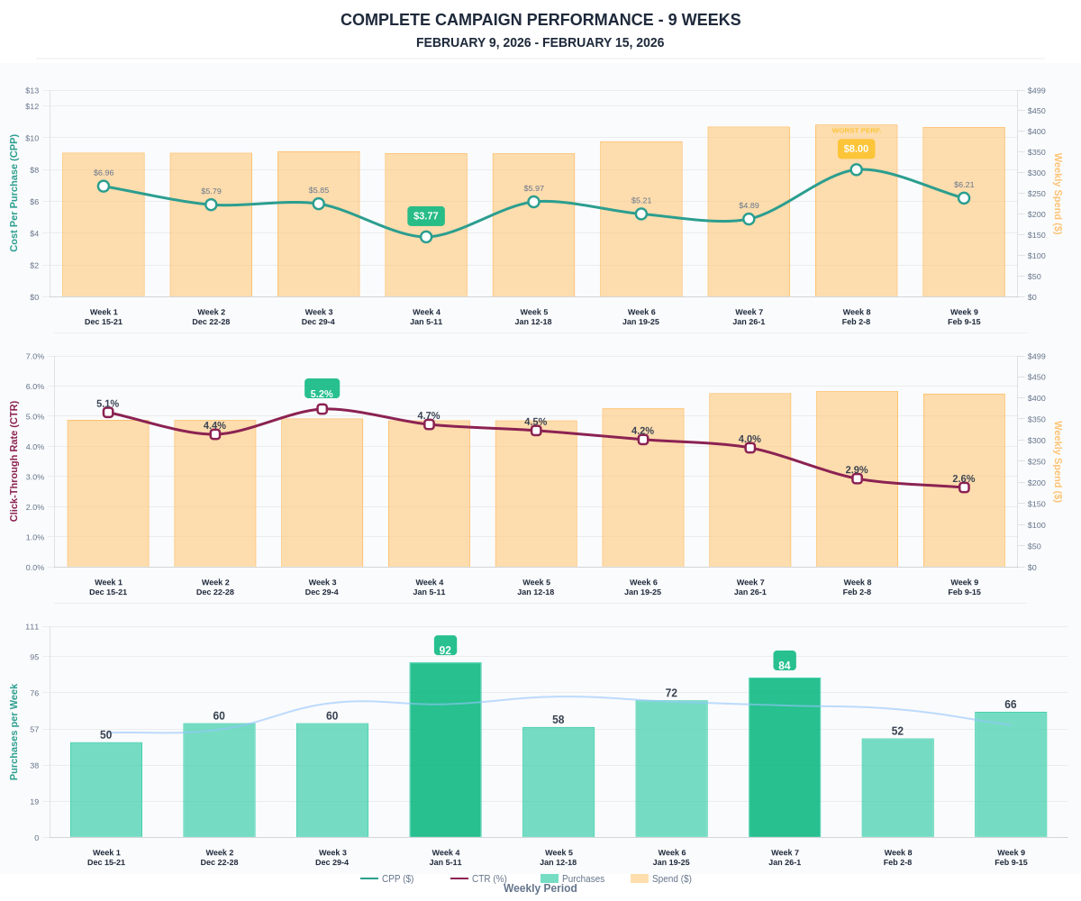

Questions? Let's chat about scaling these results.

