

Meta Ads Performance Audit
Client: NeedleFree (Comfort-In)
Campaign: PA - Sales - LP - All - CBO - 17.1
Period: 15 February 2026 – 21 February 2026

Executive Summary
The NeedleFree (Comfort-In) campaign is delivering solid results with a blended CPP of $13.54 across 15 purchases. Total ad spend for the period was $203.10 with an average CTR of 3.04%. The top performer achieved a CPP of $0.05 ((22-12-2025) - (5)). CTR is within healthy range for e-commerce campaigns.

Key Metrics
Period | Spend | Purchases | CPP | CTR
This Week | $203.10 | 15 | $13.54 | 3.04%
This Month | $1,554.74 | 132 | $11.78 | 3.35%
Since Starting | $4,193.36 | 363 | $11.55 | 4.27%

Latest Batch — Top Performers
# | Release Lot | CPP | Purchases | CTR | Ad ID | Preview
🔥 | 11-202 | $8.91 | 98 | 3.65% | ...632048571 | 
2 | 11-202 | $11.96 | 50 | 1.22% | ...051360371 | 
⭐ | 11-202 | $7.79 | 70 | 1.06% | ...051358971 | 
4 | 11-202 | $8.42 | 46 | 7.51% | ...141920571 | 
5 | 11-202 | $41.65 | 6 | 3.85% | ...141865771

Top 5 Performers by CPP — All Time
# | Release Lot | CPP | Purchases | CTR | Ad ID | Preview
🔥 | 12-202 | $0.05 | 6 | 0.00% | ...434619171 | 
2 | 11-202 | $3.69 | 4 | 6.65% | ...141920571
⭐ | 11-202 | $15.69 | 4 | 1.20% | ...051360371
🔥 = Top performer | ⭐ = Volume star | Sorted by cost per conversion (lowest first)

Release Lot Performance
• 12-202 Release: 6 conversions from 1 ad(s) – Best cost: $0.05
• 11-202 Release: 8 conversions from 2 ad(s) – Best cost: $3.69

Creative Insights
Top Performer:
(22-12-2025) - (5) – 6 conversions at $0.05 cost, 0.00% CTR
Runner Up:
(10-11-2025) - (9) – 4 conversions at $3.69 cost, 6.65% CTR

Demographic Sweet Spot
• Data pending: Demographic breakdown requires more data volume

Key Insights
What's Working:
✓ Strong overall purchase conversion with 15 sales at an efficient cost per purchase of $13.54
✓ Healthy click-through rate of 3.04%, indicating engaging ad creative and targeting
✓ Ad set from 22-12-2025 showing exceptional efficiency with 6 purchases at just $0.05 cost per purchase
✓ Multiple ad sets generating 4+ purchases, suggesting good audience diversification

Opportunities:
→ Large variance in cost per purchase between top performers ($0.05 to $15.69) indicates room for budget optimisation
→ Significant CTR differences across ad sets (0.00% to 6.65%) suggest creative effectiveness varies considerably
→ Total impression count of 15,504 indicates potential to scale successful ad sets for broader reach
→ Some ad sets showing low CTR but good conversion rates, suggesting targeting refinement potential

Recommended Next Steps
▸ Analyse creative elements from the 10-11-2025 ad set with 6.65% CTR and replicate successful components in other ads
▸ Gradually increase budget allocation to the highly efficient 22-12-2025 ad set while monitoring performance stability
▸ Create lookalike audiences based on purchasers from top-performing ad sets to expand reach while maintaining efficiency
▸ Pause or optimise ad sets with cost per purchase above campaign average of $13.54

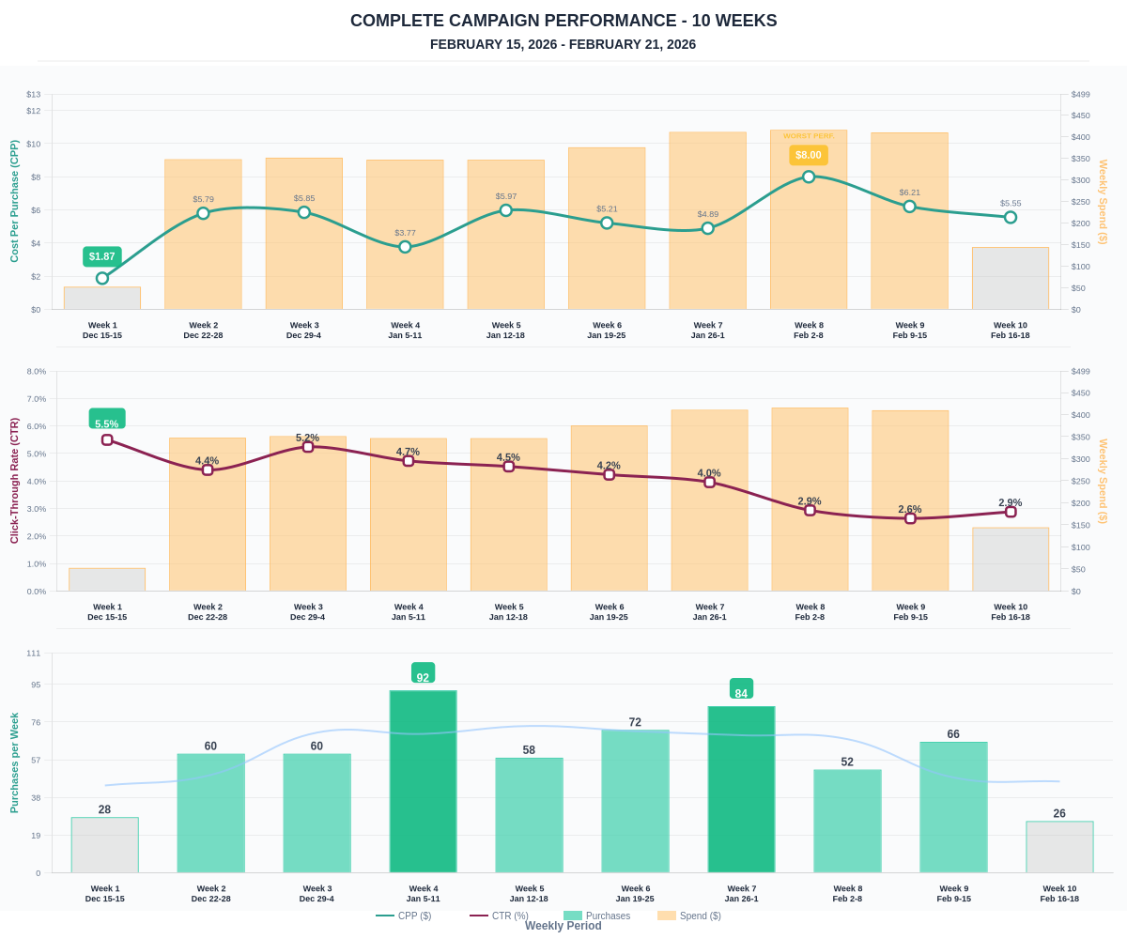

Questions? Let's chat about scaling these results.

