

Meta Ads Performance Audit
Client: NeedleFree (Comfort-In)
Campaign: PA - Sales - LP - All - CBO - 17.1
Period: 12 February 2026 – 18 February 2026

Executive Summary
The NeedleFree (Comfort-In) campaign is delivering strong performance with a blended CPP of $9.60 across 43 purchases. Total ad spend for the period was $412.75 with an average CTR of 2.82%. The top performer achieved a CPP of $0.04 ((22-12-2025) - (5)). CTR is within healthy range for e-commerce campaigns.

Key Metrics
Period | Spend | Purchases | CPP | CTR
This Week | $412.75 | 43 | $9.60 | 2.82%
This Month | $1,744.27 | 151 | $11.55 | 3.36%
Since Starting | $4,232.65 | 370 | $11.44 | 4.25%

Latest Batch — Top Performers
# | Release Lot | CPP | Purchases | CTR | Ad ID | Preview
🔥 | 11-202 | $9.00 | 98 | 3.66% | ...632048571 | 
2 | 11-202 | $12.14 | 50 | 1.23% | ...051360371 | 
⭐ | 11-202 | $7.89 | 70 | 1.06% | ...051358971 | 
4 | 11-202 | $8.44 | 46 | 7.51% | ...141920571 | 
5 | 11-202 | $41.73 | 6 | 3.85% | ...141865771

Top 5 Performers by CPP — All Time
# | Release Lot | CPP | Purchases | CTR | Ad ID | Preview
🔥 | 12-202 | $0.04 | 22 | 5.00% | ...434619171 | 
2 | 12-202 | $0.54 | 4 | 2.86% | ...717929371 | 
⭐ | 11-202 | $5.16 | 4 | 7.15% | ...141920571
4 | 11-202 | $12.43 | 8 | 3.63% | ...632048571
5 | 11-202 | $15.02 | 10 | 1.39% | ...051360371
🔥 = Top performer | ⭐ = Volume star | Sorted by cost per conversion (lowest first)

Release Lot Performance
• 12-202 Release: 26 conversions from 2 ad(s) – Best cost: $0.04
• 11-202 Release: 22 conversions from 3 ad(s) – Best cost: $5.16

Creative Insights
Top Performer:
(22-12-2025) - (5) – 22 conversions at $0.04 cost, 5.00% CTR
Runner Up:
(15-12-2025) - (4) – 4 conversions at $0.54 cost, 2.86% CTR

Demographic Sweet Spot
• Data pending: Demographic breakdown requires more data volume

Key Insights
What's Working:
✓ Strong overall CTR of 2.82% indicates compelling ad creative and targeting alignment with audience interests
✓ Excellent cost per purchase at $9.60 shows efficient conversion optimisation and audience targeting
✓ Top performing ad set (22-12-2025) achieved remarkable 5% CTR with very low CPA of $0.04, demonstrating strong creative-audience fit
✓ Consistent daily purchase volume suggests stable campaign performance and reliable conversion path

Opportunities:
→ Significant performance variance between top ad sets indicates room for budget reallocation to higher-performing creatives
→ Wide CPA range ($0.04 to $5.16) suggests opportunity to optimise lower-performing ad sets
→ CTR variations across ad sets (2.86% to 7.15%) indicate potential to improve ad relevance in some segments
→ Total impression count suggests potential to scale successful ad sets for greater reach

Recommended Next Steps
▸ Analyse creative elements from the top-performing ad set (22-12-2025) and replicate successful components in new variations
▸ Reallocate budget from ad sets with CPA above $2 to the best-performing ad sets to maximise efficiency
▸ Create lookalike audiences based on purchasers from the top-performing ad set to expand reach while maintaining performance
▸ Conduct A/B testing on ad copy and visuals using insights from highest CTR campaigns (7.15% and 5.00%)

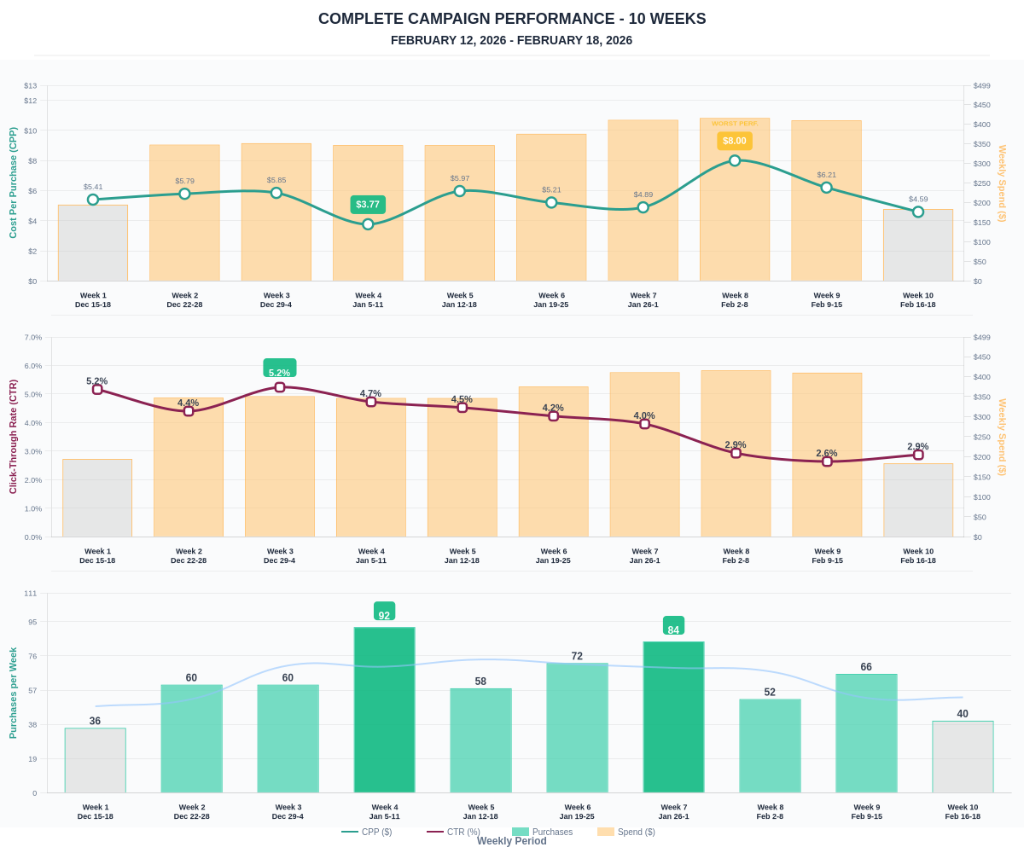

Questions? Let's chat about scaling these results.

