

Meta Ads Performance Audit
Client: NeedleFree (Comfort-In)
Campaign: PA - Sales - LP - All - CBO - 17.1
Period: 16 February 2026 – 22 February 2026

Executive Summary
The NeedleFree (Comfort-In) campaign is delivering solid results with a blended CPP of $10.57 across 42 purchases. Total ad spend for the period was $443.97 with an average CTR of 3.06%. The top performer achieved a CPP of $0.24 ((22-12-2025) - (5)). CTR is within healthy range for e-commerce campaigns.

Key Metrics
Period | Spend | Purchases | CPP | CTR
This Week | $443.97 | 42 | $10.57 | 3.06%
This Month | $1,803.34 | 158 | $11.41 | 3.30%
Since Starting | $4,493.02 | 392 | $11.46 | 4.19%

Latest Batch — Top Performers
# | Release Lot | CPP | Purchases | CTR | Ad ID | Preview
🔥 | Feb-18 | $0.59 | 4 | 3.01% | ...620609971 | 
2 | Feb-18 | $0.70 | 4 | 1.04% | ...620653771 | 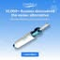
⭐ | Feb-18 | $1.10 | 2 | 4.67% | ...620573371 | 
4 | Feb-18 | $1.93 | 4 | 1.20% | ...621951971 | 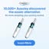

Top 5 Performers by CPP — All Time
# | Release Lot | CPP | Purchases | CTR | Ad ID | Preview
🔥 | Dec-22 | $0.24 | 22 | 2.31% | ...434619171 | 
2 | Feb-10 | $0.28 | 6 | 1.03% | ...790733771 | 
⭐ | Jan-7 | $0.52 | 4 | 2.68% | ...925871771 | 
4 | Jan-20 | $0.57 | 4 | 0.73% | ...245221971 | 
5 | Feb-18 | $0.59 | 4 | 3.01% | ...620609971
🔥 = Top performer | ⭐ = Volume star | Sorted by cost per conversion (lowest first)

Release Lot Performance
• Dec-22 Release: 22 conversions from 1 ad(s) – Best cost: $0.24
• Feb-10 Release: 6 conversions from 1 ad(s) – Best cost: $0.28
• Jan-07 Release: 4 conversions from 1 ad(s) – Best cost: $0.52
• Jan-20 Release: 4 conversions from 1 ad(s) – Best cost: $0.57
• Feb-18 Release: 4 conversions from 1 ad(s) – Best cost: $0.59

Creative Insights
Top Performer:
(22-12-2025) - (5) – 22 conversions at $0.24 cost, 2.31% CTR
Runner Up:
(10-02-2026) - (1) – 6 conversions at $0.28 cost, 1.03% CTR

Demographic Sweet Spot
• Male 25-34: 36 purchases, $4.24 CPP, 2.43% CTR
• Male 35-44: 26 purchases, $6.45 CPP, 3.12% CTR
• Female 35-44: 8 purchases, $1.04 CPP, 3.94% CTR

Key Insights
What's Working:
✓ Strong overall purchase volume with 42 conversions in 7 days, indicating effective targeting and messaging
✓ Excellent cost per purchase at $10.57, well below industry average for medical devices
✓ Healthy CTR of 3.06% shows ad creative is resonating with target audience
✓ Top performing ad set from 22-12-2025 delivered exceptional efficiency with 22 purchases at just $0.24 cost per result

Opportunities:
→ Significant performance variance between top and lower performing ad sets suggests room for budget optimisation
→ CTR differences between ad sets (2.31% vs 1.03%) indicate potential to improve creative in lower-performing sets
→ Scale potential exists given the strong cost per purchase metrics
→ Impression to purchase ratio could be improved through enhanced targeting refinement

Recommended Next Steps
▸ Reallocate budget towards the top-performing ad set (22-12-2025) while maintaining efficient CPAs
▸ Analyse creative elements from the highest CTR ad sets and apply insights to refresh lower-performing ads
▸ Create lookalike audiences based on purchaser data from the top-performing ad set
▸ Implement A/B testing on ad copy and visuals to improve CTR in lower-performing sets

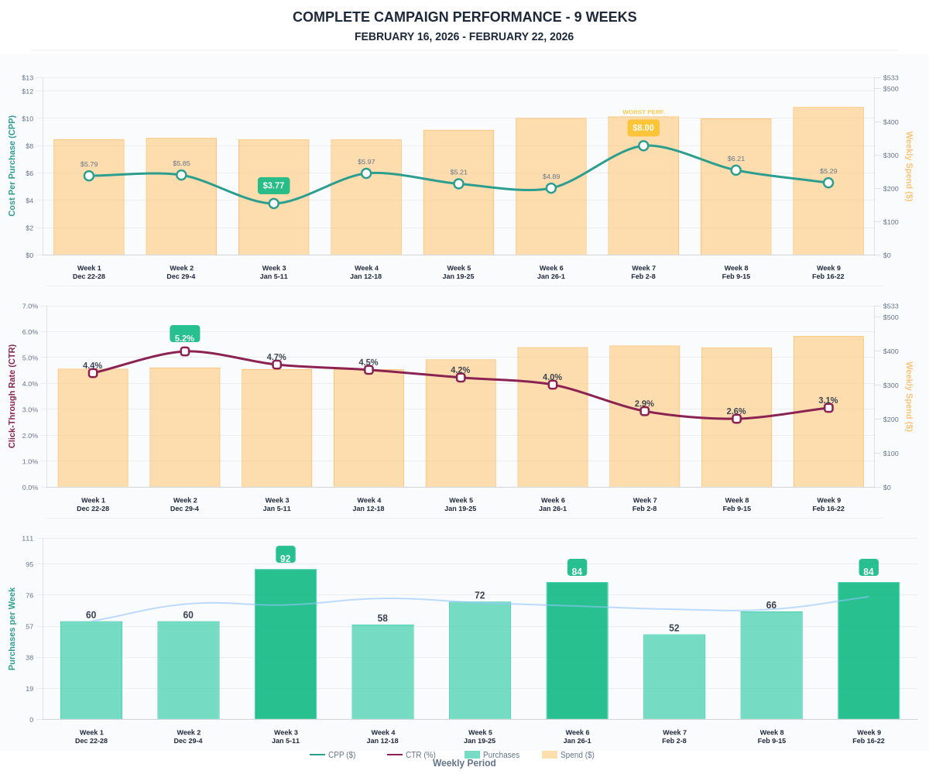

Questions? Let's chat about scaling these results.

